**We will use conditions**

**Method-1: ↓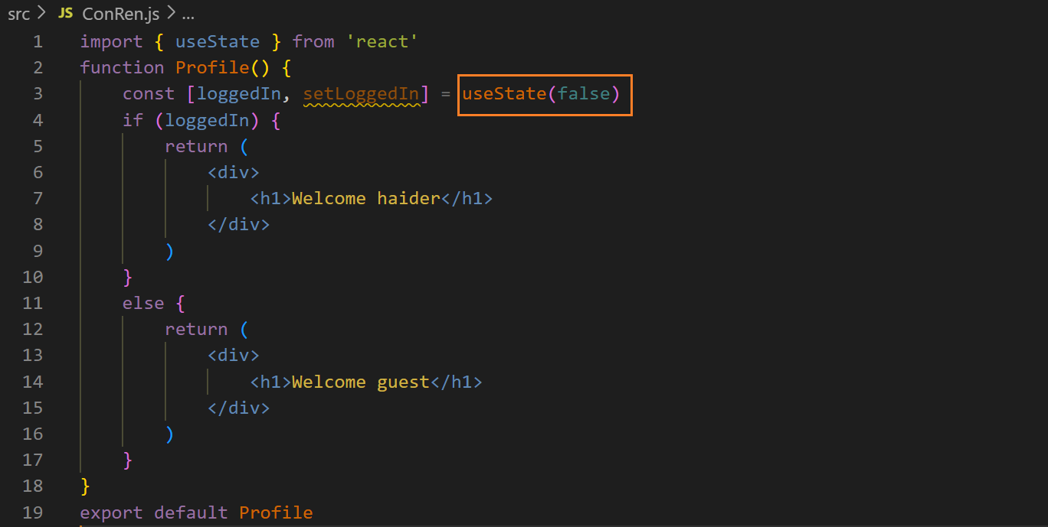output ↓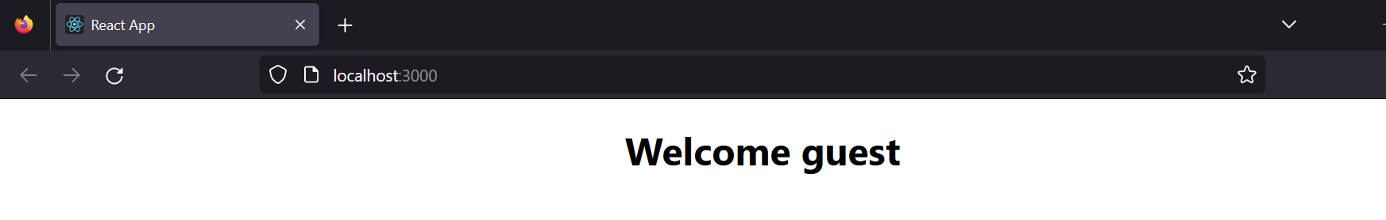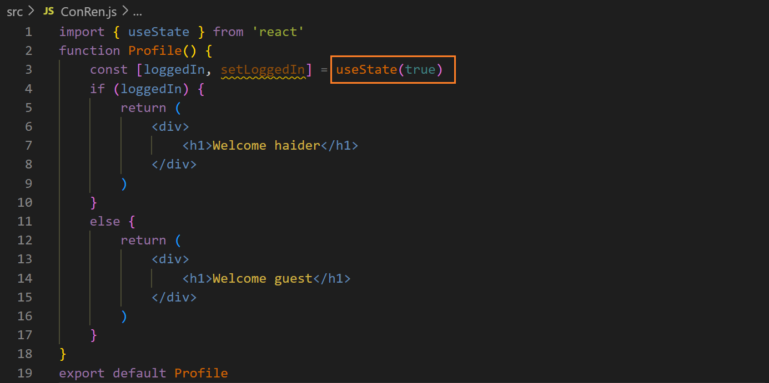output ↓**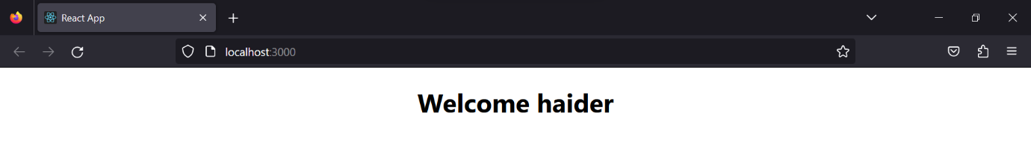

**Method-2: best way ↓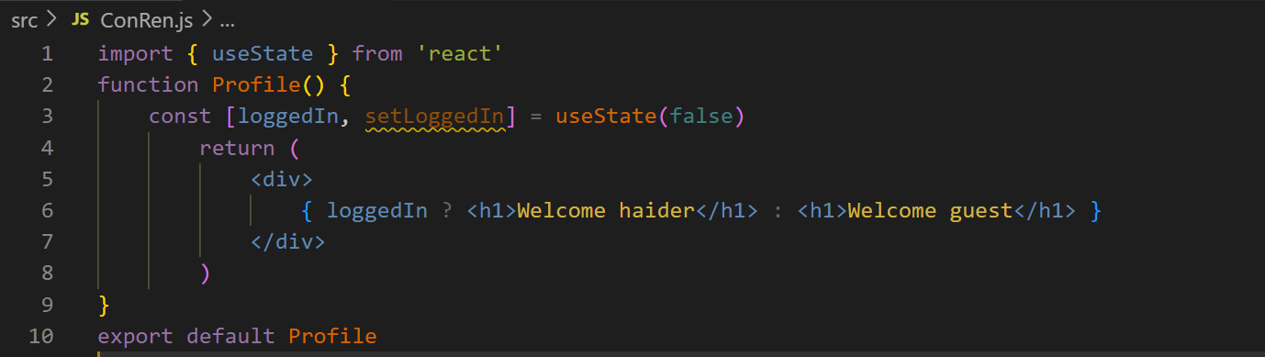output ↓**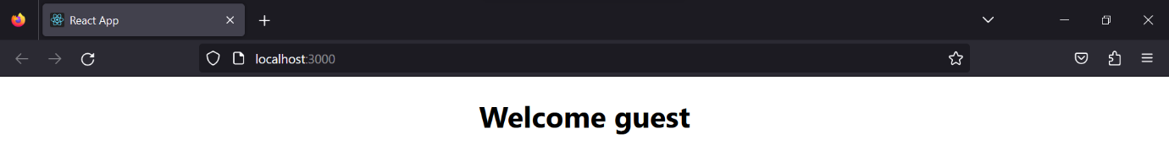

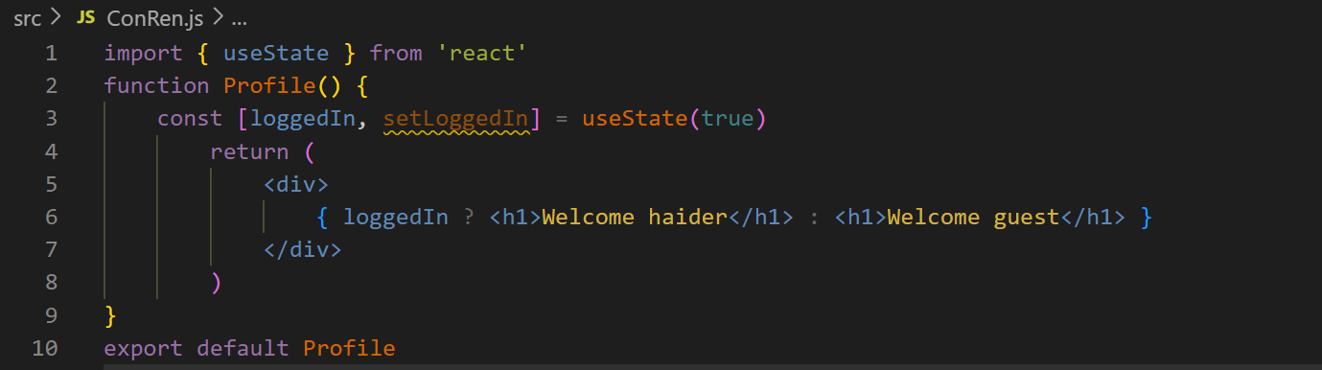**output ↓**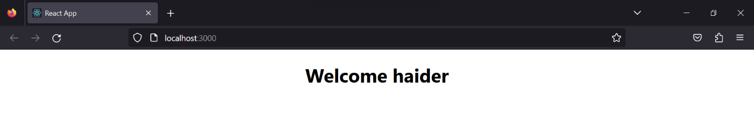

**If we have to use more than two conditions then ↓**

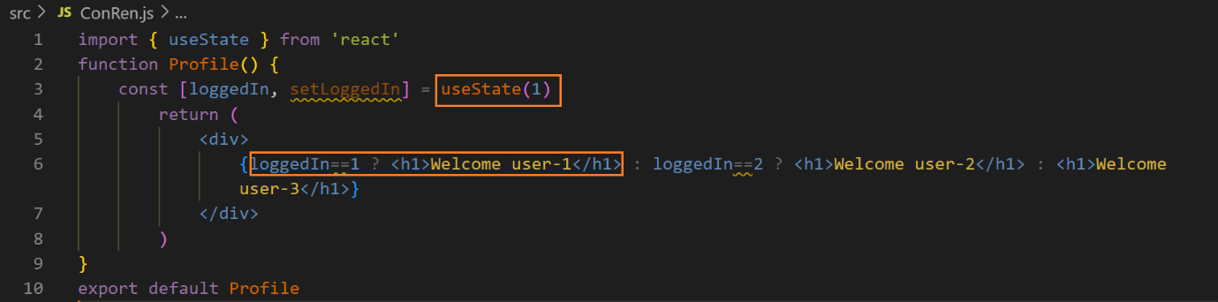**output ↓**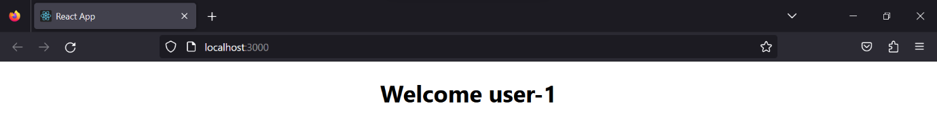

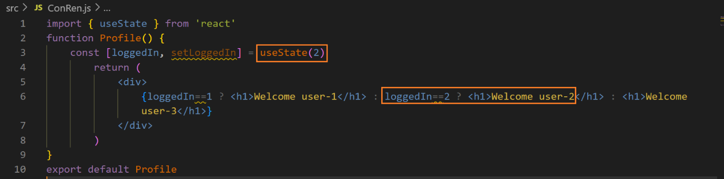**output ↓**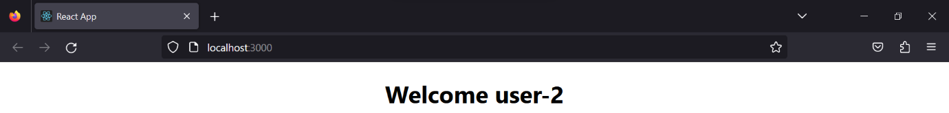

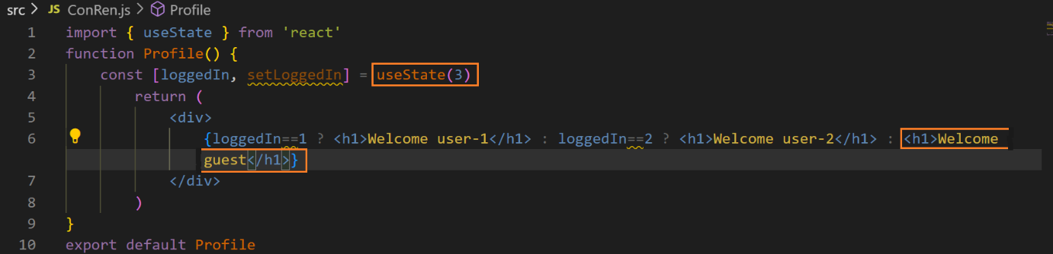**output↓**