**We will add validation and conditions such that User-ID must be greater 5 characters and less that 10 characters and similarly for password, but we will see basic validation on User-ID and password ↓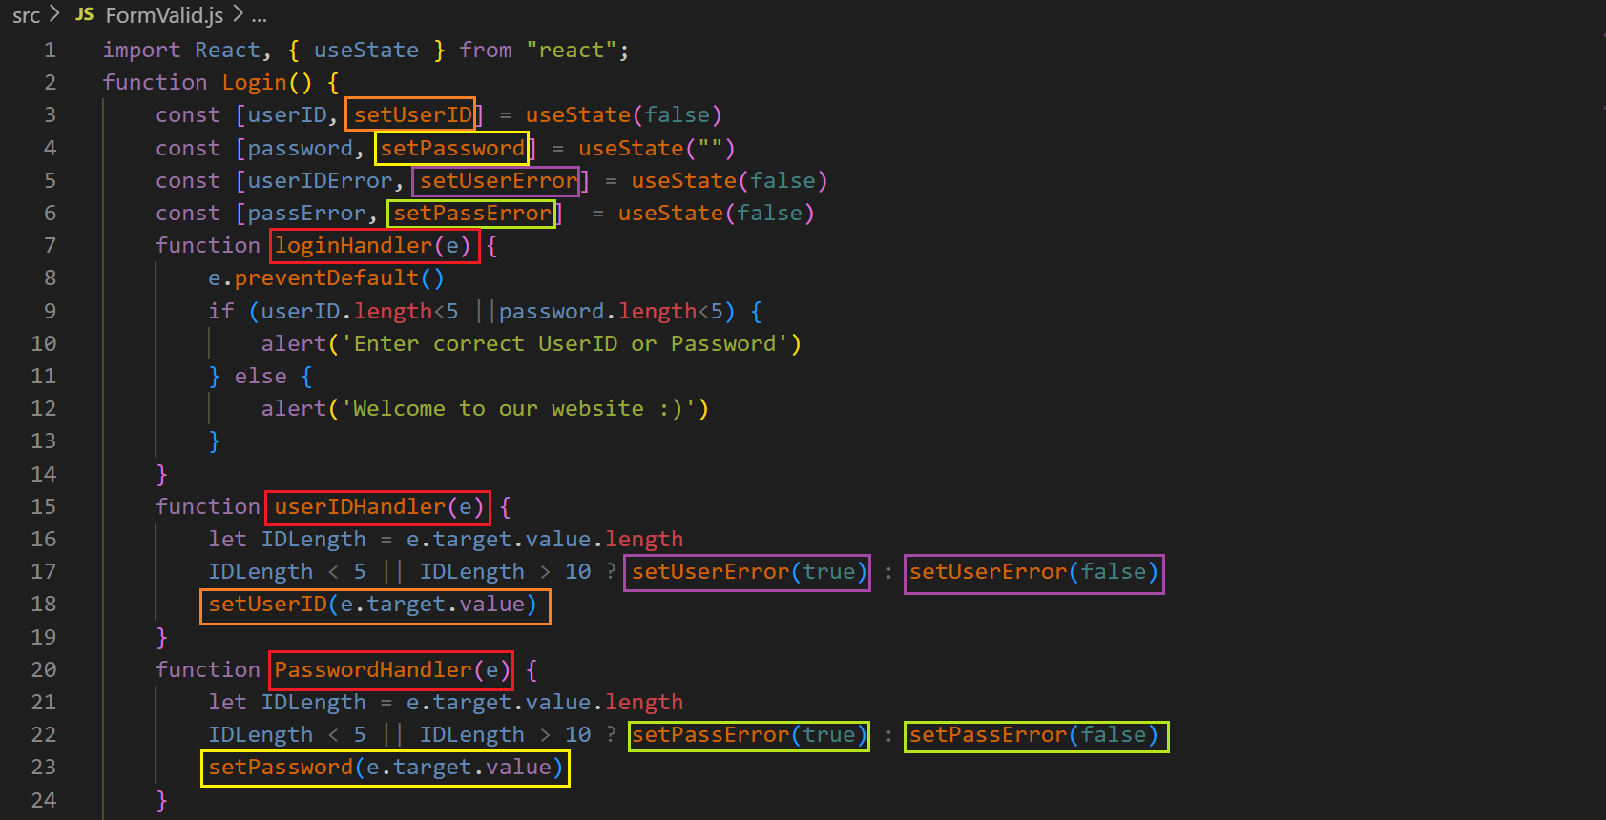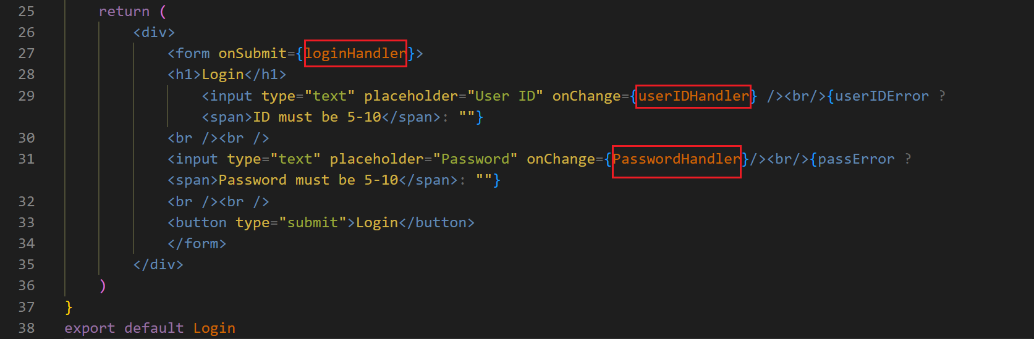output ↓**