**We will create a function in App.js file and use it as the prop of the function defined in User.js file ↓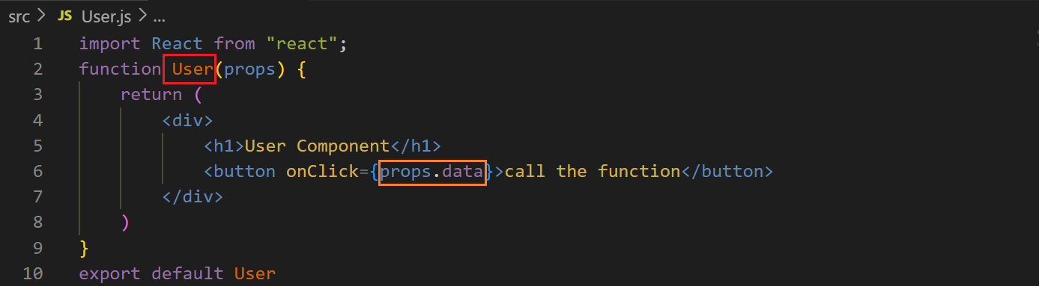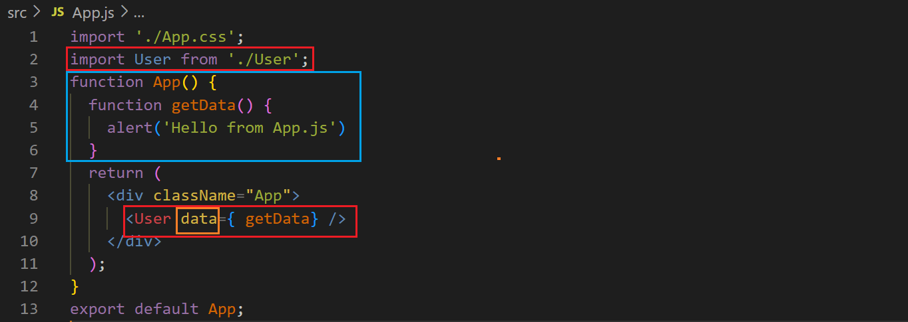output ↓**

**Before clicking the button ↓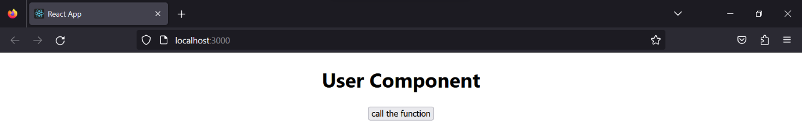 After clicking the button ↓**