**First the constructor will be called and then render whether the constructor comes after the render in code ↓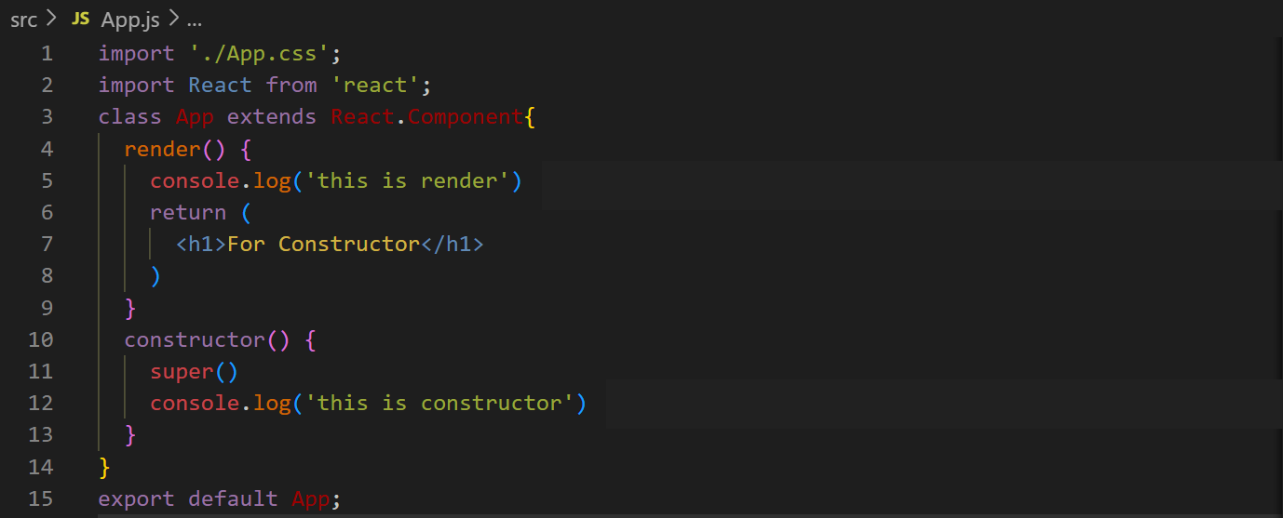output ↓**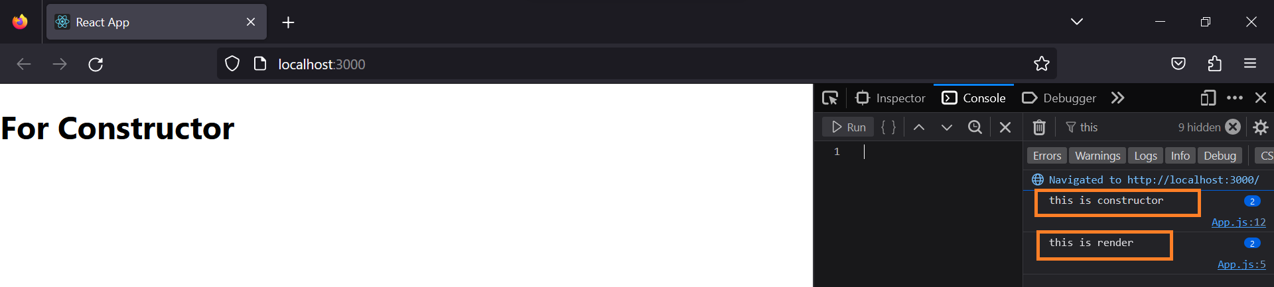

**Therefore, we use sates and such other things in this so that they are ready before loading the HTML page ↓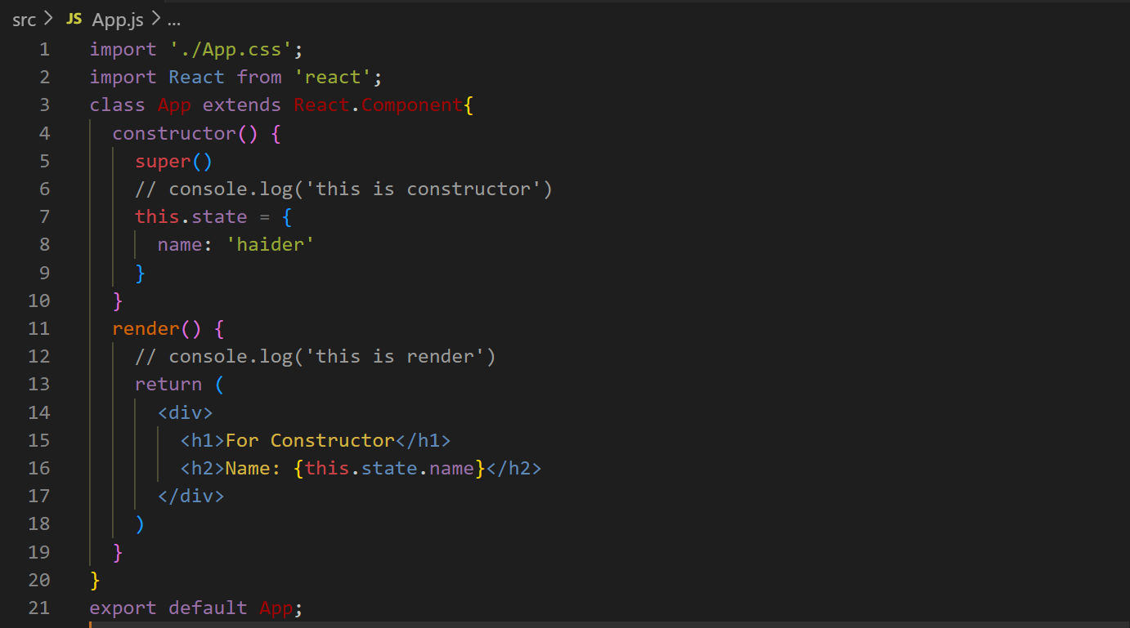output ↓**