**It is necessary for class component and whole HTML is written in it.**

**Remember, it is executed three time when component is ready, states are updated or props are updated.**

**On creating the component ↓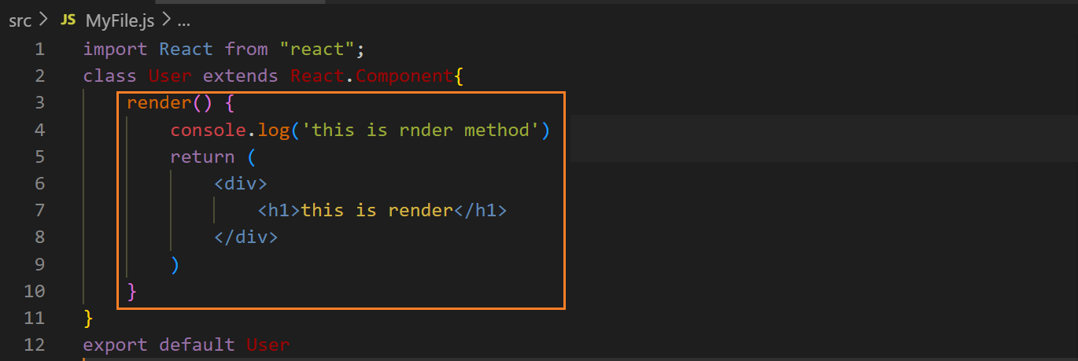output ↓**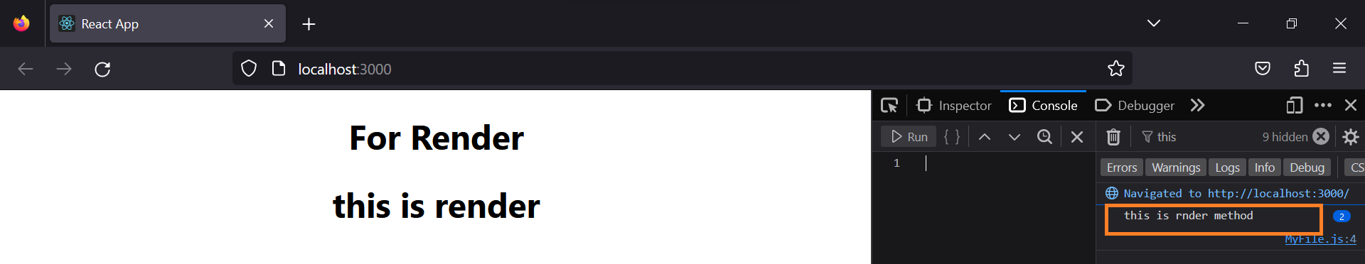

**On updating props ↓**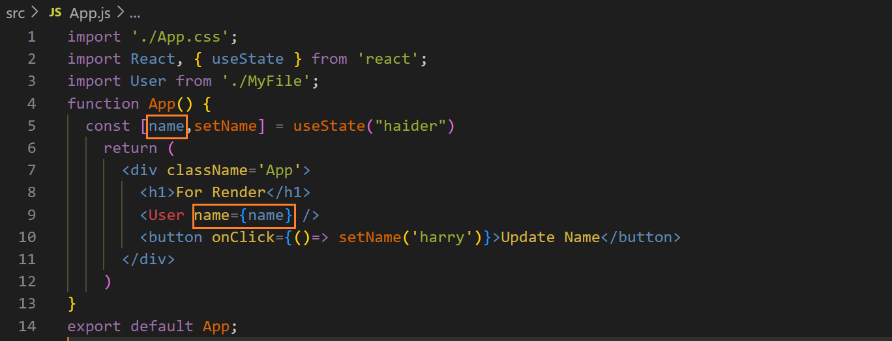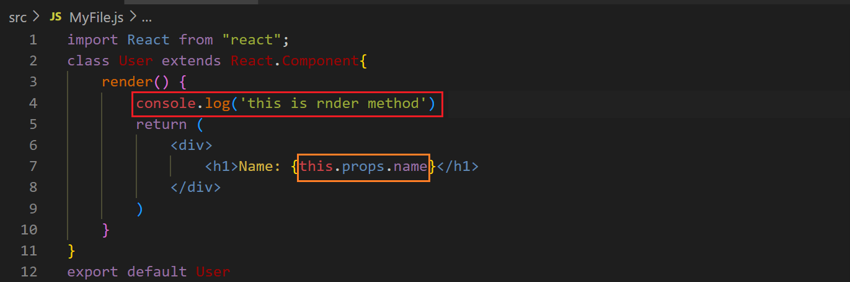

**Before clicking the button ↓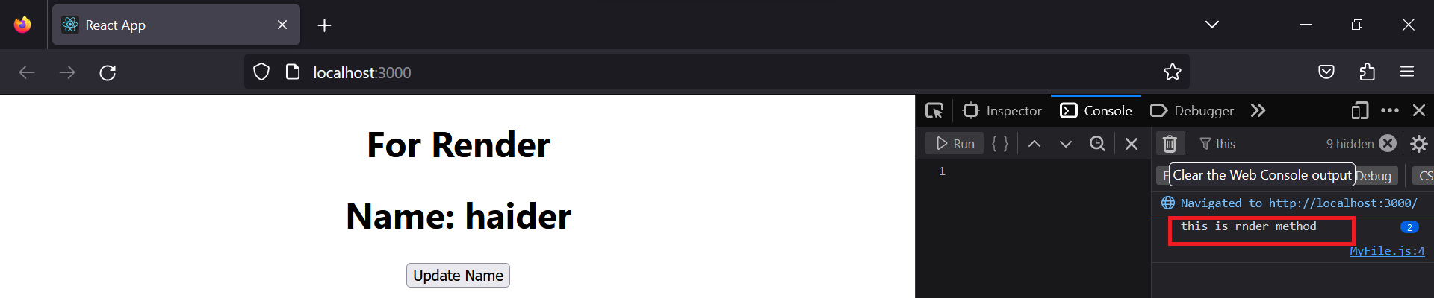 After clicking the button ↓**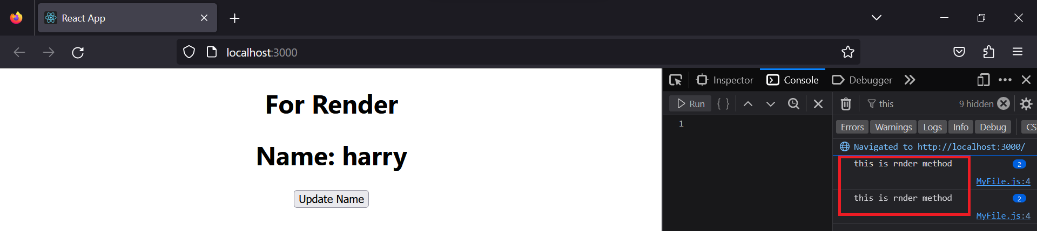

**On updating the state ↓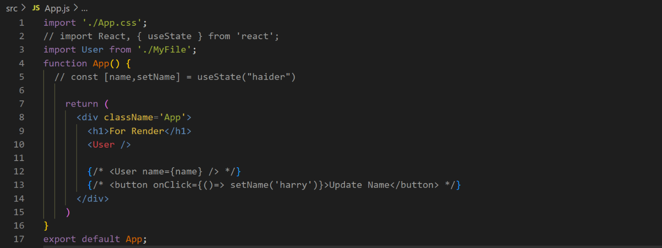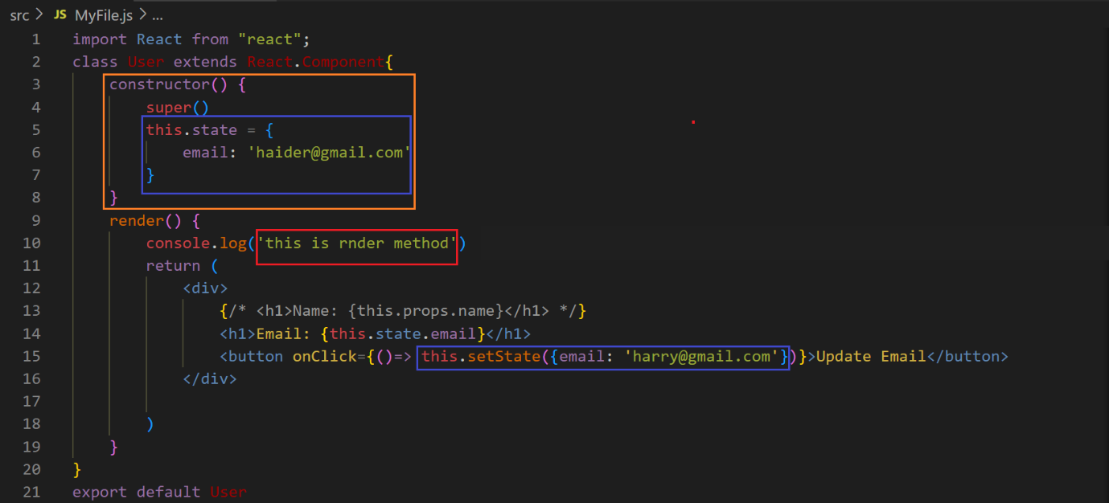before clicking the button ↓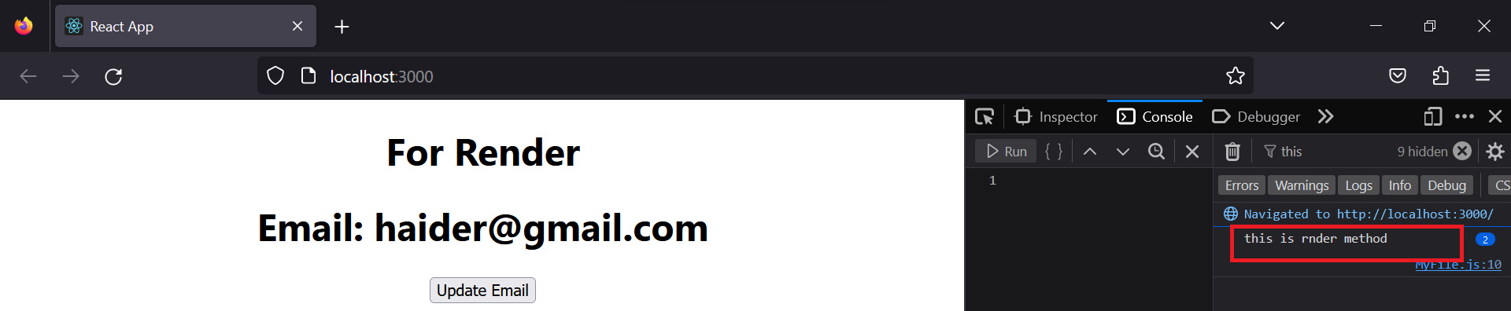after clicking the button and updating the state ↓**