**It is executed after the render ↓**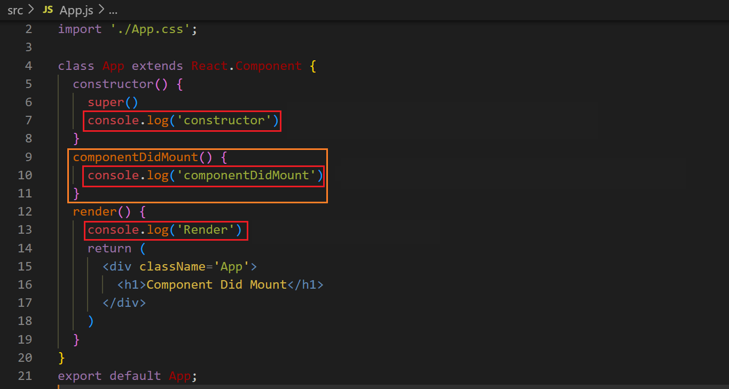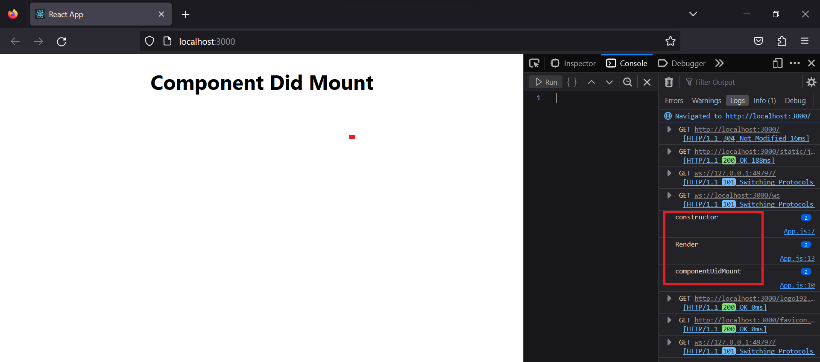

**Therefore we will use it for APIs so that the HTML page in render() would be loaded first**

**It is executed only one time**

**It is not executed on changing of state ↓**

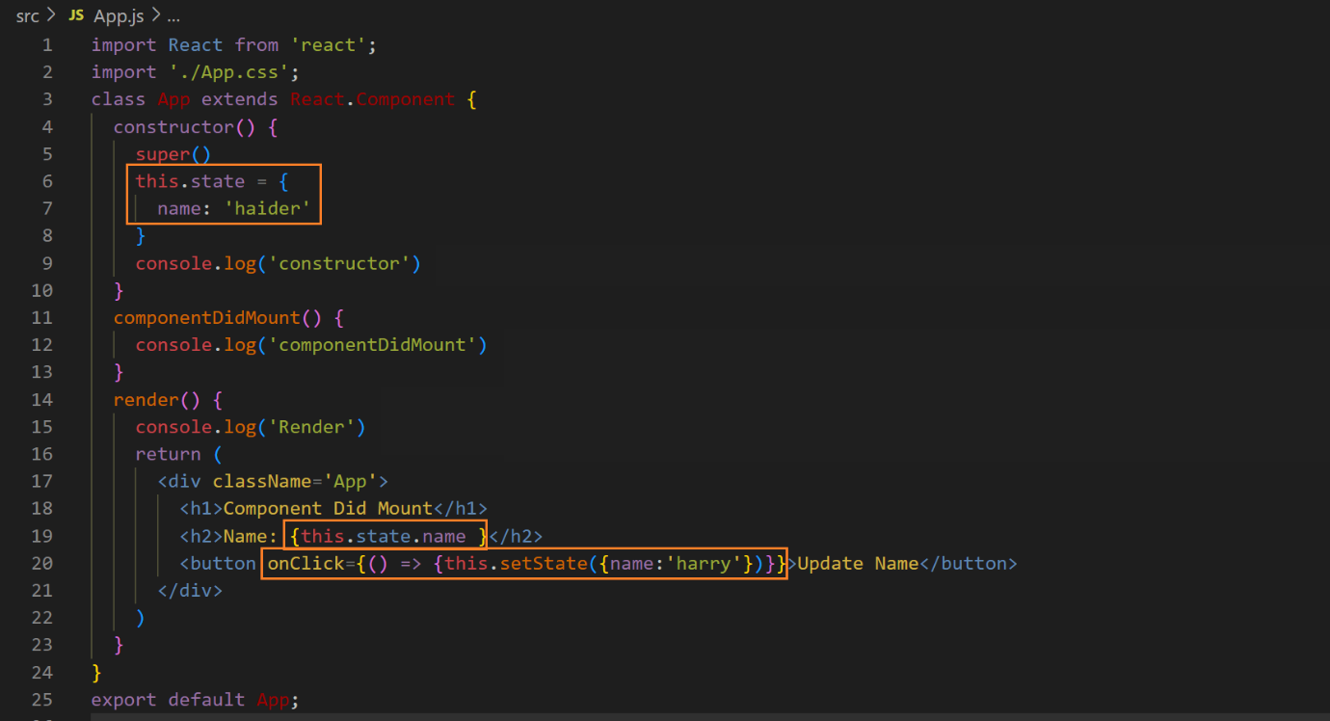**before changing the state ↓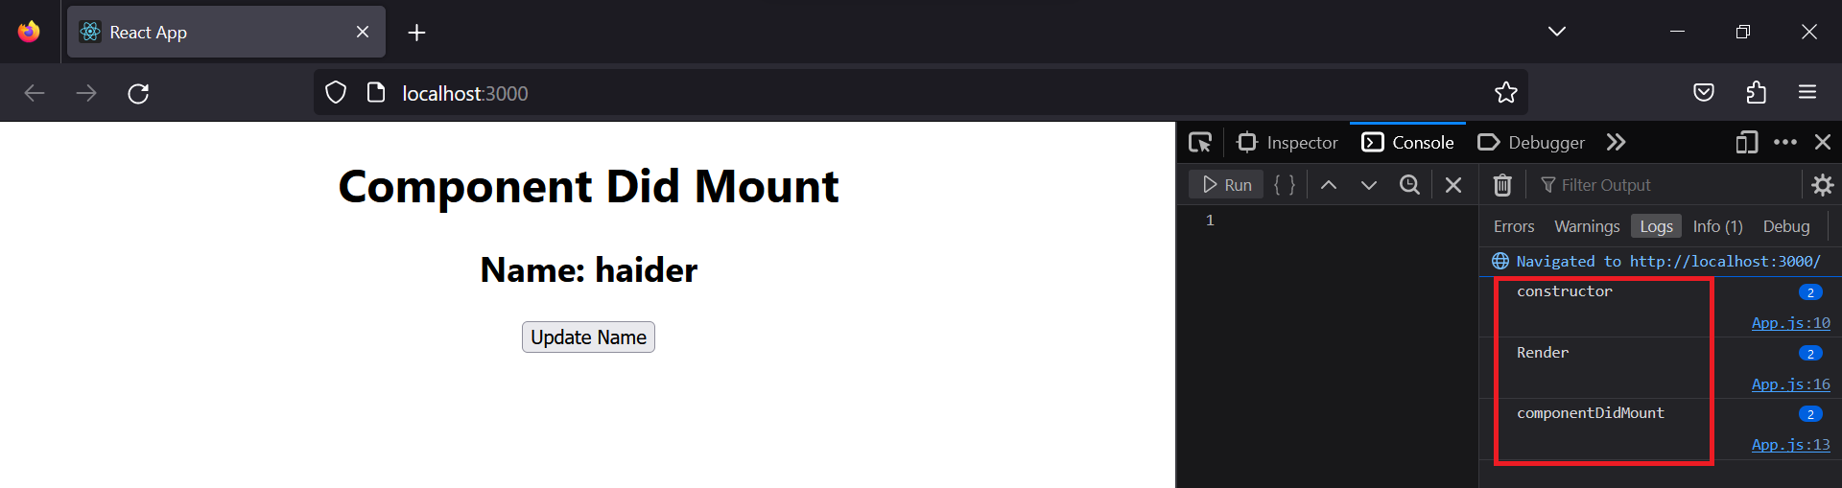 after changing the state ↓**