**it is executed when state and props are updated ↓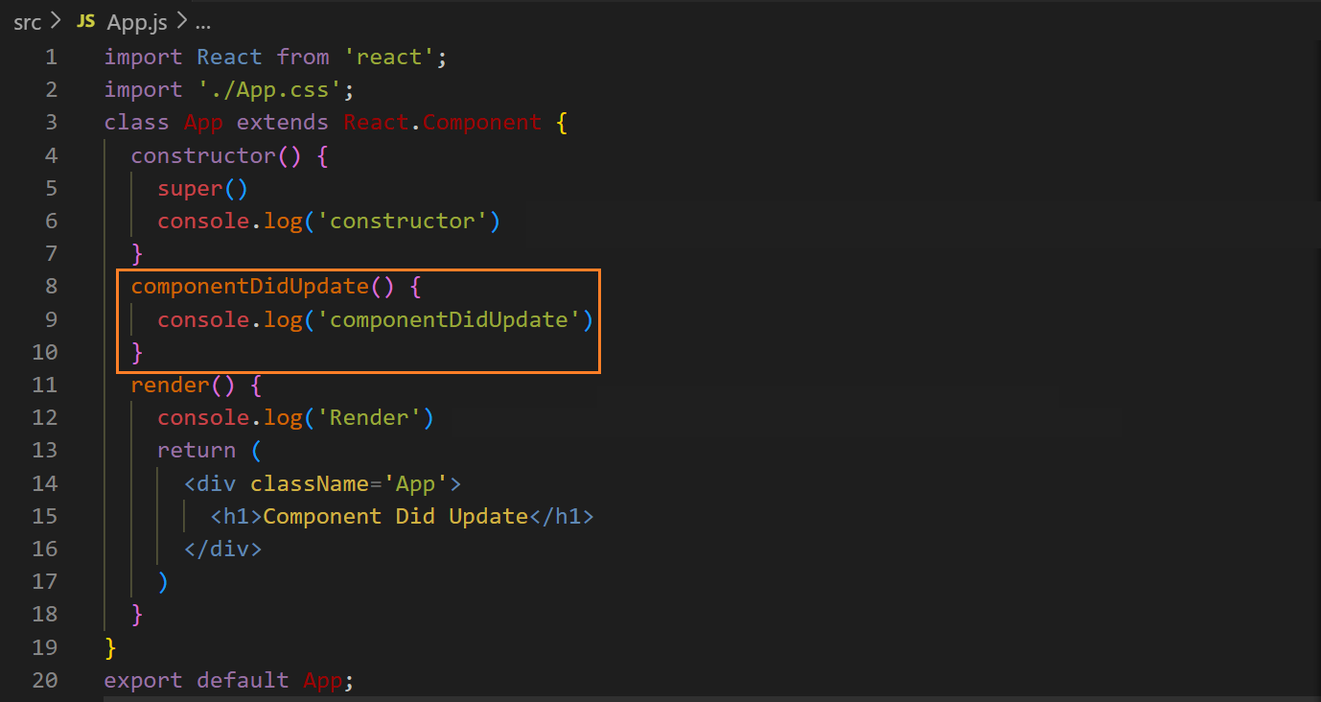output ↓**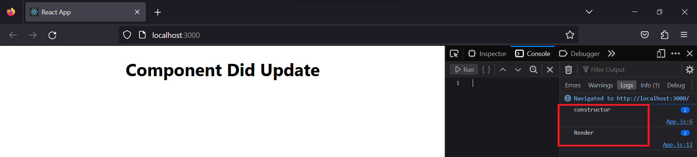

**on changing state ↓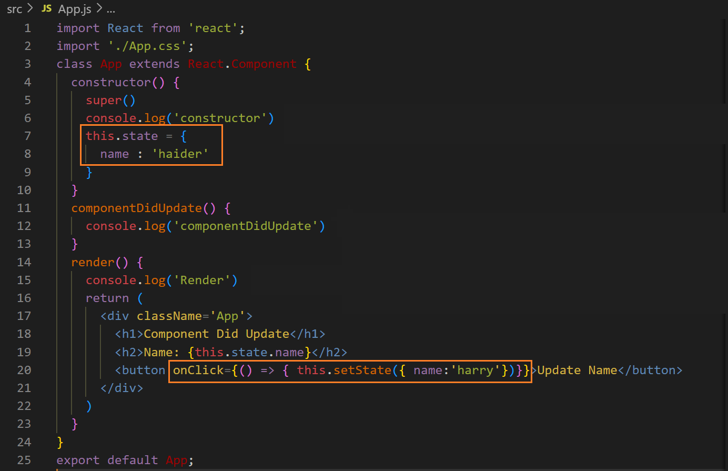before changing the state ↓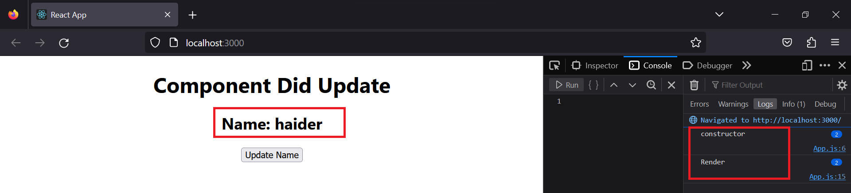 after changing the state ↓**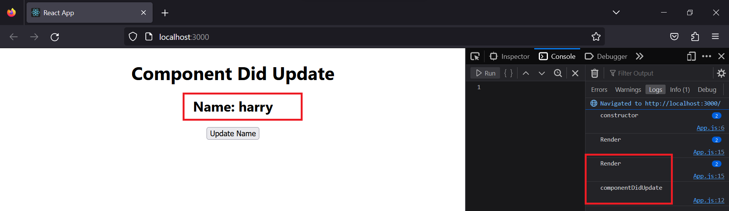

**if you click n times on button, this is executed n times, e.g.,**

**after clicking 4 times on the button ↓**

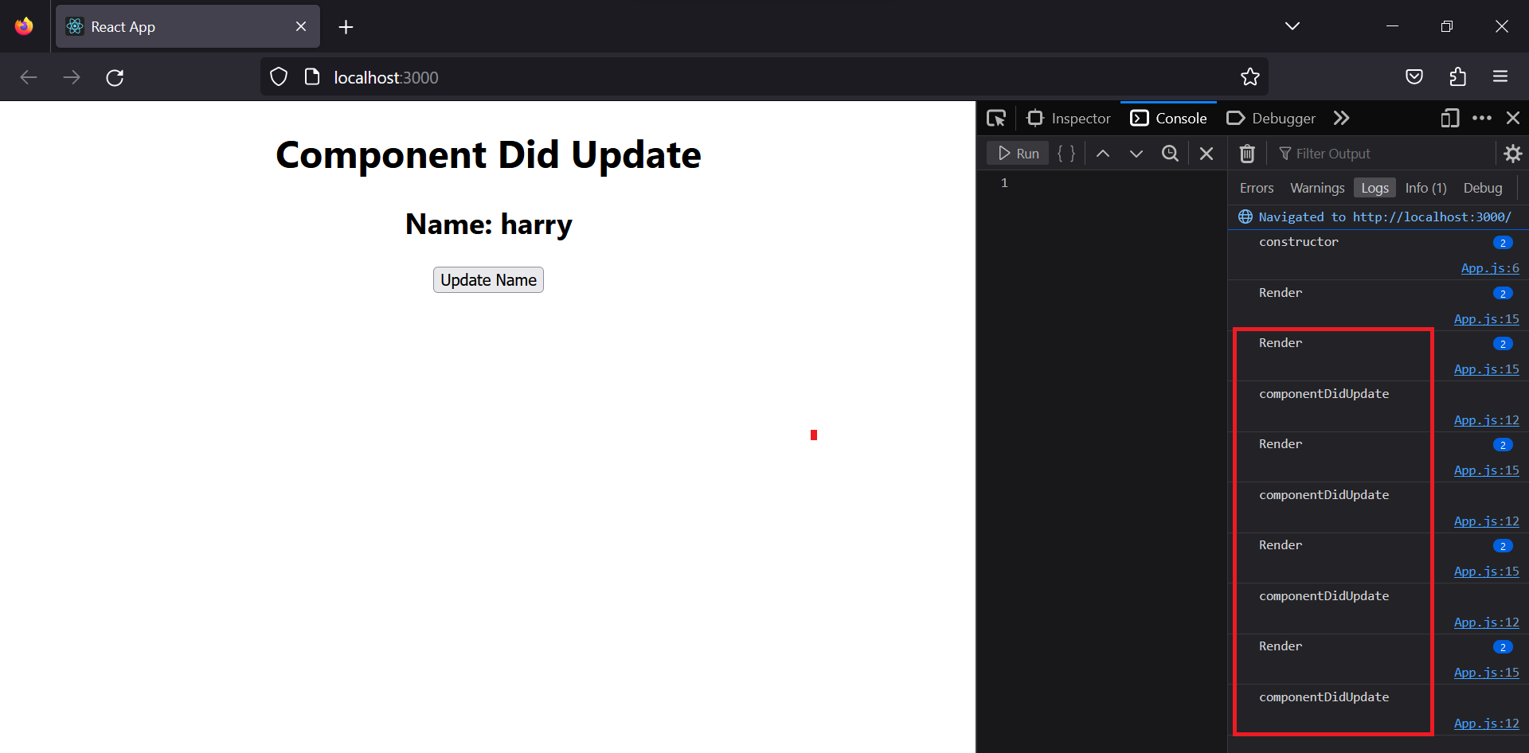

**therefore we use conditions, but first we will see parameters of it**

**prestate and preprop give the previous state and prop respectively ↓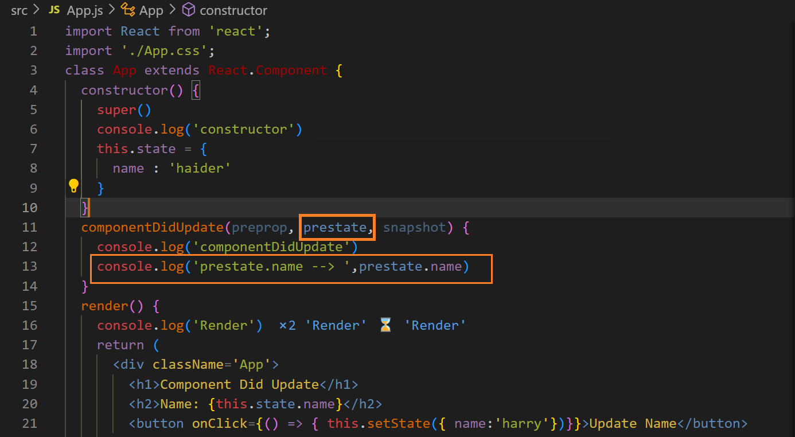output ↓**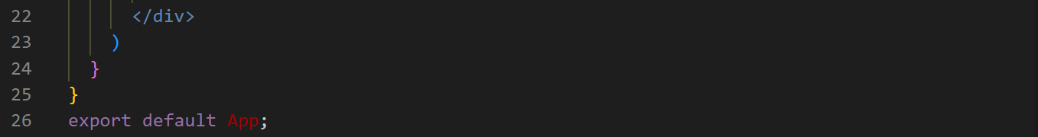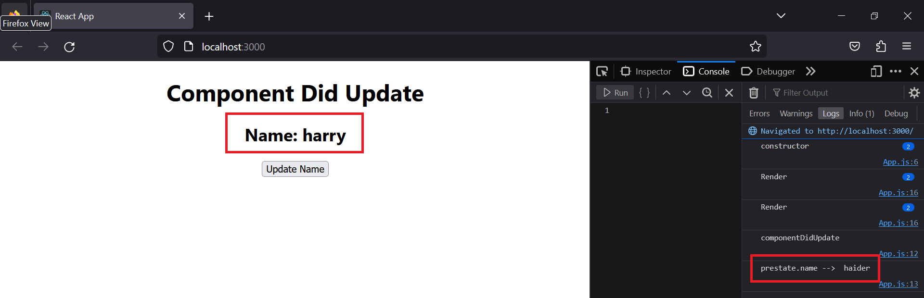

**we can update in this also but with condition, otherwise it will become an infinite loop ↓**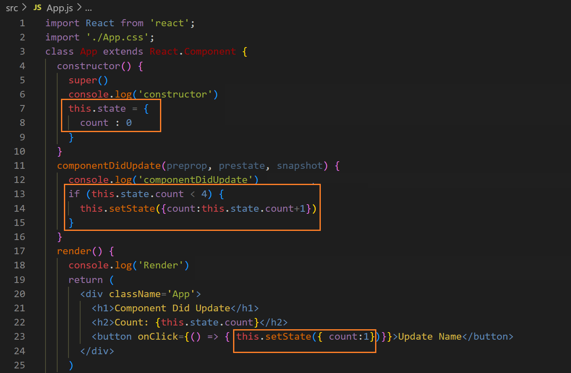

**output ↓**

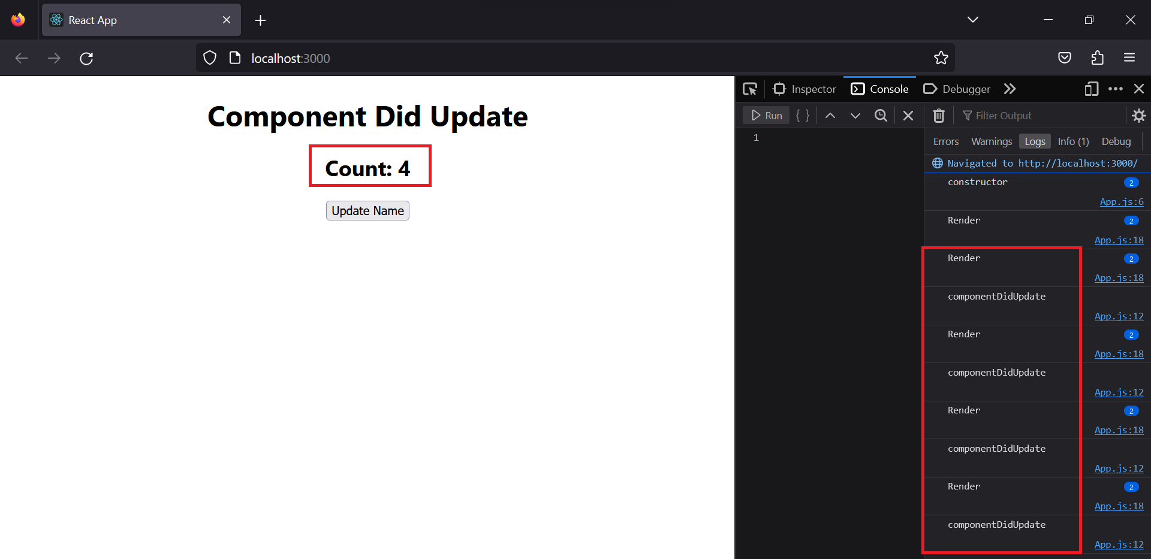

**The another parameter “snapshot” remains undefined but if we use getSnapshotBeforeUpdate() then it will be valued**