**It is executed only updating of state or prop ↓**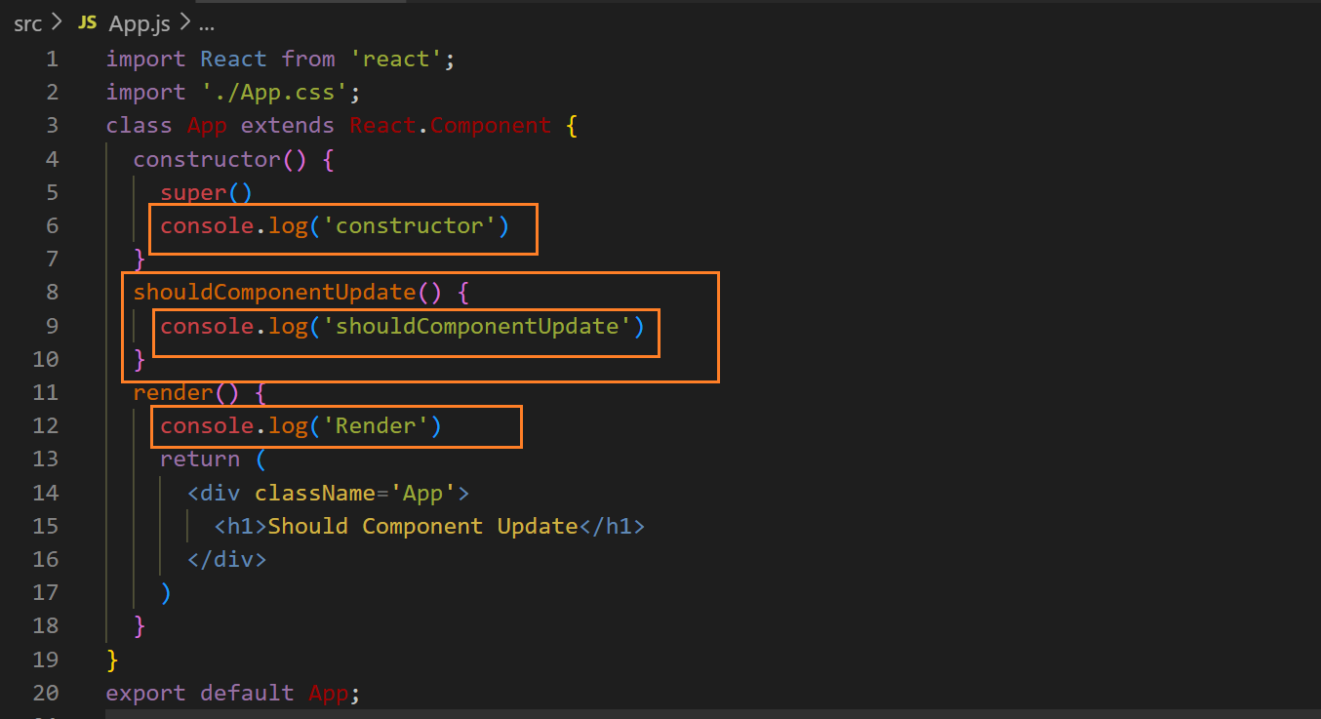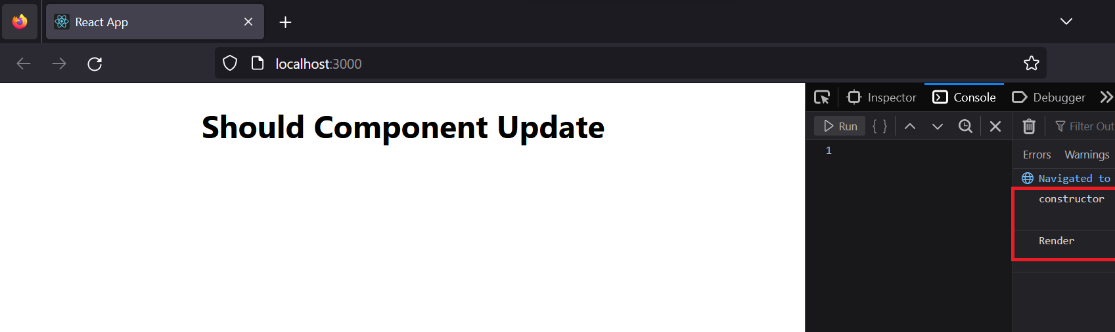

**it stops the rendering of all function whether it is render, componentDidUpdate and etc. but the updating of states and props happen, but it can happen when it return false and by default it returns false ↓**

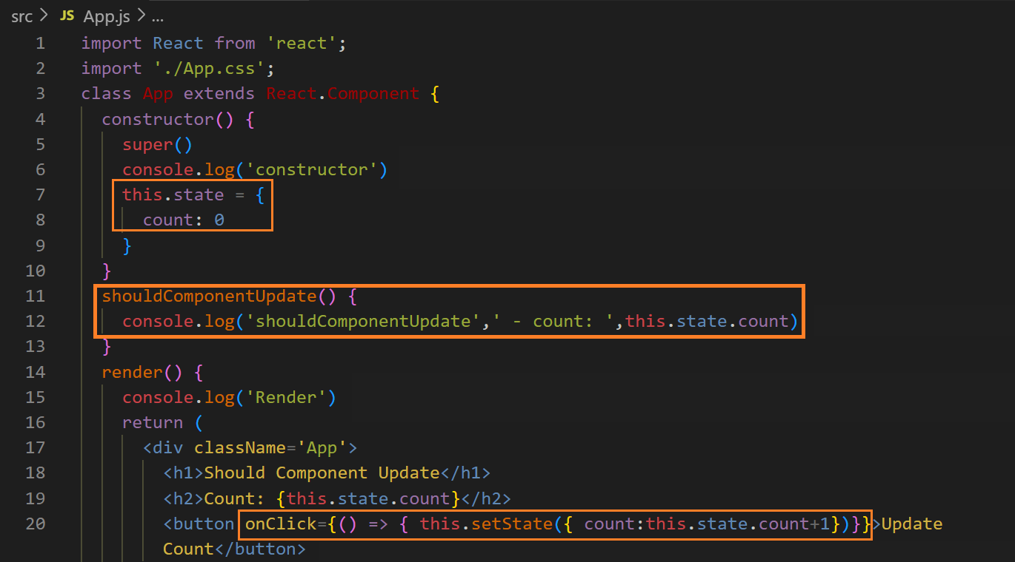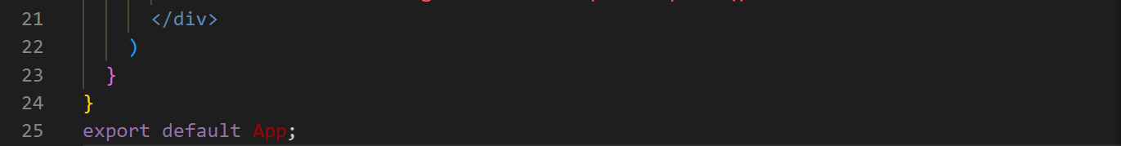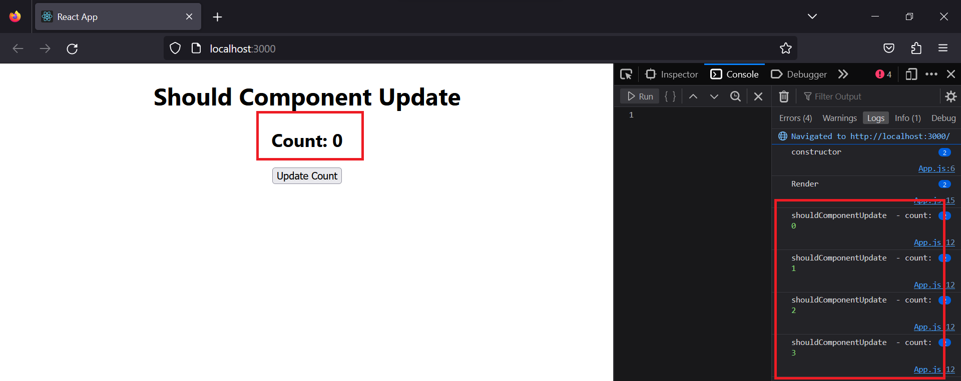

**you can see the state is changing but does not show because this function is stopping the rendering of “render” and “constructor” functions and similarly “componentDidUpdate” function**

**We have to make it to return true with return statement ↓**

**output ↓**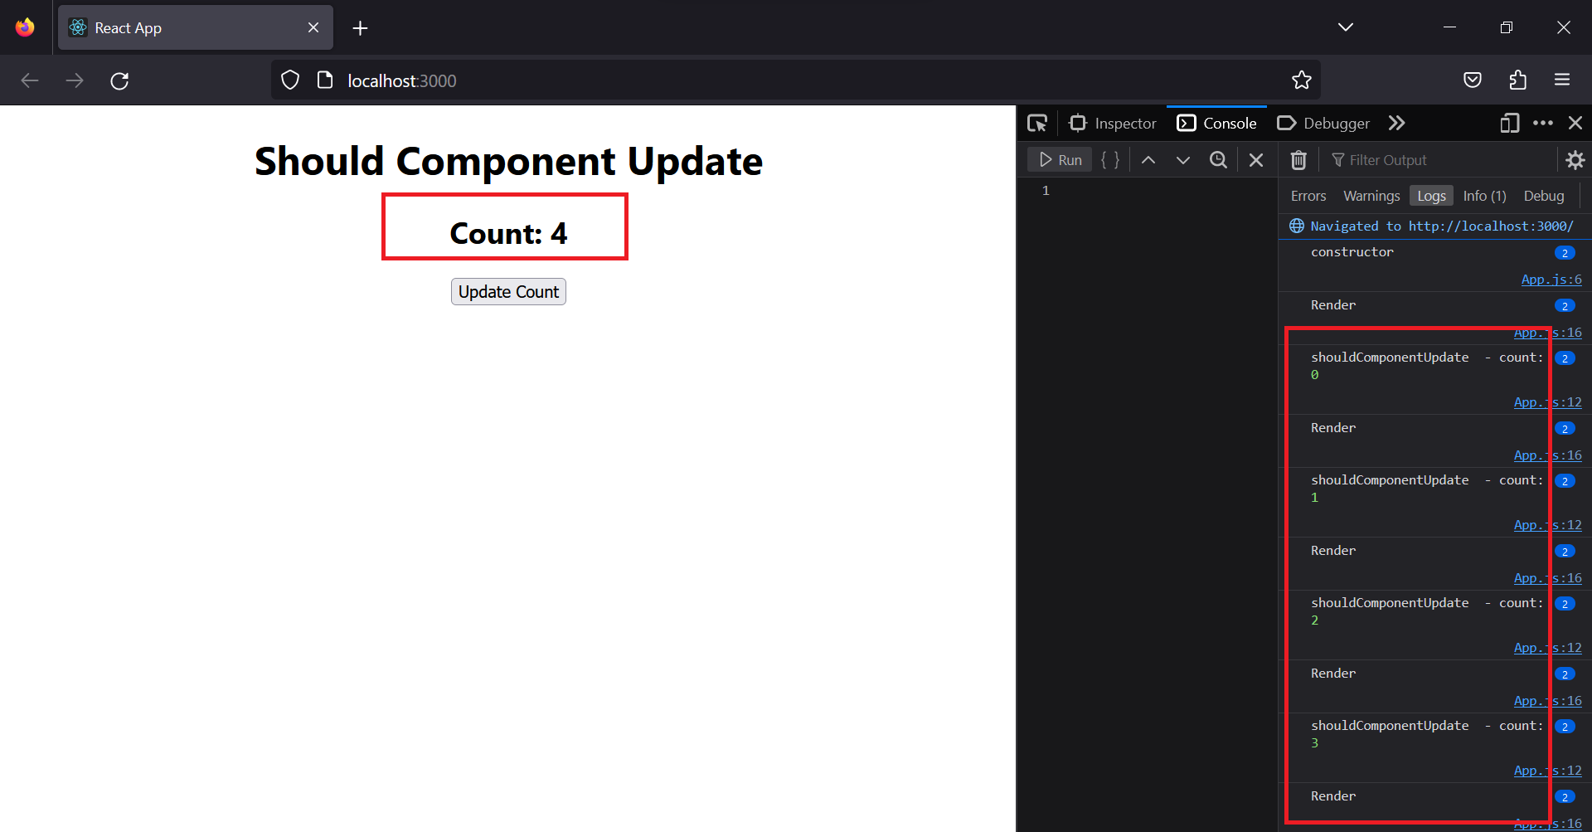

**We can apply conditions ↓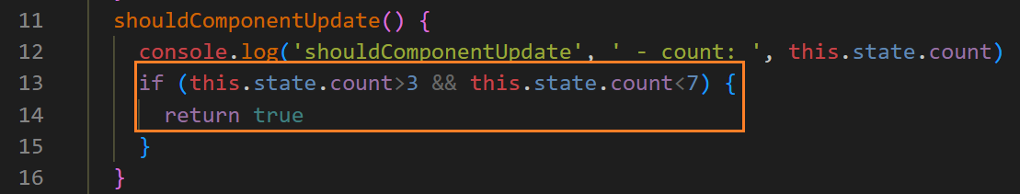after clicking four times ↓**

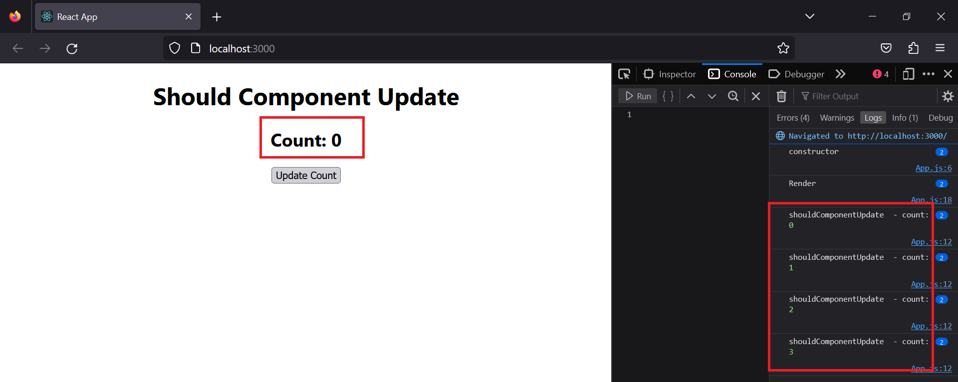

**after clicking 5 times ↓**

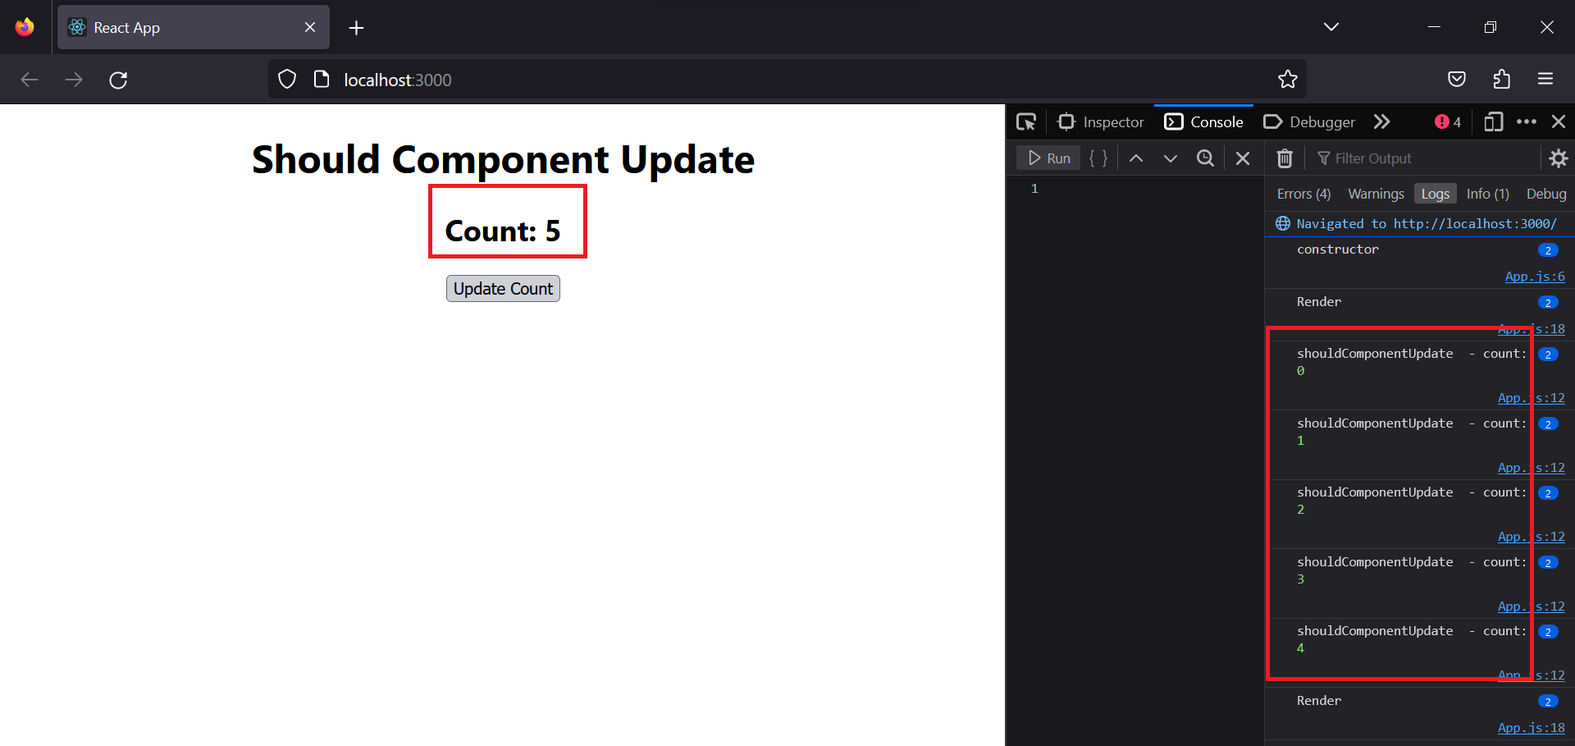

**after clicking 8 times ↓** 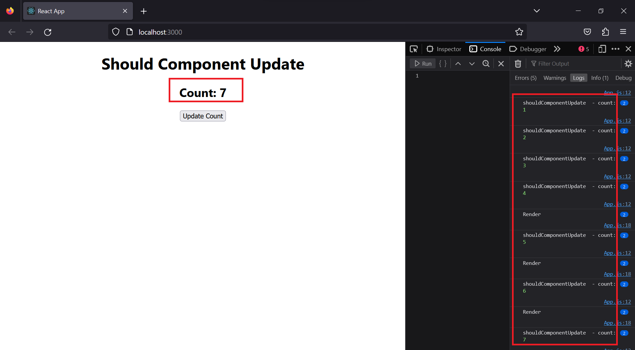

**after clicking 10 times ↓**

