**this method is executed when its component is removed from the DOM**

**we will create a button when it is clicked, the “Student” class component will be removed and this method will be called ↓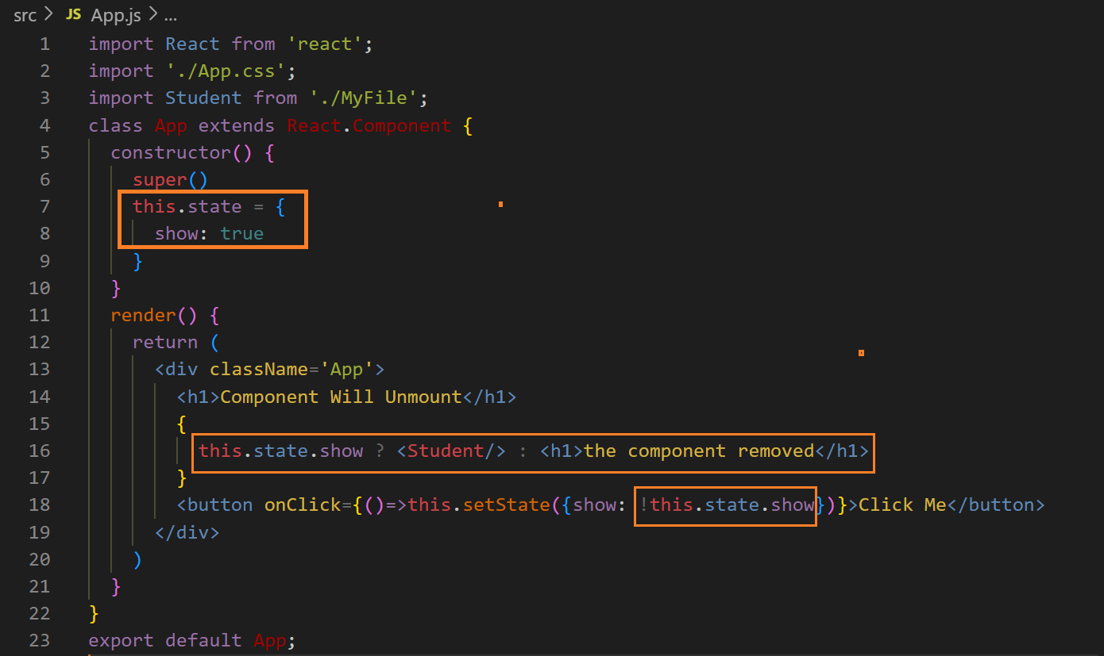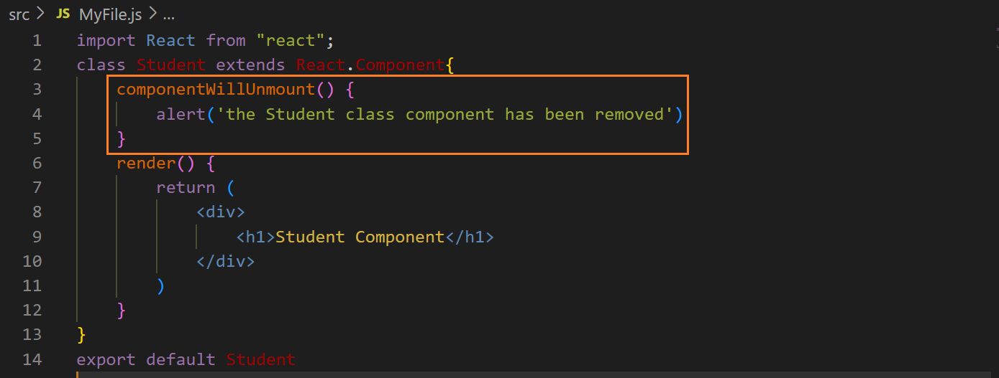 before clicking the button ↓**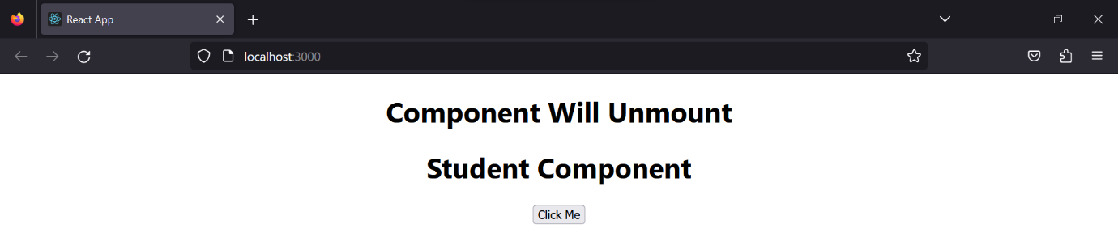

**after clicking the button ↓**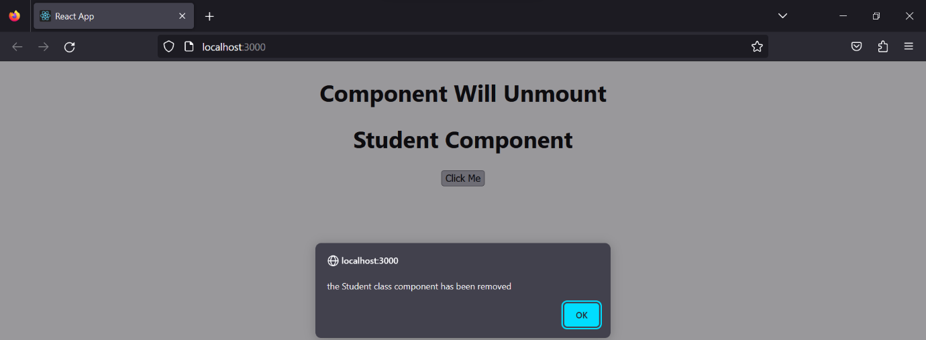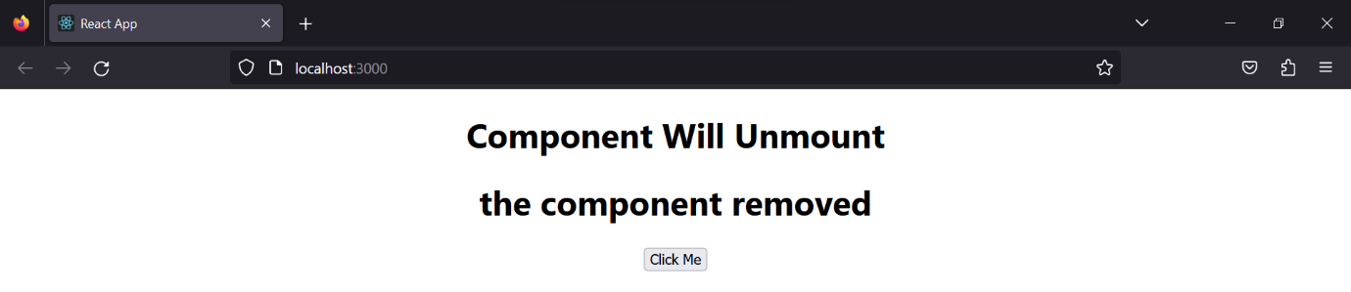

**after clicking again on the button, that component will be reloaded because we have used not operator (!) ↓**