**It is a hook and it is the combination of “componentDidMount()”, “componentDidUpdate()” and “componentWillUnmount()”, it means It will executed**

**when a component is created like “componentDidMount()”, e.g., ↓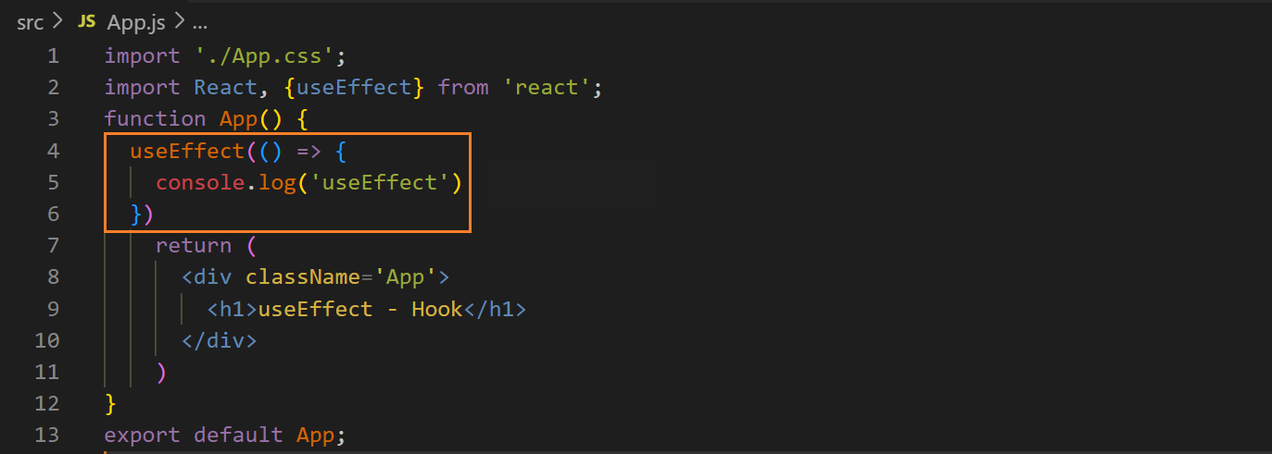output ↓**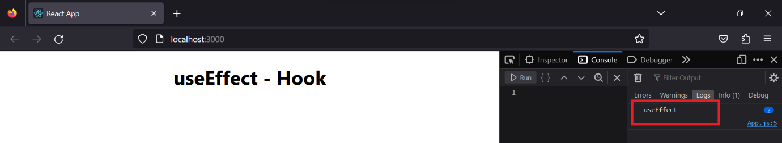

**when state is updated like “componentDidUpdate()”, e.g., ↓**

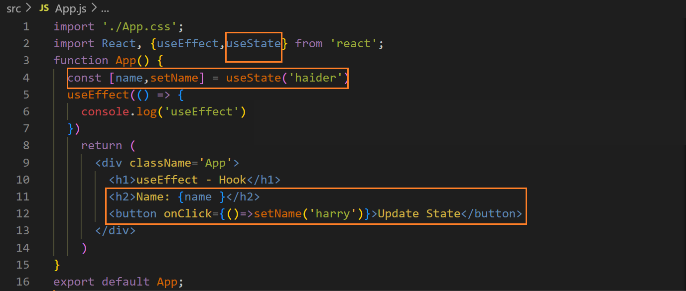**output ↓**

**Before updating the state ↓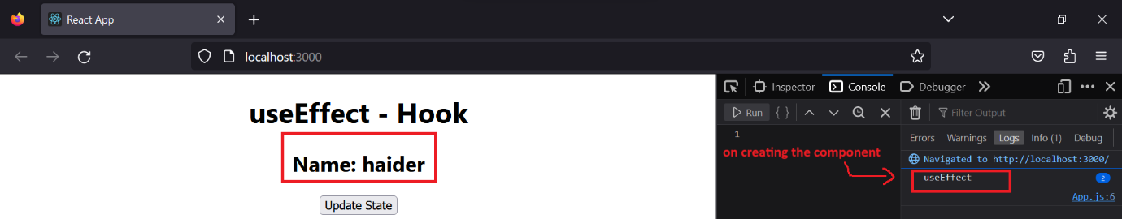 after updating the state ↓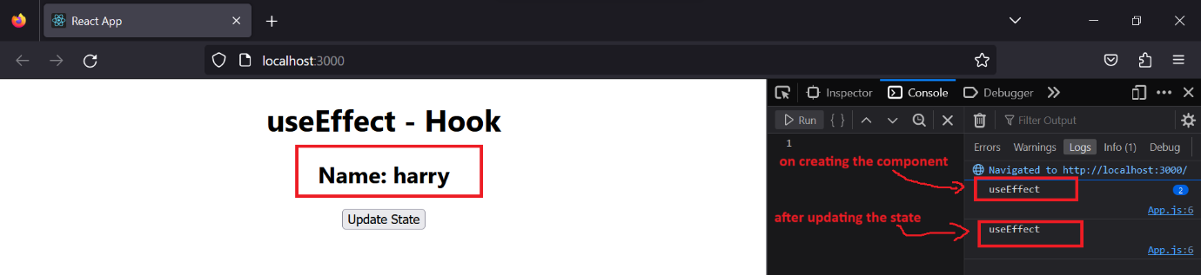If we update the state “n” times, it will be executed “n” times**

**We can use multiple “useEffect”**

**If there are more than one states then we can apply conditions so that it is executed only on updating of specific state, we will apply condition for ”data”, i.e., the method will be executed only on the updating of “data” not “count ” ↓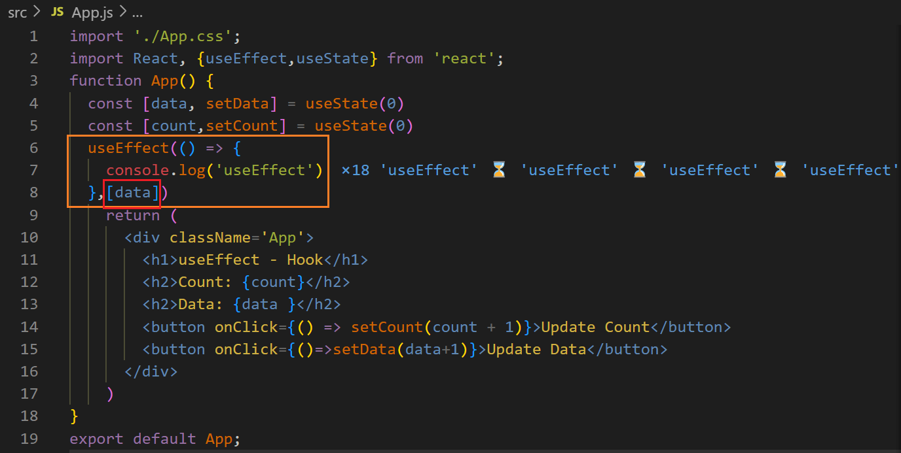before updating any state ↓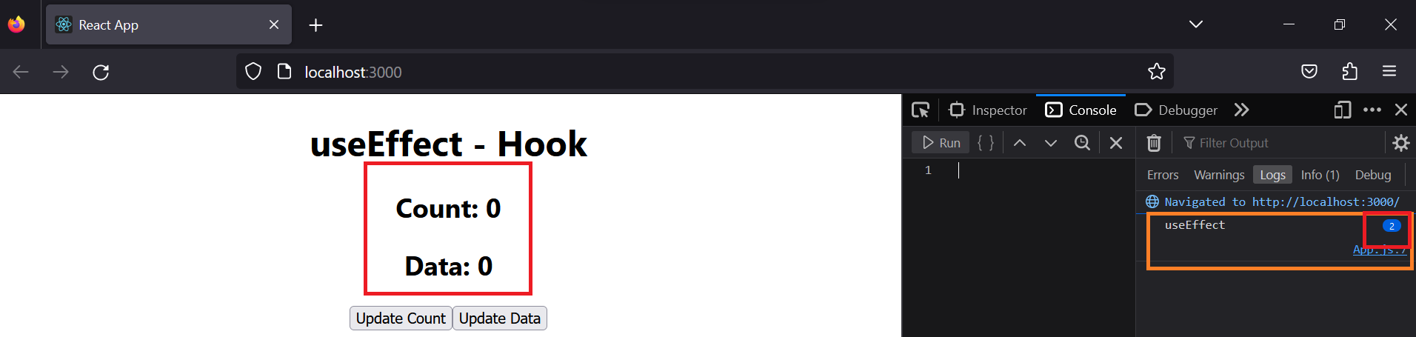after updating “count” 4-times ↓**

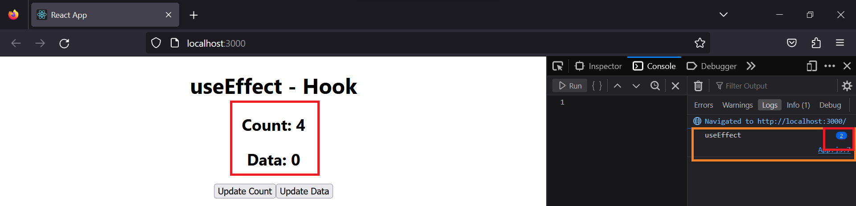**you can see the method did not executed**

**after updating “data” 3-times ↓** 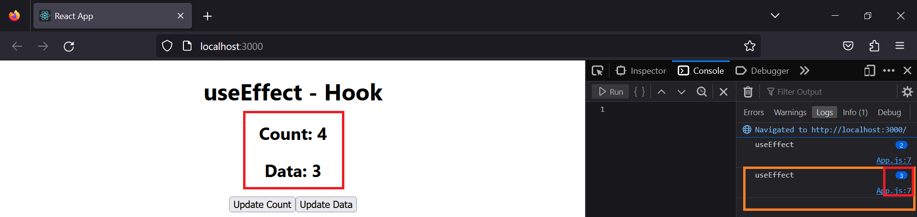

**similarly we can apply condition for props ↓**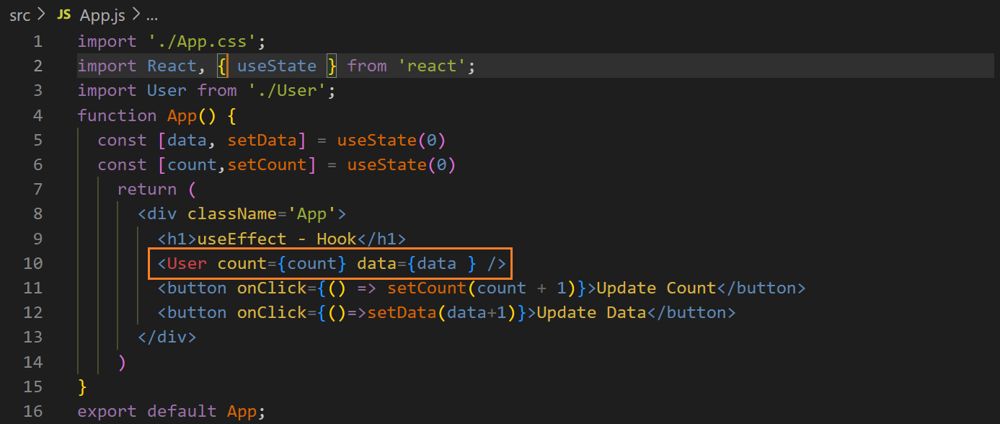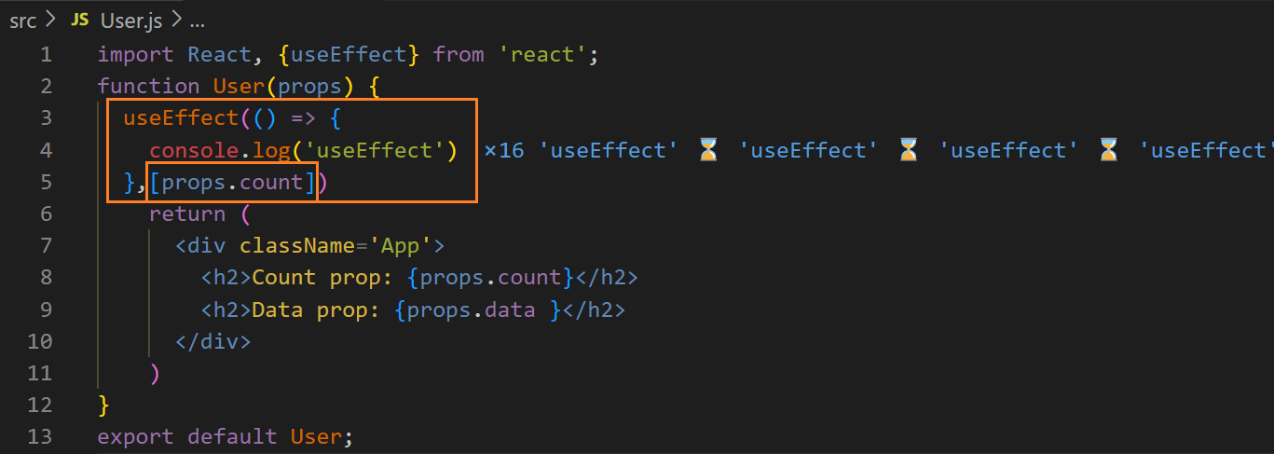

**before updating any prop ↓**

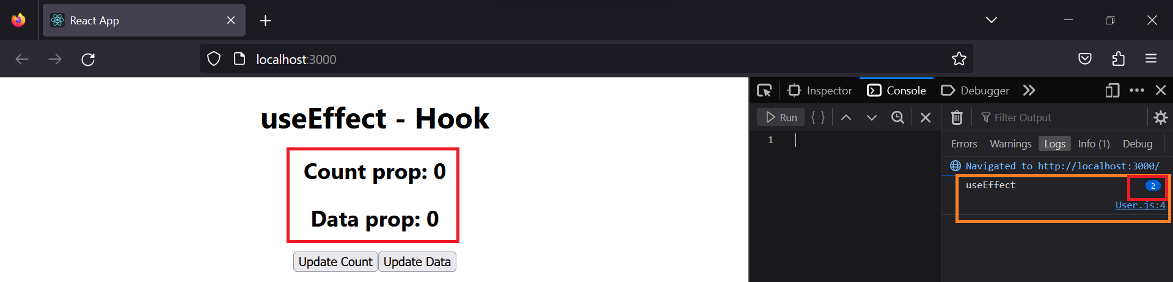**after updating data prop 4-times ↓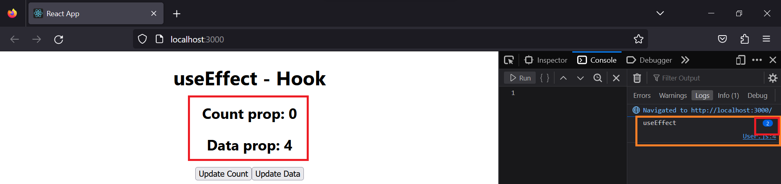you can see this method did not executed on updating data prop after updating count prop 10-times ↓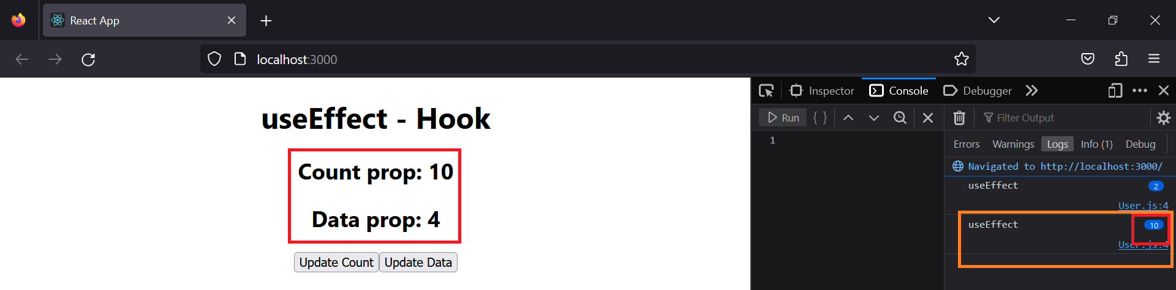you can see the method has been executed 10 times**