**There are three methods to use style**

**Method-1 🡪 creating a stylesheet, we have to import it, e.g., ↓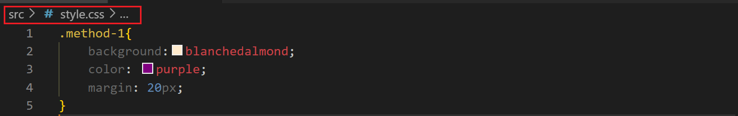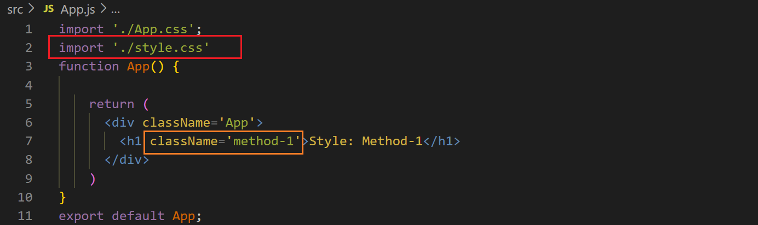output ↓**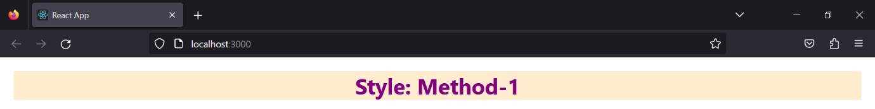

**Method-2 🡪 using the ‘style’ in the HTML tag, e.g., ↓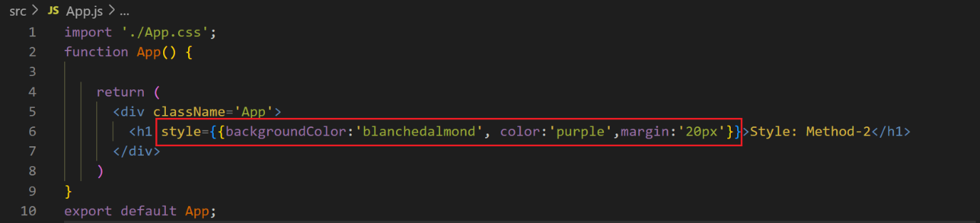output ↓**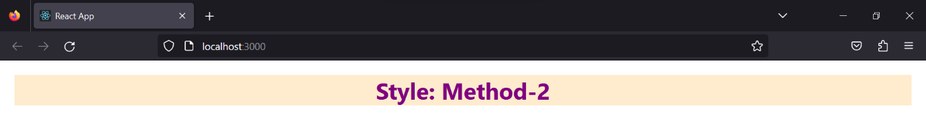

**Method-3 🡪 creating the module, the module must have the extension ‘.module.css’, we have t import “style” from “filename + extension” and we have to use “style.class”, e.g., ↓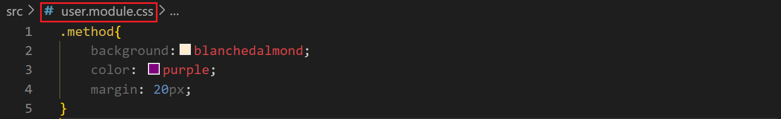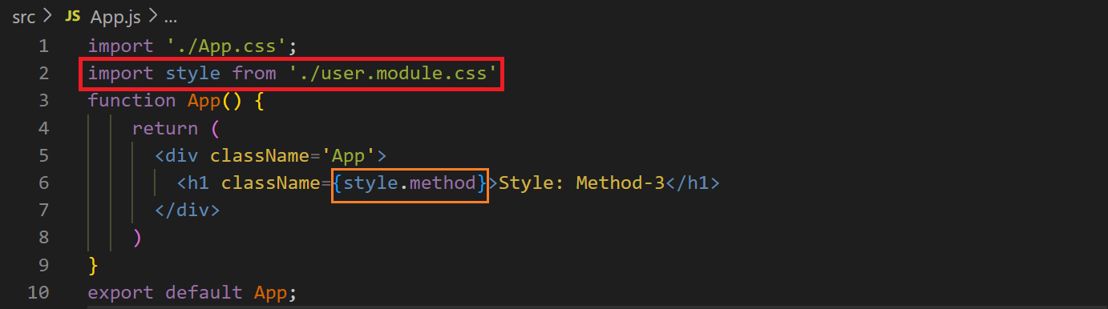output ↓**