**It is used to wrap more than one elements or components**

**When we use to or more elements or components, it gives error as you can see ↓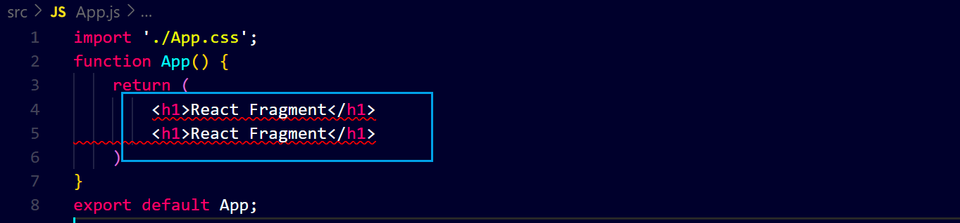to avoid it ↓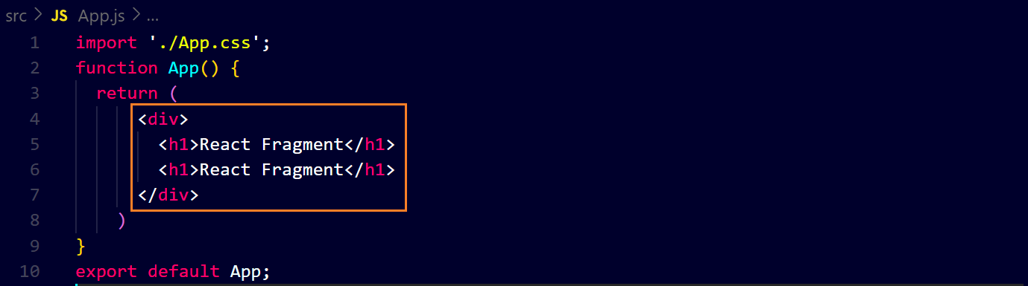or we can use ↓**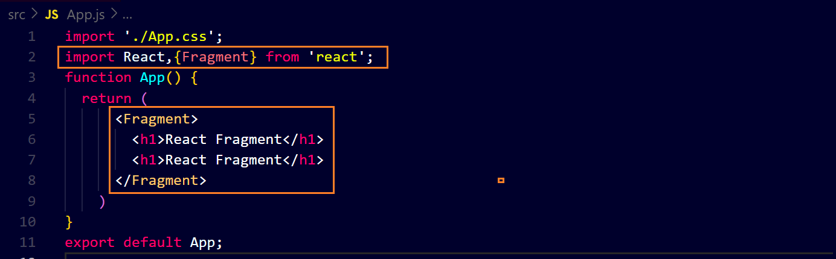

**Now we will see its actual use ↓**

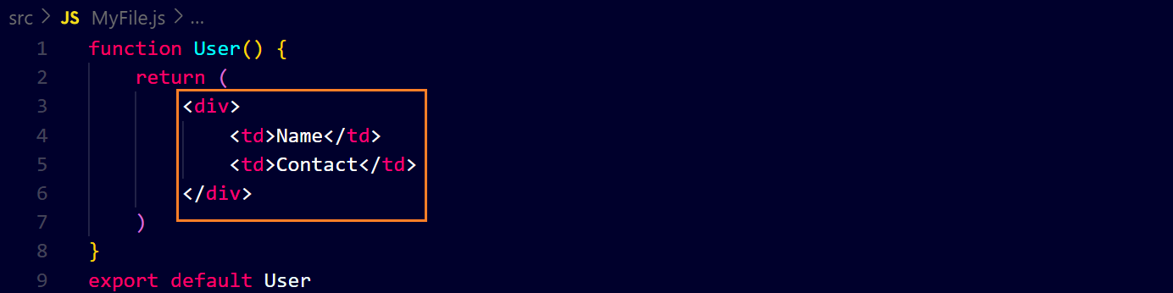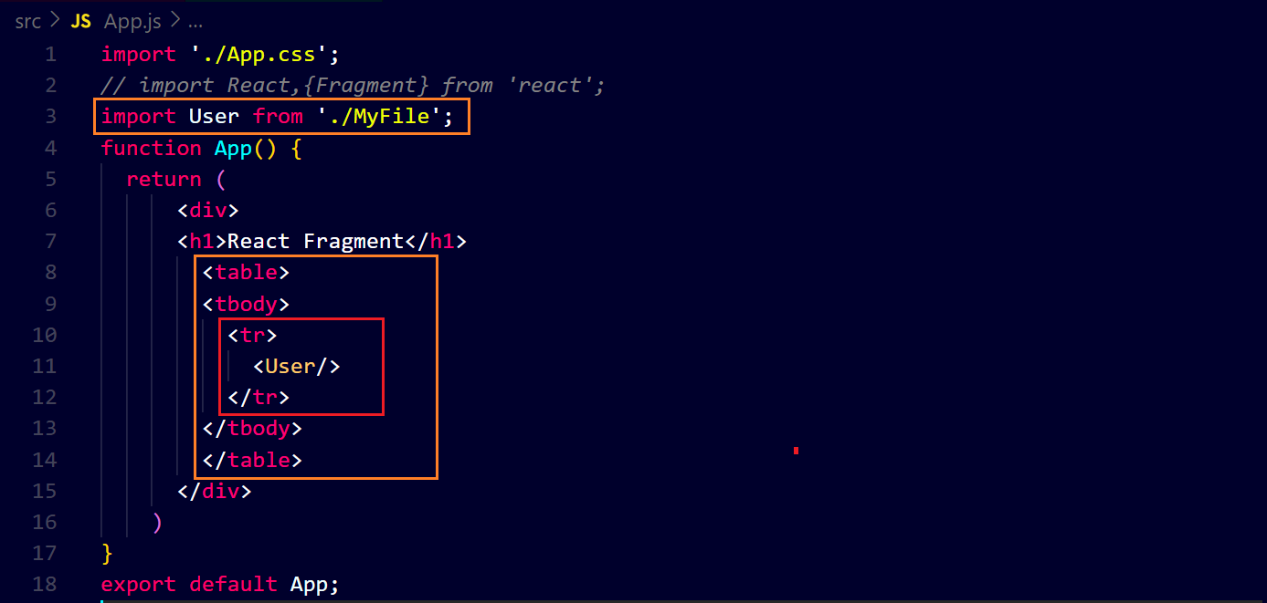**output ↓**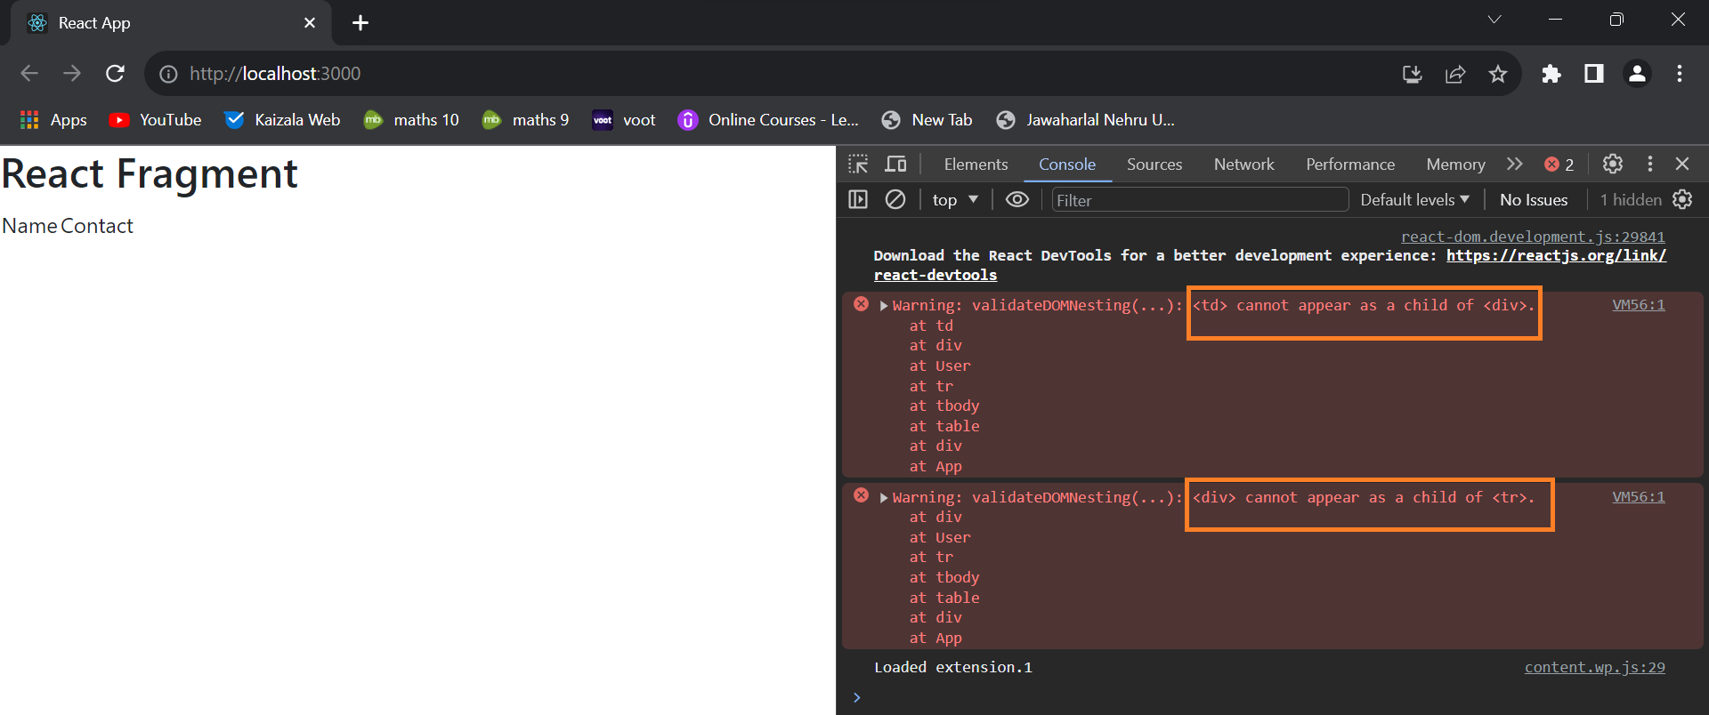

**to avoid this error ↓**

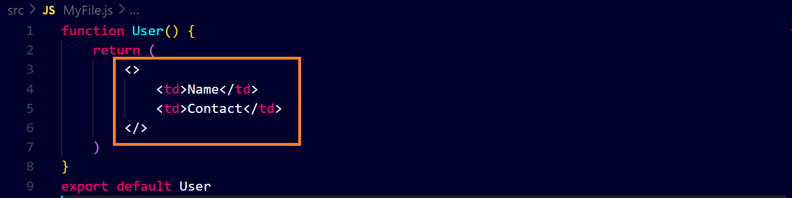**output ↓**