**To send data from child to parent component, first we have to pass parent component to the child component as prop and then we can send data from it, in this case “User” is the child component and “parentAlert” is the parent component ↓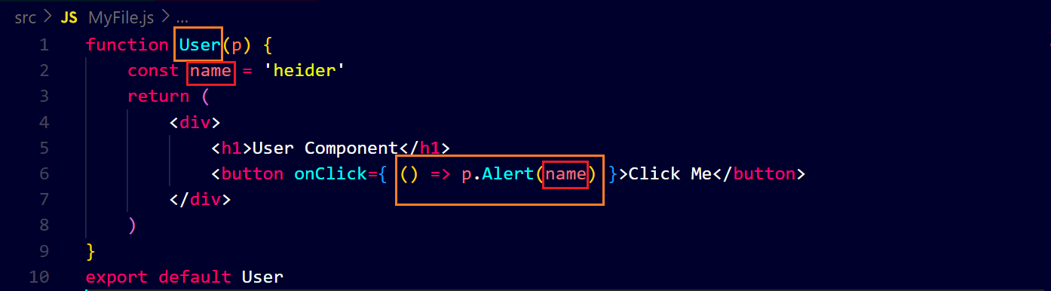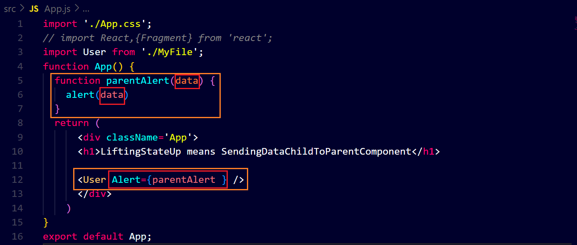after clicking the button ↓**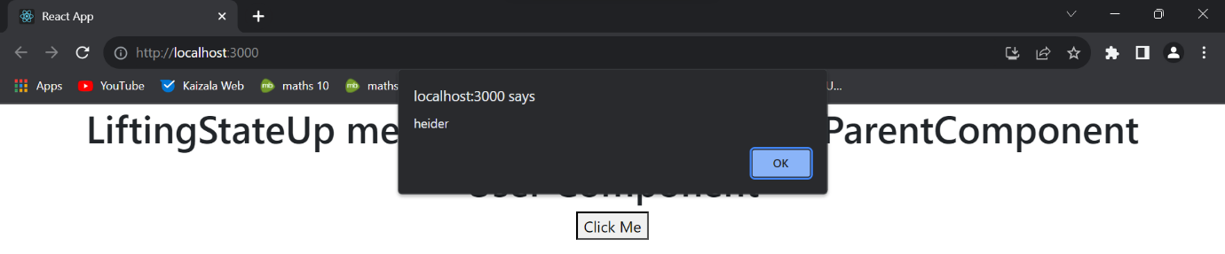

**Similarly we can pass lists and objects, etc. ↓**

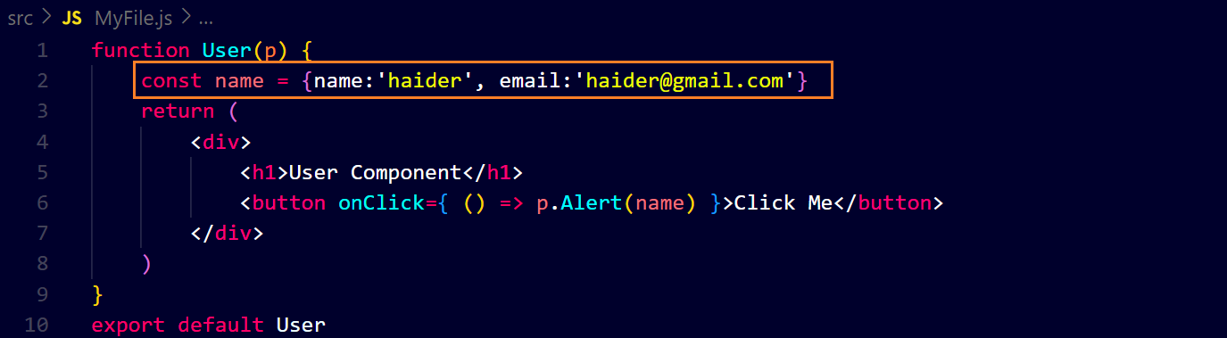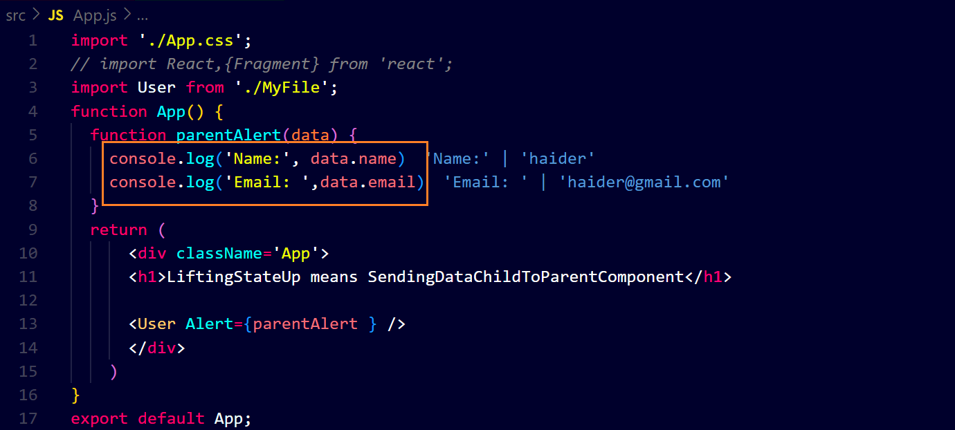**output ↓**