**It is for class component**

**The component is re-rendered whenever you update the state whether the state is been updated to the new sate or to the previous state, e.g., ↓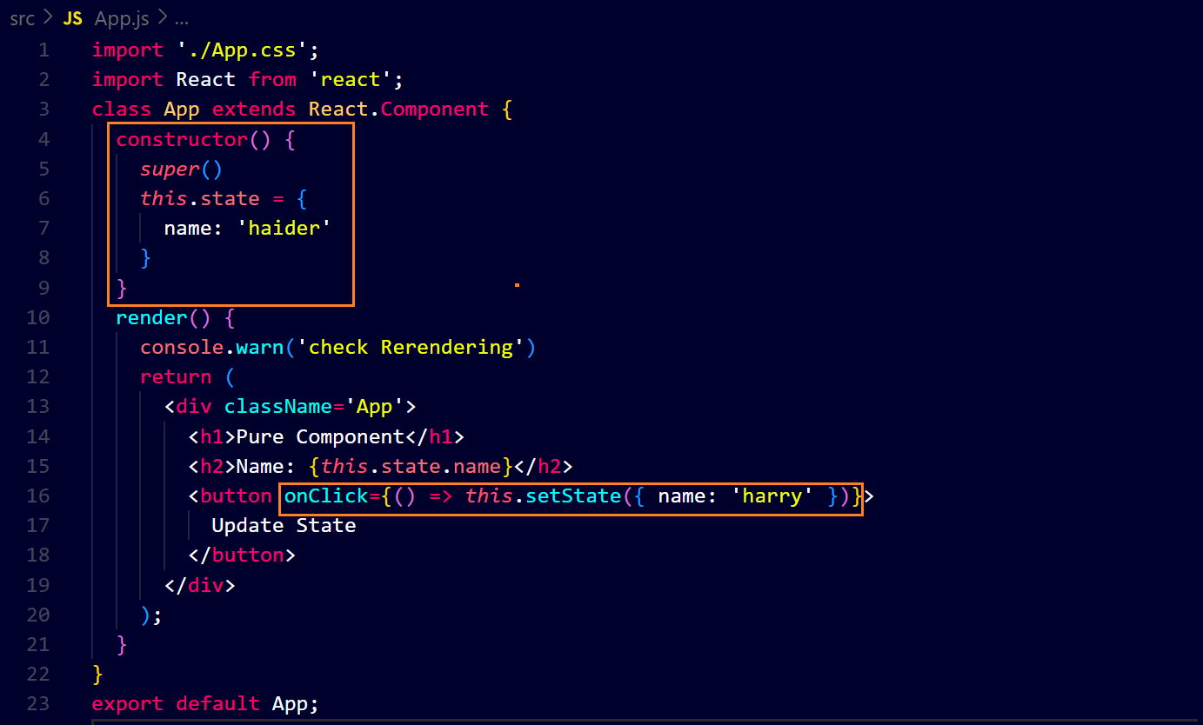output ↓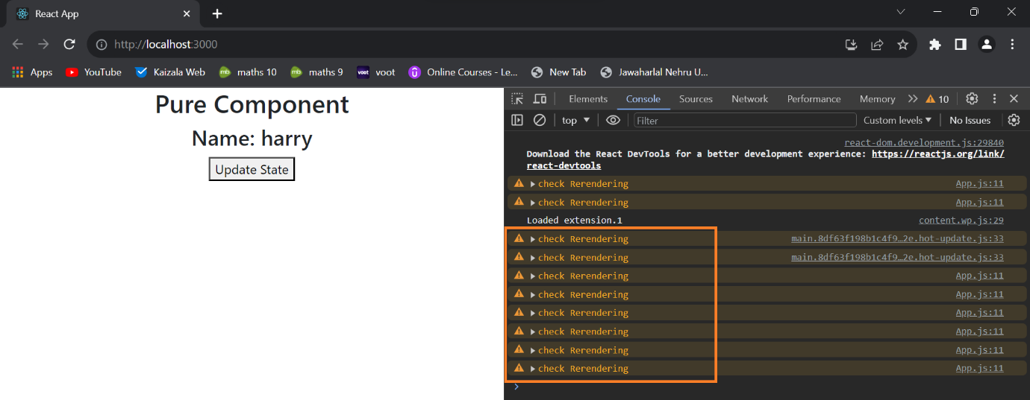you can see the state is being updated to itself after first time and the component is re-rendering.**

**Therefore we use it, it stops re-rendering of the component when the state is updated to previous state, i.e., to its same state, e.g., ↓**

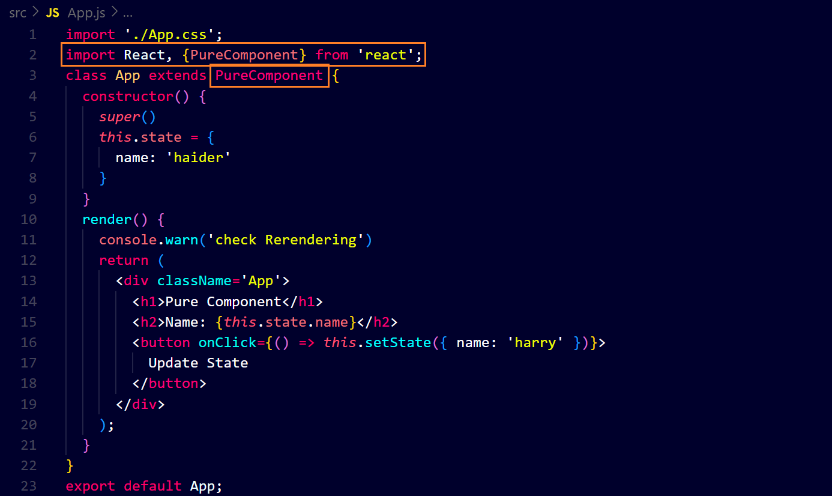**output ↓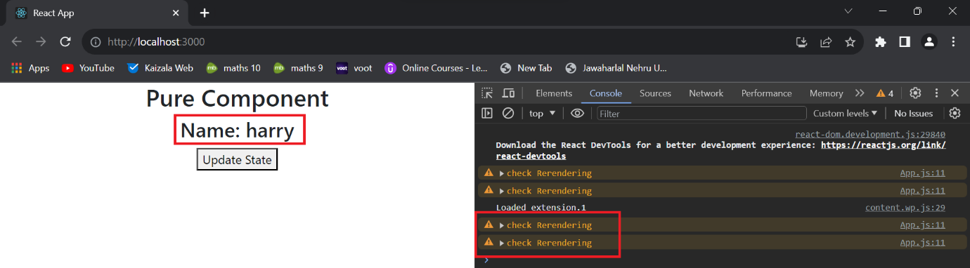you can see the component has re-rendered only one time when the state has been updated to the new state and when the state is being updated to itself then the component is not re-rendering.**

**Similarly it works when the props is updated.**