**It is used to stop unnecessary rendering of a function**

**Unnecessary rendering means 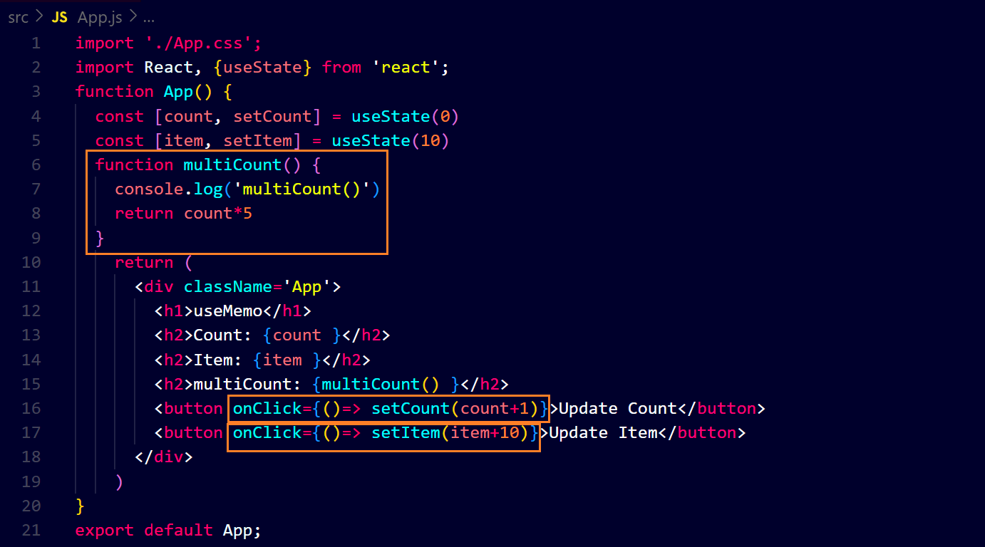the function ‘multiCount’ will work when state ‘count’ will be updated but it will re-render when state ‘item’ is updated ↓**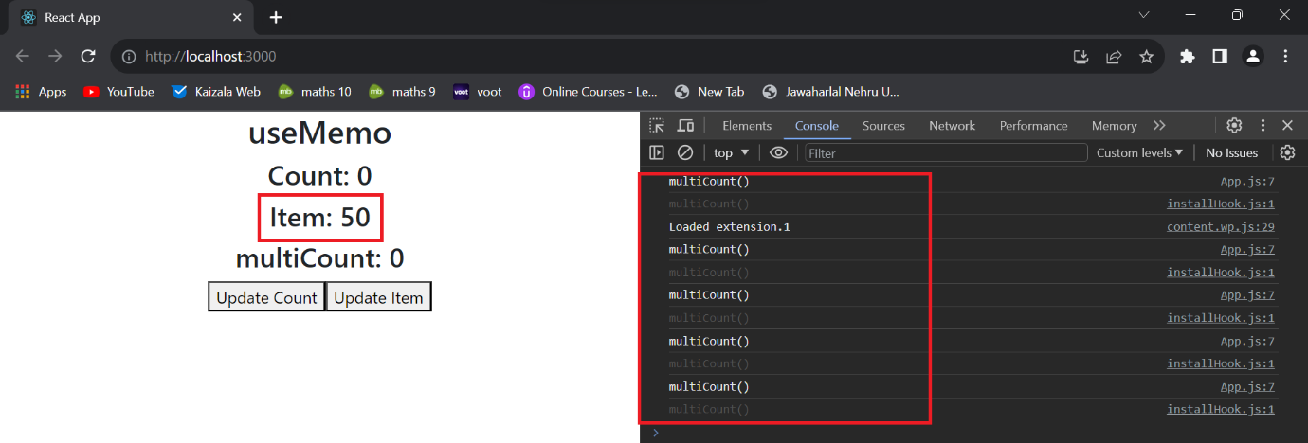

**Here we use ‘useMemo’ to stop unnecessary rendering ↓**

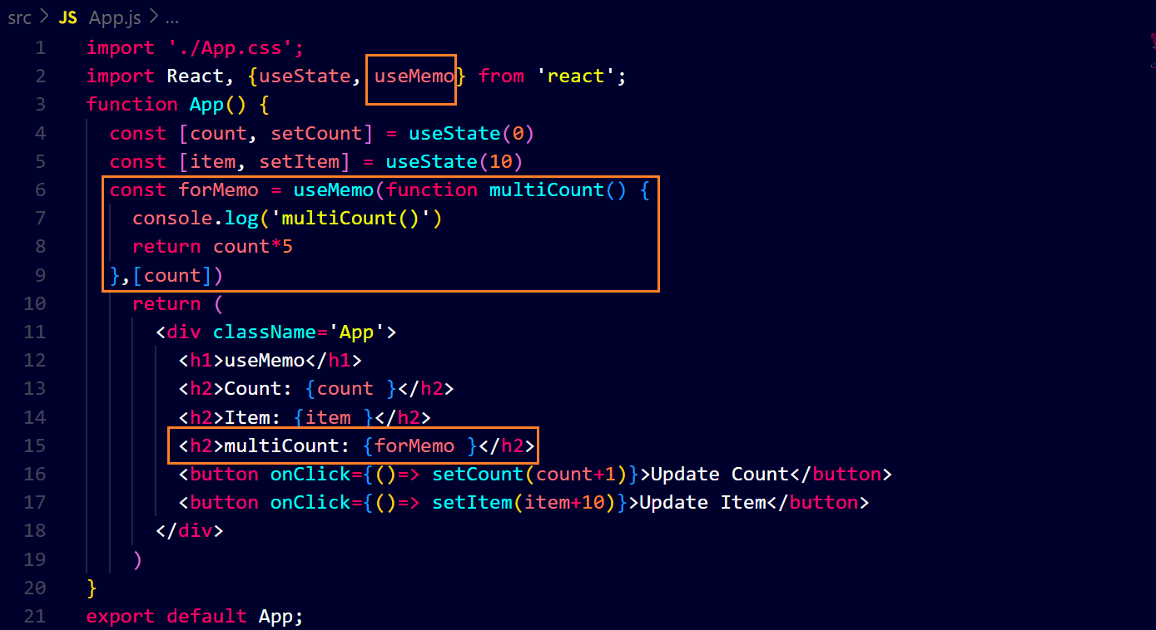**output ↓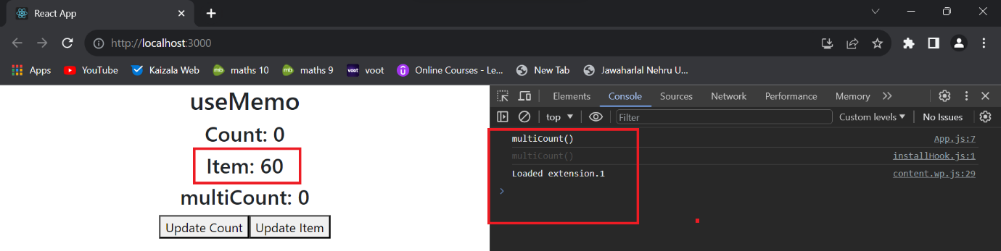you can see, on updating ‘item’, that function is not rendering render**