**It can manipulate the DOM**

**Example-1 ↓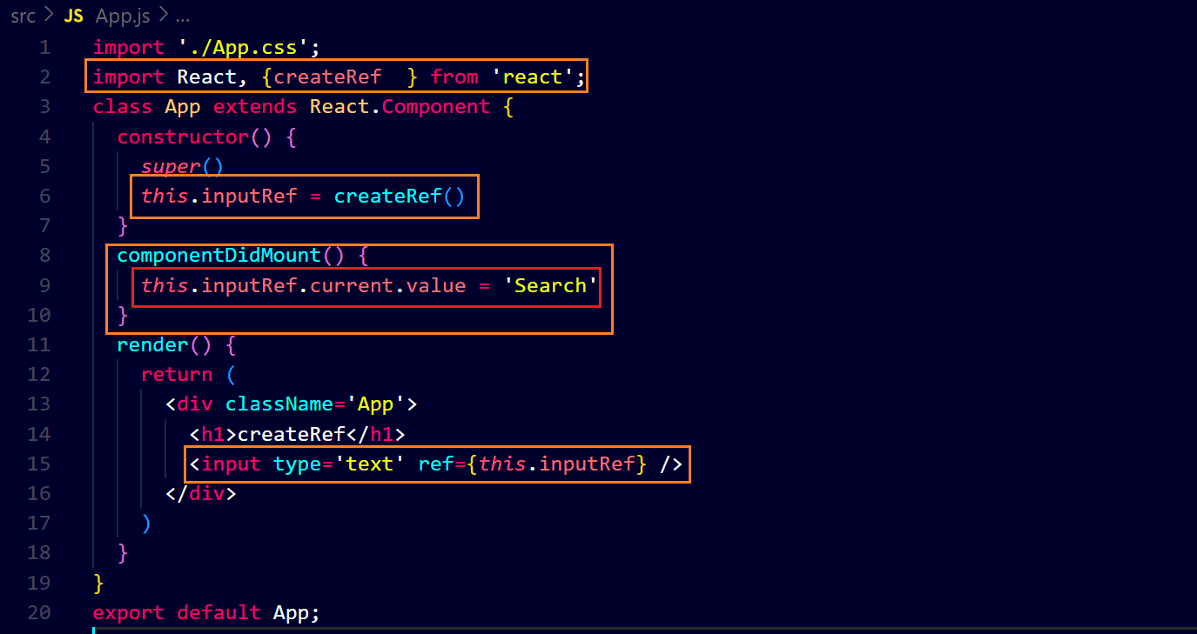output ↓**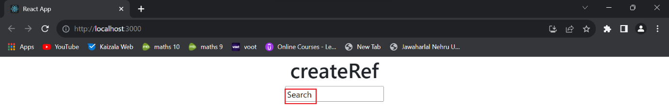

**Example-2 ↓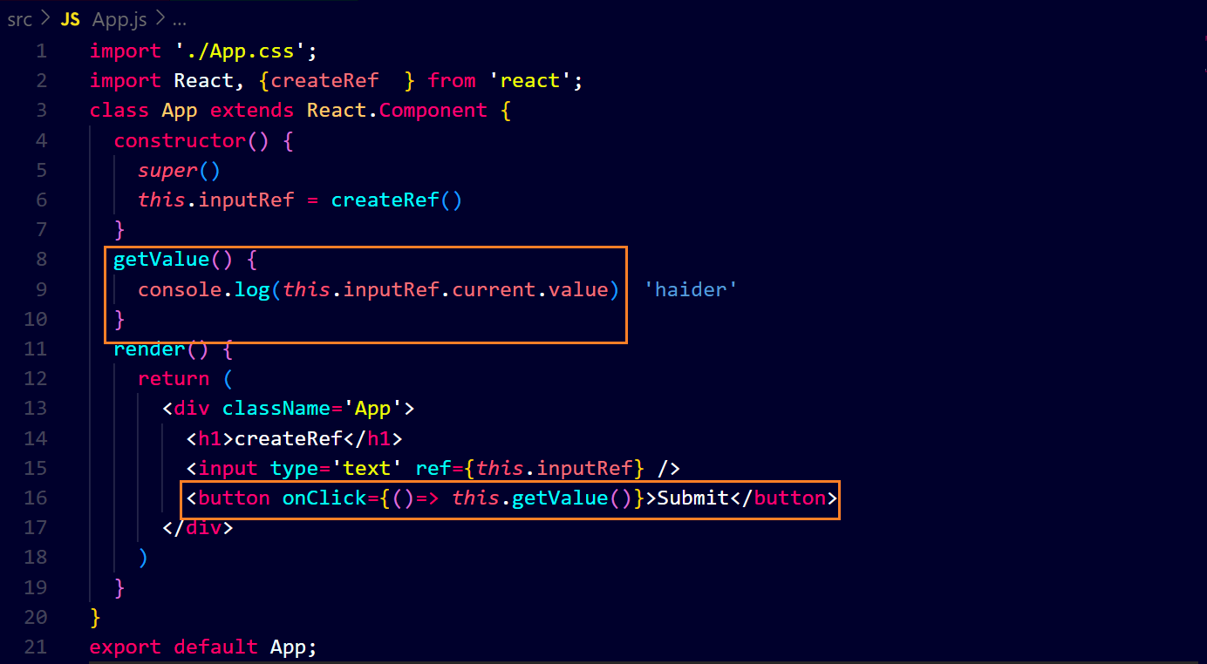output ↓**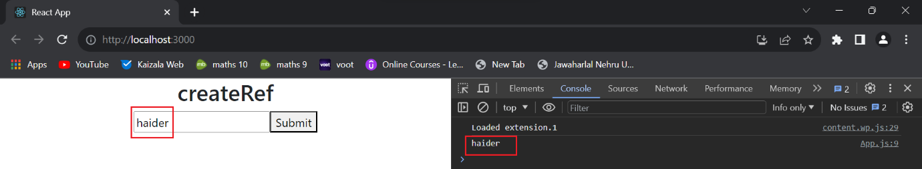

**Example-3 ↓**