**It works with function component as same as ‘createRef’ works with class component.**

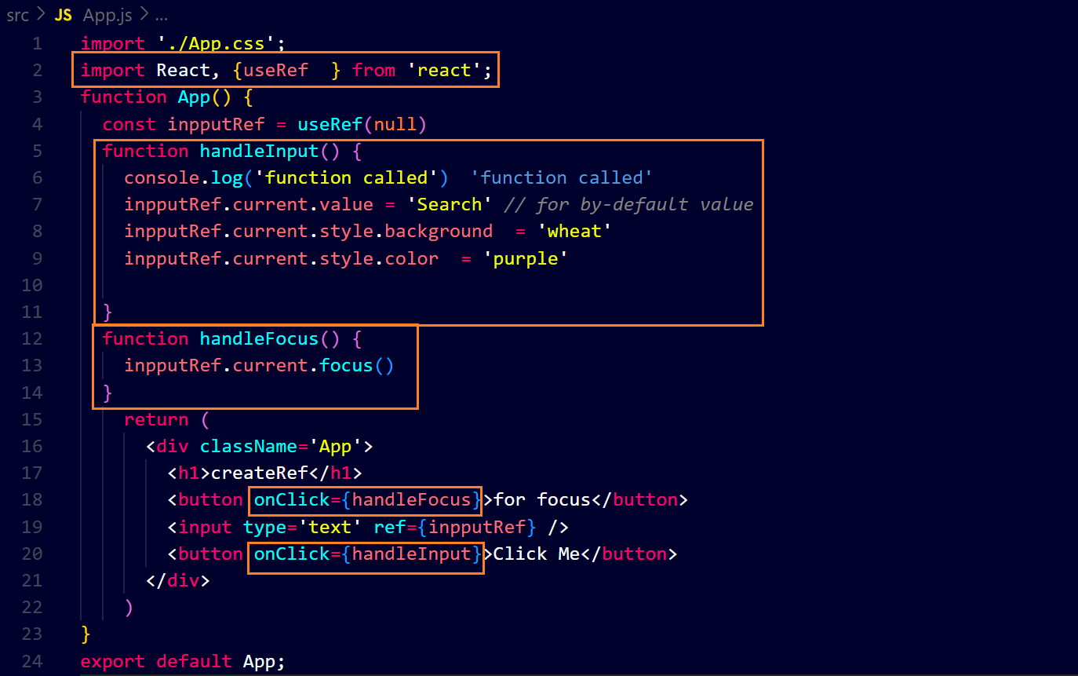**output** 