**it is used when we have to apply ‘useRef’ from parent component to child component.**

**In this case, we have ‘User’ as child component and ‘App’ as parent component, remember child component must have two parameters ↓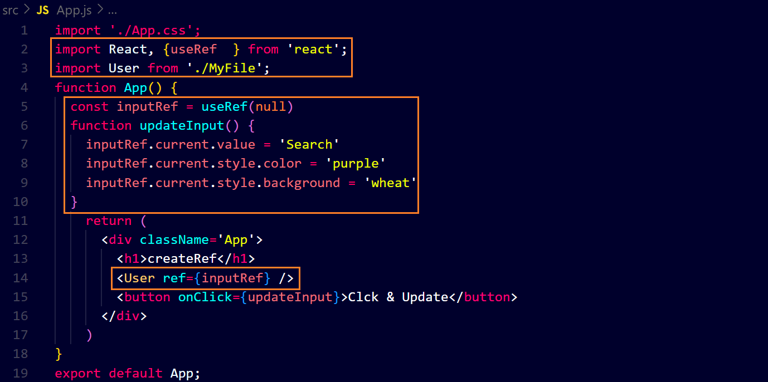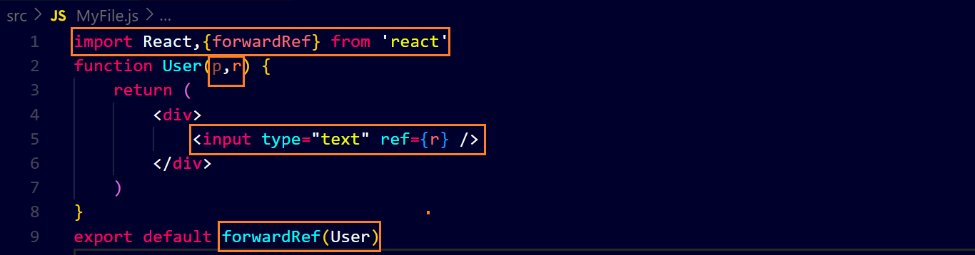output ↓**