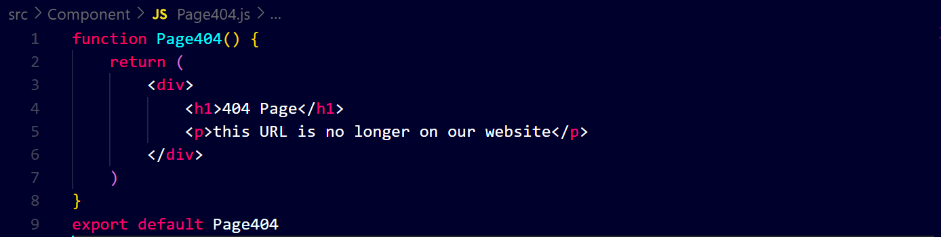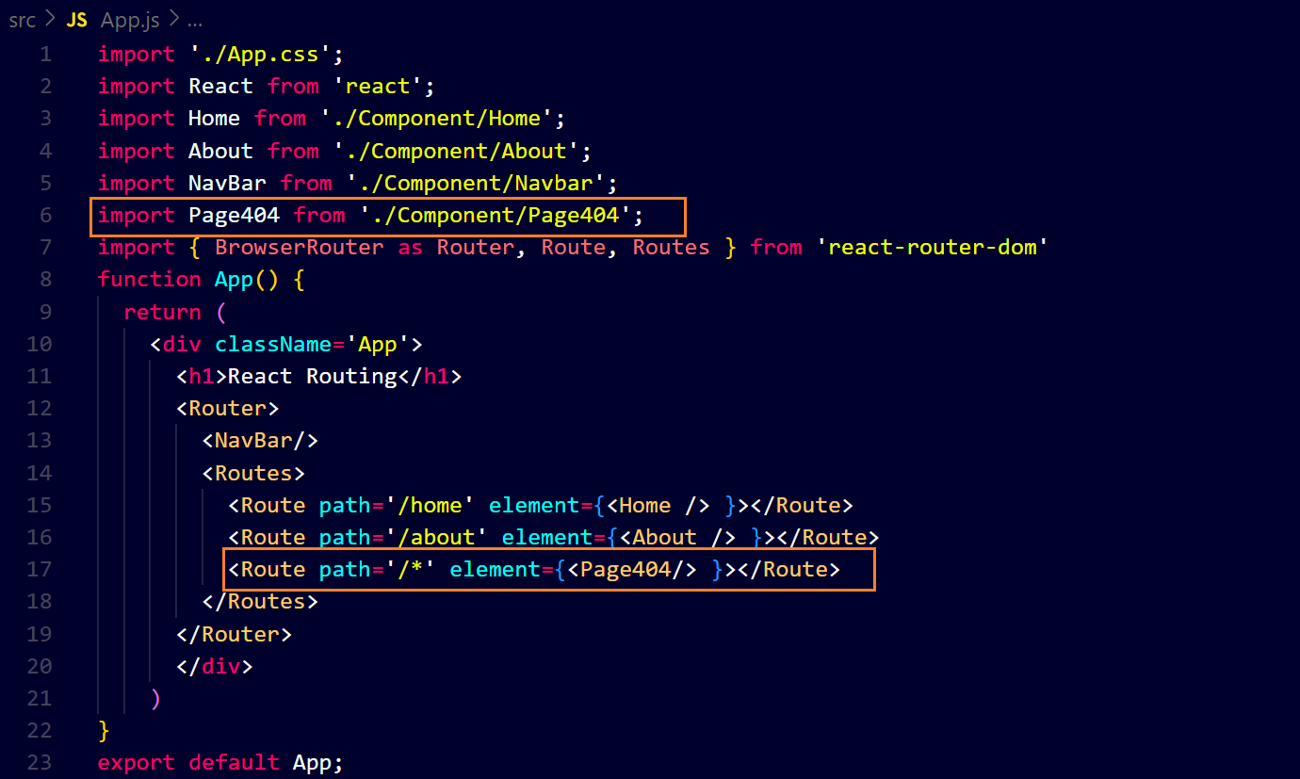

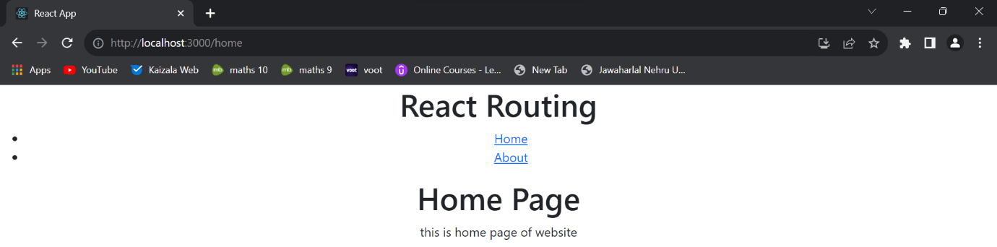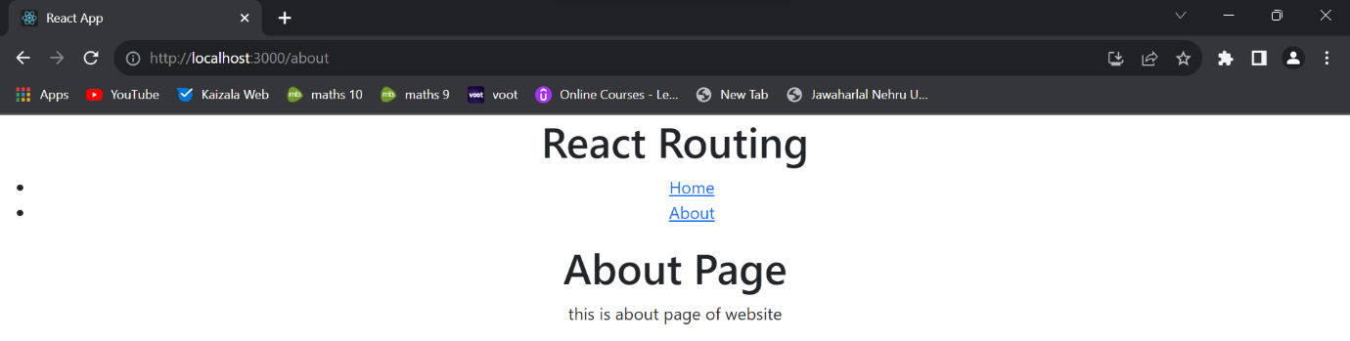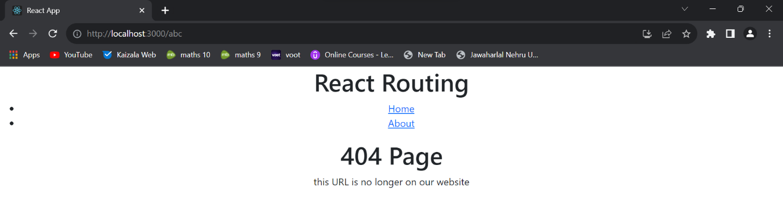

**To redirect on home page ↓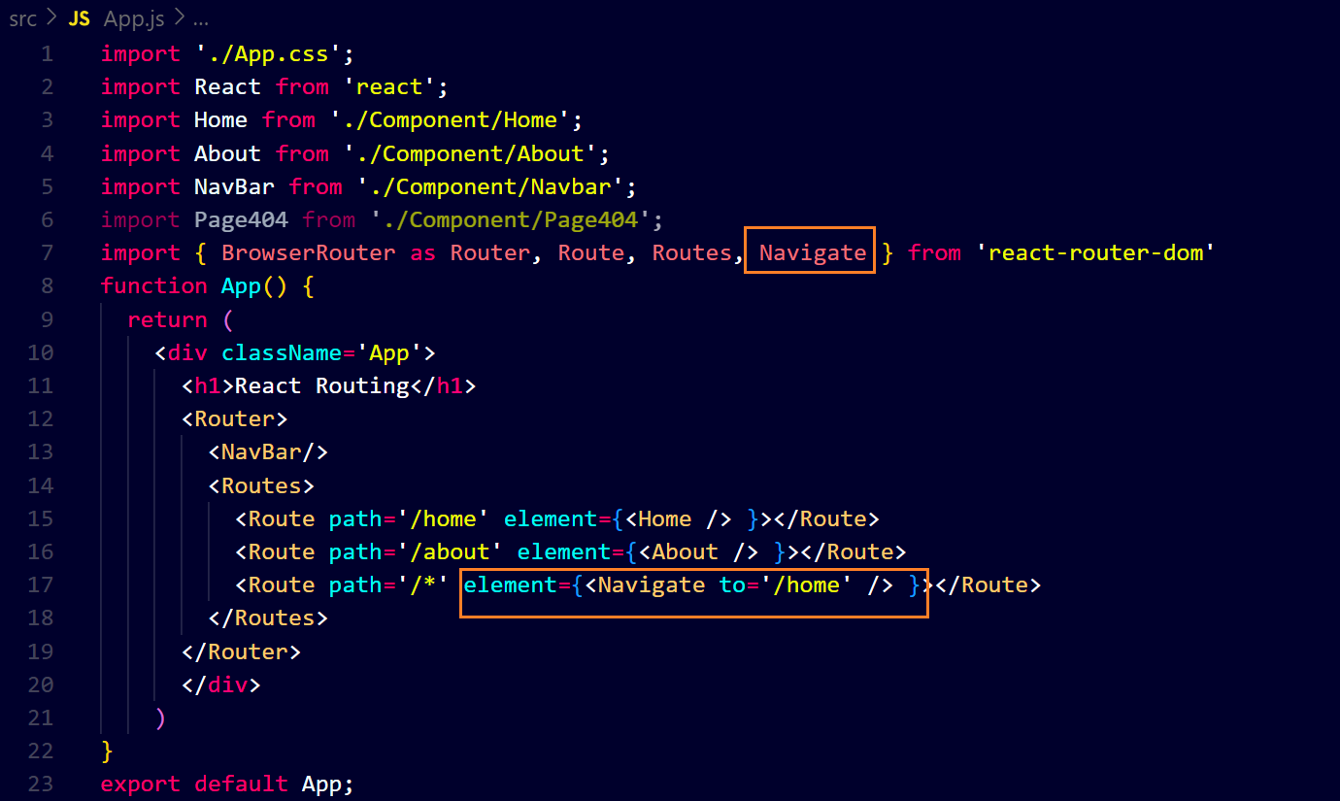whenever you will enter a wrong URL you are redirected to home page**