**we can nevigate from one page to another using a hook ‘useNavigate’ ↓**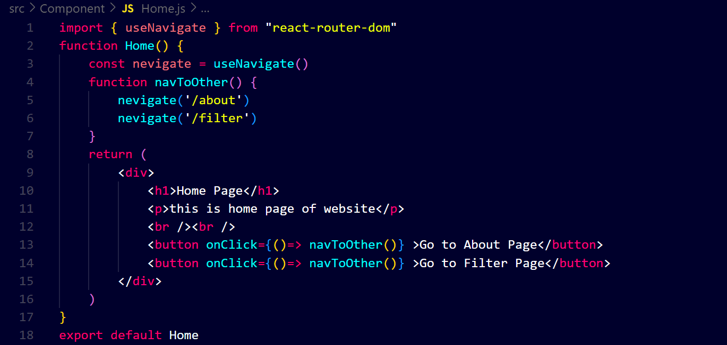

**or ↓**