**We will create three components ‘Channel’, ‘Company’ and ‘Other’↓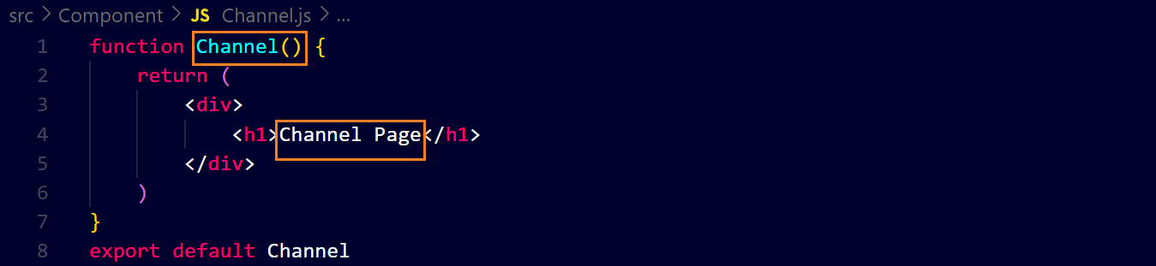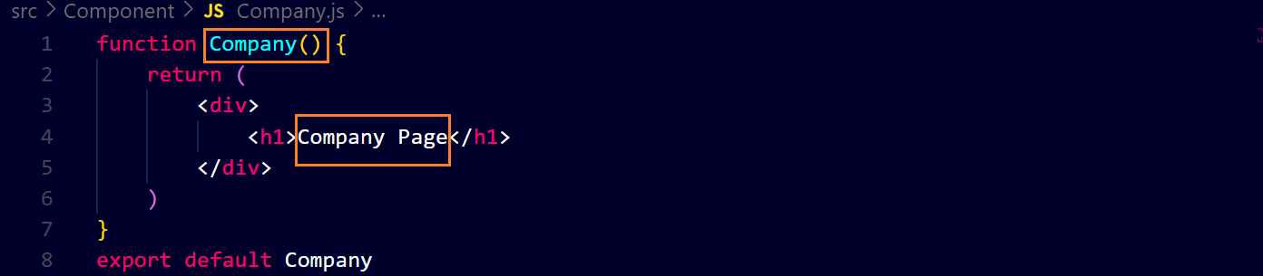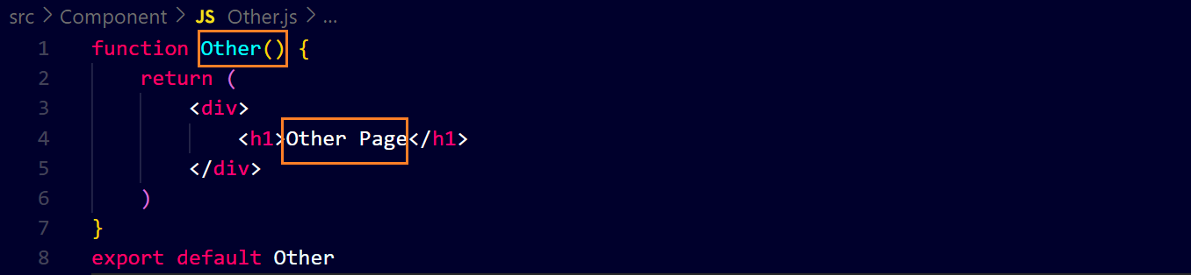 then we will attach them with ‘NavLink’ tag ‘about.js’ ↓** 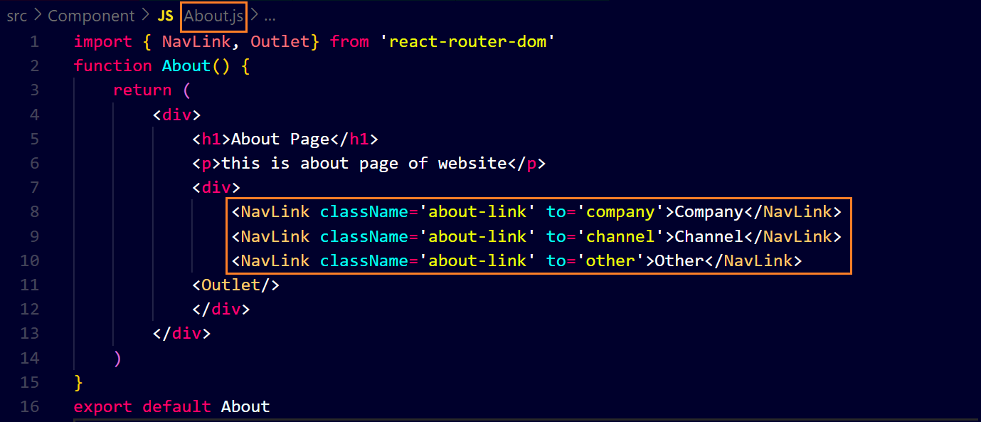

**Then we will make them as children routes of ‘About’ component ↓**

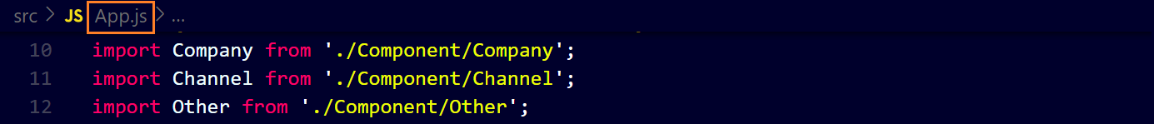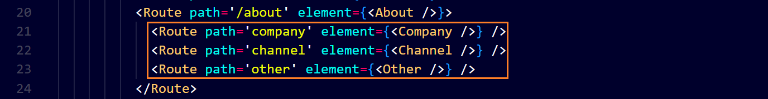**now we will add some CSS ↓**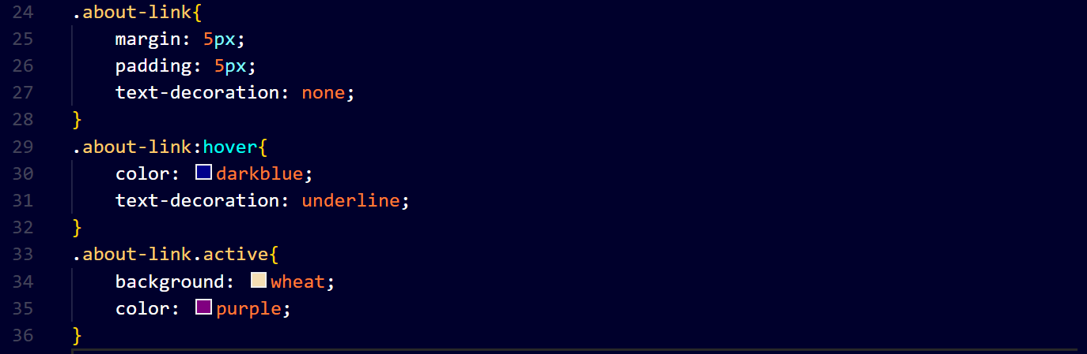

**Now the result ↓**