**It returns things like params, state, hash, search, etc. When we go from one route to another route**

**For example, on going from Home page to About Page using the button, it will return on Home page console** 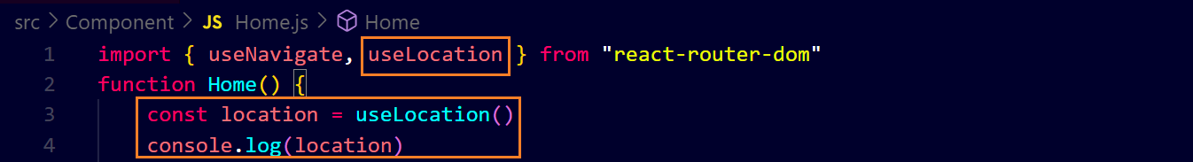 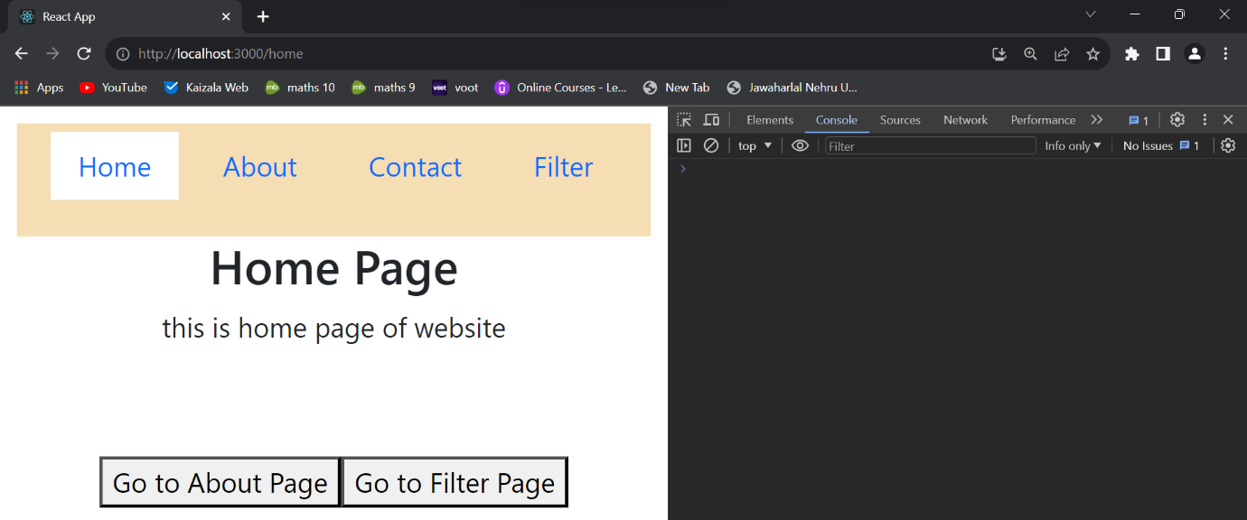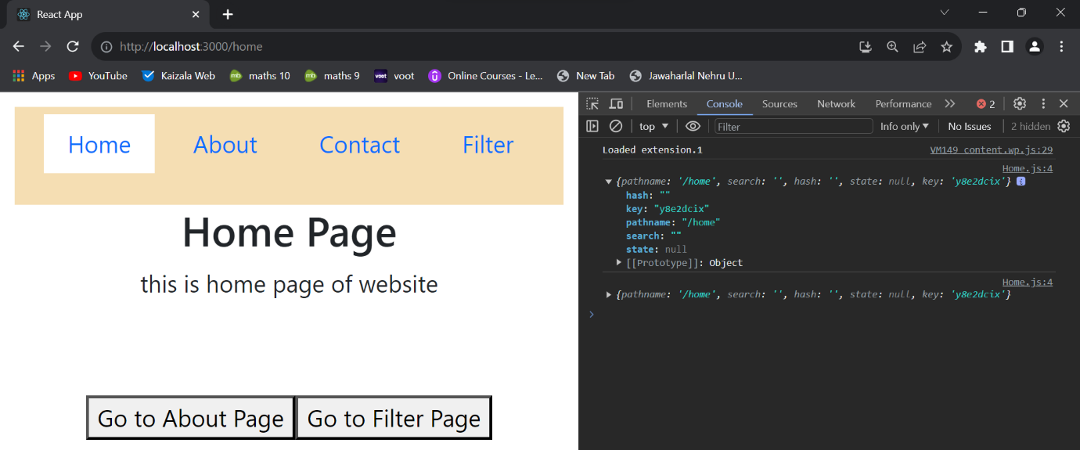

**When we go from a component to its child component, it will give pathname and remember key is dynamically generated ↓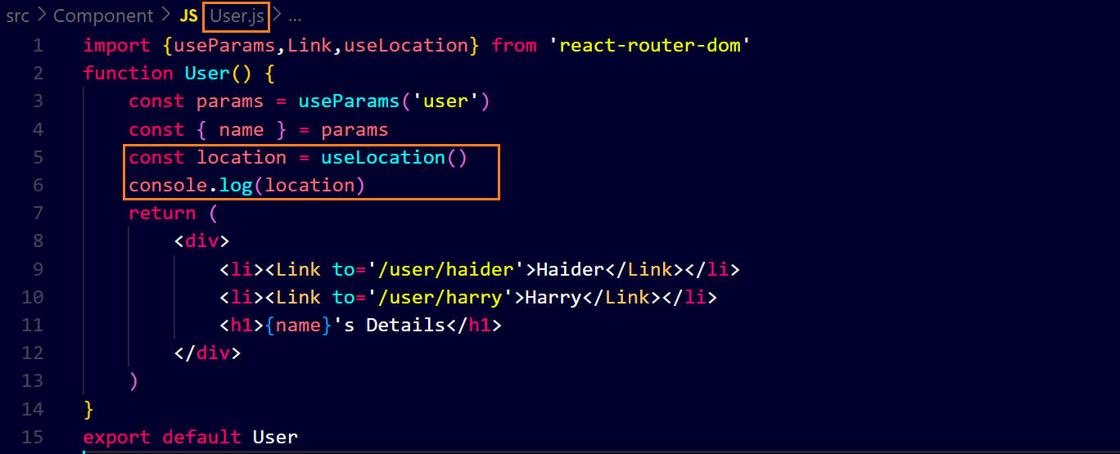output ↓**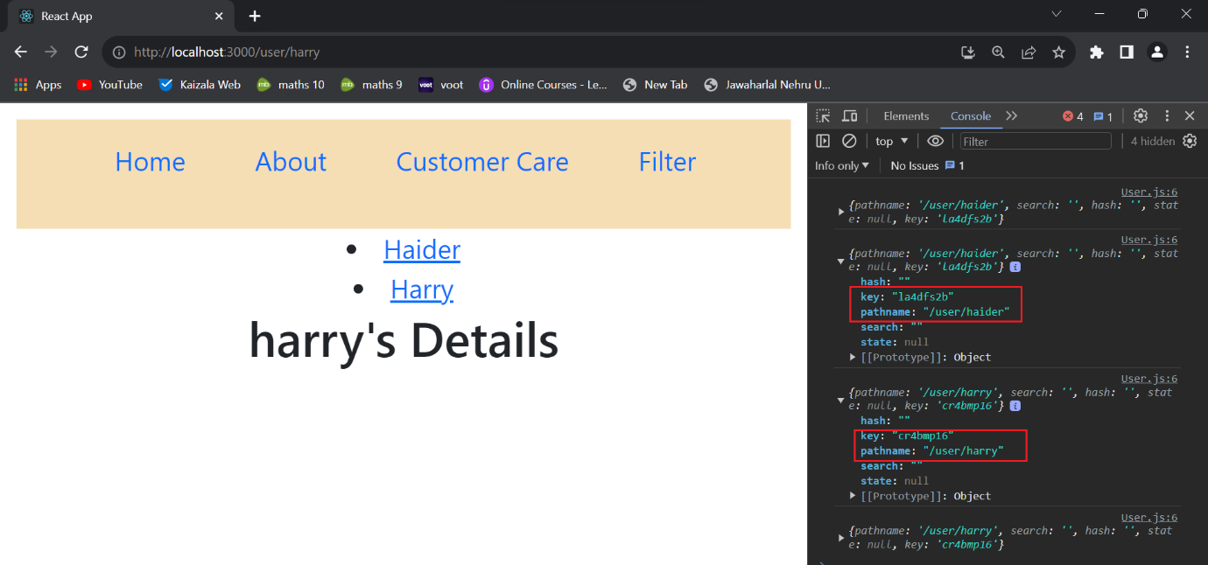

**And for state ↓**