**First we will create class component to use ‘useState’.**

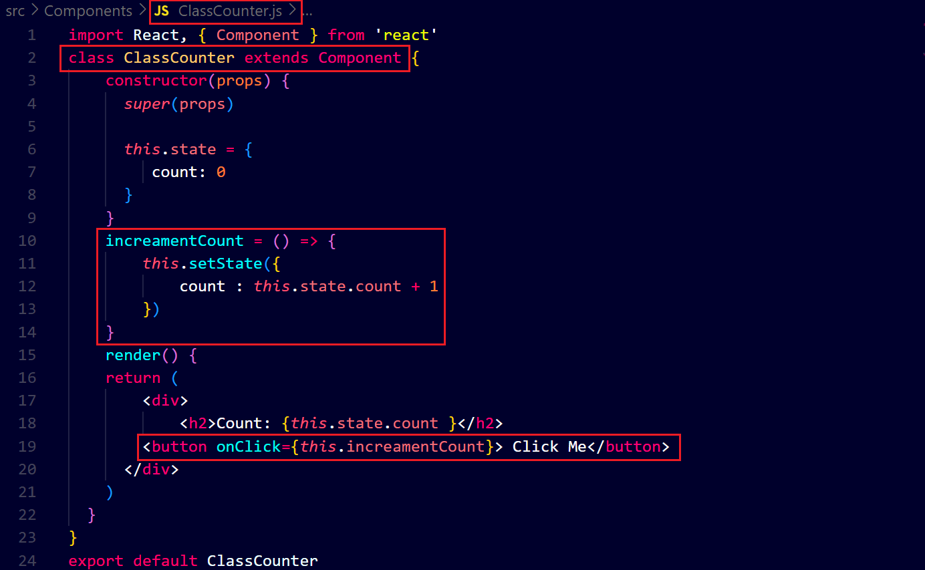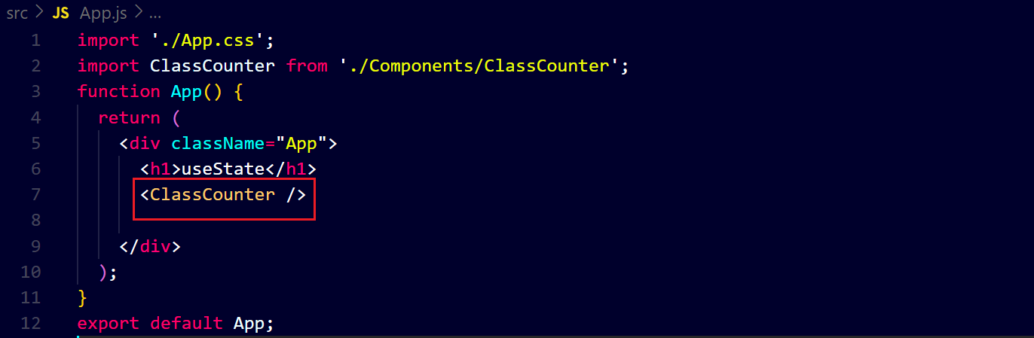**output ↓**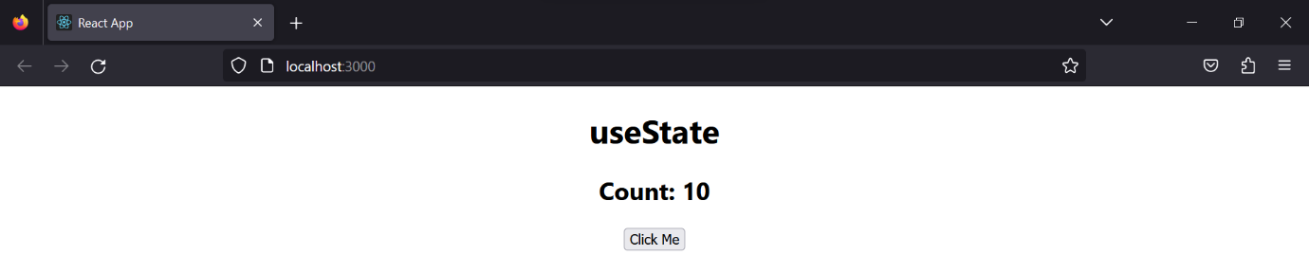

**Now we will create a function component to use ‘useState’ hook and you will see our code has less than that ↓**