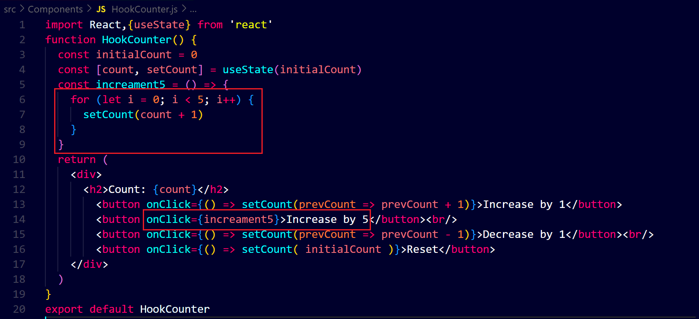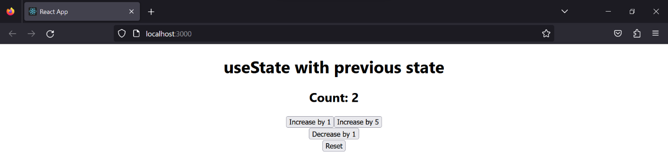**on clicking the button ‘increase by 5’ two times, the count has increased up to 2 only not up to 10, it is because the count has its initial state that is zero therefore we have to use function inside of “setCount” that has access the previous state of count ↓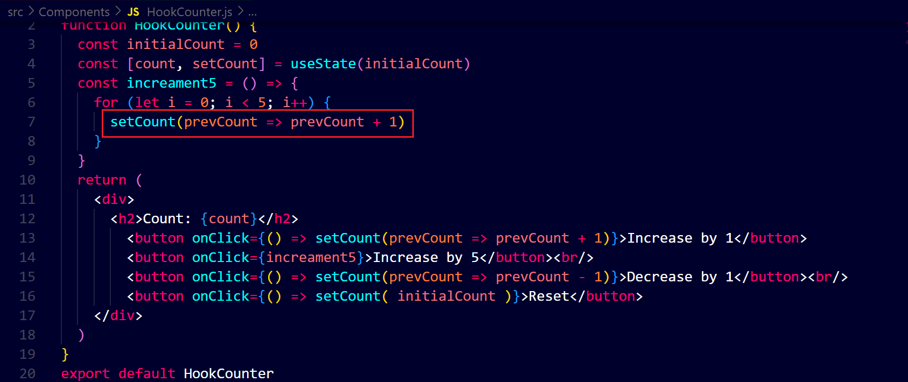output after clicking two times on that button ↓**