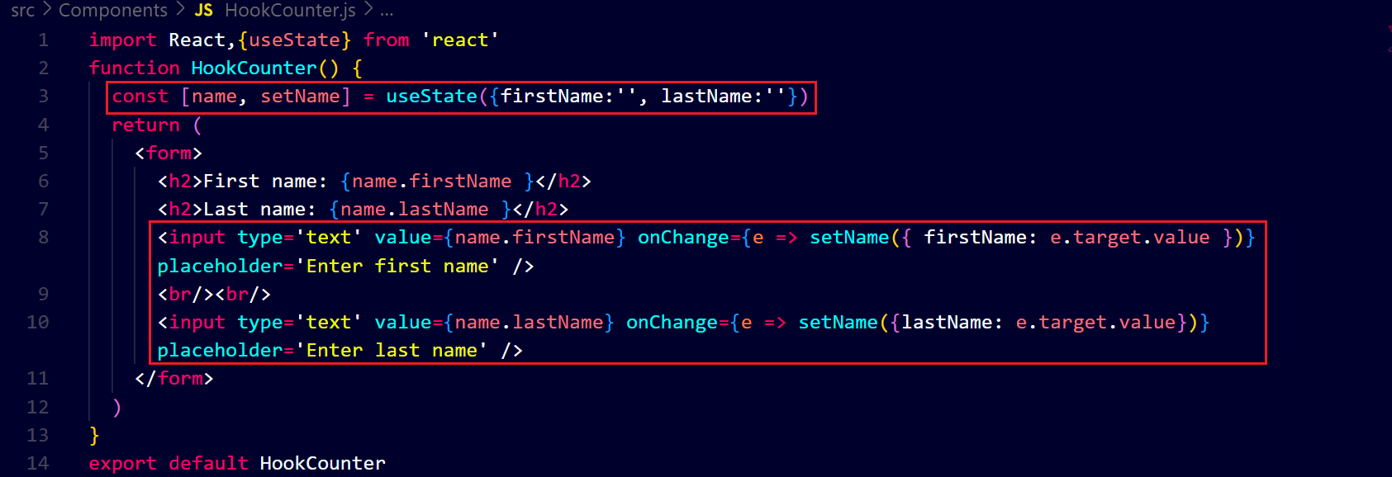 **Output ↓**

**in this, there is a problem, you can when we start entring last name, the first name disapears and when we start entring first name, the last name disapears. It is because the state does not automaticallly merge and update the object to resolve it we use spread operator like this ↓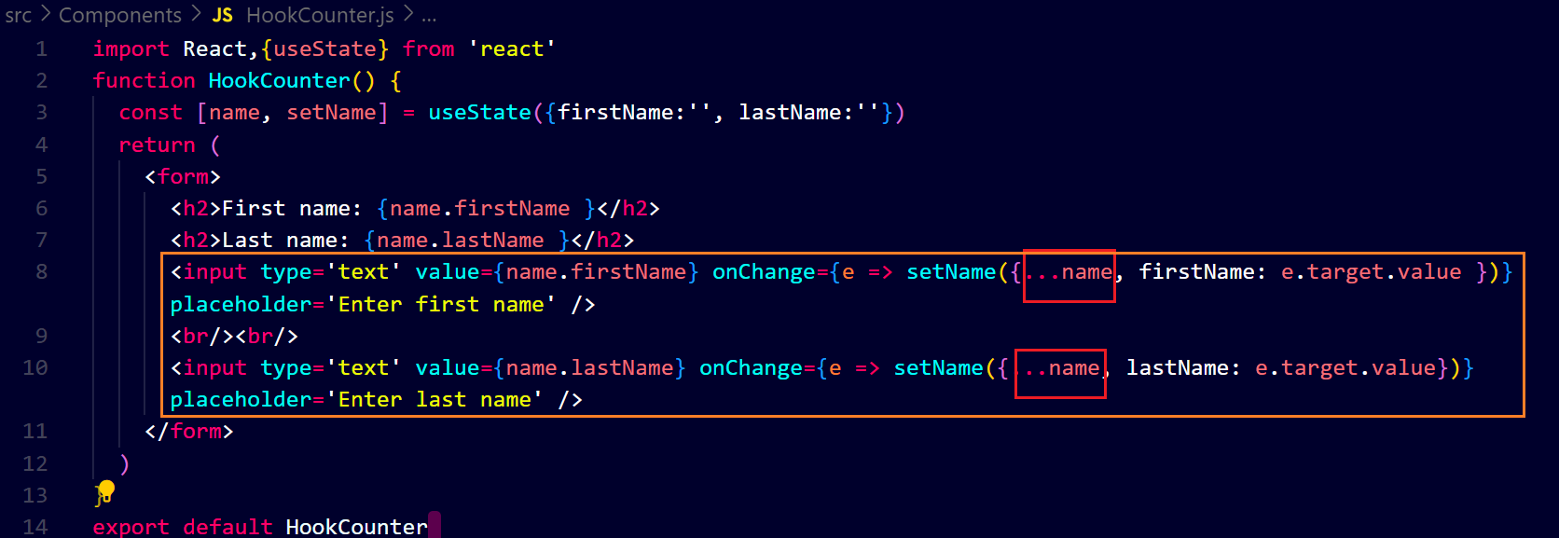output ↓**

