**Sometime we have to set condition to improve the performance.**

**You will understand from the following example ↓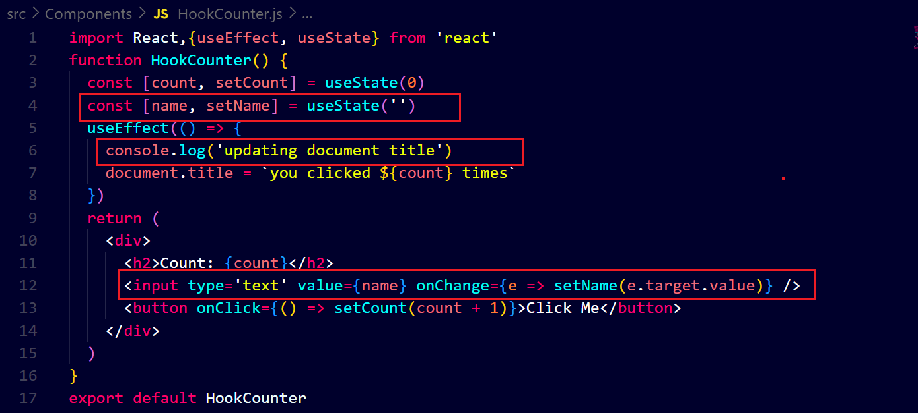output ↓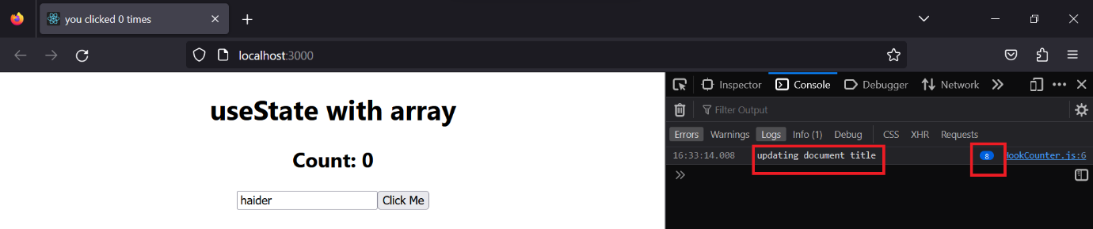you can see that whenever we enter value in the input field the useEffect hook gets executed so to stop it we have to set conditions then it will not executed unnecessary.**

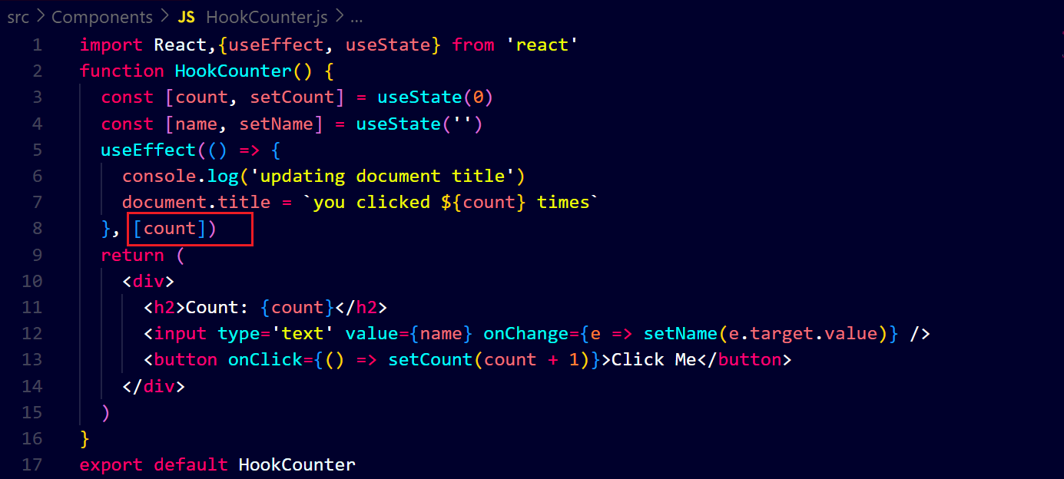**output 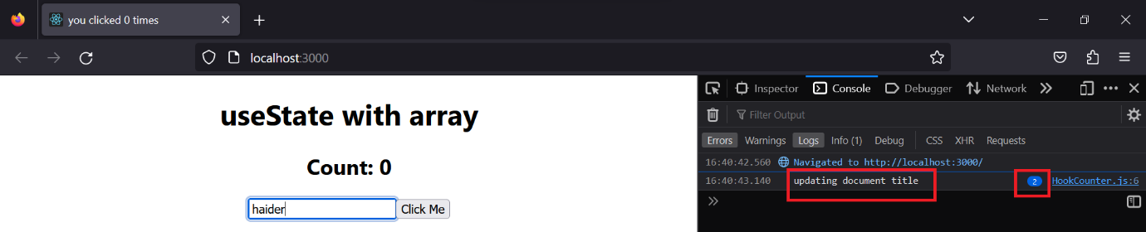you can see that after setting the condition, the useEffect hook is not run on the entering the value in the input field.**