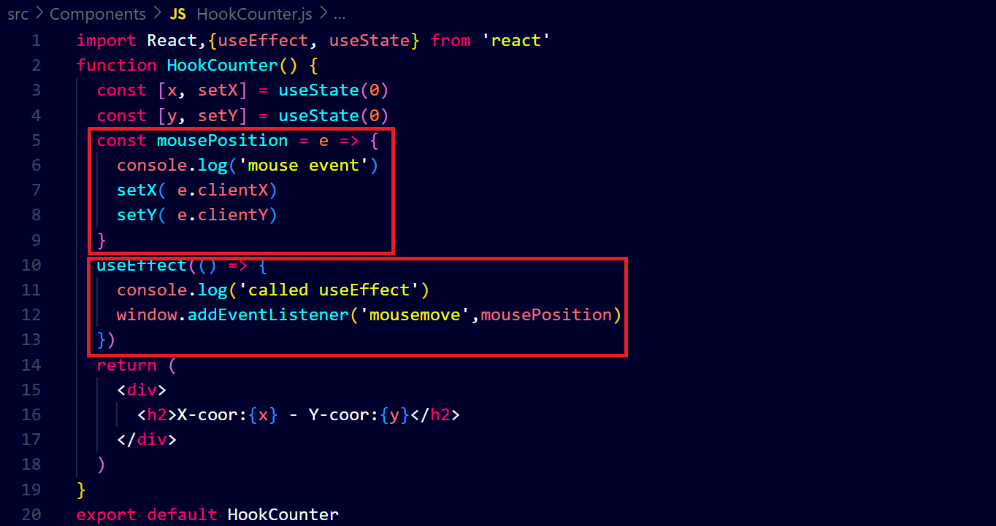**output ↓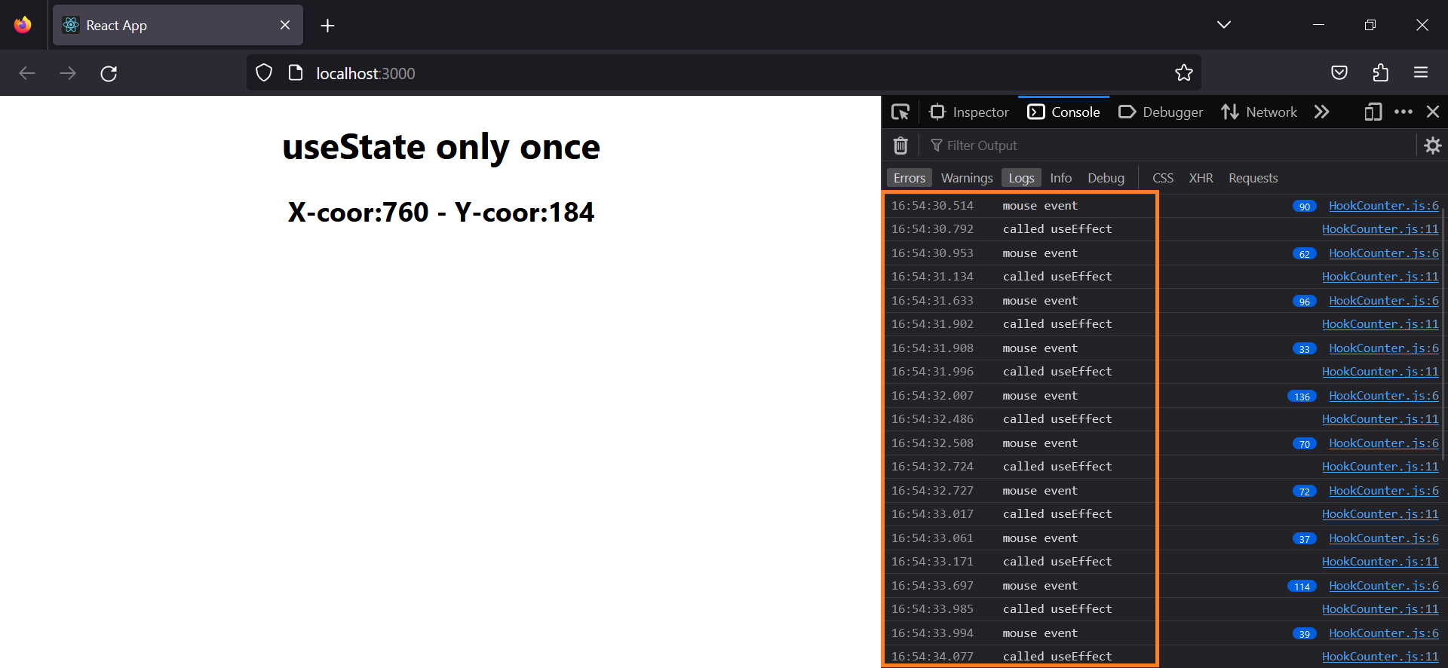you can see that whenever we place the cursor on the screen the state is changed and the useEffect is run that is unnecessary so we have to stop it from running unnecessary it will run only one time in the starting**

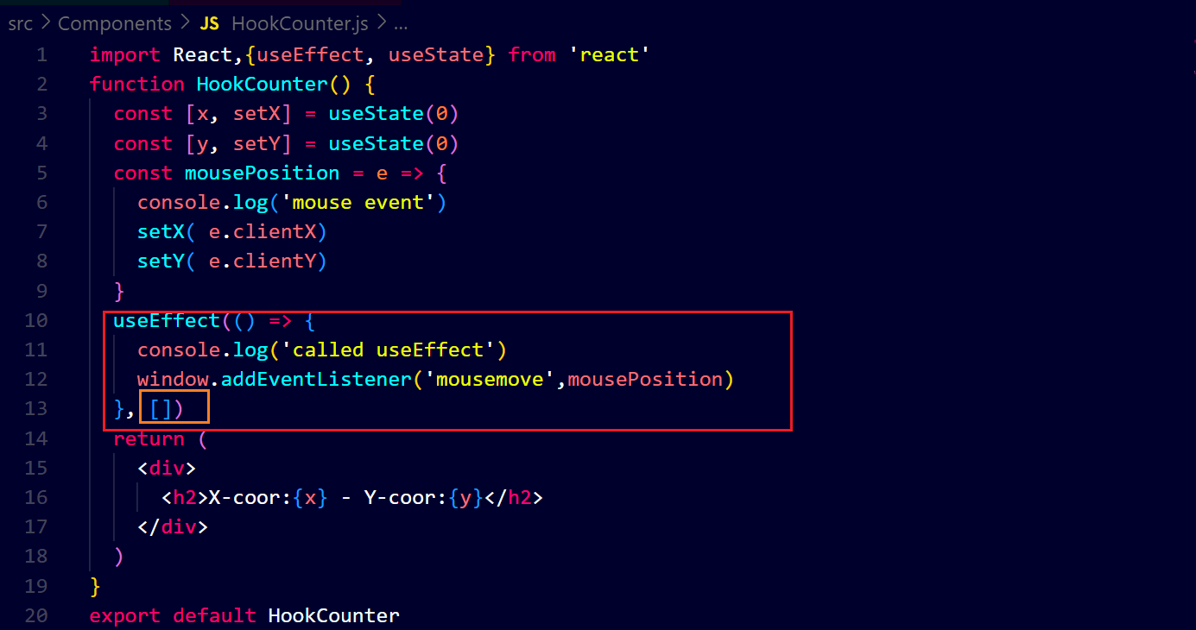**output** **↓**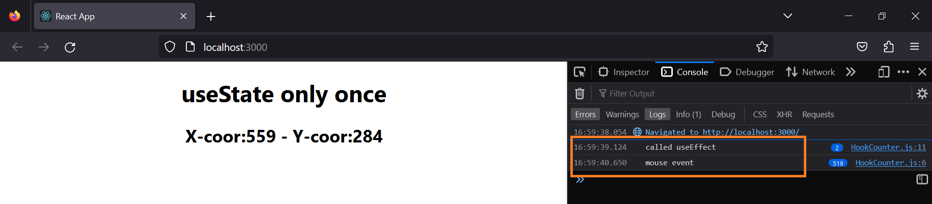

**You can see that the useEffect has been run only one time in starting due to placing an empty array.**