**We will create a component ‘MouseContainer’ and make it the parent component of the ‘HookCounter’ component that we have seen in previous class, the component display and hide the content of ‘HookCounter’ at the screen on clicking a button but there is problem that you will see ↓** 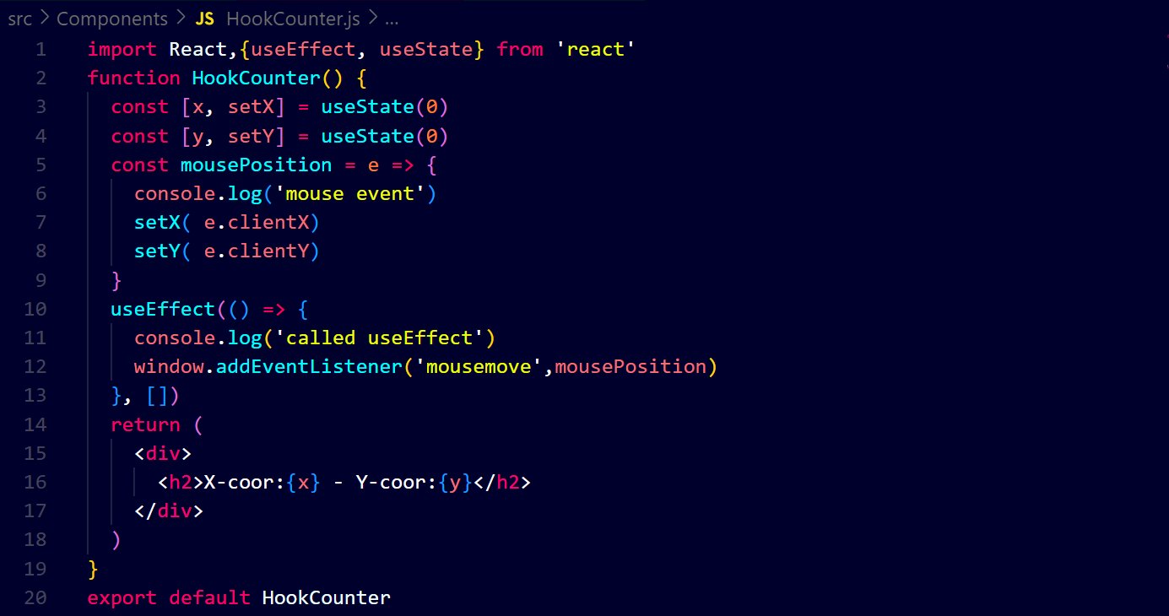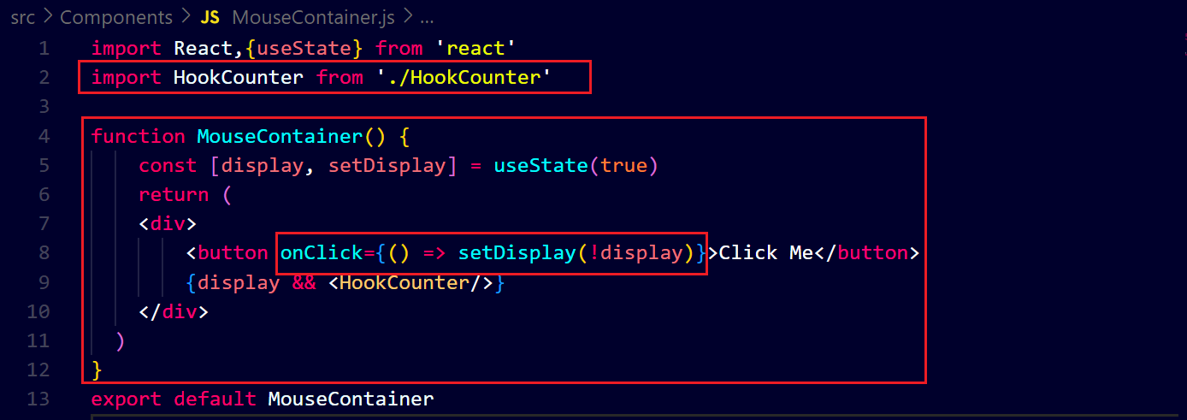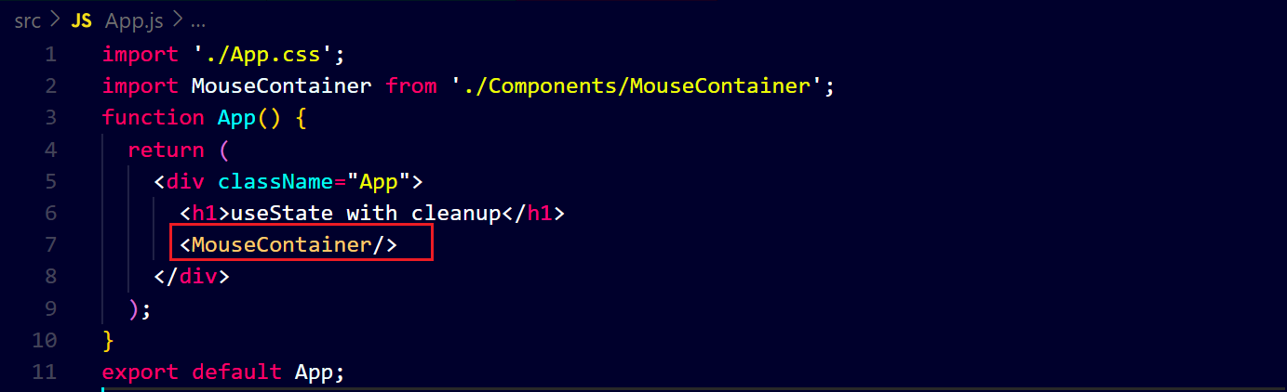

**Output ↓**

**Before clicking the button ↓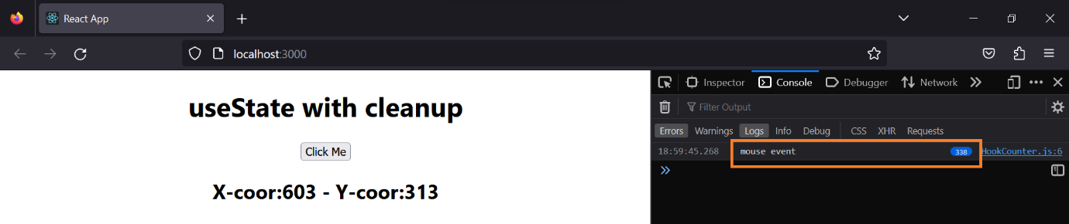after clicking the button ↓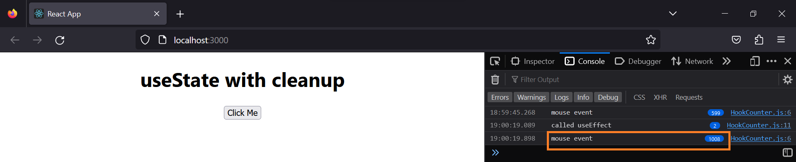you can see after clicking the button, that is hide but it functions off the screen.**

**To resolve it we have to return a function from the function passed to the use effect that will be executed when the component will unmount, it will be in ‘HokkCounter’ file ↓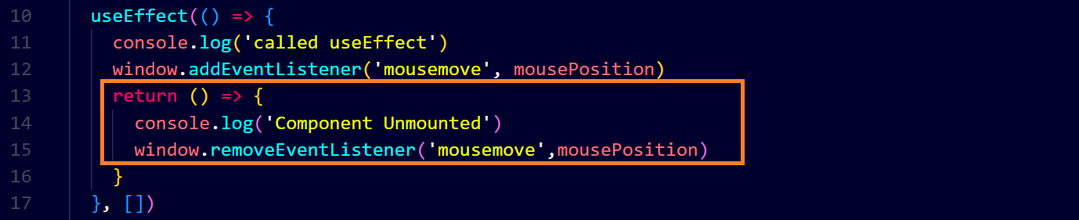before clicking the button ↓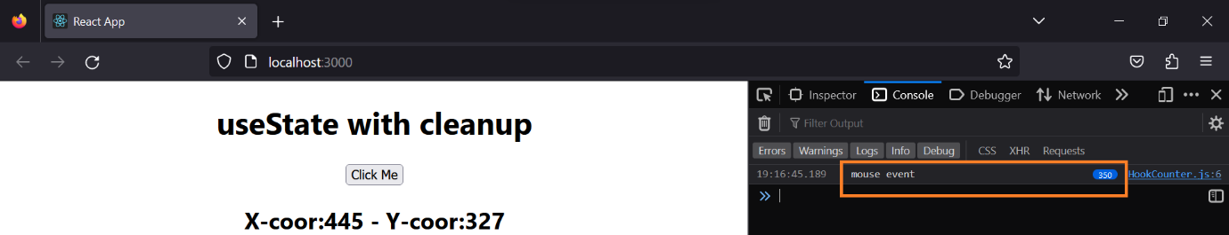after clicking the button ↓**