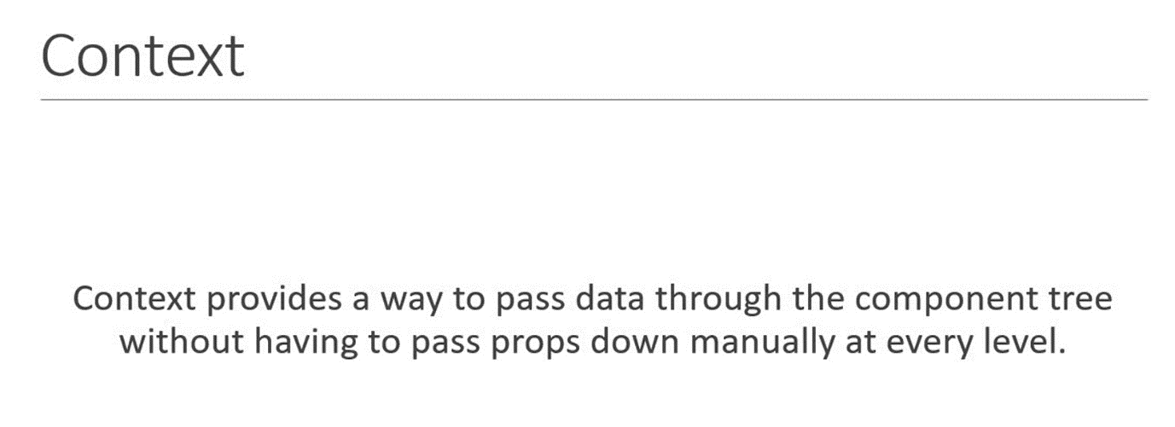

**We will create three components ‘ComponentA’, ‘ComponentB’ and ‘ComponentC’ and make ‘ComponentA’ as the parent of ‘ComponentB’ and ‘ComponentB’ as the parent of ‘ComponentC’ and we will pass prop from App component to the ‘ComponentC’ directly. ↓ 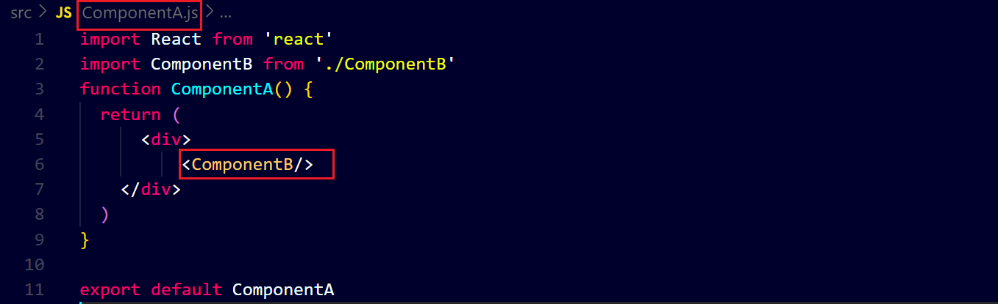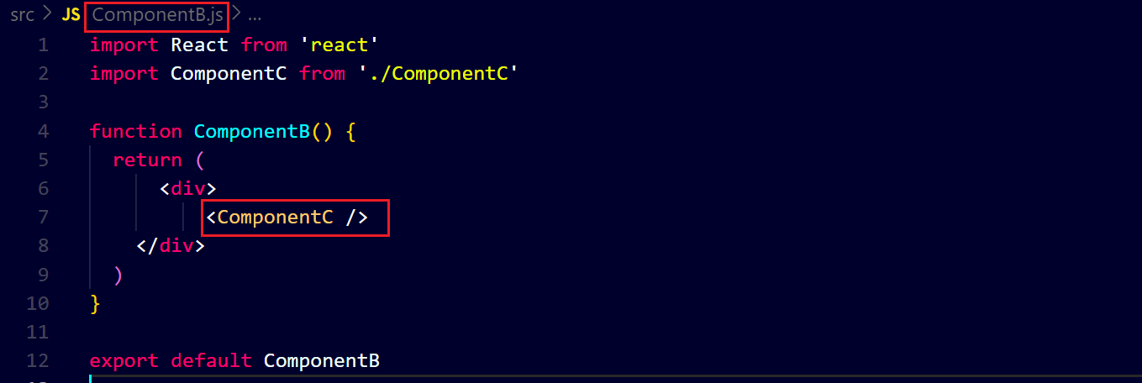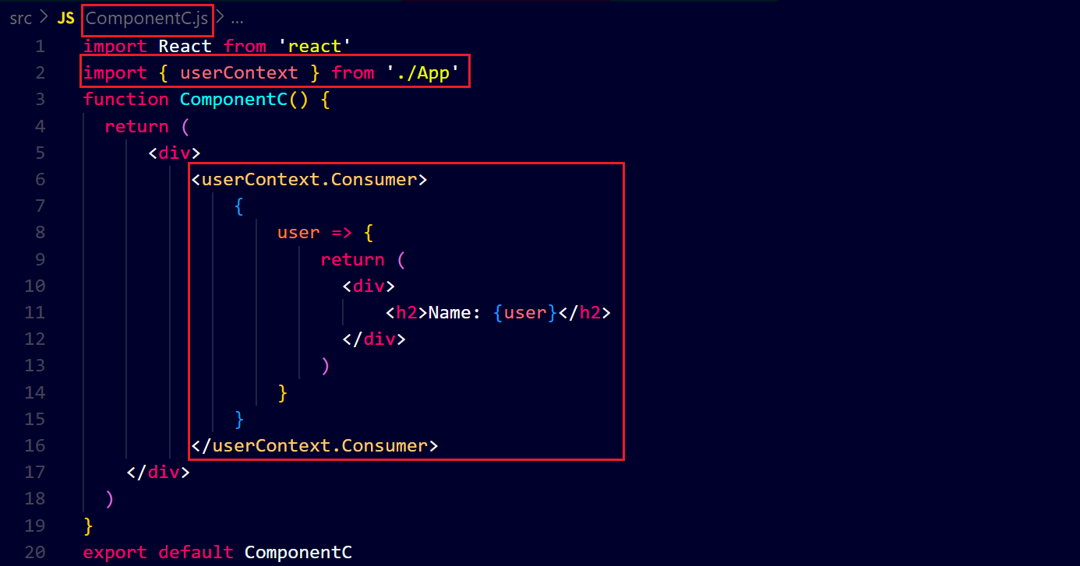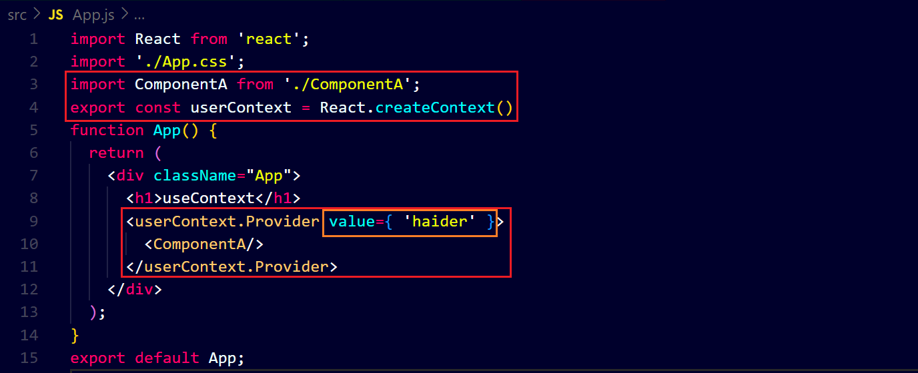output ↓**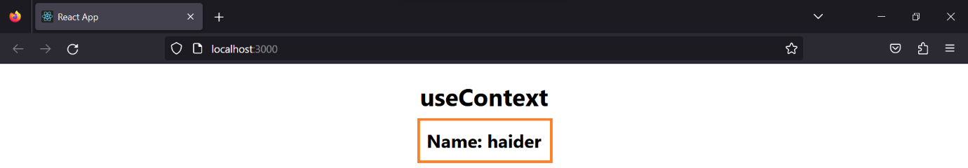

**We can create multiple context ↓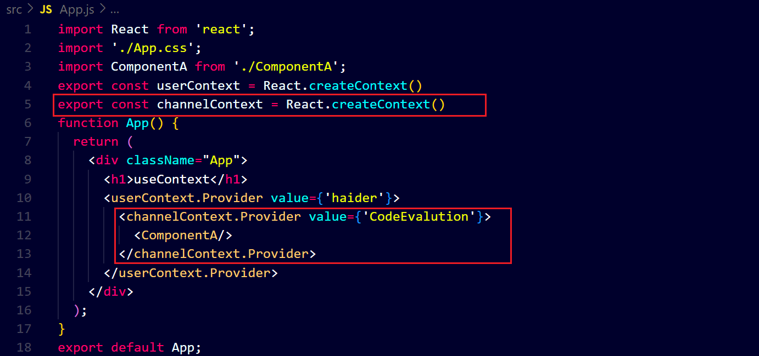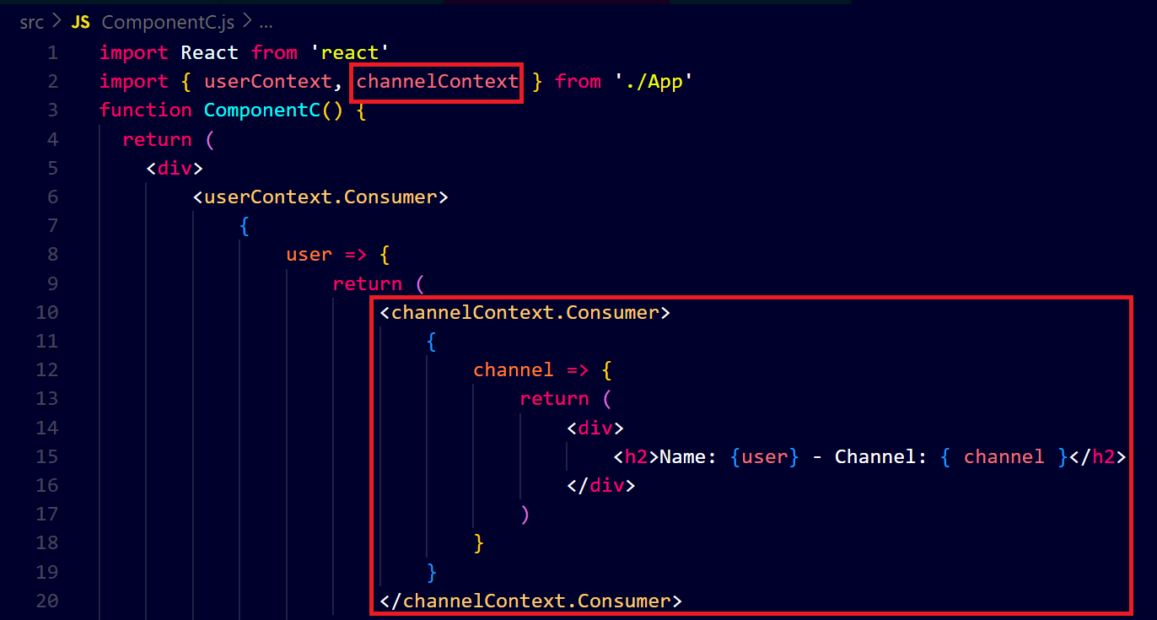output ↓**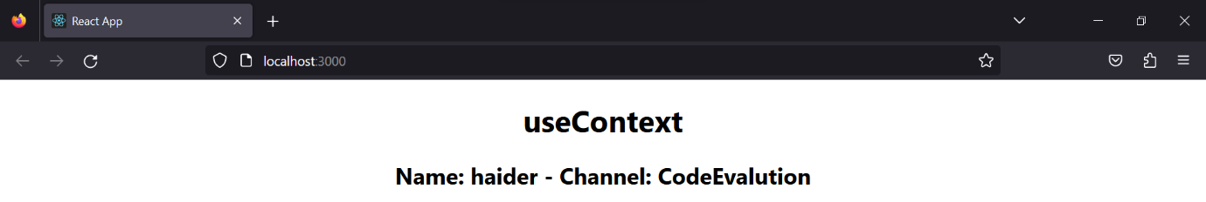

**Now we will use ‘useContext’ and you will see the code will become most efficient ↓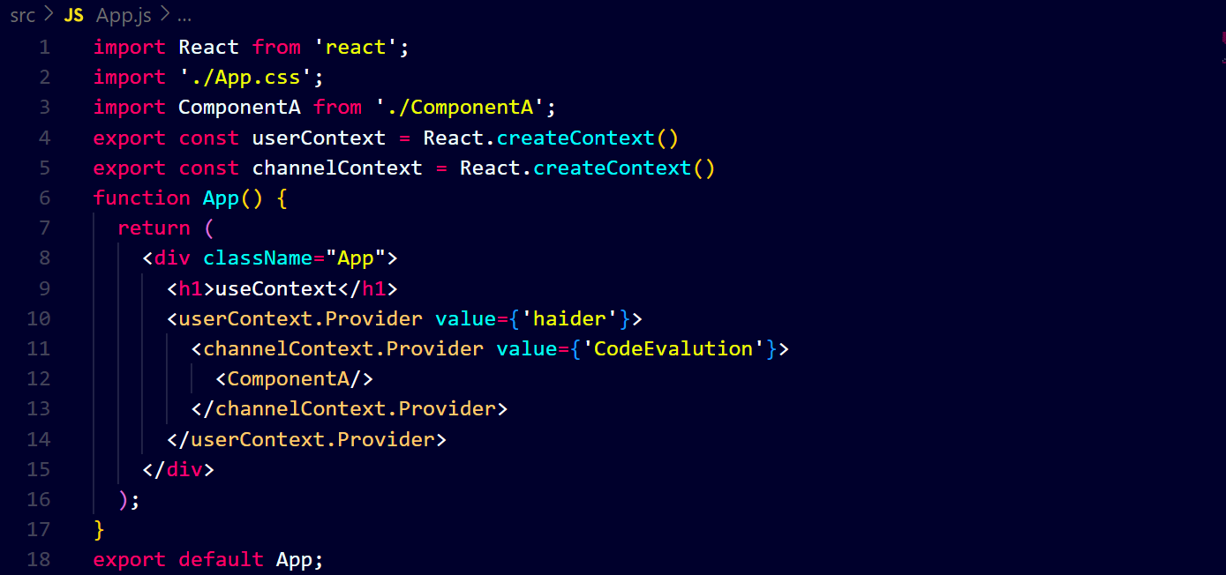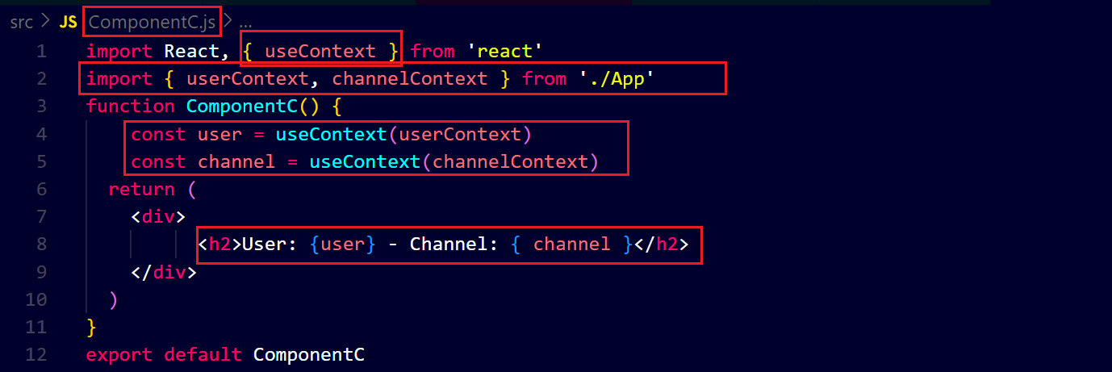output ↓**