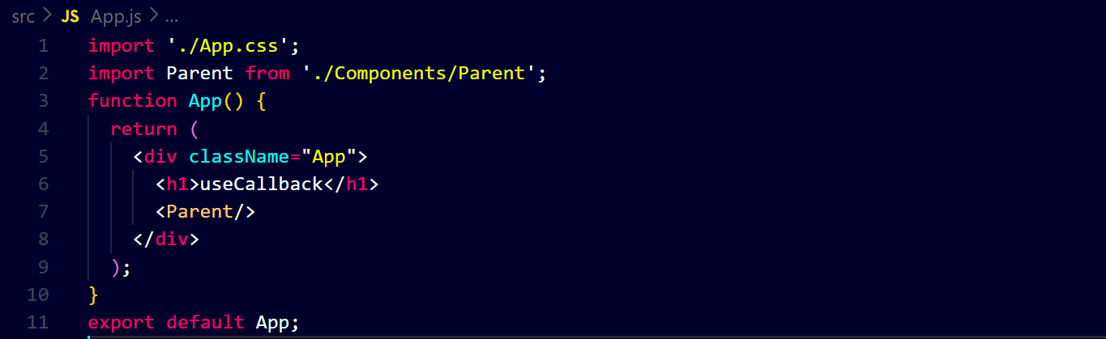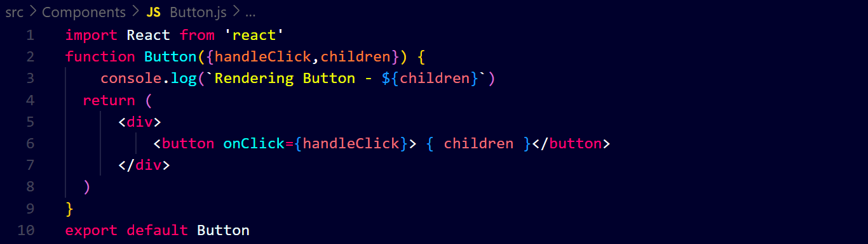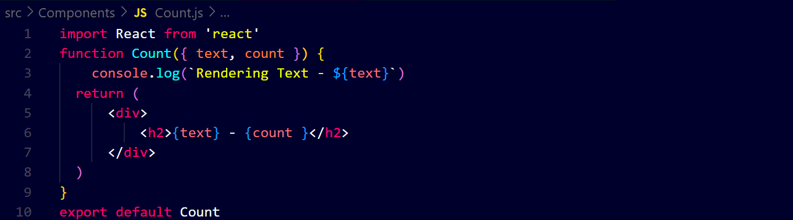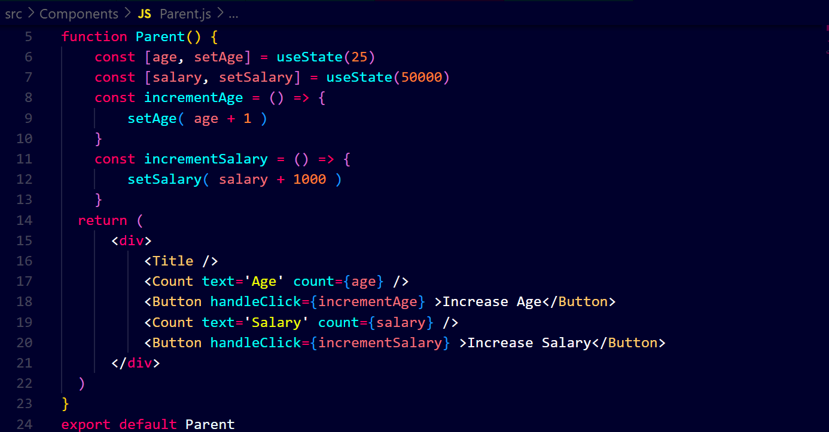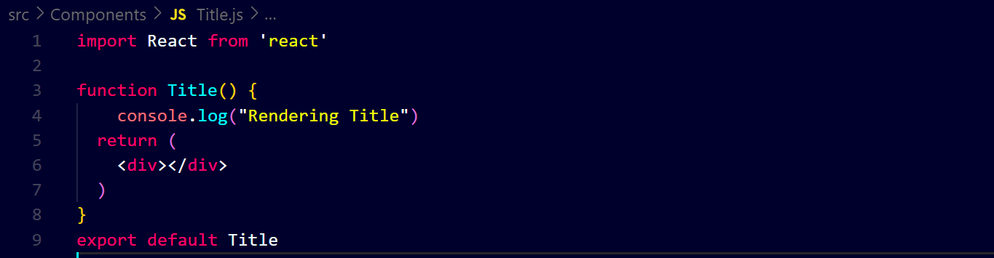**output ↓ 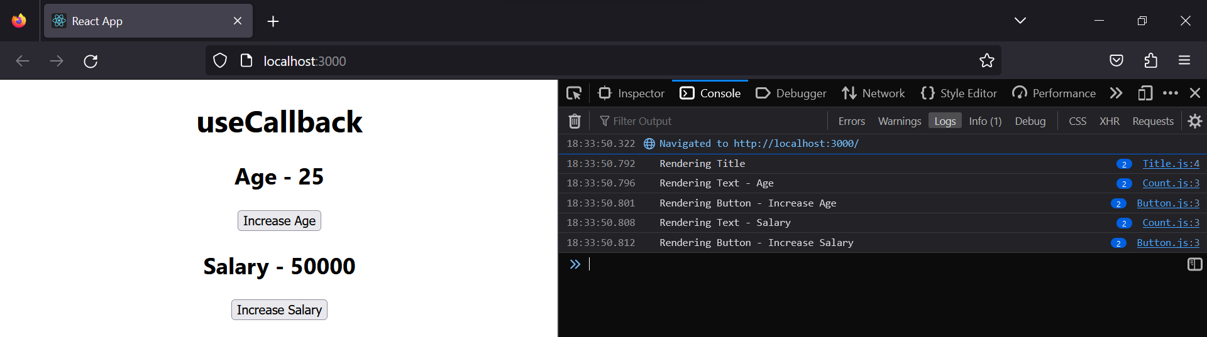after changing the age state ↓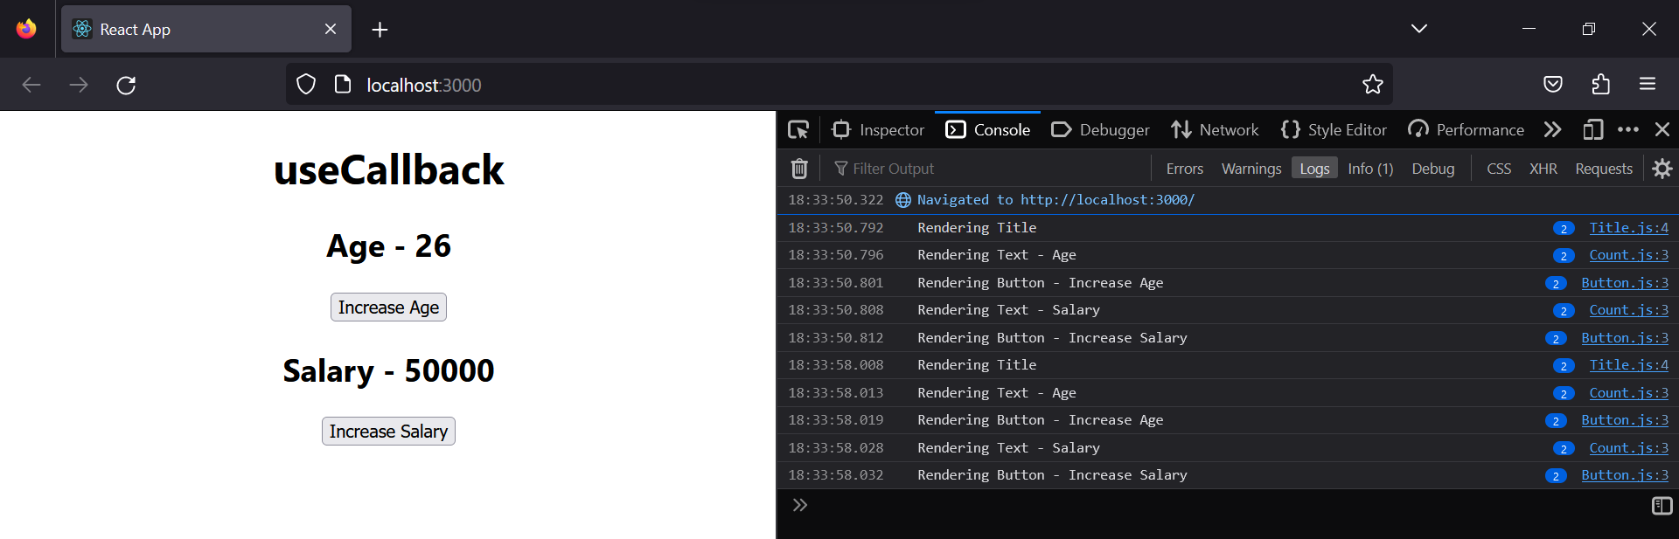 after changing the salary state ↓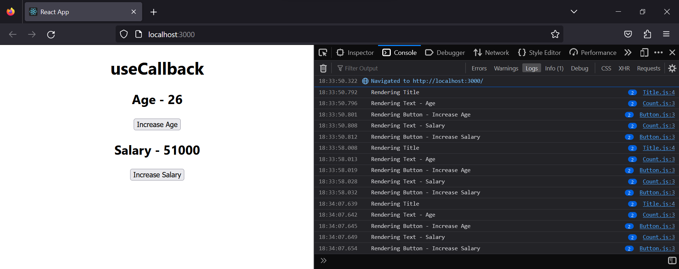you can see that, on changing anyone state, all components are re-rendering**

**We will use “React.memo()” in ‘Button’, ‘Count’ and ‘Title’ components but there is another problem, that is, on updating the age, the new ‘incrementSalary’ function is created and reners similarly it happens with ‘incrementAge’ function on updating salary**

**As you can see ↓**

**On updating age ↓**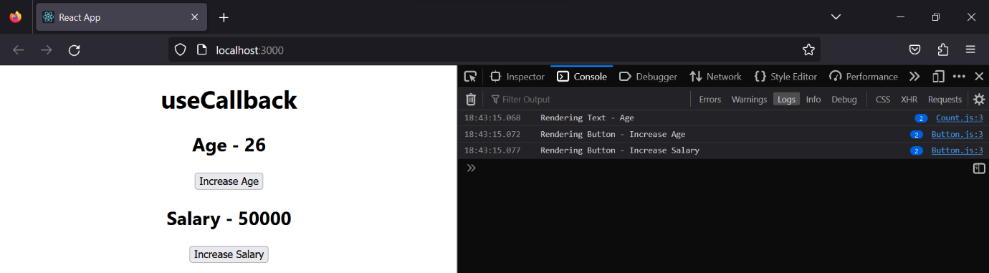

**On updating salary ↓**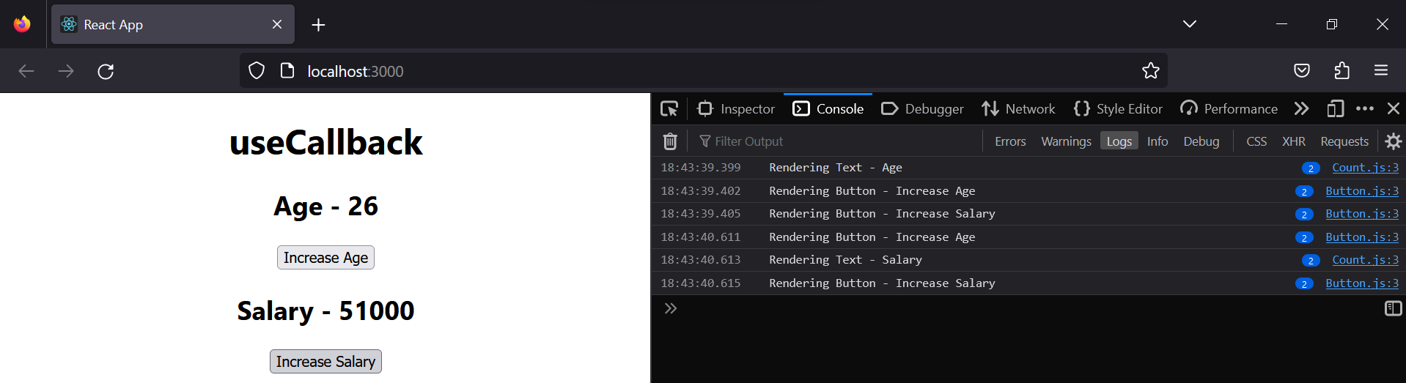

**To resolve it, we use ‘useCallback’ ↓**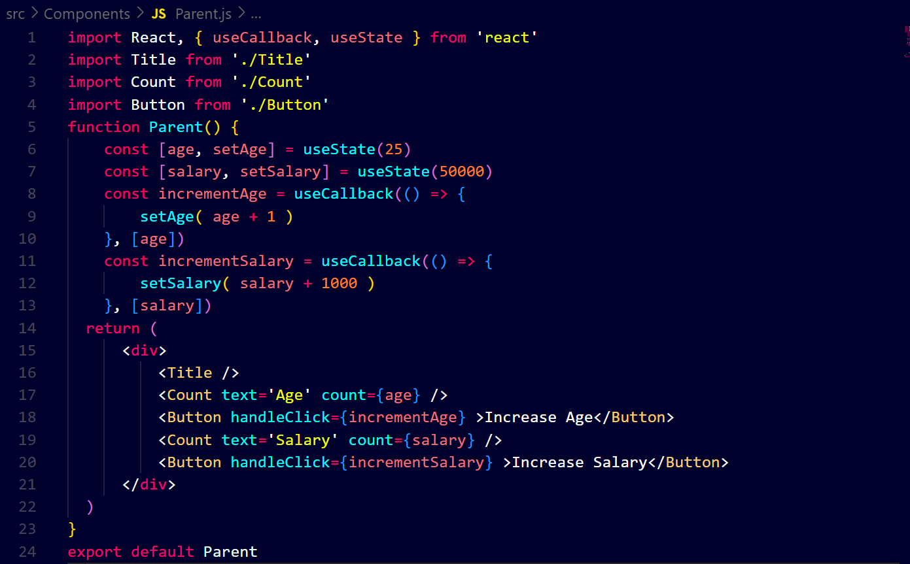

**Output ↓**

**On updating age ↓**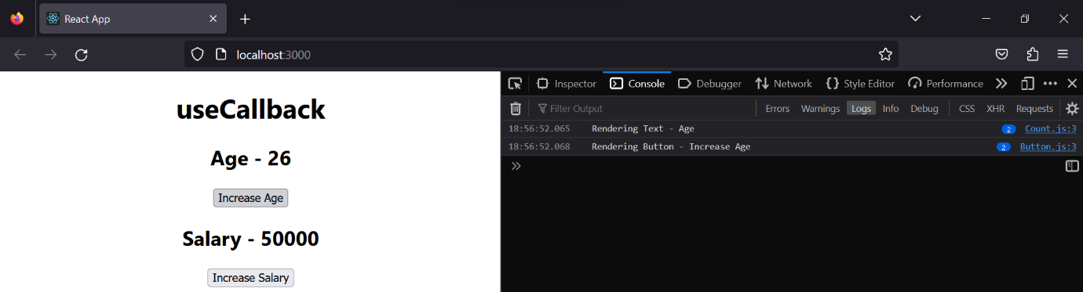

**On updating salary ↓**