**Without using float ↓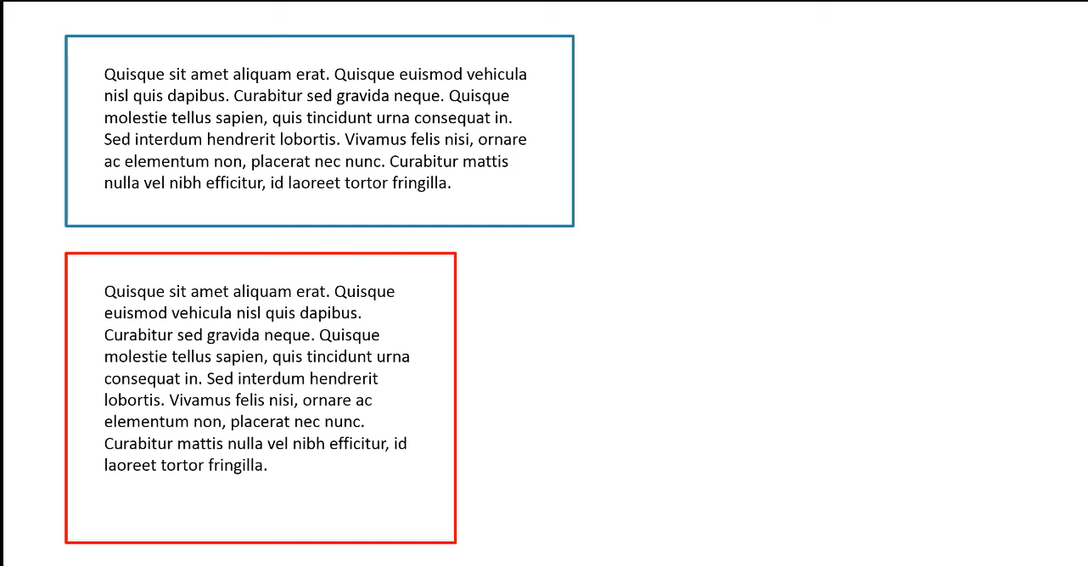using float we can place second div to the right ↓** 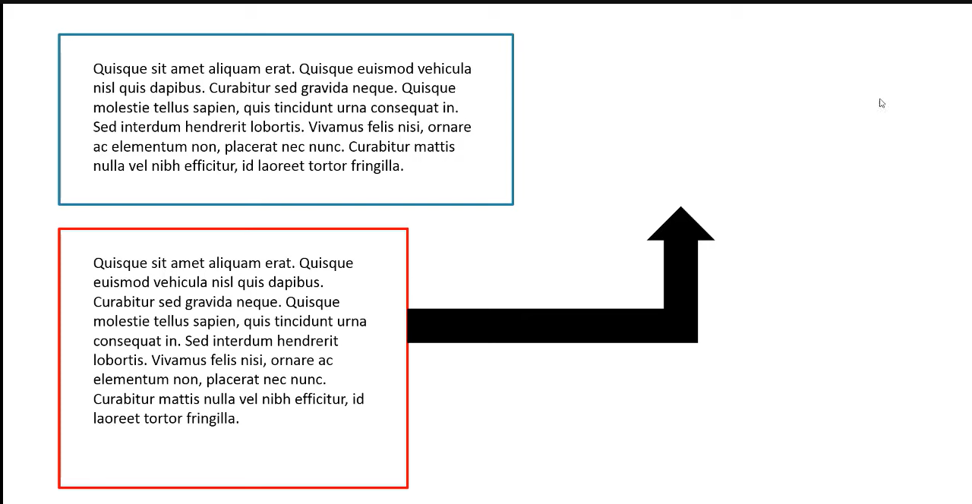

**It has three values:**

**1)left 2)right 3)none, it is by default**