Game Development (CSC495) – Lab 4
Terrain, Character Movement, Skybox & Cinemachine Follow Camera
Course | Game Development (CSC495)
Lab | Lab 4
Instructor | Dr. Syed Faraz Ahmad
Student Name | Syed Zill e haider Abbas
Registration No. | SP24-BSE-081
Submission Date | Sunday, 4 October 2026
Unity Version | Unity 6.3 (6000.3.6f1) – Universal 3D (URP)
GitHub Repository | (paste repository link here)
Scene | Assets/Scenes/SampleScene.unity

Summary
A small playable 3D scene was built in Unity 6. It combines a sculpted and painted Terrain, a Mixamo character that moves with W/A/S/D or the arrow keys, an Animator that switches between Dwarf Idle and Running using a Speed parameter, a procedural Skybox, and a Cinemachine 3 camera that follows the player.

Scene Hierarchy
SampleScene
├── Main Camera (Cinemachine Brain)
├── Directional Light
├── Global Volume
├── Terrain
├── Ch19_nonPBR (Animator + Character Movement)
└── CM_PlayerCamera (Cinemachine Camera)

Part A – Terrain Design
- Terrain created with GameObject → 3D Object → Terrain, resized to 200 × 200 × 100 and centred at the origin (position −100, 0, −100).
- Raise/Lower Terrain used to sculpt a ring of hills along the back and right edges, with valleys between the peaks.
- Smooth Height used to soften sharp peaks and the base of each hill.
- A flat central area kept clear as the player's starting point.
- Two Terrain Layers painted: grass as the base surface and ground/dirt for a branching path that leads from the start area toward the hills.
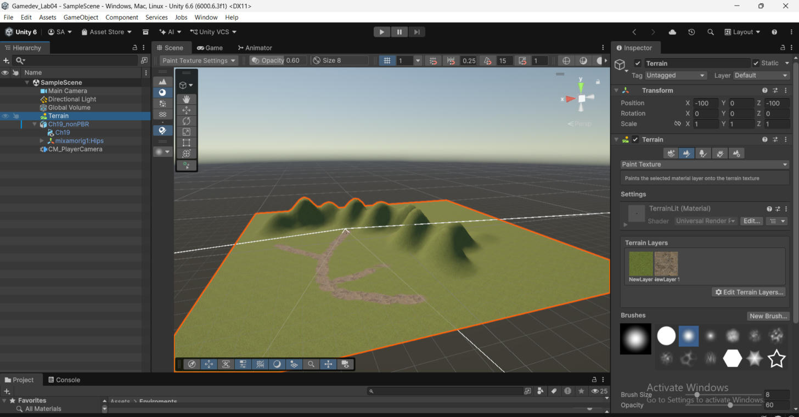
Figure 1 – Terrain overview: sculpted hills, valleys, flat start area and painted dirt path. Inspector shows the two Terrain Layers (grass and dirt).

Part B – Character Movement and Idle/Running Animation

Character and Animator setup
- Character (Ch19_nonPBR) and the Dwarf Idle and Running animations downloaded from Mixamo as FBX for Unity; Running downloaded with "In Place".
- All three FBX files imported with Rig → Humanoid; the animations copy the character's Avatar. Loop Time enabled on both clips.
- Animator Controller player_animator with two states: Dwarf Idle (default) and Running.
- Float parameter Speed. Dwarf Idle → Running when Speed > 0.1; Running → Dwarf Idle when Speed < 0.1.
- Has Exit Time disabled on both transitions; transition duration 0.1 s.
- Apply Root Motion turned OFF on the Animator, because movement is driven by the script.
- Active Input Handling set to Both (Project Settings → Player) so Input.GetAxis works.
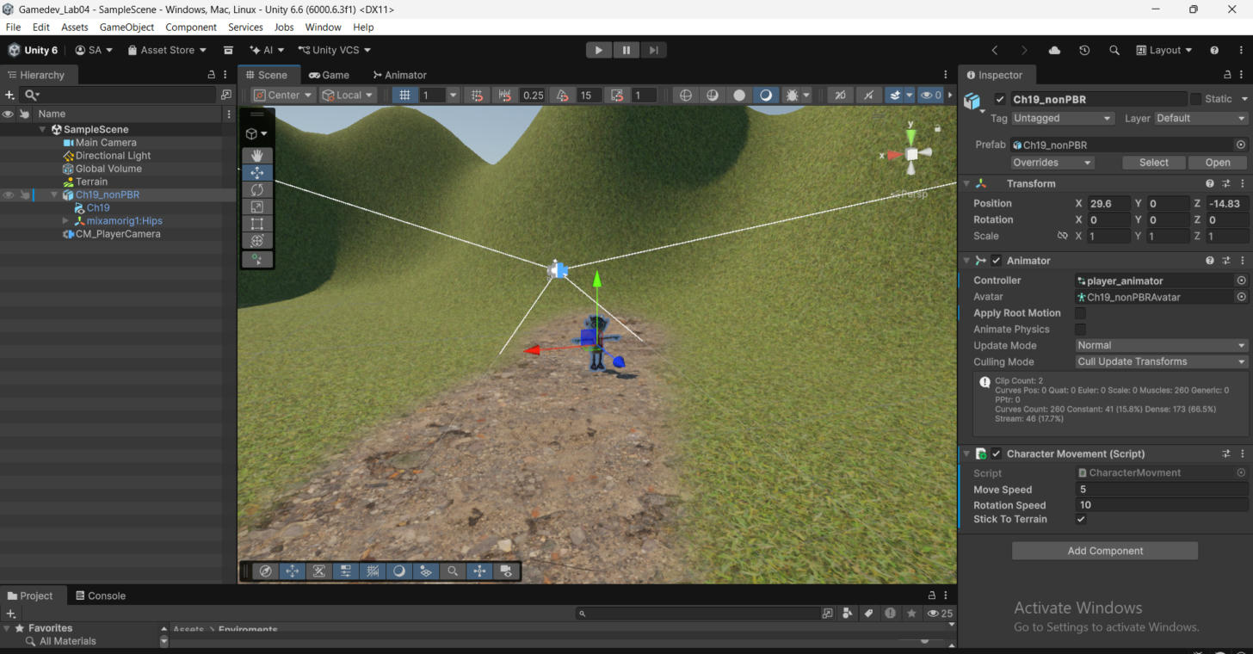
Figure 2 (Screenshot 1) – Scene view and Hierarchy showing the Terrain and the player. Inspector: Animator with player_animator, Apply Root Motion off, and the Character Movement script.
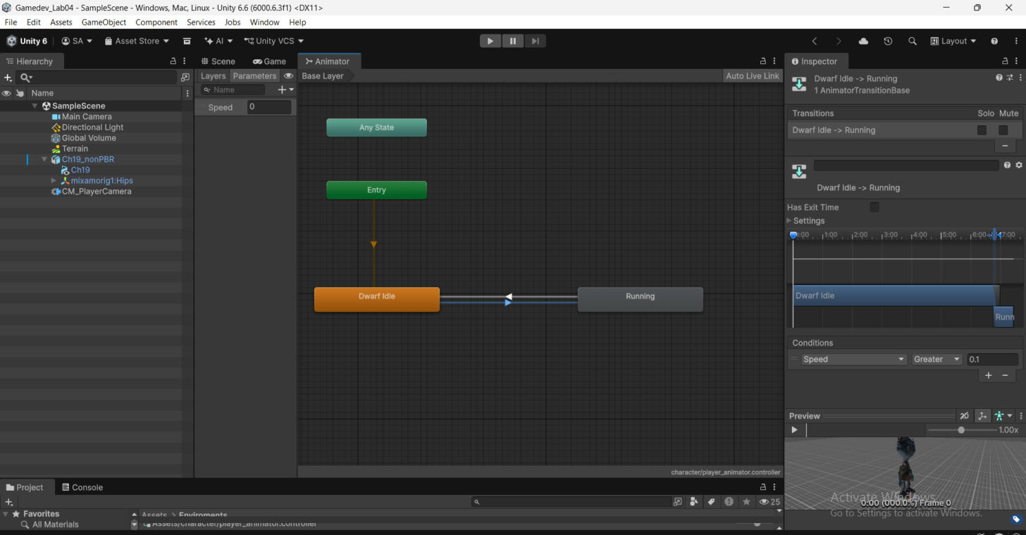
Figure 3 (Screenshot 2a) – Animator: Dwarf Idle → Running, condition Speed Greater 0.1, Has Exit Time off.
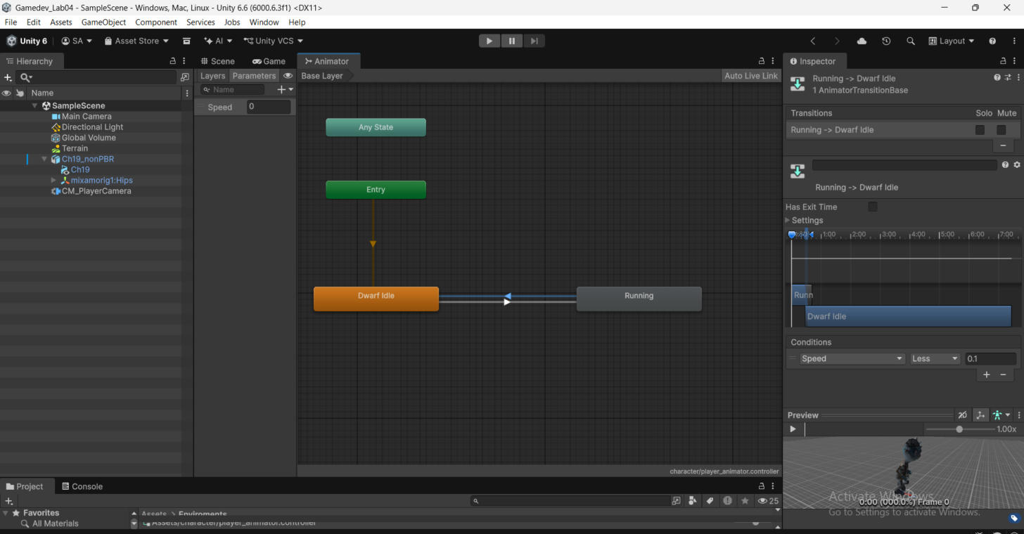
Figure 4 (Screenshot 2b) – Animator: Running → Dwarf Idle, condition Speed Less 0.1, Has Exit Time off.

CharacterMovement.cs
The script reads directional input, converts it into a movement vector, moves and rotates the character toward the movement direction, keeps it on the terrain surface, and sends the movement magnitude to the Animator:
using UnityEngine;
public class CharacterMovement : MonoBehaviour
{
public float moveSpeed = 5f; // how fast the character walks
public float rotationSpeed = 10f; // how fast it turns toward movement
public bool stickToTerrain = true; // keep feet on hills/valleys
private Animator animator;
void Start()
{
animator = GetComponent<Animator>();
}
void Update()
{
// 1. Read directional input (W/A/S/D or Arrow keys)
float horizontal = Input.GetAxis("Horizontal");
float vertical = Input.GetAxis("Vertical");
// 2. Convert input into a movement direction
Vector3 movement = new Vector3(horizontal, 0f, vertical);
movement = Vector3.ClampMagnitude(movement, 1f); // no faster diagonals
// 3. Move and rotate the character
if (movement.magnitude > 0.1f)
{
transform.position += movement * moveSpeed * Time.deltaTime;
Quaternion targetRotation = Quaternion.LookRotation(movement);
transform.rotation = Quaternion.Slerp(transform.rotation,
targetRotation,
rotationSpeed * Time.deltaTime);
}
// 4. Keep the character standing on the terrain surface
if (stickToTerrain && Terrain.activeTerrain != null)
{
Vector3 pos = transform.position;
pos.y = Terrain.activeTerrain.SampleHeight(pos)
+ Terrain.activeTerrain.transform.position.y;
transform.position = pos;
}
// 5. Update the Animator (Idle <-> Running)
animator.SetFloat("Speed", movement.magnitude);
}
}

Movement test
Input | Movement | Animation
W / Up | Forward | Running
S / Down | Backward | Running
A / Left | Left | Running
D / Right | Right | Running
Release | Stop | Dwarf Idle

Part C – Skybox
- Material Skybox_Mat created in Assets/Enviroments with the Skybox/Procedural shader.
- Settings: Sun = High Quality, Sun Size 0.04, Atmosphere Thickness 1.2, Sky Tint neutral grey (808080), Ground dark grey-brown (3D3A36), Exposure 1.3.
- Assigned in Window → Rendering → Lighting → Environment → Skybox Material.
- Directional Light set as the Sun Source and rotated to X = 50° so the sun and shadows match the sky.
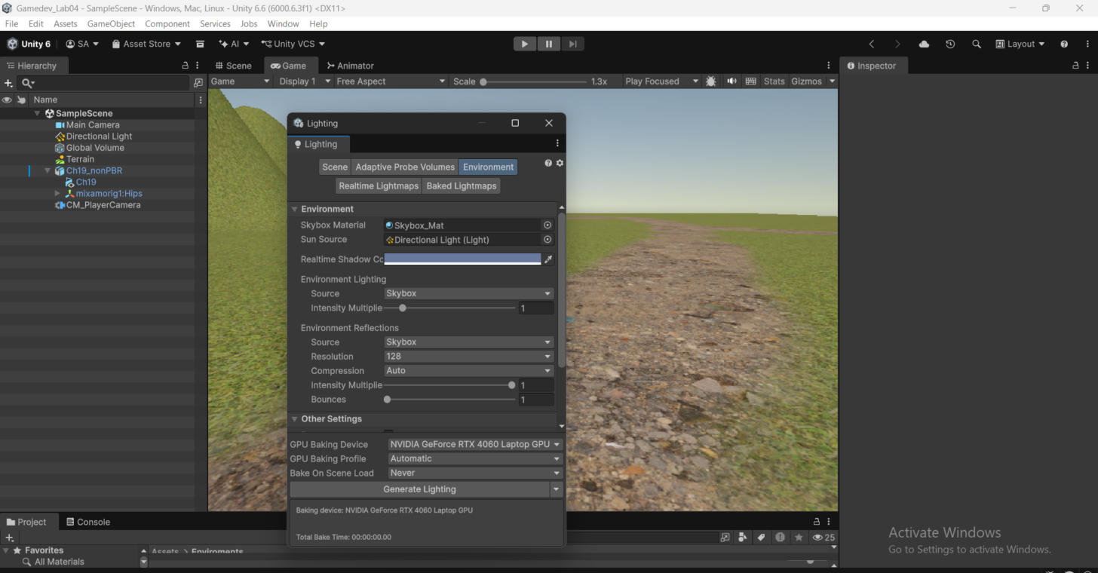
Figure 5 – Lighting → Environment: Skybox Material = Skybox_Mat, Sun Source = Directional Light. The Game view behind shows the new sky.

Part D – Cinemachine Follow Camera
- Cinemachine 3.x installed from the Package Manager (Unity Registry).
- CM_PlayerCamera created with GameObject → Cinemachine → Cinemachine Camera; the Main Camera received a Cinemachine Brain.
- Tracking Target = Ch19_nonPBR.
- Position Control = Follow, Binding Mode = World Space, Follow Offset (0, 2.5, −5), Position Damping (1, 1, 1) for a smooth follow.
- Rotation Control = Rotation Composer, so the camera keeps the player framed.
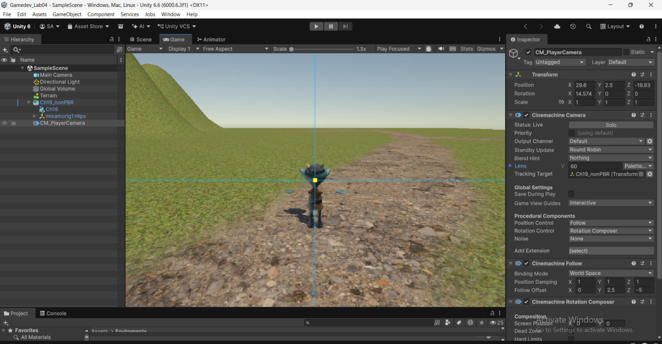
Figure 6 – CM_PlayerCamera Inspector: Tracking Target, Follow position control with offset and damping, and Rotation Composer.
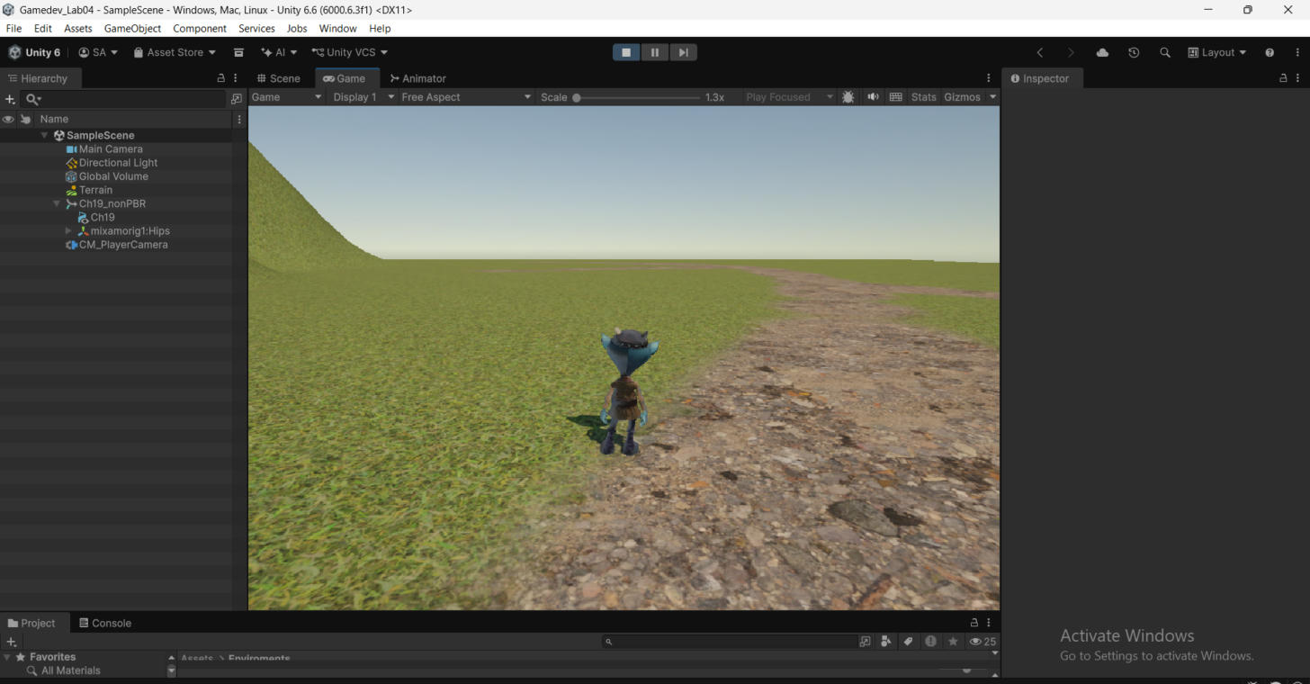
Figure 7 (Screenshot 3) – Game view in Play mode: the follow camera behind the player on the terrain path, with the hills and Skybox visible.

Part E – Final Integration Checklist
Check | Status
Terrain has meaningful height/shape variation | ✔ Done
Character starts on the Terrain | ✔ Done
W/A/S/D or arrow keys move the character | ✔ Done
Character rotates toward movement | ✔ Done
Running plays while moving | ✔ Done
Idle returns when movement stops | ✔ Done
Skybox is visible | ✔ Done
Cinemachine follows the player | ✔ Done
No critical lab-related Console errors remain | ✔ Done
Scene is saved | ✔ Done

