## 1. Overview
This document summarises the work completed so far on our Feature Extraction part for a driver drowsiness detection system using CARLA.
We have:
- Implemented data capture within CARLA's 0.9.13 version, keeping the vehicle at 15km/hr constant and only controlling left and right.
- Extracted key features from steering angle and lateral offset.
- Built and evaluated a drowsiness classification pipeline(offline).
- Conducted offline analysis comparing *normal*, *moderate*, and *drowsy* driving states.

## 2. Data Collection
- Recorded 5 minutes of driving data per condition (awake, moderate fatigue, drowsy) across 1 participant.
- Logged CSV fields:
- `timestamp`
- `steering_angle_rad(Carla.VehicleControl.Steer)(which I don’t think so is correct)
- `lateral_offset`
- `lane_id`

## 3. Feature Extraction
Implemented Python scripts to compute:
1. **Steering Metrics**
- Mean, STD, Min, Max, Median
- Skewness, Kurtosis
- Shannon Entropy
- Reversal rate (per minute)
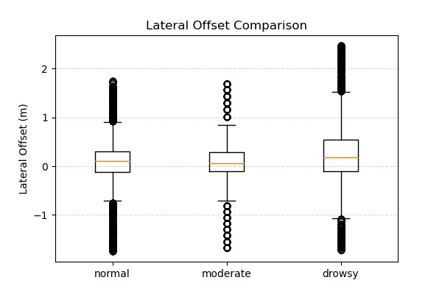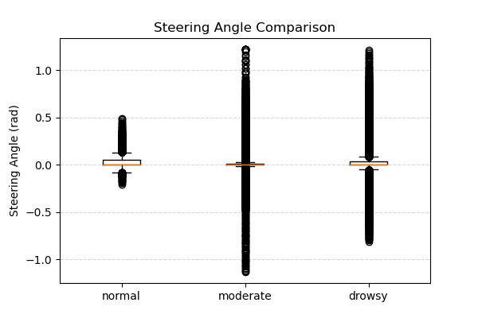
2. **Lateral and Lane Metrics**
- Standard deviation of lateral position (SDLP)
- Lane departure frequency (Hz)
- Lane keeping ratio
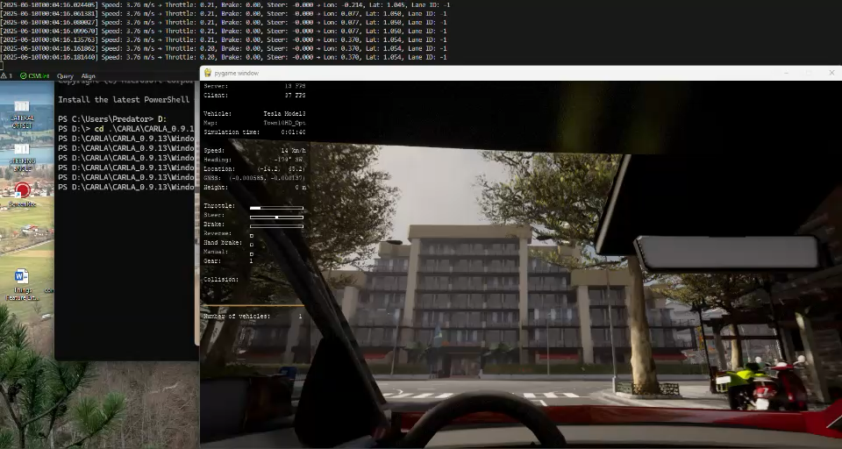
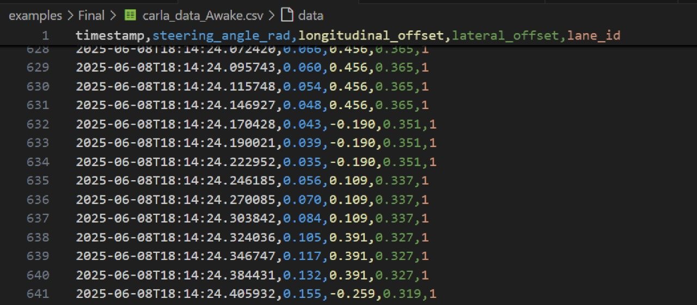

- Sliding‐window extraction (5 s windows) for real‐time feature streams, but done in an offline manner.

4. Offline Analysis
- `drowsiness_analysis.py`:
- Reads CSVs for *normal*, *moderate*, *drowsy* sessions.
- Computes all above features per session.
- Generates comparative boxplots for steering angle and lateral offset.
- Summary CSV exported with rows for each condition.

## 4. Next Steps
1. **Data Expansion**: Collect 10 min per condition for ≥ 10 or 5 drivers.
2. **Model Tuning**: Retrain with a larger dataset, experiment with additional features (i.e. Camera Module)
3. Validating our model is working properly and is able to recognise the driving pattern.

