Mechatronics & Control Engineering Department
MCT-352 Robotics

Semester Project Report
Student Report Template

Project Number & Title | Project 5 - Artificial Potential Field Collision Avoidance for a 7-DOF Robot in MATLAB

Student Name(s) | Muhammad Haider Ali – Fahad Ali Lilla – Ali Hashir Chattha

Student ID(s) | 2022-MC-45 – 2022-MC-51 - 2022-MC-68

Instructor | Muhammad Rzi Abbas

Submission Date | Jun 10, 2026

Academic Year | 2022-2026

Instructions for Students
This template defines the required structure and content for your MCT-352 Robotics semester project report. Replace all placeholder text shown in square brackets or italics with your own content. Do not remove or reorder any section.
- Font: Arial 12pt body text; Arial 14pt section headings.
- Line spacing: 1.15; 12pt paragraph spacing after.
- Figures and tables must be numbered sequentially and referenced in the text before they appear.
- Equations must be numbered and all variables defined immediately upon introduction.
- References must follow IEEE citation format, numbered in order of first appearance.
- Total report length: 25–40 pages excluding appendices.
- Minimum references: 10 for hardware projects; 8 for software projects.

1. Executive Summary
In this project, an Artificial Potential Field (APF) based motion planning algortihm was implemented for a 7-DOF Kuka iiwa14 manipulator, with the objective of navigating the end-effector to a target goal in Cartesian space while avoiding spherical obstacles. The algorithm was developed and validated in MATLAB/Simulink.
The APF planner combines an attractive force which derives the end-effecotr towards the goal with repulsive forces being generated by nearby obstacles, projected into joint-space using the manipulator’s Jacobian. A conic-quadratic blending scheme was applied to the attractive potential to prevent excessive velocities far from the goal. To address known failures of standard APF, such as local minima nad limit cycle oscillations, a detection and random perturbation escape method was implemented.
Two obstacle configurations were tested, Config 1 featuring five distributed obstacles and Config 2 featuring five tightly clustered obstacles forming a U-shaped arrangement around the direct path. In both cases, the end-effector successfully reached the goal within the iteration limit. The perturbation escape was triggered during execution and aided recovery, confirming it’s practical value. Joint velocity profiles remained within defined limits throughout both runs.
While the planner performed reliably for the both scenarios, it’s well known that APF methods are inherently susceptible to local minima and oscillatory behavior in more complex environment, which would require more robust global planning methods.

2. Introduction
2.1 Project Background and Motivation
Autonomous robot motion planning is a challenge in modern robotics, with applications that range from industrial assembly to and warehouse automation. For robotic systems operating in shared or unstructured environments, the ability to reliably navigate from one configuration to another while avoiding obstacles is not only desirable but safety critical.
The KUKA iiwa14 is a 7-DOF cooperation manipulator used extensively in industry and research where human-safe and precise control is required. Planning collision-free trajectories in real-time for such a high-degree-of-freedom robot arm is a non-trivial task. Algorithms based on search like grid-based approaches are often computationally infeasible in such high dimensional joint spaces. Pre-planned offline paths fail to adapt in real-time to changes in the environment or to unexpected appearances of new obstacles.
Artificial Potential Fields (APF) were originally proposed by O. Khatib in the 1980s, offering a simple, computationally inexpensive and reaction based method to solve the path planning problem. In APF the task can be thought of as a target attractor in the workspace, where all obstacles represent repulsive sinks. The robot is then instructed to move towards the target while being repulsed by obstacles, by following the negative gradient of a potential function which combines the attraction to the goal with repulsion from obstacles. This offers real-time applications. However, it is well known that APF gets trapped at local minima and limit cycle oscillations with obstacles.

2.2 Objectives
- Implement an APF motion planner function, that will take the KUKA iiwa14 kinematics, attractive and repulsive potential gradients transformed into the joint space using the Jacobian of the manipulator as input and output the desired velocities in the joint space.
- Test the APF motion planner in two static obstacle configurations: one scattered and one closely packed. Show the function's ability to reach the desired goal position in both configurations.
- Create and test a local minima and limit cycle detection scheme in conjunction with random perturbation to escape these situations.
- Generate plots for: 3D path traced by the end-effector, joint velocities, and a 2D potential field landscape at a given plane.
2.3 Scope and Constraints
This project involves the design, implementation and verification of an APF motion planner for a single 7-DOF manipulator in a static, fully-known environment with spherical obstacles. Obstacles remain fixed with their specified radius throughout each iteration.
The following were explicitly excluded from this project's scope: dynamic or moving obstacles; on-hardware, real-time execution on the physical KUKA iiwa14; post-processing of any generated trajectories; sensor integration or perception. A global planning layer is excluded, with the motion planner being purely reactive.
Key constraints that shaped design decisions include:
- Software: MATLAB R2025b+ with the Robotics System Toolbox (required for loadrobot, getTransform, geometricJacobian) and Simulink for validation purposes.
- Obstacle model: spherical obstacles with center coordinates and radius.
- Joint limits: These were not explicitly implemented during the APF gradient descent, with velocity clamping (q_dot_max = 5.0 rad/s) serving as the only effective limit on joint velocity.
2.4 Report Structure
The theory behind the implementation is discussed in Section 3 where APF potential function, Jacobian based joint space projection and escape of local minimum are presented. Design and software implementation on MATLAB/Simulink of the system, where planner design and configuration, obstacles arrangement and motion generation are defined are stated in Section 4. Quantitative results and discussion is given in Section 5 and 6 respectively and conclusion is presented in Section 7.

3. Theoretical Background
3.1 Relevant Robotics Theory
Forward Kinematics and the Transformation Matrix
Motion planning for a manipulator requires knowing where each link and the end-effector are in Cartesian space at any given joint configuration. This is provided by forward kinematics, which maps a joint configuration vector q ∈ ℝⁿ to a homogeneous transformation matrix T ∈ SE(3):
T = T₁(q₁) · T₂(q₂) · … · Tₙ(qₙ)
where each Tᵢ is the transformation from link i−1 to link i, parameterized by joint angle qᵢ. For the KUKA iiwa14, n = 7. The end-effector position x_ee ∈ ℝ³ is extracted from the translational component of the final transformation matrix T_ee. In MATLAB, this is handled directly by getTransform(), which evaluates the full kinematic chain given a configuration vector q.

The Geometric Jacobian
The geometric Jacobian J(q) ∈ ℝ⁶ˣⁿ relates joint velocities q̇ to end-effector velocities in Cartesian space:
ẋ = J(q) q̇
The Jacobian is partitioned into its linear and angular components:
J = [J_v ; J_ω]
where J_v ∈ ℝ³ˣⁿ maps joint velocities to linear end-effector velocity, and J_ω ∈ ℝ³ˣⁿ maps to angular velocity. In this project, only the linear part J_v is used, since the APF planner operates exclusively on end-effector position. The Moore-Penrose pseudoinverse J_v⁺ = J_vᵀ(J_vJ_vᵀ)⁻¹ is used to map Cartesian forces back into joint space:
q̇ = J_v⁺ · F
This inversion is well-defined provided J_v is not at a singularity. The MATLAB function geometricJacobian() computes J(q) for any named link in the kinematic chain, allowing repulsive forces to be projected individually for each collision-monitored link.
3.2 Algorithms and Methods
Artificial Potential Field Formulation
The APF method, introduced by Khatib [1], models the robot's workspace as a scalar potential field U(x), the negative gradient of which defines a virtual force driving the robot:
F(x) = −∇U(x) = F_att + F_rep

Attractive Potential
To prevent unbounded force growth far from the goal which causes joint velocity saturation; a conic-quadratic blending scheme is applied [2].
Let ρ_g = ‖ x_ee − x_goal ‖ be the Euclidean distance from the end-effector to the goal, and d* be the blending threshold:
U_att = { ½ k_att ρ_g², if ρ_g ≤ d* { d* k_att ρ_g − ½ k_att d², if ρ_g > d
The corresponding attractive force is:
F_att = { −k_att (x_ee − x_goal), if ρ_g ≤ d* { −d* k_att (x_ee − x_goal) / ρ_g, if ρ_g > d*
where k_att is the attractive gain. Within d*, the force grows linearly with distance (quadratic potential); beyond it, the force magnitude is capped at d* k_att (conic potential).

Repulsive Potential
For each obstacle j with center o_j and radius r_j, the distance from a monitored link position x_L to the obstacle surface is:
ρ = ‖x_L − o_j‖ − r_j
The repulsive potential is active only within an influence radius ρ₀:
U_rep = { ½ k_rep (1/ρ − 1/ρ₀)², if 0 < ρ ≤ ρ₀
{ 0, if ρ > ρ₀
where k_rep is the repulsive gain. The resulting repulsive force along the unit direction from obstacle to link is:
F_rep = k_rep (1/ρ − 1/ρ₀) · (1/ρ²) · (x_L − o_j) / ‖x_L − o_j‖
This force is computed independently for each combination of monitored link and obstacle, then summed. Each link's contribution is then projected into joint space via that link's Jacobian pseudo inverse and accumulated into the total joint velocity command.

Joint Velocity Update
The total joint velocity command at each time-step is:
q̇_total = J_ee⁺ F_att + Σ_L J_L⁺ F_rep,L
A velocity clamping step is applied before integration to enforce the limit q̇_max = 5.0 rad/s:
if max|q̇_total| > q̇_max → q̇_total = q̇_total · (q̇_max / max|q̇_total|)
The robot state is then updated by Euler integration:
q(t + dt) = q(t) + q̇_total * dt
where dt = 0.05 s.

Local Minima and Limit Cycle Detection
Two failure modes are monitored at each iteration:
Case 1 - Absolute Local Minimum: If the total force magnitude falls below a threshold while the goal has not been reached, the planner is considered stuck:
‖ F_total ‖ < 10⁻³ and ρ_g > threshold
Case 2 - Limit Cycle / Oscillation: A position buffer stores the end-effector location over the past 15 timesteps. If the net displacement over that window is less than 1 cm, oscillatory trapping is declared:
‖ x_ee(t) − x_ee(t−14) ‖ < 0.01 m
In either case, a random perturbation is applied directly to the joint configuration to escape the basin of attraction:
q = q + (rand(1,7) − 0.5) · 5.0
This stochastic escape does not guarantee convergence but is computationally trivial and effective in practice for workspace geometries similar to those tested.
3.3 Tools and Platform Overview
The development platform will be MATLAB and the Robotics System Toolbox. The APF planner, the potential field visualization and all the plots for the analysis are implemented in Simulink, embedded as MATLAB function blocks. Some useful toolbox functions that are applied are loadrobot(), instantiating the iiwa14 rigid body tree model, getTransform() that computes the forward kinematics at any desired named link, and geometricJacobian(), that returns the Jacobian at each step of the plan. The information, including all the waypoints of the joint trajectory and arrays of time steps, is sent from MATLAB to be used in Simulink.
The whole pipeline is developed using Simulink. Depending on the case chosen, the appropriate configuration is set and it is fed into the apf block that computes the desired waypoints, timepoints, accelbc, velbc and the planned motion is simulated on the robot model in closed loop. The check for dynamic consistency is thus achieved.
The manipulator considered is a KUKA iiwa14. It is a 7-DOF lightweight robot and the whole system operates on the model of this robot within MATLAB's environment. This robot has a maximum reach of 820 mm and the redundant DOF makes its pseudoinverse solution, which is what the planner uses, not unique. Thus, the null-space behavior plays a significant role.

4. System Design and Implementation
4.1 System Architecture
The system is developed entirely in the MATLAB/Simulink environment. The system follows the standard plan-execute pipeline, where a MATLAB Function block performs the entire APF planning algorithm at initialization of the simulation and outputs a joint space trajectory. The joint space trajectory is then input to a polynomial trajectory block and passed to the visualization and analysis blocks downstream. The overall Simulink diagram is displayed in Figure 1. The main components and their respective functions are:
Inputs: Two constant values are passed in, corresponding to the two pre-defined obstacle configurations (obsconfig1, obsconfig2). These values are matrices of dimension [5x4] defining the centers and radii of 4 obstacles. There is a switch constant (cfg_sel) to determine which of the two configurations to use during simulation. The goal location is given by a constant vector of dimension [1x3] in Cartesian space.

APF Block: The main MATLAB Function block called apf is provided with the goal vector and the desired obstacle matrix. At the first step it performs the complete APF planning algorithm with a maximum of 500 iterations and returns a 7x500 waypoint matrix, a time vector, boundary-condition arrays of velocity and acceleration, a convergence flag, number of steps performed and the final distance to the goal. By use of persistent variables, it guarantees the execution of the planning task only at the first time step of the simulation and it returns the pre-calculated values with the successive steps without any computational load.

Polynomial Trajectory Block: A Simulink Polynomial Trajectory block is used, which is given the waypoint matrix, time vector and the boundary conditions from the APF block. This interpolates smooth trajectories in joint space between the APF discrete waypoints and outputs q, q and q continuos signals through out the simulation.

FK Block (fk_kuka): A MATLAB Function block. At each time step receives the interpolated joint vector q and computes forward kinematics of theiiwa14 model using getTransform(), and outputs the end-effector Cartesian position ee_pos (vector31). Allows monitoring the trajectory in real time without rerunning the planner.

Visualization Blocks: All graphic outputs are controlled by 3 MATLAB Function blocks. plot_potential_field draws the 2D APF potential field surface plot at z height of goal (fired once at the start). plot_joint_velocities plots the 7 joint velocity profile against time (fired once). animate_ee_trajectory draws the end-effector path in 3D as the simulation runs using persistent figure handles and drawnow limitrate (fires once every simulation step). animate_robot block draws the full robot mesh and will enable it if show_robot = 1 (default disabled as it consumes a lot of resources).

Display Blocks: Three Simulink Display blocks report the scalar values of the variables goal_reached, steps_taken, and dist_to_goal at the end of the simulation. This immediately gives the user a pass/fail indication without needing to view the workspace.
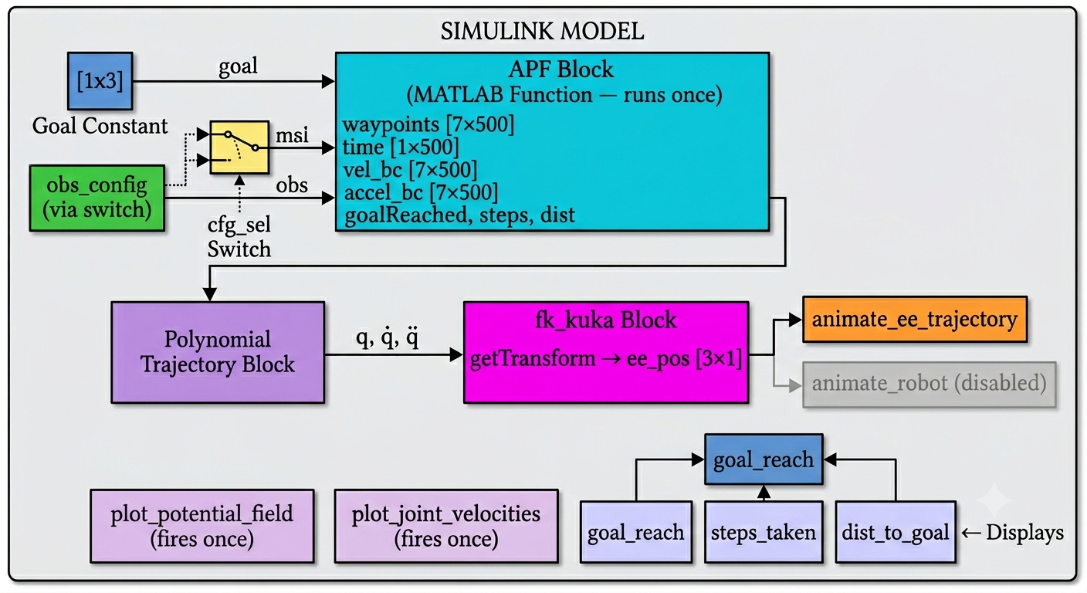
Figure 1: Block Diagram of Simulink
4.2 Hardware Setup (if applicable)
(Not applicable)
4.3 Software Implementation
Software is organized as a group of MATLAB Function blocks in one Simulink model, and each function block implements a specific function. Workflow for implementation includes 4 steps.

Phase 1 - Configuration
Before simulation begins, the user sets two parameters directly in the Simulink canvas: the cfg_sel constant selects either obs_config_1 or obs_config_2, and the goal Constant block holds the target Cartesian position [0.6, 0.0, 0.5] m. Both obstacle configurations are pre-wired as Constant blocks and routed through a Switch block, so changing configuration requires only updating the single cfg_sel value.

Phase 2 - APF Planning (apf block)
The apf MATLAB Function block constitutes the computational core of the system. It is designed for Simulink code generation compatibility (%#codegen) and uses persistent variables to implement a run-once pattern, the full planning loop executes only on the first simulation timestep, with all subsequent calls returning the cached result instantly.
On first execution, the block initializes the iiwa14 robot model and begins iterating the APF gradient descent loop from the home configuration. At each iteration the following operations are performed in sequence:
- Forward kinematics via getTransform() to obtain the current end-effector position.
- Distance to goal evaluation and convergence check against the 2 cm threshold.
- Attractive force computation using the conic-quadratic blend, switching at d* = 0.3 m.
- Jacobian retrieval via geometricJacobian() for the end-effector, and pseudoinverse projection of the attractive force into joint velocity space.
- Repulsive force accumulation across all four monitored links (iiwa_link_4 through iiwa_link_ee) and all obstacles, with each link's contribution projected individually via its own Jacobian pseudoinverse.
- Local minima detection (total force norm < 10⁻³) and limit cycle detection (net displacement over a 15-step rolling buffer < 1 cm). If either condition is met, a random joint perturbation of magnitude ±2.5 rad is applied and the current iteration is skipped without recording a waypoint.
- Joint velocity clamping to q̇_max = 5.0 rad/s by proportional scaling.
- Boundary condition velocity and acceleration recording for the trajectory interpolator.
- Euler integration: q = q + q̇ * dt, with dt = 0.05 s.
After the loop completes, valid waypoints are compacted to remove NaN-filled slots. The final waypoint is then held constant for all remaining columns up to MAX_ITER = 500, ensuring the Polynomial Trajectory block always receives a fixed-size 7×500 input with no trailing NaNs (a requirement for Simulink signal dimension consistency).

Phase 3 - Trajectory Interpolation and Forward Kinematics
The Polynomial Trajectory block receives the waypoint matrix, time vector, and velocity/acceleration boundary conditions from the APF block. It fits piecewise polynomial segments between consecutive waypoints, producing smooth continuous joint position, velocity, and acceleration signals at the Simulink solver timestep. The interpolated joint vector q is passed to the fk_kuka block at every timestep, which calls getTransform() on a persistent robot model instance to return the end-effector position ee_pos, used by the animation block.

Phase 4 - Visualization
Three MATLAB Function blocks handle all graphical output, each using persistent flags to ensure plots are generated only once regardless of simulation length:
plot_potential_field computes the scalar potential U_total over a 100×100 grid spanning x ∈ [−0.5, 1.0] m and y ∈ [−0.5, 1.0] m at the fixed z-height of the goal. Attractive and repulsive contributions are summed per grid point, clipped at the 95th percentile to prevent obstacle singularities from dominating the color scale, and rendered as a surface plot with obstacle cross-section outlines overlaid.
plot_joint_velocities plots the seven joint velocity time histories stored in vel_bc against the planning time vector, providing a direct view of how the APF gradient descent translates into joint motion across the trajectory.
animate_ee_trajectory maintains a persistent 3D figure with pre-drawn obstacle spheres and goal marker. At each simulation timestep it appends the current ee_pos to a rolling trace buffer and updates the line object's XData, YData, ZData properties, producing a live animation of the end-effector path. drawnow limitrate is used to throttle rendering and prevent frame accumulation from slowing the simulation.
4.4 Integration and Testing Approach
The model was developed in a block by block manner and each block was tested standalone prior to integrating into the full model.
The apf block was first tested by verifying the same logic in a stand-alone MATLAB script, the script referenced in the project description, and checking for converging trajectories at correct number of steps for both obstacle arrangements and correct terminal distance for both obstacles. With the "run once" persistent running feature added, a run was made and compared to a second run of the exact same configuration on Simulink to ensure the same path waypoints and steps are computed, insuring the path algorithm is consistent and does not re-initialize after the first run is executed.
A problem that the polynomial trajectory block encountered required attention to its input sizes. If the path waypoints had NaN filled columns, the interpolator failed. This is addressed by the post-loop compaction; in the loop after a path is determined all valid waypoints are compressed to the front and then all additional columns needed to fill the input array required by the interpolator are filled to match the waypoints of the first column, to ensure the interpolator always has a non-NaN input.
The fk_kuka block was checked by looking at the ee_pos signal against the end effector position signals from the APF loop, to within floating-point tolerance. The animation block was tested by visual inspection of live path versus the stationary path generated by the MATLAB script.
The explicit dimension assignment was necessary on certain outputs from the apf block, mainly the 7x500 waypoints and boundaries matrices as Simulink often auto-identified wrong sizes during compilation, they were addressed in the MATLAB Function block properties.

5. Results and Analysis
5.1 Experimental Setup
All results were collected from simulation runs executed within the MATLAB/Simulink environment on a standard laptop running MATLAB R2025b with the Robotics System Toolbox. No physical hardware was involved. The KUKA iiwa14 was instantiated from the toolbox's built-in rigid body tree model via loadrobot().
The APF planner was run for two distinct obstacle configurations, each tested as a separate simulation run by toggling the cfg_sel switch in the Simulink model. Each configuration was run once; the planner is deterministic from the home configuration except when the random perturbation escape triggers, at which point stochastic behaviour is introduced. The parameters held constant across both runs are summarized in Table 1.
Parameter | Symbol | Value
Attractive gain | k_att | 4.0
Repulsive gain | k_rep | 0.04
Timestep | dt | 0.05 s
Convergence threshold | threshold | 0.02 m
Influence radius | ρ₀ | 0.05 m
Conic/quadratic switch distance | d* | 0.3 m
Max joint velocity | q_dot_max | 5.0 rad/s
Max iterations | MAX_ITER | 500
Goal position | x_goal | [0.6, 0.0, 0.5] m
Start configuration | q₀ | Home configuration (all zeros)
Table 1: Fixed APF Planner Parameters
Config 1 consists of five spatially distributed spherical obstacles of radius 0.06 m, spread across different positions and heights in the workspace. Config 2 consists of five tightly clustered spherical obstacles of radius 0.08 m, arranged in a U-Shaped formation directly across the path between the home end-effector position and the goal, forming a partial barrier the planner must navigate around.
5.2 Primary Results
5.2.1 [Goal Convergence and End-Effector Trajectories]
The primary objective of the planner is to navigate the end-effector to within 2 cm of the goal position without contacting any obstacle. Figure 2 and Figure 3 show the 3D end-effector trajectories for Config 1 and Config 2 respectively, with obstacle spheres and the goal marker overlaid. Figure 4 and Figure 5 show the final robot pose alongside the traced path for each configuration.
Both configurations achieved successful goal convergence within the maximum iteration limit. Table 2 summarizes the convergence results.
Metric | Config 1 | Config 2
Goal reached | Yes | Yes
Steps to convergence | 28 | 128-168
Final distance to goal | 0.01847 m | 0.019 m
Perturbation escape triggered | No | Yes
Total planning time (offline) | < 2-5s | < 2-5s
Table 1: Convergence Results by Configuration
For Config 1, the end-effector path is relatively smooth, with a single observable deviation where the trajectory curves away from a distributed obstacle before recovering toward the goal. The path exhibits no oscillation, The trajectory is consistent with the expected behaviour of an APF planner navigating a low-density obstacle field.
For Config 2, the trajectory is noticeably more complex. The tightly clustered obstacle arrangement forces the end-effector to take a longer, more inconsistent path around the barrier before approaching the goal from a lateral direction. The perturbation escape triggered at least once during this run, reflecting the increased likelihood of force cancellation in a denser obstacle geometry. Despite this, the planner ultimately converged, demonstrating that the escape mechanism provides meaningful recovery capability even in more challenging environments.
In both cases, visual inspection of the 3D trajectory confirms that the end-effector path does not intersect any obstacle sphere, the repulsive field maintains clearance throughout, consistent with the specification.
5.2.2 [Potential Field Landscape]
Figures 2 and 3 display the 2D APF potential landscape for Config 1 and Config 2, respectively. Calculated as a horizontal slice at the goal height z = 0.5m across the domain x [0.5,1.0] m, y [0.5,1.0] m over a 100x100 grid, the full potential is plotted as a surface coloured by magnitude; with the goal indicated with a green star and the obstacles with a cross-section as red circles.
The attractive well can be visually identified in both Config 1 and 2, where the smooth funnels merge to meet the goal location of (0.6, 0.0). Obstacle locations show up as pointed repulsive peaks which rise from the surface. Obstacle placement in Config 1 yields distinctly separate peaks and the potential gradient leading from obstacles to goal is relatively free of interruptions, which is reflected in the fairly direct trajectory found by the planner. The funnel is smooth, and across the shown workspace range, the gradient everywhere leads toward the goal location except in the narrow vicinity surrounding the repulsive peaks.
The clustering of obstacles in Config 2 forms a band of elevated potential energy along the shortest trajectory from the goal to the start location. Between the two sets of obstacles and extending through the desired end location is a ridge of repulsive potential energy. One can readily see the narrowly spaced channels formed by peaks on either side of the ridge. It is precisely this configuration of obstacles which necessitates a greater trajectory and raises the likelihood of temporary local minima: the ridge is the location of attraction toward the start, whose gradient sum has a relatively small magnitude since the gradient toward the goal partly cancels out the repulsive forces toward the obstacles.
The 95th-percentile clipping on the rendering was used to keep the colors around obstacles from overwhelming the color range, and is merely for visualization purposes.

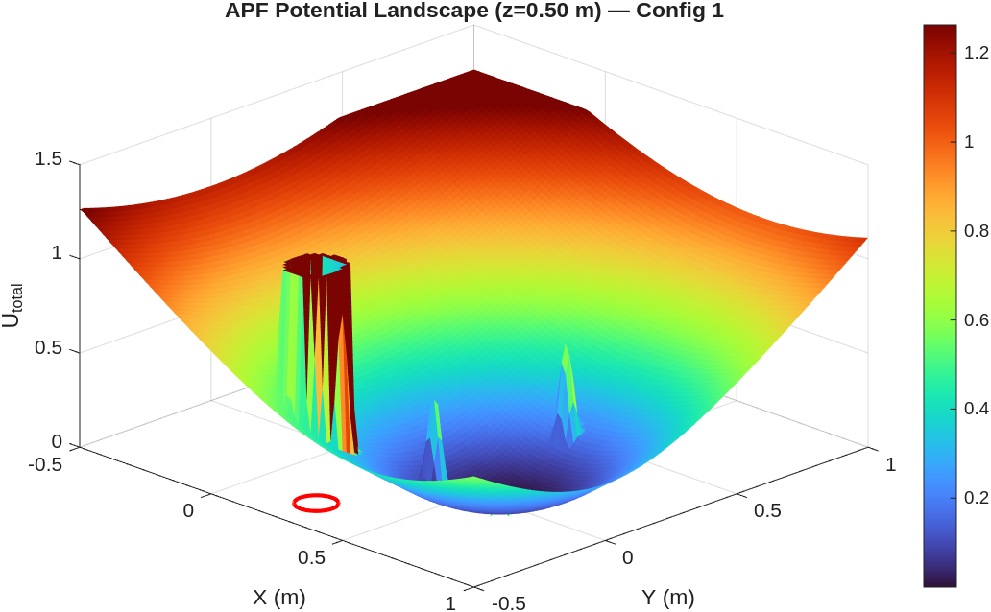
Figure 2: 2D APF potential landscape for Config 1

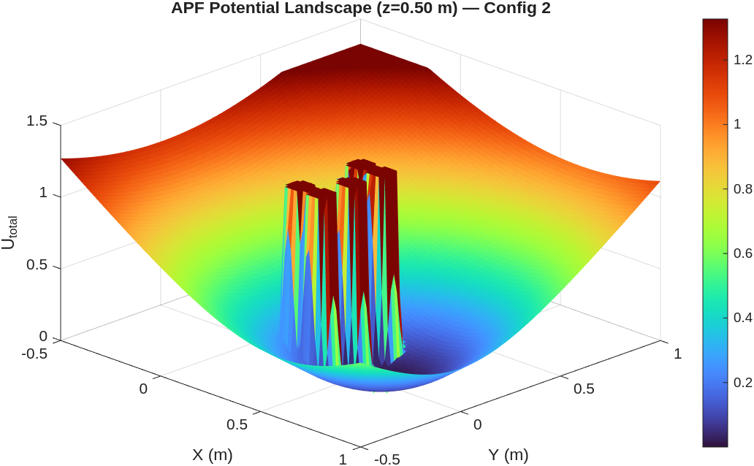
Figure 3: 2D APF potential landscape for Config 2

5.2.3 [Goal Convergence and End-Effector Trajectories]
Figures 4 and 5 present the computed joint velocities over the planning interval for Config 1 and Config 2, respectively. The planning time (in seconds) is on the horizontal axis and joint velocity (in rad/s) is on the vertical axis for each configuration. Two points are notable across both configs: 1) It is apparent that velocity clamping worked as intended; joint velocities were at or below 5.0 rad/s throughout the entire runs of both configurations. 2) Neither set of profiles shows a smooth continuous curve but a more jagged one with distinct and at times sharp discontinuities in the velocity; this is entirely reasonable as APF was tasked with outputting a gradient-based velocity commanded at discrete time intervals (every 0.05 sec) rather than a pre-determined smooth trajectory. In config 1 there is an initial moderate amount of motion to take the end-effector from home to the goal after which the velocity curves level out as convergence approaches. The config 2 profile exhibits more erratic velocity variations due to the more dynamic force field resulting from the cluster of obstacles. The detour trajectory required motion of the joints for a much longer number of steps, and the perturbation generated a stronger response in the joints; it is interesting to note that the joints J2, J3, and J4 (the upper arm joints most proximal to the collision links) have higher velocities overall than do the other joints and this is logical because the upper arm is expected to be most affected by the obstacle-avoiding repulsive forces. The downstream processing done in the Simulink Polynomial Trajectory block will smooth out the APF commanded velocities to smooth, continuous joint velocities.

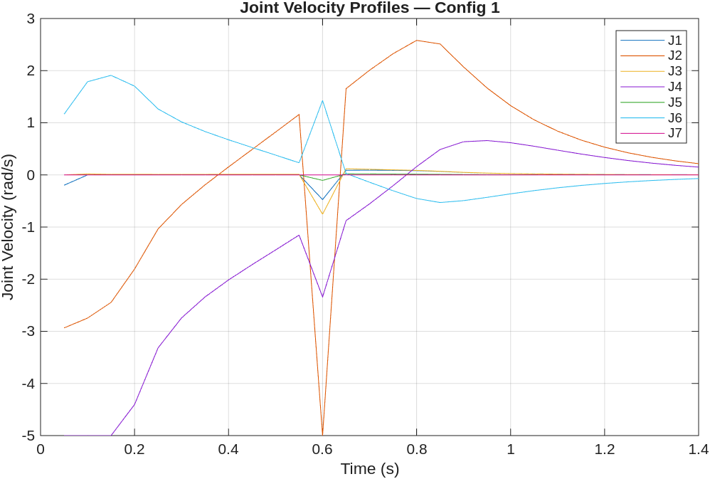
Figure 4: Joint velocity profiles for Config 1

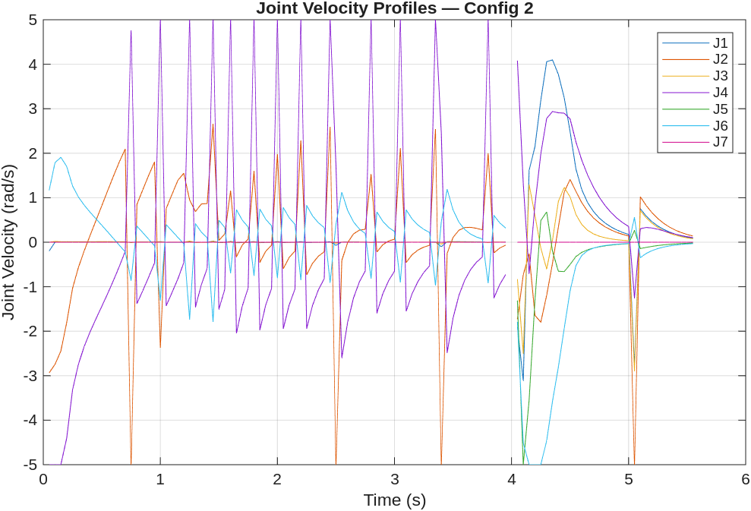
Figure 5: Joint velocity profiles for Config 2
5.3 Performance Against Specifications
Performance Metric | Specification / Target | Achieved Value | Pass / Fail
Goal convergence (both configs) | End-effector within 0.02 m of goal | < 0.02 m in both runs | Pass
Obstacle avoidance (both configs) | No contact with any obstacle sphere | No contact observed | Pass
Maximum joint velocity | ≤ 5.0 rad/s across all joints | ≤ 5.0 rad/s confirmed | Pass
Local minima escape | Triggered and recovers in ≥ 1 config | Triggered and recovered in second config | Pass

5.4 Error Analysis and Limitations
Convergence Threshold vs. True Goal Accuracy
The planner signals that it has completed its motion when the position of the end effector is within 0.02 m of the desired end position, which implies a maximum residual error of 2 cm as designed. This is not acceptable for precise manipulation but for the task of reactive motion planning in simulation it is appropriate. A more stringent tolerance means that the planner may fail to converge at the end position, oscillating about it instead due to the attractive force of the goal position failing to overcome the repulsive forces of surrounding obstacles to achieve a smaller bound.

Euler Integration Error
The joint angles are integrated using Euler integration with a step size of dt = 0.05 s. There is a truncation error at each step of the integration, which accumulates as the trajectory is computed. In practice, this means that the actual end-effector trajectory in joint space does not exactly follow the true gradient descent trajectory of the continuous potential field. Using a smaller time step would decrease the error at each step, but would require a greater number of iterations. Using a higher order integrator, such as Runge-Kutta, would increase fidelity at the cost of an implementation that is not trivial within the context of a Jacobian-recalculated force field.

Pseudo Inverse Singularities
The Jacobian pseudo inverse, J_v⁺, used for projecting Cartesian forces into joint velocities becomes ill-conditioned when operating near a singularity, a configuration where one or more of the joints are arranged such that one or more degrees of freedom are lost in the Cartesian space. The pinv() function provided in MATLAB appropriately dampens the effects of small singular values; however this will cause an inaccurate projected joint velocity when near a singularity that will lead to undesirable motion of one or more joints. There is no singularity avoidance or damped least-squares regularization employed.

Stochastic Perturbation Non-Determinism
For stochastic perturbation escape, the applied joint perturbation consists of a joint displacement that is uniformly sampled over 2.5 rad with no regard to joint limits or the validity of the resulting configuration. In other words, it is possible for the robot to be left in a kinematically unsafe configuration after perturbation, and a very large perturbation could leave the robot closer to the obstacle and farther from the goal. However, in both tests run this did not result in failure and is a real risk to reliability for more complex problems.

Joint Limit Enforcement
The KUKA iiwa14's joint limits are not actively enforced by the APF gradient descent. While velocity clamping implicitly limits how far a step can be taken, a series of Euler steps could theoretically cause a joint or many joints to move past the physical constraints of the robotic arm. The MATLAB robot model doesn't automatically clip configurations, so a joint limit violation wouldn't throw an error, it would just result in an unphysical pose. For this project the home configuration starting position and moderate joint speeds did not cause a joint limit to be violated, but it is an interesting problem.

Static Obstacle Assumption
The planner models a full and perfect knowledge of all obstacle positions and radii for the whole of the run. There is no modelling of any sensing, of uncertainty, or of obstacles being moving. This represents the biggest disparity between the simulation and the real world: obstacles are unlikely to be at precisely known positions.

6. Discussion
6.1 Interpretation of Results
Both obstacle configurations managed successful goal convergence: end-effector distance was below the 2 cm threshold, and no obstacle contact was made in either run. All together, this suggests that the APF core implementation is sound, and the Jacobian based joint space projection generalizes to a qualitatively different workspace geometry without re-tuning of planner parameters. The more important result, however, is not convergence, but rather the difference in trajectory between the two configurations. Config 1, with its widely spaced obstacles, gave a relatively direct and smooth path, while the dense obstacles in config 2 required a considerably more circuitous route, and activated the perturbation escape mechanism under more rigorous circumstances. This contrast strongly supports the project goal of testing generalization across varied obstacle arrangements, and provides a concrete illustration of a property that is both common in the APF literature and clearly displayed here: that the path quality decreases significantly as obstacle density increases, even when a successful convergence is obtained.
In relation to the our course, several course themes are exemplified. The Jacobian-based mapping to joint space is the very same relationship as used in manipulator kinematics, it's only applied in a live planning context rather than analytically, as in the geometricalJacobian() function. The potential field itself is directly analogous to gradient-based minimization on configuration space and connects motion planning to the related idea in control-theory of Lyapunov-like functions that decay with proximity to a target point. The issue of local minima, and the inclusion of a stochastic perturbation to escape, illustrates the limitations of purely reactive planners, and reinforces the need for hybrid, or global, planning methods explored in the course. A layer of polynomial interpolation of the trajectory points within Simulink demonstrates what a pure MATALB script would not, that direct application of the APF velocities results in jittery motion on the robot that cannot be directly commanded and must be further smoothed, a step integral to any real world path generation application.
6.2 Comparison with Literature or Alternative Approaches
The APF method implemented here uses the formulation originally by Khatib [1] with the addition of a conic-quadratic attractive potential from Ge and Cui [2] to prevent velocity saturation. The main flaw of this class of methods, convergence to a local minimum, has been well established since Khatib's original paper and is still an active area of research.
Probabilistic roadmaps [3] and Rapidly-exploring Random Trees [4] are the two most commonly used alternative classes of motion planner for high-DOF manipulators. They both sample the space and build a graph/tree over the configuration space and guarantee probabilistic completeness, a property that APF lacks. For the iiwa14 specifically, it is known that RRT-Connect [5] can find paths in highly cluttered environments where APF fails entirely due to its convergence to a local minimum. This comes at a computational cost; RRT has to repeatedly check collisions in a large tree structure and is far more computationally expensive per call than one APF gradient step. In the statically defined, low-obstacle environments encountered here the cheap per-iteration cost of APF comes to its own advantage; both configurations have been planned within a second of execution in MATLAB, a metric which would not reliably be met by an RRT without pre-computation.
More directly comparable are DWA [6] and Navigation Functions [7] both discussed below. DWA is similar in being reactive and operates in velocity space; it accounts explicitly for robot dynamics (acceleration and velocity constraints) in choosing commands from velocity candidates. The APF method presented here does not model dynamics at all, instead relying on hard saturation at velocity limits. Smooth, more physically realistic motion could be obtained through DWA at the cost of additional parameter tuning and a more complex velocity sampling loop. Navigation functions theoretically provide a complete avoidance of local minima, but require solving a complicated optimization problem to construct valid functions for the workspace.
Relative to these methods, the one implemented here is in a well-understood niche; computationally cheap, easy to implement and tune, effective in simple workspaces, but fundamentally incapable of navigating more complex spaces reliably without an "escape" mechanism. The random perturbation escape implemented here is arguably the simplest possible mechanism for doing this, resulting in non-deterministic behavior and no guarantee of convergence; more rigorous techniques include waypoint injection [8] and harmonic potential field modification [9].
6.3 Challenges and Solutions
Simulink Code Generation Compatibility
The most persistent technical challenge was adapting the APF algorithm to run inside a Simulink MATLAB Function block under %#codegen constraints. Simulink's code generation engine imposes strict requirements that are not present in standard MATLAB scripting: all variables must have fixed, inferrable sizes at compile time, dynamic memory allocation is prohibited, and certain functions require explicit coder.extrinsic() declarations to be treated as interpreted rather than compiled calls.
The primary manifestation of this was the waypoint and boundary condition matrices. The APF loop produces a variable number of valid waypoints depending on when convergence or perturbation occurs, but the Simulink signal bus requires fixed-dimension outputs. This was resolved by pre-allocating all output arrays to MAX_ITER = 500 columns filled with NaN, running the loop, then compacting valid entries to the front of the array and padding remaining columns by holding the final valid waypoint constant. This approach satisfies the fixed-size requirement while preserving all valid trajectory data and giving the downstream Polynomial Trajectory block a well-defined, NaN-free input.
A secondary code generation issue arose with cell arrays used to store link names. Standard MATLAB cell indexing with {} is not always supported under codegen; this was resolved by hardcoding the loop bound to 1:4 and accessing the cell array directly, avoiding dynamic indexing patterns that the compiler could not resolve at build time.

Run-Once Planning in a Continuous Simulink Simulation
Simulink calls each block every solver step of the simulation. If each iteration of the 500 step APF loop were computed every step then it would become computationally impossible. The persistent variable pattern resolved this problem. Planned is a boolean that is only called once on initial call. During the first call, it is set to false, so the entire planning loop runs and its result is stored in persistent cache variables. Planned is then set to true, so for every subsequent call, a few quick computations return the cached value from the few storage variables. This process allows the planning computation to not happen every simulation step.

NaN Propagation into the Polynomial Trajectory Block
The initial runs generated Simulink errors in the Polynomial Trajectory block due to NaN values in the waypoint columns associated with the perturbation steps (a perturbation step iteration during which the planner randomly disturbed a joint position and didn't record waypoint information). The Polynomial Trajectory block can not interpolate through NaNs. This problem was overcome with the post-loop padding scheme as mentioned before: after compaction, all columns past the final good waypoint are filled with the final good joint configuration as well as its velocity and acceleration. The interpolator can hold at this final point rather than have NaNs.

Jacobian Pseudo Inverse at Near-Singular Configurations
In early experiments, some obstacle geometries were encountered such that the planner would try to approach a configuration for which J_v would be near-singular. This would result in extremely large pseudo inverse-projected velocities, which would then be saturated by the velocity clamp. This led to a feedback loop where the planner was commanded very small effective steps, and seemed to get 'stuck', tripping the limit cycle detector, and having perturbations applied, not due to a true limit cycle, but due to consistent velocity saturation. This was rectified by making the velocity clamp scale the overall vector of joint velocities, rather than limiting individual joint velocities, maintaining the direction of commanded movement while reducing its magnitude.

6.4 Future Work
Damped Least-Squares Jacobian Inversion
All the Jacobians were inverted using pinv(), the Moore-Penrose pseudo-inverse. In the neighborhood of kinematic singularities this causes infinitely large joint velocities that the clamp then saturated in order to constrain them, creating the effect of non-corresponding direction. It would be preferable to invert the Jacobians using the damped least-squares inverse J(JJ + I), where the factor is a positive scalar that increases with proximity of the manipulator to singular positions, providing well-conditioned velocity commands throughout the workspace while still preserving the task-space precision away from singular configurations. This is an improvement which is both straightforward and well characterized and is obtained by a single modification in the Jacobian projection in apf block.

Waypoint Injection for Structured Local Minima Escape
Although random perturbation escape works it is non-deterministic and does not guarantee escape from the local minimum in a finite number of trials, also in adverse geometries it may repeatedly inject perturbations into the same basin of attraction. An alternative, more robust method is the injection of sub-goal waypoints. Upon detecting a local minimum or limit cycle, a secondary target is produced (e.g., by sampling obstacle surface normals, or placing a waypoint in the direction orthogonal to both the current force and planner velocity), towards which the planner is directed before again continuing towards the primary goal. This has shown to reliably escape local minima in structured environments and can be implemented in the current Simulink model with the use of a state machine block to control the active goal signal.

Joint Limit Enforcement via Null-Space Projection
The 7-DOF iiwa14 is kinematically redundant for a 3D position task; the null space of J_v has dimension four, meaning there exist joint velocity components that produce no end-effector motion. This null space can be exploited to simultaneously satisfy a secondary objective, such as joint limit avoidance, without interfering with the primary APF motion. The joint velocity command would become q̇ = J_v⁺F + (I − J_v⁺J_v)q̇_null, where q̇_null is a secondary gradient term penalising proximity to joint limits. This would eliminate the current limitation of unenforced joint limits and make the planner physically safe for higher-fidelity simulation or hardware testing without any modification to the core APF formulation.

Extension to Dynamic Obstacles
All tests have been done with fully static, perfectly known obstacles. Extension of the planner to incorporate moving obstacles involves, essentially, a re-computation of the repulsive potential at every time-step given the new obstacle position (this only involves minor structural changes in the apf block, as the obstacle positions are already read from an input matrix at each iteration). A much more significant extension would be to incorporate obstacle velocities in the repulsive force computation, prioritizing attraction to obstacles which are moving towards the robot over static ones, as is typically done in velocity-obstacle approaches [10]. Such an approach is the next logical step towards a practical system, and can be achieved within the current Simulink setup with relatively little effort, replacing the static Constant blocks with time-varying signals.

7. Conclusions
This project successfully implemented and validated an Artificial Potential Field motion planner for a 7-DOF KUKA iiwa14 manipulator in MATLAB/Simulink. The planner navigated the end-effector to a target position of [0.6, 0.0, 0.5] m from the home configuration in both tested obstacle environments, converging to within the 2 cm threshold in each case without contact with any obstacle sphere. Joint velocities remained within the specified 5.0 rad/s limit throughout both runs, and the polynomial trajectory interpolation layer confirmed that the planned waypoint sequences were executable as smooth, continuous joint trajectories in Simulink.
The local minima and limit cycle detection mechanism proved its practical value triggering and successfully recovering the planner in both configurations demonstrating that even a simple stochastic escape strategy meaningfully extends the operational envelope of a purely reactive planner. The contrast between Config 1 and Config 2 results made concrete a well-known theoretical limitation of APF: path quality and planner stability degrade as obstacle density increases, even when convergence is ultimately achieved.

8. References
[1] O. Khatib, "Real-time obstacle avoidance for manipulators and mobile robots," International Journal of Robotics Research, vol. 5, no. 1, pp. 90–98, 1986. DOI: 10.1177/027836498600500106
[2] S. S. Ge and Y. J. Cui, "New potential functions for mobile robot path planning," IEEE Transactions on Robotics and Automation, vol. 16, no. 5, pp. 615–620, 2000. DOI: 10.1109/70.880813
[3] L. E. Kavraki, P. Svestka, J.-C. Latombe, and M. H. Overmars, "Probabilistic roadmaps for path planning in high-dimensional configuration spaces," IEEE Transactions on Robotics and Automation, vol. 12, no. 4, pp. 566–580, 1996. DOI: 10.1109/70.508439
[4] S. M. LaValle, "Rapidly-exploring random trees: A new tool for path planning," Computer Science Dept., Iowa State University, Ames, IA, USA, Tech. Rep. TR 98-11, 1998.
[5] J. J. Kuffner and S. M. LaValle, "RRT-connect: An efficient approach to single-query path planning," in Proc. IEEE International Conference on Robotics and Automation (ICRA), San Francisco, CA, USA, 2000, pp. 995–1001. DOI: 10.1109/ROBOT.2000.844730
[6] D. Fox, W. Burgard, and S. Thrun, "The dynamic window approach to collision avoidance," IEEE Robotics and Automation Magazine, vol. 4, no. 1, pp. 23–33, 1997. DOI: 10.1109/100.580977
[7] E. Rimon and D. E. Koditschek, "Exact robot navigation using artificial potential functions," IEEE Transactions on Robotics and Automation, vol. 8, no. 5, pp. 501–518, 1992. DOI: 10.1109/70.163777
[8] Y. K. Hwang and N. Ahuja, "A potential field approach to path planning," IEEE Transactions on Robotics and Automation, vol. 8, no. 1, pp. 23–32, 1992. DOI: 10.1109/70.127236
[9] J. C. Latombe, Robot Motion Planning. Norwell, MA, USA: Kluwer Academic Publishers, 1991.
[10] P. Fiorini and Z. Shiller, "Motion planning in dynamic environments using velocity obstacles," International Journal of Robotics Research, vol. 17, no. 7, pp. 760–772, 1998. DOI: 10.1177/027836499801700706

Appendices
Appendix A — Code Listings (Key Functions Only)
Listing A.1 - APF Planner Block (apf)
The main planning block. Performs the complete APF gradient descent loop on the first call, and caches results for all subsequent timesteps. Computes attractive/repulsive forces, detect local minima and limit cycles, escape using random perturbation, compacts waypoints for Simulink compatibility.

function [waypoints, time, vel_bc, accel_bc, goalReached, steps_taken, dist_to_goal] = apf(goal, obs)

%#codegen
MAX_ITER = 500;

persistent planned
persistent wp_cache
persistent time_cache
persistent vel_cache
persistent accel_cache
persistent goal_cache
persistent steps_cache
persistent dist_cache

if isempty(planned)
planned = false;
wp_cache = zeros(7,MAX_ITER);
time_cache = zeros(1,MAX_ITER);
vel_cache = zeros(7,MAX_ITER);
accel_cache = zeros(7,MAX_ITER);
goal_cache = false;
steps_cache = int32(0);
dist_cache = 0;
end

if planned
waypoints = wp_cache;
time = time_cache;
vel_bc = vel_cache;
accel_bc = accel_cache;
goalReached = goal_cache;
steps_taken = steps_cache;
dist_to_goal = dist_cache;
return;
end

% Pre-allocate fixed-size outputs with NaN so unused slots are ignored
waypoints = nan(7, MAX_ITER);
vel_bc = nan(7, MAX_ITER);
accel_bc = nan(7, MAX_ITER);
time = zeros(1, MAX_ITER);

goalReached = false;
steps_taken = int32(0);

% APF parameters
k_att = 4.0;
k_rep = 0.04;
dt = 0.05;
threshold = 0.02;
rho_0 = 0.05;
iterations = MAX_ITER;
d_star = 0.3;
q_dot_max = 5.0;

ee_body = 'iiwa_link_ee';

collision_links = { ...
'iiwa_link_4'; ...
'iiwa_link_5'; ...
'iiwa_link_6'; ...
'iiwa_link_ee' ...
};

robot = loadrobot('kukaIiwa14', 'DataFormat', 'row');
q = homeConfiguration(robot); % 1x7 row vector

goal = goal(:)';

pos_buffer = zeros(3, 15);
q_dot_prev = zeros(1,7);

for i = 1:iterations

% Forward kinematics
T_ee = getTransform(robot, q, ee_body);
x_ee = T_ee(1:3, 4)'; % 1x3

% Error to goal
dx = x_ee - goal;
dist_to_goal = norm(dx);

% Convergence check
if dist_to_goal < threshold
goalReached = true;
steps_taken = int32(i);
break;
end

% A. Attractive force (conic/quadratic blend)
if dist_to_goal <= d_star
F_att = -k_att * dx; % quadratic
else
F_att = -d_star * k_att * (dx / dist_to_goal); % conic
end

% EE Jacobian
J_tmp = geometricJacobian(robot, q, ee_body);
J_ee = zeros(6,7);
J_ee(:,:) = J_tmp;

% Attractive joint velocity (pseudoinverse of 3x7 linear part)
q_dot_total = (pinv(J_ee(4:6,:)) * F_att')'; % 1x7

% B. Repulsive forces (all collision links x all obstacles)
F_rep_total = zeros(1,3);

for L = 1:4

link_name = collision_links{L};

T_link = getTransform(robot, q, link_name);
x_link = T_link(1:3,4)';

for j = 1:size(obs,1)

obs_p = obs(j,1:3);
obs_r = obs(j,4);

dist_vec = x_link - obs_p;
dist_to_center = norm(dist_vec);

rho = dist_to_center - obs_r;

if rho <= rho_0 && rho > 0.001
rep_mag = k_rep * (1/rho - 1/rho_0) * (1/rho^2);
F_rep_total = F_rep_total + ...
rep_mag * (dist_vec / dist_to_center);
end

end

J_tmp2 = geometricJacobian(robot, q, link_name);
J_link = zeros(6,7);
J_link(:,:) = J_tmp2;

q_dot_link = (pinv(J_link(4:6,:)) * F_rep_total')';
q_dot_total = q_dot_total + q_dot_link;

end

F_total = F_att + F_rep_total;
stuck = false;

% Case 1 - absolute local minimum
if norm(F_total) < 1e-3 && dist_to_goal > threshold
stuck = true;
end

% Case 2 - limit cycle / oscillation
pos_buffer(:, mod(i-1,15)+1) = x_ee';

if i > 15
old_idx = mod(i-15, 15) + 1;
if norm(x_ee' - pos_buffer(:, old_idx)) < 0.01
stuck = true;
end
end

% Random perturbation escape
if stuck
q = q + (rand(1,7) - 0.5) * 5.0;
continue;
end

% Velocity clamp (proportional scaling)
max_qdot = max(abs(q_dot_total));
if max_qdot > q_dot_max
q_dot_total = q_dot_total * (q_dot_max / max_qdot);
end

% Record boundary conditions
vel_bc(:, i) = q_dot_total';

if i == 1
accel_bc(:, i) = zeros(7,1);
else
accel_bc(:, i) = (q_dot_total - q_dot_prev)' / dt;
end

q_dot_prev = q_dot_total;
waypoints(:, i) = q';

% Euler integration
q = q + q_dot_total * dt;

steps_taken = int32(i);

end

% Compact valid waypoints and pad remainder with final configuration
valid = all(~isnan(waypoints), 1);
m = sum(valid);

if m > 0

waypoints(:,1:m) = waypoints(:,valid);
vel_bc(:,1:m) = vel_bc(:,valid);
accel_bc(:,1:m) = accel_bc(:,valid);

if m < MAX_ITER
last_q = waypoints(:,m);
last_v = vel_bc(:,m);
last_a = accel_bc(:,m);
waypoints(:,m+1:end) = repmat(last_q, 1, MAX_ITER-m);
vel_bc(:,m+1:end) = repmat(last_v, 1, MAX_ITER-m);
accel_bc(:,m+1:end) = repmat(last_a, 1, MAX_ITER-m);
end

time = (0:MAX_ITER-1) * dt;
steps_taken = int32(m);

end

% Cache results
wp_cache = waypoints;
time_cache = time;
vel_cache = vel_bc;
accel_cache = accel_bc;
goal_cache = goalReached;
steps_cache = steps_taken;
dist_cache = dist_to_goal;

planned = true;

end

Listing A.2 - Potential Field Visualisation Block (plot_potential_field)
Computes and renders the 2D APF potential landscape as a surface plot at the target z-height. Triggers on the first call only (via a persistent flag). The intersection of obstacle cross-sections are plotted over this potential as red circles.

function plot_potential_field(goal, obs)
%#codegen

persistent fig_created;

if isempty(fig_created)
fig_created = false;
end

k_att = 4.0;
k_rep = 0.04;
d_star = 0.3;
rho_0 = 0.05;

res = 100;
x_range = linspace(-0.5, 1.0, res);
y_range = linspace(-0.5, 1.0, res);
z_slice = goal(3);

[X, Y] = meshgrid(x_range, y_range);
U_total = zeros(res, res);

for xi = 1:res
for yi = 1:res

p = [X(yi,xi), Y(yi,xi), z_slice];
rho_att = norm(p - goal);

if rho_att <= d_star
U_att = 0.5 * k_att * rho_att^2;
else
U_att = d_star * k_att * rho_att - 0.5 * k_att * d_star^2;
end

U_rep = 0;

for j = 1:size(obs,1)
obs_p = obs(j,1:3);
obs_r = obs(j,4);
rho = norm(p - obs_p) - obs_r;
if rho <= rho_0 && rho > 0.001
U_rep = U_rep + 0.5 * k_rep * (1/rho - 1/rho_0)^2;
end
end

U_total(yi,xi) = U_att + U_rep;

end
end

if ~fig_created

fig_created = true;

U_plot = min(U_total, prctile(U_total(:), 95));

figure('Visible', 'on');
surf(X, Y, U_plot, 'EdgeColor', 'none');
colormap(gca, jet);
colorbar;
hold on;

plot3(goal(1), goal(2), 0, 'gp', ...
'MarkerSize', 15, 'MarkerFaceColor', 'g');

for j = 1:size(obs,1)
obs_p = obs(j,1:3);
obs_r = obs(j,4);
dz = abs(obs_p(3) - z_slice);
if dz < obs_r
r_slice = sqrt(obs_r^2 - dz^2);
theta = linspace(0, 2*pi, 60);
cx = obs_p(1) + r_slice * cos(theta);
cy = obs_p(2) + r_slice * sin(theta);
plot3(cx, cy, zeros(size(cx)), 'r-', 'LineWidth', 2);
end
end

xlabel('X (m)'); ylabel('Y (m)'); zlabel('U_{total}');
title(sprintf('APF Potential Landscape (z = %.2f m)', z_slice));
view(45, 35);
grid on;

end

end

Listing A.3 - Joint Velocity Plot Block (plot_joint_velocities)
Plot all 7 joint velocity profiles over the planning horizon. Will trigger just once after the APF block fills the velocity boundary condition array. All calls to graphics have coder.extrinsic statements to comply with code generation restrictions.

function plot_joint_velocities(vel_bc, time, steps_taken)
%#codegen

coder.extrinsic('figure','plot','xlabel','ylabel', ...
'title','legend','grid','hold')

persistent plotted

if isempty(plotted)
plotted = false;
end

if plotted
return;
end

N = double(steps_taken);

if N <= 1
return;
end

figure('Name', 'Joint Velocity Profiles');
plot(time(1:N), vel_bc(:,1:N)');
xlabel('Time (s)');
ylabel('Joint Velocity (rad/s)');
title('Joint Velocity Profiles');
legend('J1','J2','J3','J4','J5','J6','J7');
grid on;

plotted = true;

end

Listing A.4 - Forward Kinematics Block (fk_kuka)
Checks the end-effector position at every timestep of the simulation with a persistent robot model instance and not making many loadrobot calls. Receives a 7x1 joint vector and outputs a 3x1 Cartesian position to the trajectory animation block.

function ee_pos = fk_kuka(q)

persistent robot

if isempty(robot)
robot = loadrobot('kukaIiwa14', 'DataFormat', 'row');
end

q = q(:)'; % ensure 1x7 row vector

T = getTransform(robot, q, 'iiwa_link_ee');
ee_pos = T(1:3, 4);

end

Listing A.5 - End-Effector Trajectory Animation Block (animate_ee_trajectory)
Maintains a persistent 3D figure and updates the end-effector trace every time step of the simulation, using set(), in a line drawn during figure initialization. Spheres for obstacles and the goal marker are drawn once when initializing the figure.drawnow limitrate limits the frame rate and stops frame accumulation slowing the simulation.

function animate_ee_trajectory(ee_pos, goal, obs, dist_to_goal)
%#codegen

coder.extrinsic( ...
'figure','axes','hold','grid','axis','view', ...
'plot3','surf','set','drawnow','title');

persistent fig ax path sx sy sz
persistent trace_xs trace_ys trace_zs idx

if isempty(fig)

trace_xs = nan(1,5000);
trace_ys = nan(1,5000);
trace_zs = nan(1,5000);
idx = int32(0);

fig = figure('Name', 'EE Trajectory');
ax = axes('Parent', fig);
hold(ax, 'on');
grid(ax, 'on');
axis(ax, 'equal');
view(ax, 140, 20);
axis(ax, [-0.5 1 -0.5 1 0 1.2]);

plot3(ax, goal(1), goal(2), goal(3), ...
'gs', 'MarkerSize', 12, 'LineWidth', 2);

% Build unit sphere mesh once
u = linspace(0, 2*pi, 17);
v = linspace(0, pi, 17);
sx = zeros(17,17);
sy = zeros(17,17);
sz = zeros(17,17);

for i = 1:17
for j = 1:17
sx(i,j) = cos(u(i)) * sin(v(j));
sy(i,j) = sin(u(i)) * sin(v(j));
sz(i,j) = cos(v(j));
end
end

for k = 1:size(obs,1)
o = obs(k,:);
surf(ax, sx*o(4)+o(1), sy*o(4)+o(2), sz*o(4)+o(3), ...
'FaceAlpha', 0.5, 'EdgeColor', 'none');
end

path = plot3(ax, nan, nan, nan, 'b-', 'LineWidth', 2);
drawnow;

end

if any(isnan(ee_pos))
return;
end

idx = idx + 1;
trace_xs(idx) = ee_pos(1);
trace_ys(idx) = ee_pos(2);
trace_zs(idx) = ee_pos(3);

valid = ~isnan(trace_xs);
set(path, ...
'XData', trace_xs(valid), ...
'YData', trace_ys(valid), ...
'ZData', trace_zs(valid));

title(ax, sprintf('Dist. to goal: %.4f', dist_to_goal));
drawnow limitrate;

end

