**LAB (1) TASK # 1**

**Code:**

using System;

class ScientificCalculator

{

static void Main()

{

while (true)

{

Console.WriteLine("----- Scientific Calculator -----");

Console.WriteLine("1. Sine");

Console.WriteLine("2. Cosine");

Console.WriteLine("3. Tangent");

Console.WriteLine("4. Log (Base 10)");

Console.WriteLine("5. Exit");

Console.Write("Select an option (1-5): ");

int choice = int.Parse(Console.ReadLine());

if (choice == 5)

{

Console.WriteLine("Exiting... Thank you!");

break;

}

Console.Write("Enter the value (in degrees): ");

double degrees = double.Parse(Console.ReadLine());

// Convert to radians since Math methods use radians

double radians = degrees * (Math.PI / 180);

double result = 0;

switch (choice)

{

case 1:

result = Math.Sin(radians);

Console.WriteLine($"Sin({degrees}) = {result}");

break;

case 2:

result = Math.Cos(radians);

Console.WriteLine($"Cos({degrees}) = {result}");

break;

case 3:

result = Math.Tan(radians);

Console.WriteLine($"Tan({degrees}) = {result}");

break;

case 4:

if (degrees > 0)

{

result = Math.Log10(degrees);

Console.WriteLine($"Log({degrees}) = {result}");

}

else

{

Console.WriteLine("Error: Logarithm is undefined for non-positive values.");

}

break;

default:

Console.WriteLine("Invalid option. Try again.");

break;

}

Console.WriteLine();

}

}

}

**OUTPUT**

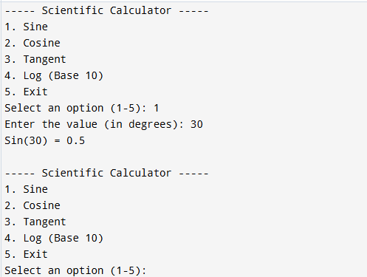

**Task # 2**

**Code:**

using System;

using System.Data;

class Program

{

static void Main()

{

DataTable table = new DataTable();

table.Columns.Add("Name", typeof(string));

table.Columns.Add("Age", typeof(int));

while (true)

{

Console.WriteLine("Enter Name:");

string name = Console.ReadLine();

Console.WriteLine("Enter Age:");

string ageInput = Console.ReadLine();

if (int.TryParse(ageInput, out int age))

{

table.Rows.Add(name, age);

Console.WriteLine("\nCurrent Data:\n");

// Display the table like DataGridView

Console.WriteLine("{0,-20} {1,-5}", "Name", "Age");

Console.WriteLine(new string('-', 26));

foreach (DataRow row in table.Rows)

{

Console.WriteLine("{0,-20} {1,-5}", row["Name"], row["Age"]);

}

Console.WriteLine("\nDo you want to add another entry? (y/n)");

string again = Console.ReadLine();

if (again.ToLower() != "y")

break;

}

else

{

Console.WriteLine("Invalid age. Please enter a numeric value.");

}

}

Console.WriteLine("Program Ended."); } }

