**LAB (2) TASK (1)**

**Code:**

using System;

using System.Text.RegularExpressions;

class Program

{

static void Main()

{

Console.WriteLine("Enter a logical expression:");

string input = Console.ReadLine();

string pattern = @"\b(AND|OR|NOT)\b|&&|\|\||!";

MatchCollection matches = Regex.Matches(input, pattern);

if (matches.Count > 0)

{

Console.WriteLine("\nLogical operators found:");

foreach (Match match in matches)

{

Console.WriteLine(match.Value);

}

}

else

{

Console.WriteLine("No logical operators found in the expression.");

}

}

}

**Output:**

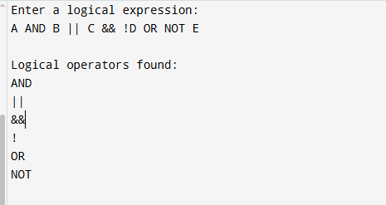

**Task # 2**

**Code:**

using System;

using System.Text.RegularExpressions;

class Program

{

static void Main()

{

Console.WriteLine("Enter an expression with relational operators:");

string input = Console.ReadLine();

string pattern = @"==|!=|>=|<=|>|<";

MatchCollection matches = Regex.Matches(input, pattern);

if (matches.Count > 0)

{

Console.WriteLine("\nRelational operators found:");

foreach (Match match in matches)

{

Console.WriteLine(match.Value);

}

}

else

{

Console.WriteLine("No relational operators found in the expression.");

}

}

}

**OUTPUT:**

