**LAB(3) TASK (1)**

**Code:**

using System;

using System.Text.RegularExpressions;

class Program

{

static void Main()

{

Console.WriteLine("Enter a value to check for floating point number (max 6 characters):");

string input = Console.ReadLine();

string pattern = @"^\d{0,5}(\.\d{1,5})?$";

if (Regex.IsMatch(input, pattern) && input.Length <= 6)

{

Console.WriteLine("Valid floating point number with max length 6.");

}

else

{

Console.WriteLine("Invalid input. Not a valid float or length > 6.");

}

}

}

**OUTPUT:**

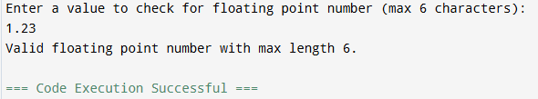

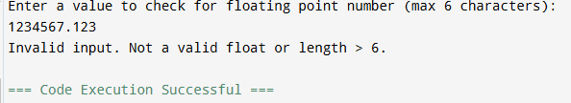

**Task # 2**

**Code:**

using System;

using System.Data;

using System.Text.RegularExpressions;

class Program

{

static void Main()

{

DataTable table = new DataTable();

table.Columns.Add("Input", typeof(string));

table.Columns.Add("Valid (Scientific Notation)", typeof(string));

Console.WriteLine("Enter 3 scientific notation values (e.g., 8e4, 5e-2):");

for (int i = 0; i < 3; i++)

{

Console.Write($"Input #{i + 1}: ");

string input = Console.ReadLine();

string pattern = @"^\d+e[-+]?\d+$";

string result = Regex.IsMatch(input, pattern) ? "Yes" : "No";

table.Rows.Add(input, result);

}

Console.WriteLine("\nResults (like DataGridView):");

Console.WriteLine("{0,-10} | {1}", "Input", "Valid (Scientific Notation)");

Console.WriteLine(new string('-', 40));

foreach (DataRow row in table.Rows)

{

Console.WriteLine("{0,-10} | {1}", row["Input"], row["Valid (Scientific Notation)"]);

} } }

**Output:**

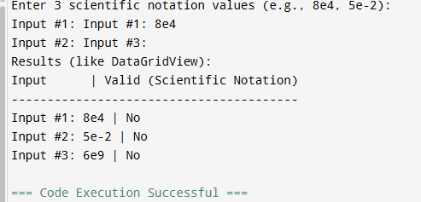

**TASK # 3**

**Code:**

using System;

using System.Data;

using System.Text.RegularExpressions;

class Program

{

static void Main()

{

string text = @"This is a test document. The team managed to meet the milestone on time.

Multiple members tried their maximum to make the task a success.";

Console.WriteLine("Original Document:\n");

Console.WriteLine(text);

string pattern = @"\b[tT|mM]\w*";

MatchCollection matches = Regex.Matches(text, pattern);

DataTable table = new DataTable();

table.Columns.Add("Matched Word", typeof(string));

foreach (Match match in matches)

{

table.Rows.Add(match.Value);

}

Console.WriteLine("\nWords starting with 't' or 'm':");

Console.WriteLine("-----------------------------");

foreach (DataRow row in table.Rows)

{

Console.WriteLine(row["Matched Word"]); } } }

**Output:**

