# Summary

The hazard analysis conducted by HazEL for New Zealand Wine Ltd revealed insights into the potential risks associated with different categories of chemicals used in their wine fields. In the category of Fungicides, the analysis identified three chemicals with the least hazard: fenhexamid, fluopiram, and famoxadone. For Insecticides and acaricides, the chemicals with the least hazard were abamectin, spinosad, and acetamiprid. In the Herbicides category, linuron, picloram, and clopyralid were found to have the least potential harm. As for Wound dressings, carvone, pyraclostrobin, and copper sulfate were the chemicals with the least hazard. Considering the environmental and human health effects, these chemicals can be preferred options for New Zealand Wine Ltd to minimize potential risks in their wine fields.

# Methodology

Substances are evaluated on three primary dimensions: toxicity, exposure, and emerging concern. Thirty-four toxicity parameters and nine exposure parameters are used, representative of key environmental and human health measures, and consistent with international standardised methodology for assessing environmental and human health risk. The tool also uses four parameters to express 'emerging concern'.The methodology is designed with sufficient coverage and inbuilt redundancy so that when data for some parameters are unavailable, a robust comparison can still be made, thus the tool can compare like-with-like even when different data points are available.

The toxicity parameters cover GHS classifications, data from reputable studies, and regulatory limits set by government bodies, relating to both human and environmental health. A user-changeable weighting scheme allows for preferred data sources to be prioritised. These parameters are also categorised as acute/chronic and mammalian/aquatic to refine the prioritisation process with respect to end-use scenarios, using relative weightings. In populating these parameters, priority is given to data gathered from common model species, to ensure uniformity among values for substances being compared. Exposure limits from multiple regulatory bodies enable the use of those most relevant to the user's locality.

The exposure dimension includes measures relating to degradability, mobility, bioaccumulation, volume of use, and recorded presence in water monitoring programmes.

Raw data are drawn from several reputable sources and appropriately transformed (by log-transformation and normalisation) to a scale from 0 (least concern, out of the substances within the group) to 1 (greatest concern).

Measures of emerging concern are derived from appearances in academic journals published by Taylor and Francis Publishing Group and reflect not only the number of references to a particular substance but also their change over time. ANOTHER SENTENCE

This is the first sentence. This is a second sentence.

## Fungicides used in Analysis:

The table provided includes a list of chemicals used as fungicides by New Zealand Wine Ltd. A total of 35 chemicals have been analyzed in this Hazard Analysis report. Each chemical is identified by its CAS (Chemical Abstracts Service) number, which is a unique identification number assigned to each chemical substance.

Hazard Evaluation Ltd (HazEL), a New Zealand-based company specializing in chemical risk analysis, has conducted a comprehensive evaluation of these fungicides. The goal of this analysis is to assess the environmental and human health effects of each chemical and determine their level of hazard.

By comparing the various parameters and ranking the chemicals according to their potential risks, HazEL aims to provide New Zealand Wine Ltd with valuable information to make well-informed decisions regarding the use of fungicides in their wine fields. This analysis will help identify which chemicals pose the greatest hazards and which ones may be preferred for use in specific categories.

|  |  |
| --- | --- |
| Chemical Name | CAS NO. |
| Boscalid. | 188425-85-6 |
| pydiflumetofen | 1228284-64-7 |
| procymidone | 32809-16-8 |
| calcium polysulfide | 1344-81-6 |
| Polyoxin D zinc salt | 146659-78-1 |
| dimethomorph | 110488-70-5 |
| cyprodinil | 121552-61-2 |
| captan | 133-06-2 |
| dicloran | 99-30-9 |
| chitosan | 9012-76-4 |
| iprodione | 36734-19-7 |
| dithianon | 3347-22-6 |
| fenhexamid | 126833-17-8 |
| proquinazid | 189278-12-4 |
| pyrimethanil | 53112-28-0 |
| cyproconazole | 94361-06-5 |
| penconazole | 66246-88-6 |
| Potassium bicarbonate | 298-14-6 |
| fluazinam | 79622-59-6 |
| difenoconazole | 119446-68-3 |
| fludioxonil | 131341-86-1 |
| metalaxyl-M | 70630-17-0 |
| mefentrifluconazole | 1417782-03-6 |
| mancozeb | 8018-01-7 |
| azoxystrobin | 131860-33-8 |
| carbendazim | 10605-21-7 |
| metiram | 9006-42-2 |
| fluopyram | 658066-35-4 |
| pyraclostrobin | 175013-18-0 |
| myclobutanil | 88671-89-0 |
| folpet | 133-07-3 |
| fenpyrazamine | 473798-59-3 |
| Metrafenone | 220899-03-6 |

## Insecticides and acaricides used in Analysis:

The provided table includes a list of chemicals for insecticides and acaricides that have been analyzed for hazard concerns. There are a total of 14 chemicals compared in this analysis. These chemicals have been assessed based on their environmental and human health effects to provide information on their potential hazards.

The Hazard Evaluation Ltd (HazEL) has performed a Chemical Risk Analysis for the target company, New Zealand Wine Ltd, which is one of the largest wine growers in New Zealand. HazEL has analyzed a range of chemicals used by New Zealand Wine Ltd in their wine fields, specifically focusing on insecticides and acaricides. The goal of this analysis is to identify the most and least hazardous chemicals in this category, aiding New Zealand Wine Ltd in making informed decisions about the chemicals they use.

The table provides the names of the chemicals along with their unique identification numbers called CAS Registry Numbers. These numbers are assigned to each chemical substance by the Chemical Abstracts Service. By analyzing and comparing the hazard concerns of these chemicals, HazEL aims to help New Zealand Wine Ltd minimize potential harm and ensure the safety of their wine production. With this information, New Zealand Wine Ltd can prioritize the use of chemicals that pose the least risk to the environment and human health, ultimately contributing to their goal of sustainable and responsible wine production.

|  |  |
| --- | --- |
| Chemical Name | CAS NO. |
| imidacloprid | 138261-41-3 |
| lambda-cyhalothrin | 91465-08-6 |
| spinosad | 168316-95-8 |
| deltamethrin | 52918-63-5 |
| buprofezin | 69327-76-0 |
| Rapeseed oil | 120962-03-0 |
| cypermethrin | 52315-07-8 |
| calcium polysulfide | 1344-81-6 |
| Emamectin benzoate | 155569-91-8 |
| tebufenozide | 112410-23-8 |
| indoxacarb | 173584-44-6 |
| pyrethrins | 8003-34-7 |
| spirotetramat | 203313-25-1 |
| methoxyfenozide | 161050-58-4 |
| tau-fluvalinate | 102851-06-9 |

## Herbicides used in Analysis:

The table provided contains a list of chemicals or products used for hazard analysis. Specifically, these chemicals belong to the herbicides category. In total, there are 14 herbicide products compared in this table for the target company, New Zealand Wine Ltd.

Hazard Evaluation Ltd (HazEL), a New Zealand-based company specializing in chemical risk analysis, has performed a hazard evaluation of these herbicides for New Zealand Wine Ltd. HazEL ranks chemicals based on their environmental and human health effects, providing valuable insights into their potential risks. The goal of this analysis is to identify and compare the hazard levels of different herbicides, enabling New Zealand Wine Ltd to make informed decisions regarding the use of these chemicals in their wine fields.

By examining the provided table, HazEL has identified the chemical names and CAS numbers of the 14 herbicides under evaluation. These include indaziflam, fluazifop-P-butyl, amitrol, diuron, oryzalin, terbuthylazine, pendimethalin, carfentrazone-ethyl, oxyfluorfen, clethodim, glyphosate, flumioxazin, glufosinate ammonium, and linuron. Each chemical is associated with a unique CAS Registry Number, which serves as a unique identification for these substances.

Through this hazard analysis, HazEL aims to determine which herbicides pose the most significant hazards and to identify the chemicals with the least potential harm. This information will allow New Zealand Wine Ltd to prioritize the use of safer alternatives and ensure the well-being of both the environment and human health in their wine fields.

|  |  |
| --- | --- |
| Chemical Name | CAS NO. |
| indaziflam | 950782-86-2 |
| fluazifop-P-butyl | 79241-46-6 |
| amitrol | 61-82-5 |
| diuron | 330-54-1 |
| oryzalin | 19044-88-3 |
| terbuthylazine | 5915-41-3 |
| pendimethalin | 40487-42-1 |
| carfentrazone-ethyl | 128639-02-1 |
| oxyfluorfen | 42874-03-3 |
| clethodim | 99129-21-2 |
| glyphosate | 1071-83-6 |
| flumioxazin | 103361-09-7 |
| Glufosinate ammonium | 77182-82-2 |
| linuron | 330-55-2 |

## Wound dressing used in Analysis:

The provided table consists of 6 chemicals used for wound dressing in the wine fields of New Zealand Wine Ltd. Each chemical is identified by its Chemical Abstracts Service (CAS) Registry Number. The chemicals listed in the table are boric acid (CAS NO. 10043-35-3), flusilazole (CAS NO. 85509-19-9), tebuconazole (CAS NO. 107534-96-3), fluazinam (CAS NO. 79622-59-6), octhilinone (CAS NO. 26530-20-1), and Pine Tar (CAS NO. 8011-48-1).

The table provides a comprehensive list of the chemicals used for wound dressing, allowing for easy comparison and analysis. The CAS Registry Number assigned to each chemical ensures accurate identification, as these numbers are unique for every chemical substance described in the scientific literature. By examining the hazard analysis of these chemicals, we can determine which ones pose the highest and lowest risks for New Zealand Wine Ltd.

In the analysis conducted by Hazard Evaluation Ltd, these 6 wound dressing chemicals were evaluated based on their environmental and human health effects. The goal of the analysis was to identify the hazards associated with each chemical and provide useful insights for decision-making. By comparing the parameters and ranking of each chemical, Hazel aims to support New Zealand Wine Ltd in making informed choices regarding the selection of the most suitable and least hazardous wound dressing chemical for their wine fields.

|  |  |
| --- | --- |
| Chemical Name | CAS NO. |
| boric acid. | 10043-35-3 |
| flusilazole | 85509-19-9 |
| tebuconazole | 107534-96-3 |
| fluazinam | 79622-59-6 |
| octhilinone | 26530-20-1 |
| Pine Tar | 8011-48-1 |

# Results

## Fungicides Analysis:

HazEL has performed a hazard analysis report for the fungicides used by New Zealand Wine Ltd in their wine fields. The analysis was done based on three parameters: toxicity combined score, exposure combined score, and emerging concern score.

Among the fungicides, the chemical with the highest toxicity combined score is fluazinam. This chemical is followed by dithianon and carbendazim. These three chemicals have the highest toxicity scores among the fungicides analyzed.

In terms of exposure combined score, the chemical with the highest score is calcium polysulfide. The next two chemicals with higher exposure scores are fenpyrazamine and pydiflumetofen. These chemicals have higher chances of exposure compared to other fungicides.

For emerging concern score, azoxystrobin has the highest value among the fungicides. The next two chemicals with higher emerging concern scores are cyproconazole and fluazinam. These chemicals have higher research interest, suggesting that more information on their effects may become available soon.

The analysis report provides valuable insights into the hazard concerns of the fungicides used by New Zealand Wine Ltd. Understanding the relative toxicity, exposure, and emerging concerns of these chemicals can help the company make informed decisions to minimize potential risks and prioritize the use of safer alternatives.

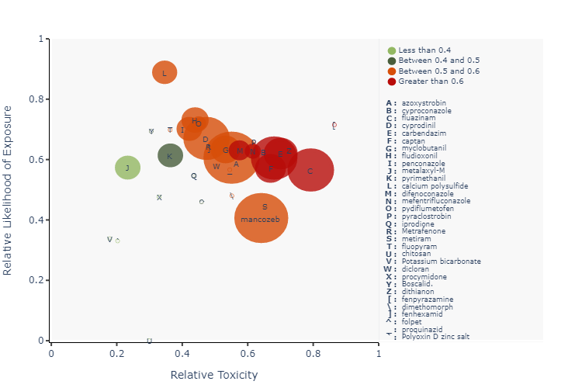

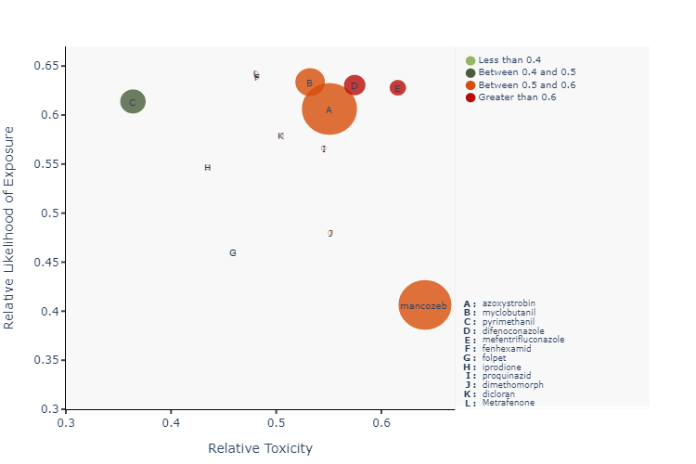

## Insecticides and acaricides Analysis:

Hazard Evaluation Ltd (HazEL) has conducted a comprehensive analysis of insecticides and acaricides used by New Zealand Wine Ltd in their wine fields. The analysis focused on three parameters: Toxicity Combined Score, Exposure Combined Score, and Emerging Concern Score.

The chemical that has the maximum Toxicity Combined Score is lambda-cyhalothrin. The next two chemicals with high scores in this parameter are Emamectin benzoate and deltamethrin. These chemicals exhibit higher toxicity levels compared to others in the table.

In terms of Exposure Combined Score, the chemical with the highest value is calcium polysulfide, indicating a higher likelihood of exposure to this chemical. The following two chemicals with higher scores in this parameter are tebufenozide and imidacloprid.

When considering the Emerging Concern Score, imidacloprid ranks first, suggesting that more research interest has been focused on this chemical. The next two chemicals in this parameter are cypermethrin and lambda-cyhalothrin.

Based on these findings, it is important for New Zealand Wine Ltd to be aware of the potential hazards associated with lambda-cyhalothrin, Emamectin benzoate, and deltamethrin due to their high Toxicity Combined Scores. Additionally, attention should be given to calcium polysulfide, tebufenozide, and imidacloprid due to their high Exposure Combined Scores. Lastly, imidacloprid, cypermethrin, and lambda-cyhalothrin should be monitored as they have received relatively higher research interest based on the Emerging Concern Score. These insights can assist the company in making informed decisions regarding the preference and usage of insecticides and acaricides in their wine fields.

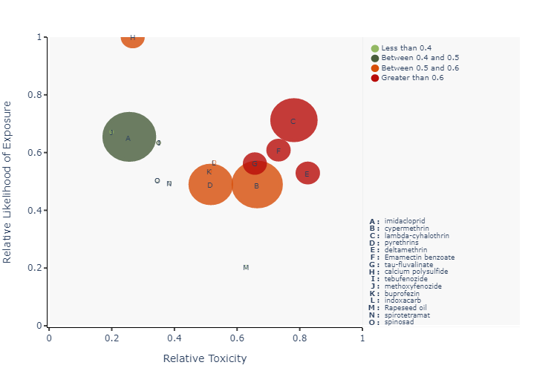

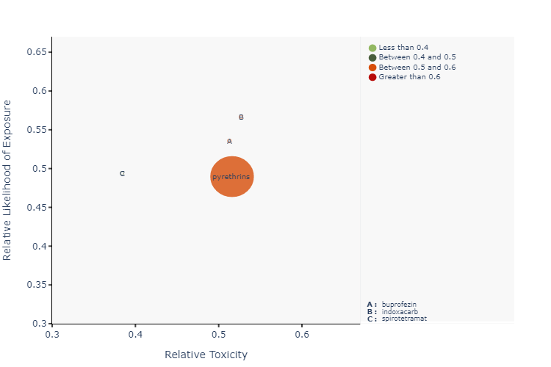

## Herbicides Analysis:

Hazard Evaluation Ltd (HazEL) has performed a comprehensive analysis of herbicides for New Zealand Wine Ltd, the target company. The analysis includes parameters such as the Toxicity Combined Score, Exposure Combined Score, and Emerging Concern Score for each chemical.

Based on the analysis, it was found that diuron has the highest Toxicity Combined Score among the herbicides. The next two herbicides with higher Toxicity Combined Scores are flumioxazin and oxyfluorfen. It is important to note that higher scores indicate a higher level of toxicity.

In terms of Exposure Combined Score, linuron has the highest value among the herbicides. The two herbicides following linuron with higher Exposure Combined Scores are terbuthylazine and glyphosate. A higher Exposure Combined Score suggests a higher likelihood of exposure to the chemical.

For the Emerging Concern Score, linuron has the highest score among the herbicides. The next two herbicides with higher Emerging Concern Scores are diuron and glyphosate. A higher Emerging Concern Score indicates that research interest for the chemical has been relatively high, and more information about the product is likely to become available soon.

New Zealand Wine Ltd uses these herbicides in their wine fields. It is important for the company to be aware of the potential hazards associated with the chemicals they use. Based on the analysis, diuron and flumioxazin have the highest Toxicity Combined Scores, linuron has the highest Exposure Combined Score, and linuron has the highest Emerging Concern Score. These findings can help the company make informed decisions about the herbicides they use and consider less toxic alternatives if necessary to minimize the potential risks to the environment and human health.

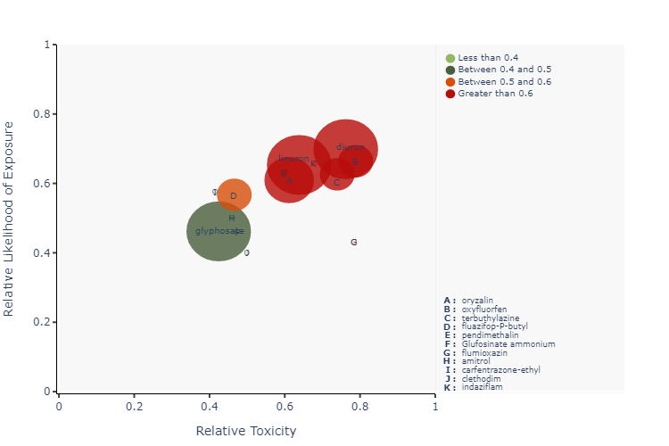

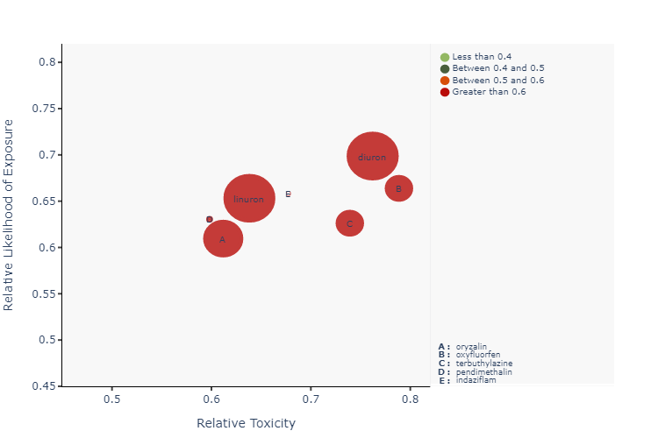

## Wound dressing Analysis:

Hazard Evaluation Ltd (HazEL) has conducted a comprehensive analysis of the wound dressing products used by New Zealand Wine Ltd, in their wine fields. The analysis focused on three parameters: Toxicity Combined Score (Raw), Exposure Combined Score (Raw), and Emerging Concern Score (raw).

Based on the provided table, the chemical "boric acid" has the highest Toxicity Combined Score (Raw) among the wound dressing products. This suggests that it may have the highest potential for toxic effects. The next two chemicals with higher Toxicity Combined Scores are "fluazinam" and "octhilinone".

In terms of Exposure Combined Score (Raw), the chemical "tebuconazole" has the highest value among the wound dressing products. This indicates that there is a higher chance of exposure to this chemical compared to others. The next two chemicals with higher Exposure Combined Scores are "flusilazole" and "fluazinam".

Regarding the Emerging Concern Score (raw), the chemical "tebuconazole" has the highest value among the wound dressing products. This suggests that there has been relatively more research interest and information available about this chemical compared to others. The next two chemicals with higher Emerging Concern Scores are "boric acid" and "octhilinone".

Overall, based on the analysis of the provided table, it can be observed that "tebuconazole" stands out as having the highest scores in two out of three parameters (Exposure Combined Score and Emerging Concern Score). This implies that it may require closer attention in terms of its potential hazards and the need for further research.

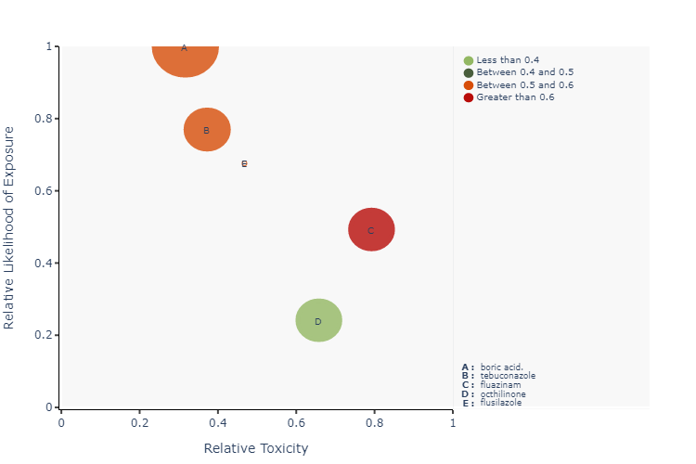

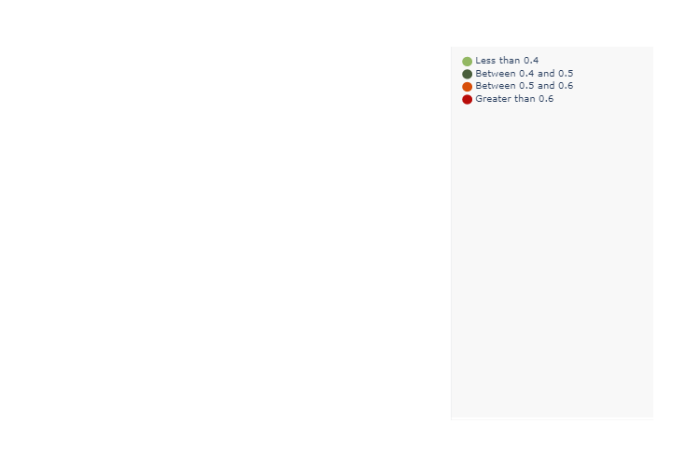

# References

**Fungicides References**

1. **Boscalid.:** http://www.example.com/?advertisement=approval
2. **pydiflumetofen:** https://basin.example.net/
3. **procymidone:** http://www.example.org/bridge
4. **calcium polysulfide:** http://example.com/blow
5. **Polyoxin D zinc salt:** http://www.example.com/?advertisement=approval
6. **dimethomorph:** https://basin.example.net/
7. **cyprodinil:** http://www.example.org/bridge
8. **captan:** http://example.com/blow
9. **dicloran:** http://www.example.com/?advertisement=approval
10. **chitosan:** https://basin.example.net/
11. **iprodione:** http://www.example.org/bridge
12. **dithianon:** http://example.com/blow
13. **fenhexamid:** http://www.example.com/?advertisement=approval
14. **proquinazid:** https://basin.example.net/
15. **pyrimethanil:** http://www.example.org/bridge
16. **cyproconazole:** http://example.com/blow
17. **penconazole:** http://www.example.com/?advertisement=approval
18. **Potassium bicarbonate:** https://basin.example.net/
19. **fluazinam:** http://www.example.org/bridge
20. **difenoconazole:** http://example.com/blow
21. **fludioxonil:** http://www.example.com/?advertisement=approval
22. **metalaxyl-M:** https://basin.example.net/
23. **mefentrifluconazole:** http://www.example.org/bridge
24. **mancozeb:** http://example.com/blow
25. **azoxystrobin:** http://www.example.com/?advertisement=approval
26. **carbendazim:** https://basin.example.net/
27. **metiram:** http://www.example.org/bridge
28. **fluopyram:** http://example.com/blow
29. **pyraclostrobin:** http://www.example.com/?advertisement=approval
30. **myclobutanil:** https://basin.example.net/
31. **folpet:** http://www.example.org/bridge
32. **fenpyrazamine:** http://example.com/blow
33. **Metrafenone:** http://example.com/blow

**Insecticides References**

1. **imidacloprid:** https://www.example.com/?blood=blade&books=baseball
2. **lambda-cyhalothrin:** http://www.example.com/?advertisement=approval
3. **spinosad:** https://basin.example.net/
4. **deltamethrin:** http://www.example.org/bridge
5. **buprofezin:** http://example.com/blow
6. **Rapeseed oil:** http://example.org/approval/border.aspx?believe=baby&bath=birthday
7. **cypermethrin:** https://www.example.com/?blood=blade&books=baseball
8. **calcium polysulfide:** http://www.example.com/?advertisement=approval
9. **Emamectin benzoate:** http://example.com/blow
10. **tebufenozide:** http://www.example.com/?advertisement=approval
11. **indoxacarb:** https://basin.example.net/
12. **pyrethrins:** http://www.example.org/bridge
13. **spirotetramat:** http://example.com/blow
14. **methoxyfenozide:** http://www.example.org/bridge
15. **tau-fluvalinate:** http://example.com/blow

**Herbicides References**

1. **indaziflam:** http://example.org/approval/border.aspx?believe=baby&bath=birthday
2. **fluazifop-P-butyl:** https://www.example.com/?blood=blade&books=baseball
3. **amitrol:** http://www.example.com/?advertisement=approval
4. **diuron:** https://basin.example.net/
5. **oryzalin:** http://www.example.org/bridge
6. **terbuthylazine:** http://example.com/blow
7. **pendimethalin:** http://example.org/approval/border.aspx?believe=baby&bath=birthday
8. **carfentrazone-ethyl:** https://www.example.com/?blood=blade&books=baseball
9. **oxyfluorfen:** http://www.example.com/?advertisement=approval
10. **clethodim:** http://example.org/approval/border.aspx?believe=baby&bath=birthday
11. **glyphosate:** https://www.example.com/?blood=blade&books=baseball
12. **flumioxazin:** http://www.example.com/?advertisement=approval
13. **Glufosinate ammonium:** https://basin.example.net/
14. **linuron:** http://www.example.org/bridge

**Wound Dressing References**

1. **boric acid.:** http://example.org/approval/border.aspx?believe=baby&bath=birthday
2. **flusilazole:** https://www.example.com/?blood=blade&books=baseball
3. **tebuconazole:** http://www.example.com/?advertisement=approval
4. **fluazinam:** https://basin.example.net/
5. **octhilinone:** http://www.example.org/bridge
6. **Pine Tar:** http://example.com/blow