# Summary:

Hazard Evaluation Ltd (HazEL) has conducted a hazard analysis report for Pyper Vision's ASDEI product. ASDEI is an airfield defogging agent that Pyper Vision aims to commercialize. HazEL compared ASDEI with other chemicals and products to assess its environmental and human health effects. The analysis focused on toxicity, exposure, and emerging concerns. The report highlighted that ASDEI had higher exposure compared to other chemicals, indicating a greater likelihood of contact. Additionally, ASDEI was flagged for emerging concerns, suggesting ongoing research and potential for new information. HazEL's mission is to reduce chemical harm and provide efficient tools for decision making. This analysis supports Pyper Vision in understanding the relative hazard concerns of ASDEI compared to other chemical products, aiding in their commercialization strategy.

# Methodology

Substances are evaluated on three primary dimensions: toxicity, exposure, and emerging concern. Thirty-four toxicity parameters and nine exposure parameters are used, representative of key environmental and human health measures, and consistent with international standardised methodology for assessing environmental and human health risk. The tool also uses four parameters to express 'emerging concern'.The methodology is designed with sufficient coverage and inbuilt redundancy so that when data for some parameters are unavailable, a robust comparison can still be made, thus the tool can compare like-with-like even when different data points are available.

The toxicity parameters cover GHS classifications, data from reputable studies, and regulatory limits set by government bodies, relating to both human and environmental health. A user-changeable weighting scheme allows for preferred data sources to be prioritised. These parameters are also categorised as acute/chronic and mammalian/aquatic to refine the prioritisation process with respect to end-use scenarios, using relative weightings. In populating these parameters, priority is given to data gathered from common model species, to ensure uniformity among values for substances being compared. Exposure limits from multiple regulatory bodies enable the use of those most relevant to the user's locality.

The exposure dimension includes measures relating to degradability, mobility, bioaccumulation, volume of use, and recorded presence in water monitoring programmes.

Raw data are drawn from several reputable sources and appropriately transformed (by log-transformation and normalisation) to a scale from 0 (least concern, out of the substances within the group) to 1 (greatest concern).

Measures of emerging concern are derived from appearances in academic journals published by Taylor and Francis Publishing Group and reflect not only the number of references to a particular substance but also their change over time. ANOTHER SENTENCE

This is the first sentence. This is a second sentence.

## Chemicals Used In the Analysis:

The table provided contains a list of chemicals that were analyzed in a hazard evaluation conducted by Hazard Evaluation Ltd (HazEL). The table includes information such as the chemical name, CAS registry number, and category. These chemicals were compared based on different parameters to assess their environmental and human health effects. The target product from Pyper Vision, ASDEI, was one of the chemicals analyzed. ASDEI, with CAS NO. 9003-05-8, falls under the category of "De-icer." The target product was compared with a total of 15 other products, including chemicals used for jet exhaust, herbicide, defogger, fire suppressant, surfactant, solvent, aircraft cleaner, and jet exhaust components. This hazard analysis aims to provide insights into the relative hazard concerns of ASDEI compared to other chemical products, supporting Pyper Vision in their goal to commercialize their ASDEI product.

|  |  |  |
| --- | --- | --- |
| Chemical Name | CAS NO. | Category |
| Bromochlorodifluoromethane | 353-59-3 | Jet Exaust |
| ethylene | 74-85-1 | Jet Exaust |
| PFHxA | 307-24-4 | Herbicide |
| Trans-dichloroethylene | 156-60-5 | Defogger |
| Triethanolamine | 102-71-6 | De-icer |
| Benzene | 71-43-2 | De-icer |
| 2-butoxyethanol | 111-76-2 | Fire suppressant |
| ASDEI | 9003-05-8 | De-icer |
| 1-Bromopropane | 106-94-5 | De-icer |
| Potassium formate | 590-29-4 | De-icer |
| Ethylene glycol | 107-21-1 | Surfactant |
| Sodium acetate | 127-09-3 | Solvent |
| glyphosate | 1071-83-6 | Solvent |
| Propylene glycol | 57-55-6 | Aircraft cleaner |
| Ethoxylated alcohol | 68213-23-0 | Jet exhaust component |
| formaldehyde | 50-00-0 | Fire suppressant |

# Results

## Hazel Analysis:

Hazard Evaluation Ltd (HazEL) conducted a hazard analysis report for the target product, ASDEI, from Pyper Vision. The report compared ASDEI with other chemicals and products based on different parameters provided in the table.

According to the analysis, ASDEI is ranked in terms of its toxicity combined score, exposure combined score, and emerging concern score compared to the other chemicals in the table. The chemical with the maximum value for each parameter is as follows:

- Toxicity Combined Score: Ethoxylated alcohol has the highest toxicity combined score.

- Exposure Combined Score: ASDEI itself has the highest exposure combined score.

- Emerging Concern Score: Benzene has the highest emerging concern score.

For each parameter, the next two chemicals/products with larger values can be identified as follows:

Toxicity Combined Score:

1. Ethoxylated alcohol

2. Benzene

Exposure Combined Score:

1. ASDEI

2. Ethylene glycol

Emerging Concern Score:

1. Benzene

2. Glyphosate

The hazard analysis report provides a comprehensive understanding of ASDEI's hazard concerns compared to other chemicals/products in terms of toxicity, exposure, and emerging concerns. Pyper Vision can utilize this information in their commercialization strategy for ASDEI.

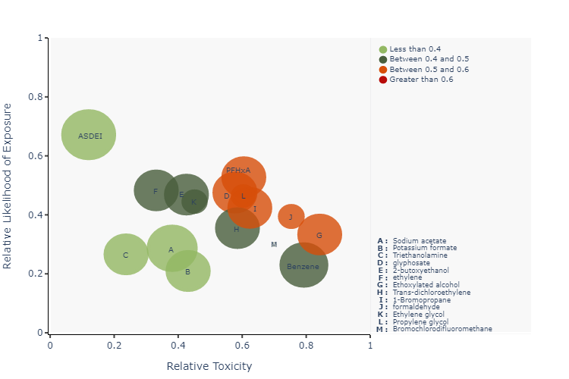

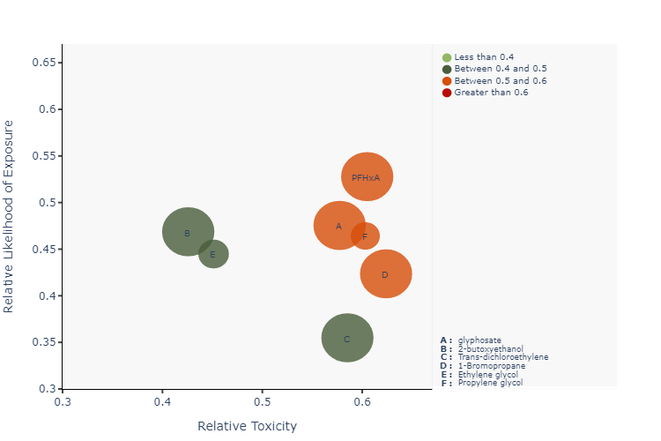

# References

1. **Bromochlorodifluoromethane:** http://example.org/approval/border.aspx?believe=baby&bath=birthday
2. **ethylene:** https://www.example.com/?blood=blade&books=baseball
3. **PFHxA:** http://www.example.com/?advertisement=approval
4. **Trans-dichloroethylene:** https://basin.example.net/
5. **Triethanolamine:** http://www.example.org/bridge
6. **Benzene:** http://example.com/blow
7. **2-butoxyethanol:** http://example.org/approval/border.aspx?believe=baby&bath=birthday
8. **ASDEI:** https://www.example.com/?blood=blade&books=baseball
9. **1-Bromopropane:** http://www.example.com/?advertisement=approval
10. **Potassium formate:** https://basin.example.net/
11. **Ethylene glycol:** http://www.example.org/bridge
12. **Sodium acetate:** http://example.com/blow
13. **glyphosate:** http://www.example.com/?advertisement=approval
14. **Propylene glycol:** https://basin.example.net/
15. **Ethoxylated alcohol:** http://www.example.org/bridge
16. **formaldehyde:** http://example.com/blow