**Calendar Event Document**

**GIT Hub URL:**

<https://github.com/haiderali-arain/calendar-events>

Steps:

1. Checkout project
2. Build Project
3. Swagger UI Implemented so following URL can be used to execute URIs
   1. <http://localhost:8080/swagger-ui.html>
4. JWT Token authentication implemented, so execute following URI first to obtain token. With user name(user) and password(user)
   1. <http://localhost:8080/auth>



1. Then following URIs can be executed to fetch events records by providing access token. Please provide access token as follow.
   1. Bearer **Access_Token**

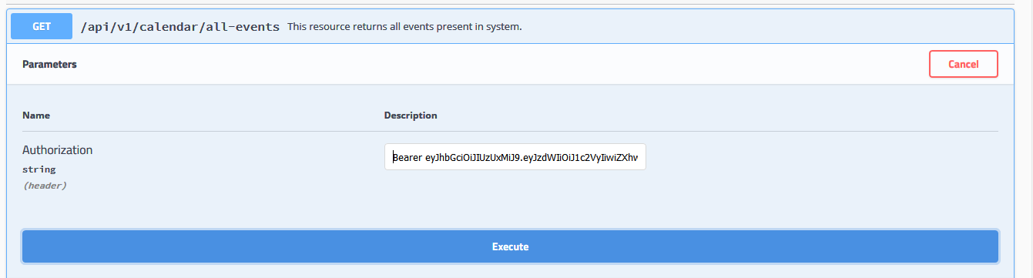

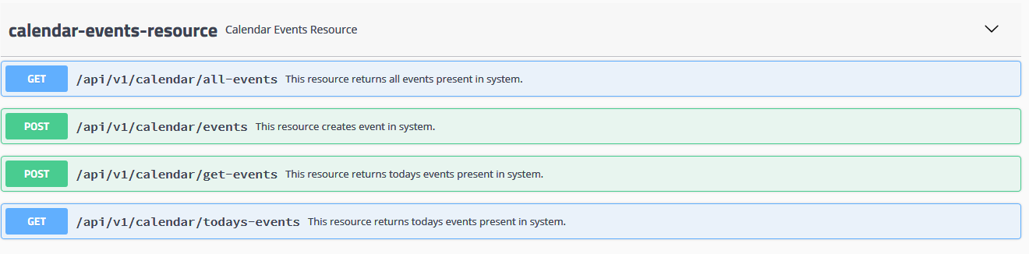

In This project I tried to implement few following things so that you can have idea of my coding style.

1. Interface based coding
2. Layer Separation
3. Swagger API
4. JPA Repository
5. Spring Boot
6. JWT Token implementation
7. H2 database

Following are things that I did not implement because of time, but I am providing approach that I would use If I had implemented.

1. Test Cases: For API I have used in my projects not in this.
   1. End to End Testing using TestRestTemplate
   2. Junit with Mockito to write service layer test cases
2. Reminder: In Spring boot @Schedule annotation is there which can be used to schedule method which will take care of reminders. i.e method will fetch present day events and check if event reminder time is same time to send reminder and set flag of reminder.
3. Update: for update after accepting and validating fetch record from database and update record with field from request and then persist record.