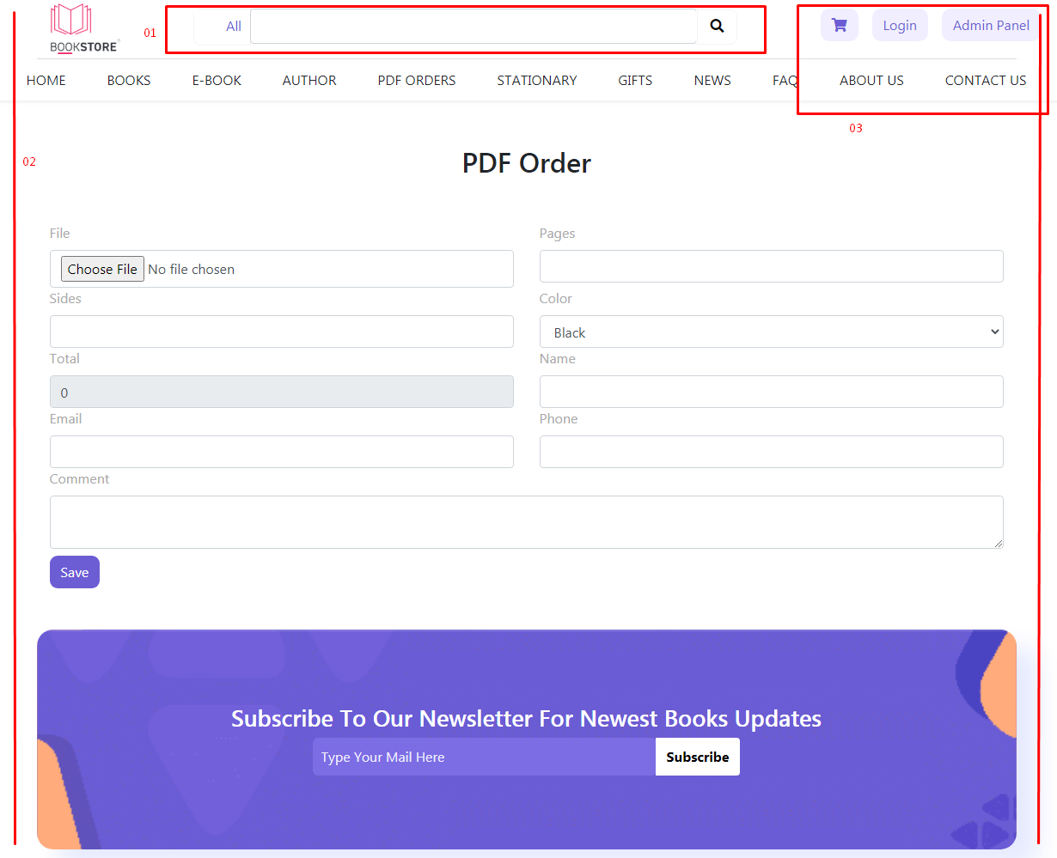

01 - Check search bar, iski alignment sahe nhe arhe hai

02 - page ka margin out hai header ki taraf se

03 - Admin panel out araha hai page alignment k hisaab se

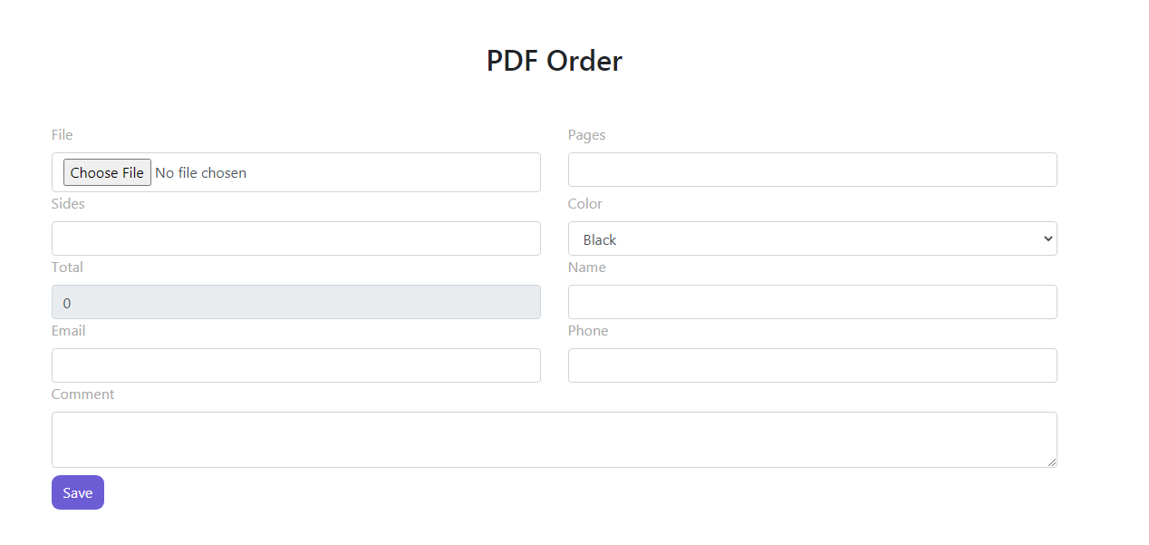

PDF printing ka meine apko bataya tha file upload hoge customer sirf page, size, cover & qty select karayga and uska order place hojaega

_________________________________________________________________________________________________

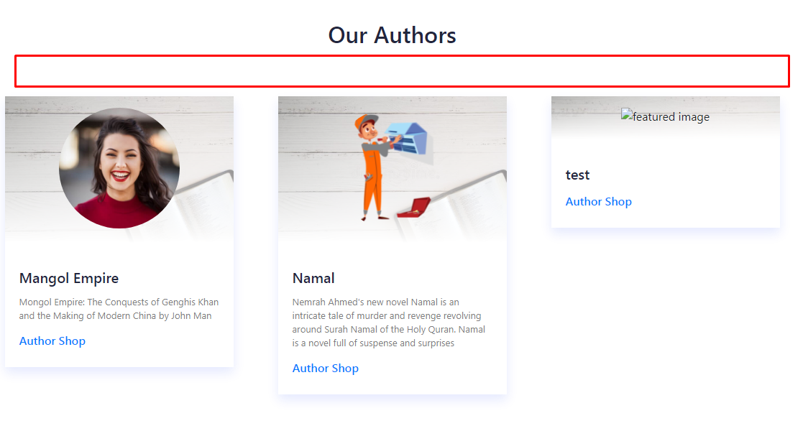

yaha per author ka search bar hoga and Alphabets hogay jis se starting A to Z tak sub authors ajaegay and 1 line mei 5 authors ayegay

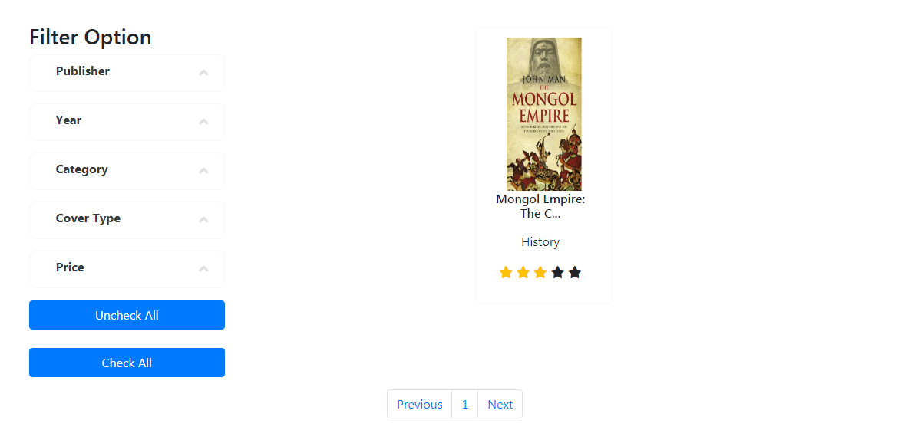

E books mei price nhe aegay sirf download ka option ayega jis k login kerna zaruri hai and 2nd option ayega print kernay ka jis per woh click ker k size, paper &cover select karayga amount ayege or uska order place ker dega

_________________________________________________________________________________________________

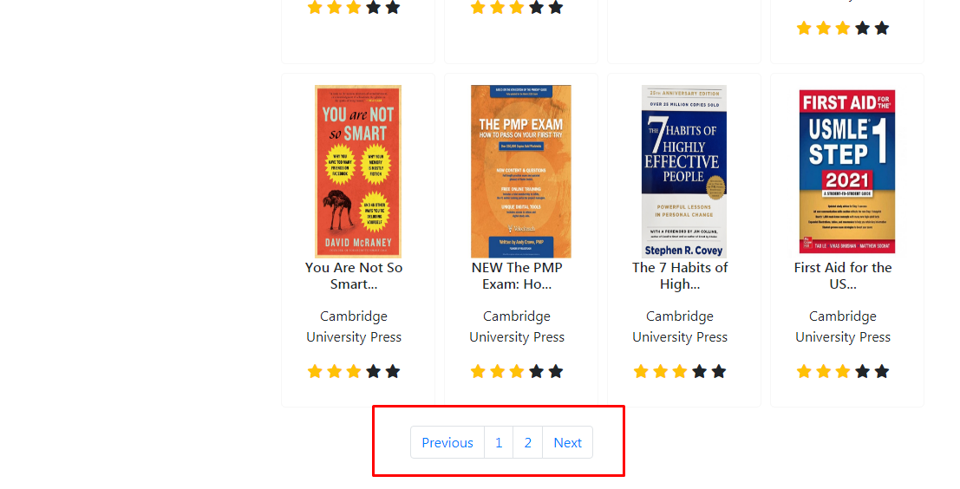

Yaha per load more ka option ayega or side bar jo empty hai us per New arrvials and featured products ayegay isi category se related

______________________________________________________________________________________________

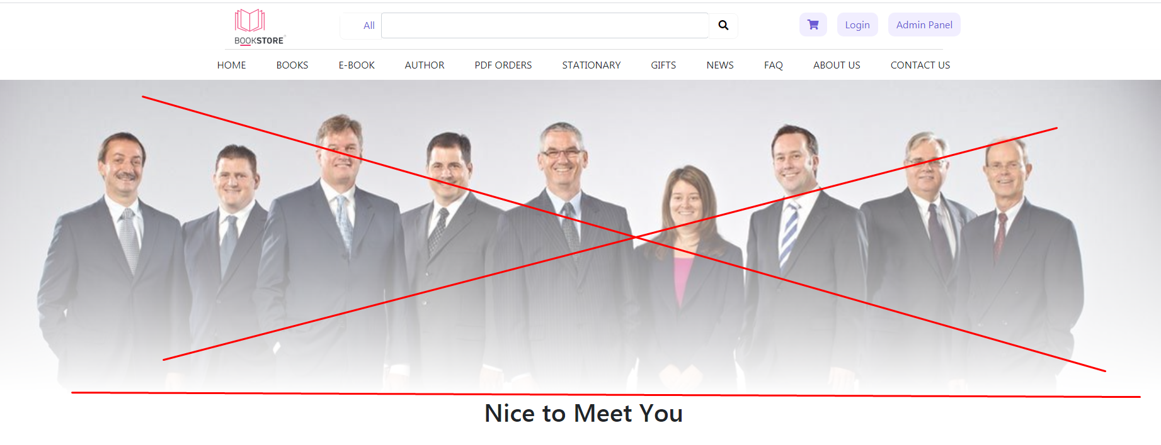

ye hat jaega and sirf nice to meed you se start hoga

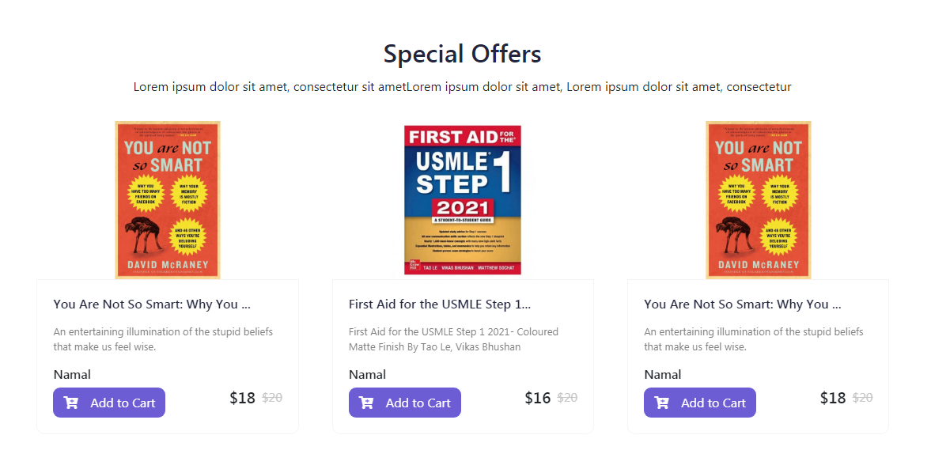

is mei or bhi books ayege is per arrow laga dein ta k ye move hoti rahay

______________________________________________________________________________________________

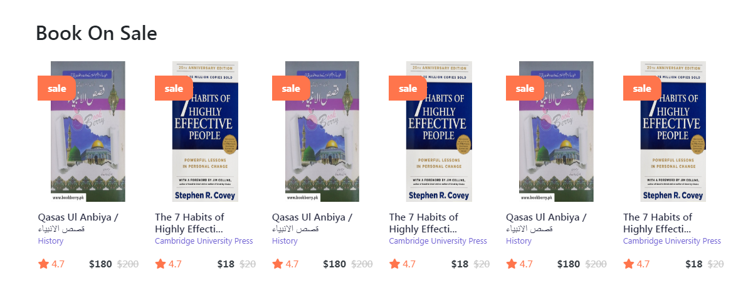

isko 2 line kerdo and is mei bhi neechy button de do load more ka jis per customer click karay tow or books show hojaye

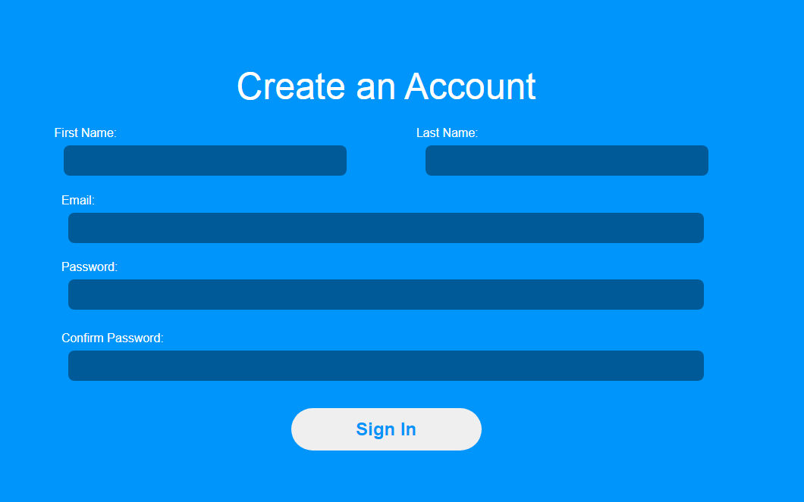

Is mei social login nhe hai is mei social login add ker dein

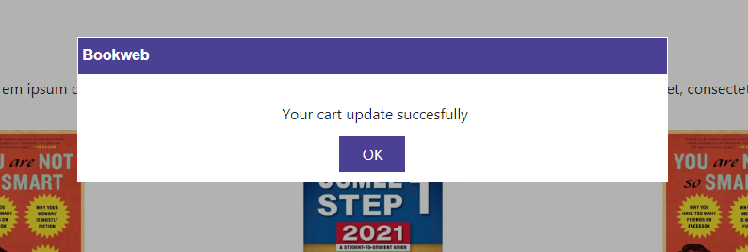

Add to cart kernay per ye araha hai isko hata dein sirf light view per notification ajaye

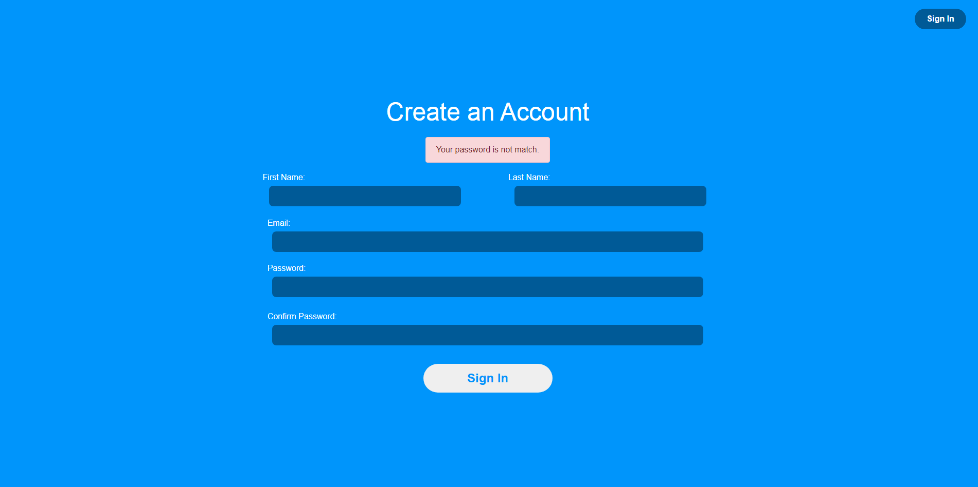

is mei back kerna perhta hai isko side per **(**close **X)** ka icon de dein ta k customer ko close ker sakay

NOTE: Baqi is mei classified ka option he nhe hai.. is mei classified wala option on karo ta k pata chalay woh kaisa bana hai and logo bhi humara laga do or theme ko humaray logo k hisaab se rakhna hai abhi colour theme blue per hai jab k humari pink per hai isko check kerlo and jo samjh na aye woh pooch lena