Sentiment Analysis of Movie Reviews using Artificial Intelligence

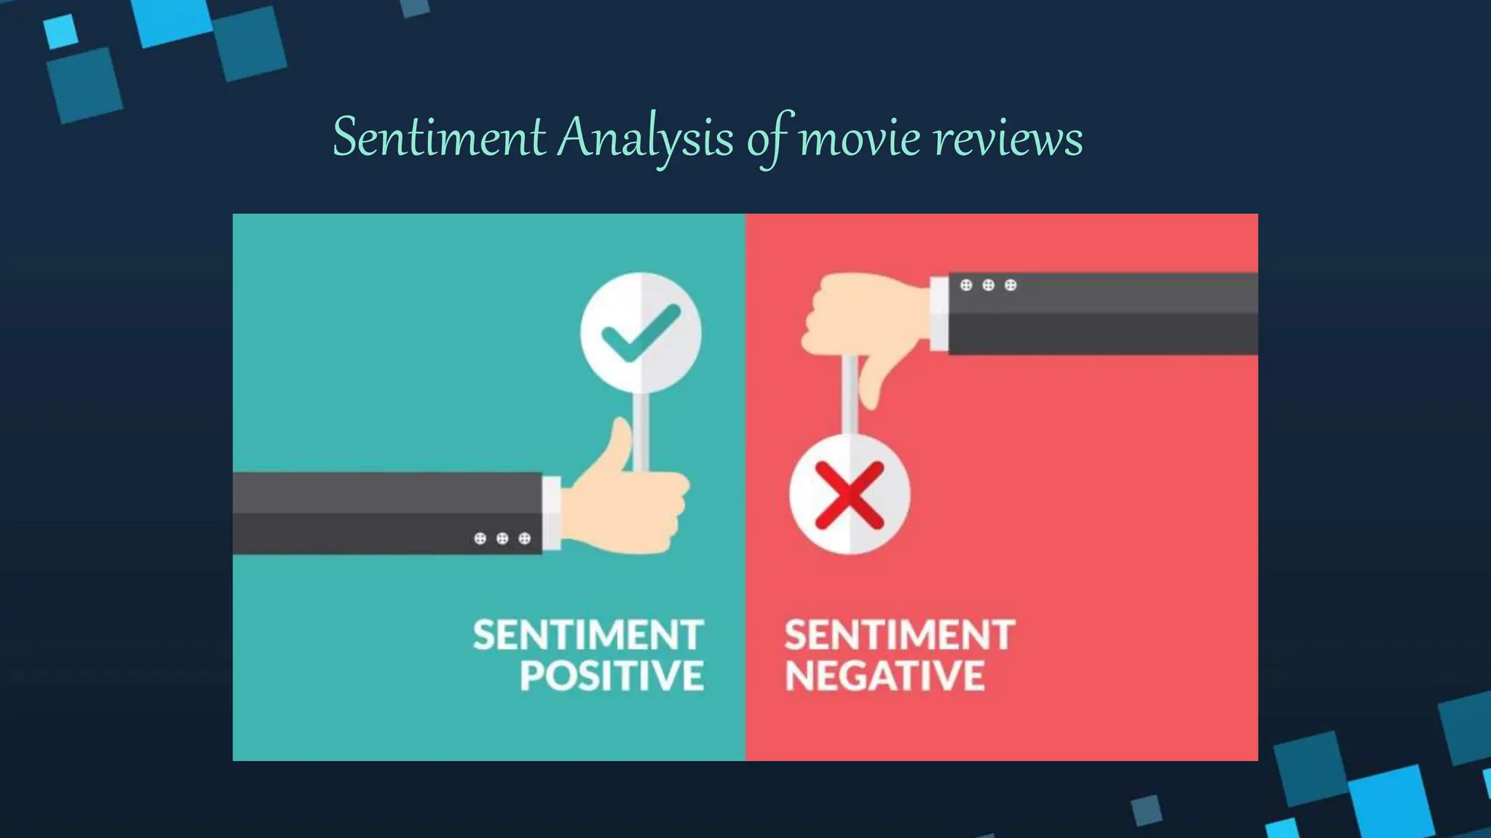
Course Name : Artificial Intelligence Lab
Student Name : Haider Ali
Registration No : 23PWDSC0123
Instructor Name: Dr. Wajeeha Khalil
Department : Data Science
Semester : 5th – Fall 2025

Contents
Sentiment Analysis of Movie Reviews using Artificial Intelligence 1
1. Problem Domain 2
2. Motivation 2
3. Introduction 2
4. Objectives 2
5. Intended Users / Stakeholders 2
6. Dataset Description and Sources 2
7. Data Preprocessing 3
8. Methodology 3
9. Tools and Technologies 3
10. Implementation 3
11. Testing 3
12. Results and Discussion 3
13. Challenges and Limitations 3
14. Conclusion 3
15. Future Enhancements 3
16. References 4
System Workflow Diagram 5
Context Diagram (0-Level DFD) 5

1. Problem Domain
This project lies in the domain of Natural Language Processing (NLP) and Artificial Intelligence. It focuses on extracting meaningful insights from textual data, specifically movie reviews. The application area includes customer feedback analysis, social media monitoring, and opinion mining. In the real world, organizations receive thousands of reviews daily, making manual analysis impractical. Therefore, an automated sentiment analysis system is essential to classify opinions quickly and accurately.

2. Motivation
With the rapid growth of online platforms, users express opinions through reviews and comments. Understanding these opinions is critical for improving products and services. Traditional manual methods are time-consuming and prone to human error. This project is motivated by the need for an efficient AI-based system that can automatically analyze sentiments, saving time and resources while improving decision-making.

3. Introduction
Sentiment analysis is a subfield of text analytics that identifies emotional tone in text. This project develops an AI-based system that classifies movie reviews as positive or negative. Artificial Intelligence enables machines to understand language patterns and make predictions. By applying machine learning algorithms, the system learns from labeled data and predicts sentiment for new reviews.

4. Objectives
The objectives of this project are to build an automated sentiment classification system, preprocess textual data effectively, apply machine learning algorithms for training, evaluate model performance using standard metrics, and demonstrate the practical use of AI in opinion mining.

5. Intended Users / Stakeholders
Primary users include data analysts, marketing teams, and businesses who want to analyze customer feedback. Secondary stakeholders include decision-makers and product developers. The system helps them understand customer satisfaction, improve quality, and make data-driven decisions.

6. Dataset Description and Sources
The dataset used is the IMDb Movie Reviews dataset obtained from Kaggle. It contains 50,000 reviews labeled as positive or negative. Each record includes review text and its corresponding sentiment. The dataset is balanced and widely used for sentiment analysis research.

7. Data Preprocessing
Data preprocessing involves cleaning text by removing punctuation, converting to lowercase, removing stopwords, and tokenization. Feature extraction is performed using TF-IDF vectorization. The dataset is then split into training and testing sets to evaluate performance.

8. Methodology
The methodology of this project defines the overall approach and sequence of steps used to develop the sentiment analysis system. It explains how data is collected, processed, and transformed into meaningful predictions using Artificial Intelligence techniques.
This project follows a machine learning–based approach combined with Natural Language Processing (NLP) techniques. The methodology is divided into the following main phases:

1. Data Collection
The first step involves collecting a large dataset of movie reviews. For this project, the IMDb Movie Reviews dataset was used, which contains 50,000 labeled reviews. Each review is categorized as either positive or negative. This labeled data is essential for supervised learning.

2. Data Preprocessing
Raw text data is usually noisy and unstructured. Therefore, preprocessing is performed to clean and normalize the text. This includes:
Converting text to lowercase
Removing HTML tags and special characters
Removing punctuation and numbers
Eliminating stopwords (e.g., “is”, “the”, “and”)
Removing extra spaces
This step improves the quality of data and ensures that only meaningful words are used for training the model.

3. Feature Extraction (TF-IDF)
Since machine learning models cannot understand text directly, the cleaned text is converted into numerical form using TF-IDF (Term Frequency–Inverse Document Frequency).
TF-IDF assigns importance to words based on:
How often they appear in a review
How rare they are across all reviews
This helps the model focus on important words that contribute to sentiment.

4. Model Training
After feature extraction, the dataset is divided into training and testing sets. The training data is used to teach the model patterns between words and sentiment labels.
The Naive Bayes algorithm is used because it is efficient, fast, and well-suited for text classification tasks.

5. Model Evaluation
The trained model is evaluated using the testing dataset. Performance metrics such as accuracy, precision, recall, and F1-score are calculated to measure the effectiveness of the model.

6. Prediction on New Data
Finally, the trained model is used to predict sentiment for new, unseen user input, demonstrating real-world applicability.

9. Tools and Technologies
The project is implemented in Python using libraries such as Pandas, NumPy, NLTK, and Scikit-learn. Jupyter Notebook or Google Colab is used as the development environment.

10. Implementation
The implementation phase describes how the sentiment analysis system was actually built using programming tools and libraries.
The system is implemented using Python programming language and the Scikit-learn library. The implementation is divided into several modules to ensure clarity and modularity.

1. Input Module
This module is responsible for receiving the movie reviews from the dataset or from user input. The data is read from the CSV file using the Pandas library.

2. Preprocessing Module
In this module, all text cleaning operations are performed. This includes:
Lowercasing the text
Removing HTML tags
Removing punctuation and numbers
Removing stopwords
This ensures that the data is clean and standardized before being passed to the machine learning model.

3. Feature Extraction Module
The cleaned text is converted into numerical feature vectors using the TF-IDF Vectorizer. Each review is represented as a vector of numbers, where each number represents the importance of a word in that review.

4. Classification Module
This is the core module of the system. The Naive Bayes classifier is trained using the training dataset. The model learns the probability of words appearing in positive and negative reviews and builds a statistical representation of each class.

5. Output Module
The output module displays the predicted sentiment (positive or negative) for each review. It also shows evaluation results such as accuracy and confusion matrix.
This modular implementation makes the system easy to understand, maintain, and extend in the future.

11. Testing
Testing is a critical phase to ensure that the system works correctly and produces reliable results.

Testing Strategy
The system is tested using the train-test split method, where:
80% of the data is used for training
20% of the data is used for testing
This ensures that the model is evaluated on unseen data.
Types of Testing Performed

1. Functional Testing
Functional testing ensures that each component of the system works as expected. For example:
Checking whether the dataset loads correctly
Verifying that preprocessing removes unwanted characters
Ensuring that predictions are generated without errors

2. Performance Testing
Performance testing measures how well the model performs. This is done using standard evaluation metrics:
Accuracy – overall correctness of the model
Precision – how many predicted positives are actually positive
Recall – how many actual positives were correctly identified
F1-Score – balance between precision and recall
These metrics provide a complete view of the model’s performance.

12. Results and Discussion
The results section presents the outcomes of the implemented sentiment analysis system and discusses their significance.

Model Performance
After training, the Naive Bayes classifier achieved good accuracy in classifying movie reviews into positive and negative categories. The high accuracy indicates that the model has successfully learned the patterns in the data.

Confusion Matrix Analysis
The confusion matrix shows:
True Positives – correctly predicted positive reviews
True Negatives – correctly predicted negative reviews
False Positives – negative reviews predicted as positive
False Negatives – positive reviews predicted as negative
A high number of correct predictions demonstrates the effectiveness of the model.

Discussion
The results show that machine learning can effectively analyze human emotions from text. The system performs well on clear and direct opinions. However, it may struggle with sarcasm or mixed emotions, which is a known limitation of basic NLP models.
Overall, the results confirm that the proposed approach is suitable for sentiment classification tasks.

13. Challenges and Limitations
During the development of this project, several challenges and limitations were encountered:

1. Sarcasm and Irony
The model cannot easily detect sarcasm. For example, a sentence like “This movie was so good I fell asleep” may be misclassified.

2. Context Understanding
The model works on individual words and does not fully understand the context of a sentence. This limits its ability to interpret complex emotions.

3. Dataset Dependency
The performance of the model depends heavily on the quality of the dataset. Any bias or imbalance in the dataset can affect results.

4. Limited Emotion Categories
The system only classifies reviews into positive and negative categories. It does not support neutral or mixed sentiments.

5. Computational Limitations
Due to limited hardware resources and time constraints, advanced deep learning models were not implemented.

14. Conclusion
This project successfully demonstrates the application of Artificial Intelligence and Natural Language Processing in sentiment analysis. An AI-based system was developed to automatically classify movie reviews into positive and negative sentiments.
Through proper data preprocessing, feature extraction, and machine learning techniques, the system achieved good accuracy and reliability. The project highlights how AI can be used to understand human emotions from text and assist businesses in decision-making.
The learning outcomes of this project include:
Understanding of NLP concepts
Practical experience with machine learning algorithms
Improved skills in data preprocessing and model evaluation
Overall, the project fulfills its objectives and provides a strong foundation for future work in text analytics.

15. Future Enhancements
Although the current system performs well, several improvements can be made in the future:

1. Deep Learning Integration
Advanced models such as LSTM, GRU, and BERT can be implemented to improve accuracy and understand context better.

2. Multi-Class Sentiment Analysis
Instead of only positive and negative, the system can be extended to include:
Neutral
Very positive
Very negative

3. Real-Time Analysis
The system can be integrated with social media platforms such as Twitter to analyze real-time opinions.

4. Multilingual Support
Support for multiple languages can be added to analyze sentiments from different regions.

5. Graphical User Interface (GUI)
A user-friendly interface can be developed so that non-technical users can easily use the system.

16. References
Kaggle IMDb Dataset, Scikit-learn Documentation, NLP research articles, Python official documentation.

System Workflow Diagram
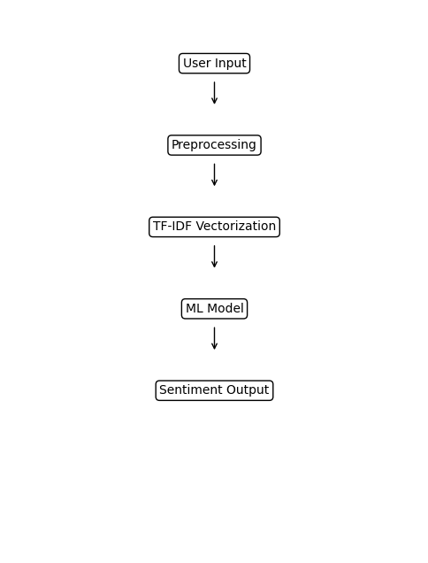

Context Diagram (0-Level DFD)
