Assignment # 1  
JAVASCRIPT

Module A  - Mobile & Cloud Computing

**ALERTS**

1. Write a script to greet your website visitor using JS alert box.
2. Write a script to display following message on your web page:

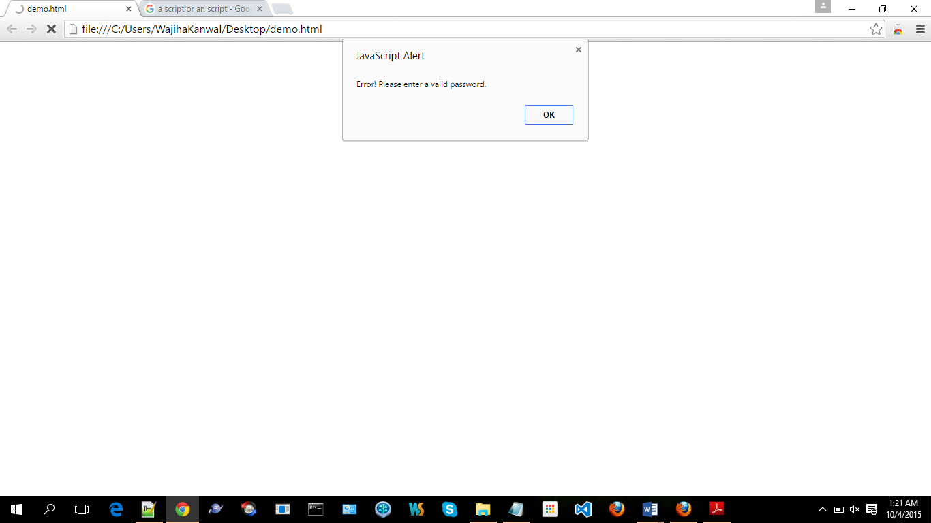

1. Write a script to display following message on your web page: (Hint : Use line break)

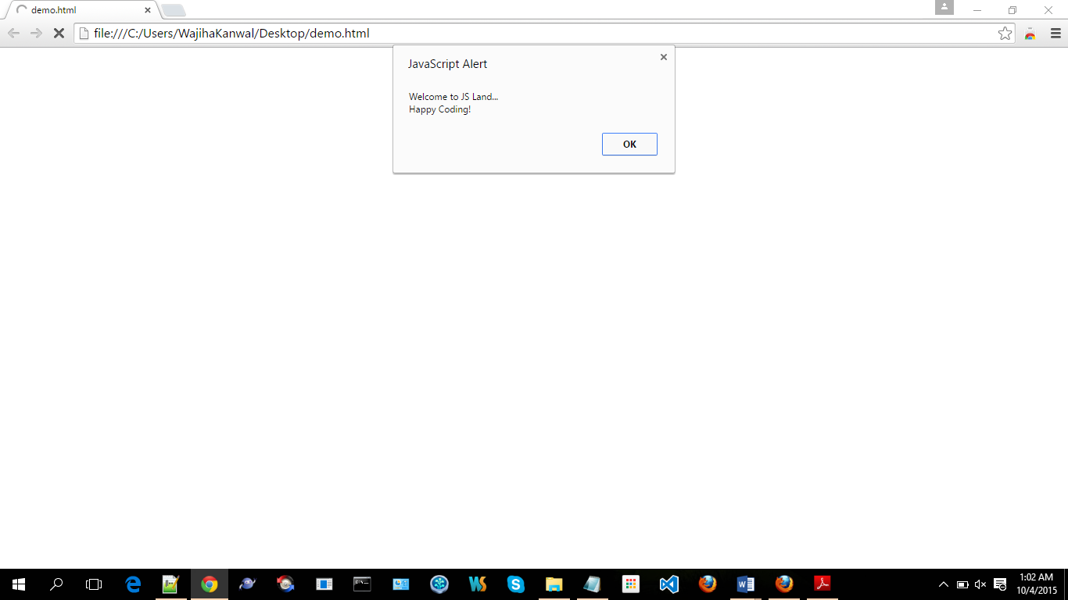

1. Write a script to display following messages in sequence:

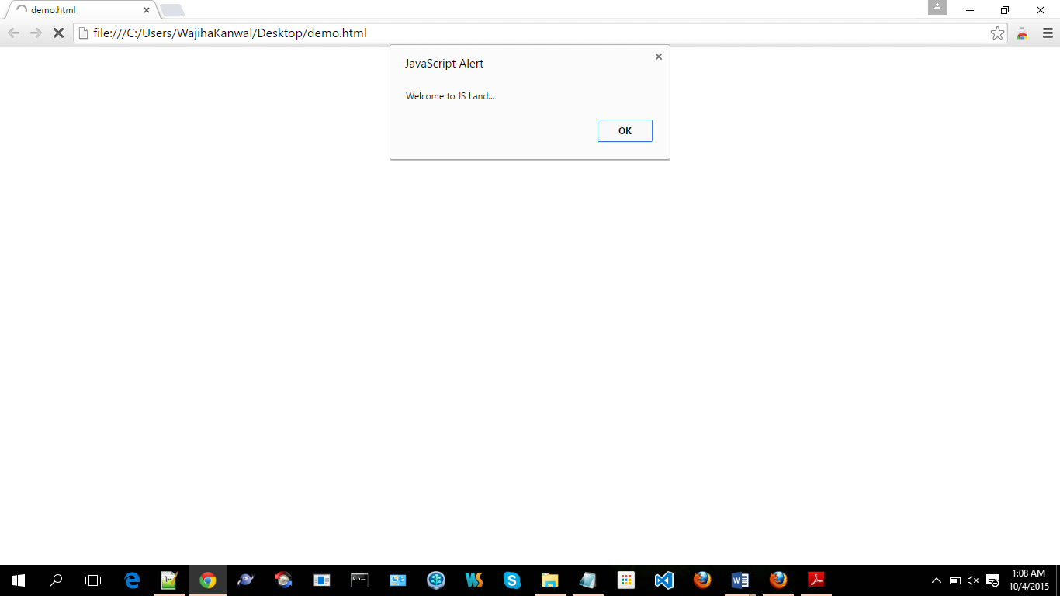

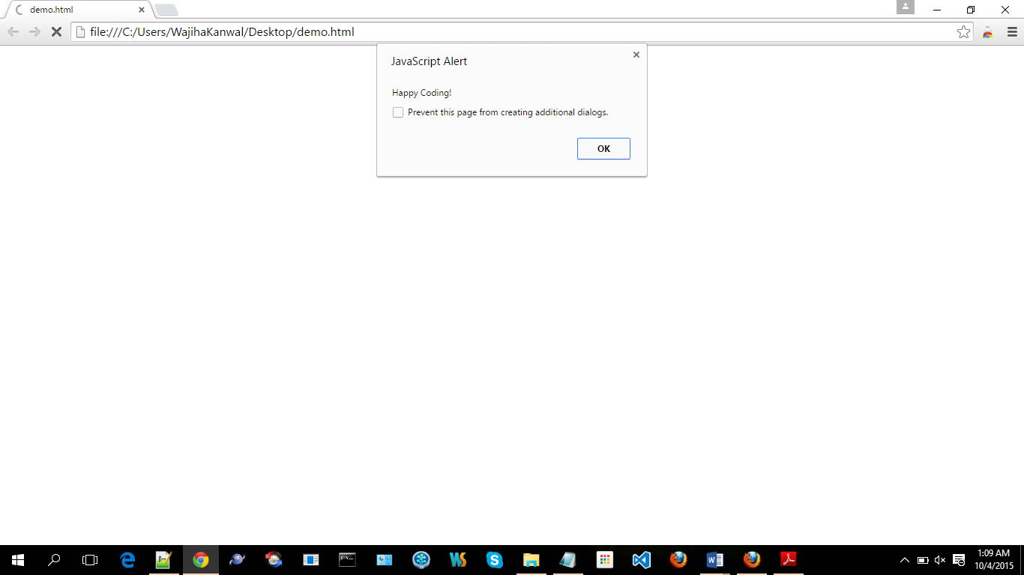

1. Generate the following message through browser’s developer console:

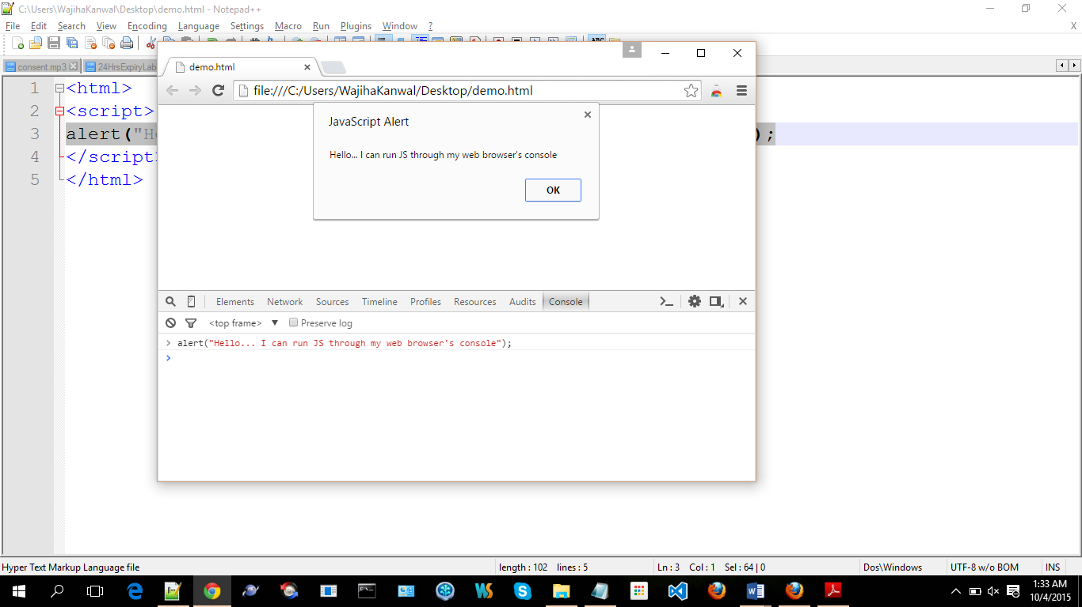

1. Make use of alerts in your new/existing HTML & CSS project.
2. Practice placement of <script></script> element in following sections of your project in exercise 6:
   1. Head
   2. Body (before your page’s HTML)
   3. Body (inside your page’s HTML)
   4. Body (after your page’s HTML)