SHUBAYR
شُبَيّر
Online Multi-Section Store — Web & Mobile Application
Software Engineering Analysis & System Design
وثيقة التحليل والتصميم الهندسي للنظام

Project / المشروع | Shubayr Online Store (Web + Mobile)
Document Type | Technical Analysis & Architecture Specification
Prepared for / أُعدّت لـ | Shubayr Development Team
Store Model | Single-owner, multi-section store (white-label)
Platforms | Web (Next.js) · Flutter (customer/delivery/admin + Web admin)
Version | 2.0 (incorporates team review)
Date | August 2026
Status | Approved for development

Confidential — prepared as an engineering blueprint for the Shubayr project team.

Table of Contents · المحتويات

1. Executive Summary 3
2. Project Overview & Vision 4
3. Project Scope 5
4. Stakeholders & User Roles 6
5. Functional Requirements 7
6. Non-Functional Requirements 9
7. Recommended Technology Stack 10
8. System Architecture 12
9. UML & System Diagrams 13
10. Database Design 24
11. API Design Overview 25
12. Security & Data Protection 26
13. Localization & RTL Support 27
14. Delivery Roadmap & Milestones 28
15. Budget Breakdown (US $10,000) 29
16. Recommended Team 30
17. Risks & Mitigations 31
18. Future Enhancements 32
19. Version 2.0 — Team Review Architecture 33
20. Appendix — Glossary 39

1. Executive Summary
الملخص التنفيذي
Shubayr is a full-scale online store built around the concept of a digital shopping mall: a single, trusted business offering many departments under one roof — phones and accessories, laptops and computers, home appliances, clothing, cosmetics, sports equipment, electricals, and a dedicated nursing and medical-supplies section, with room to add more departments over time.
This document is the engineering blueprint for delivering Shubayr as two coordinated products sharing one backend: a mobile application for iOS and Android built with Flutter, and a web storefront. It defines the recommended technology stack, the full set of UML diagrams (use case, class, entity-relationship, sequence, activity, state, component, and deployment), the data model, the API surface, security and localization requirements, a phased delivery roadmap, and a cost breakdown aligned with the project's US $10,000 budget.
For the first release, orders are settled by Cash on Delivery (COD). The architecture isolates payment behind a pluggable payment module, so online gateways (for example ZainCash, FastPay, Qi Card, or card processors) can be added later without reworking the order flow.
الملخص
«شُبَيّر» متجر إلكتروني متكامل يعمل كمجمّع تسوّق رقمي يضم أقسامًا متعددة (تليفونات وإكسسوارات، لابتوبات، أجهزة منزلية، ملابس، كوزماتك، أجهزة رياضية، كهربائيات، وقسم خاص بالتمريض والمستلزمات الطبية) مع إمكانية إضافة أقسام جديدة لاحقًا. توضّح هذه الوثيقة المكدّس التقني الموصى به، وجميع مخططات UML، ونموذج البيانات، وواجهات الـ API، ومتطلبات الأمان، وخطة التنفيذ، وتوزيع الميزانية ضمن حدود 10,000 دولار. الدفع في الإصدار الأول عبر الدفع عند الاستلام، مع تصميم يسمح بإضافة بوابات دفع إلكترونية لاحقًا.

2. Project Overview & Vision
نظرة عامة على المشروع والرؤية

2.1 Vision
Deliver the smoothest way for customers in the local market to shop across many product categories from one branded store, on the phone in their pocket or in a browser, with a checkout that is trusted (Cash on Delivery), fast, and fully Arabic-first while remaining bilingual.

2.2 Business Objectives
- Unified storefront: Give one business a single online presence covering all of its departments.
- Wider reach: Increase reach and sales beyond the physical shop through mobile and web.
- Operational control: Give staff a simple dashboard to manage products, stock, orders, and delivery.
- Future-proof: Build on a foundation that scales to more departments and online payments later.

2.3 Store Departments (Sections)
The store is organized into departments, each acting like a section of a mall. Categories are hierarchical, so each department can hold sub-categories (e.g. Phones → Smartphones, Chargers, Cases).
# | Department (English) | القسم (بالعربية) | Example sub-categories
1 | Phones & Accessories | تليفونات وإكسسوارات | Smartphones, chargers, cases, earphones
2 | Laptops & Computers | لابتوبات وحواسيب | Laptops, monitors, keyboards, storage
3 | Home & Appliances | أجهزة منزلية | Kitchen, cleaning, small appliances
4 | Clothing & Fashion | ملابس وأزياء | Men, women, kids, footwear
5 | Cosmetics & Beauty | كوزماتك ومستحضرات تجميل | Skincare, makeup, fragrance
6 | Sports Equipment | أجهزة رياضية | Fitness gear, supplements, apparel
7 | Electricals & Electronics | كهربائيات وإلكترونيات | Cables, lighting, small electronics
8 | Nursing & Medical Supplies | قسم التمريض والمستلزمات الطبية | First aid, care supplies, devices

Additional departments can be added by staff at any time without code changes, thanks to the dynamic category model.

3. Project Scope
نطاق المشروع

3.1 In Scope
- Customer mobile app (Flutter, iOS + Android) and responsive web storefront.
- Staff admin dashboard for catalog, inventory, orders, delivery, promotions, and reports.
- OTP-based phone registration and login, customer profiles and multiple delivery addresses.
- Product catalog with hierarchical departments, variants, images, search, filtering, and reviews.
- Cart, wishlist, coupons, and Cash-on-Delivery checkout.
- Order lifecycle management, delivery assignment, and status tracking with push/SMS notifications.
- Arabic + English localization with full right-to-left (RTL) support; currency in IQD.

3.2 Out of Scope (Phase 1)
- Online/card payment gateways (designed for, but integrated in a later phase).
- Multi-vendor marketplace (multiple independent sellers) — single-owner model for now.
- Advanced AI recommendations and loyalty/points program (future enhancement).
- In-app live chat / customer-service ticketing (future enhancement).

3.3 Assumptions
- One business owns and fulfils all inventory; there is one central stock.
- Delivery is handled by the store's own agents within defined delivery zones.
- The client provides product data, images, branding, and an SMS/OTP provider account.
- Cash on Delivery is the only payment method at launch.
الملخص
يشمل النطاق تطبيق الهاتف (Flutter) ومتجر الويب ولوحة تحكم الموظفين، مع تسجيل الدخول عبر رمز التحقق OTP، وكتالوج منتجات بأقسام متعددة، وسلة ومفضلة وكوبونات، والدفع عند الاستلام، وتتبّع الطلبات، ودعم كامل للغة العربية (RTL). لا يشمل الإصدار الأول بوابات الدفع الإلكتروني ولا نموذج البائعين المتعددين، وهي مؤجلة لمراحل لاحقة مع تصميم يسمح بإضافتها.

4. Stakeholders & User Roles
الأطراف المعنية وأدوار المستخدمين
The system uses Role-Based Access Control (RBAC). Each role sees only the features it is permitted to use.
Role | الدور | Key capabilities
Guest | زائر | Browse and search products, view details, register/login.
Customer | زبون | Cart, wishlist, place COD orders, track orders, reviews, manage profile & addresses.
Delivery Agent | مندوب توصيل | View assigned deliveries, update delivery status.
Store Manager | مدير المتجر | Manage products, categories, inventory, orders, promotions.
Admin | مسؤول النظام | All manager rights plus users & roles, settings, reports & analytics.

5. Functional Requirements
المتطلبات الوظيفية
Requirements are grouped by module. Each is a capability the delivered system must provide.
ID | Module | Requirement
FR-1 | Accounts & Auth | Phone + OTP registration/login, JWT sessions, profile, multiple addresses, RBAC.
FR-2 | Catalog | Hierarchical departments/categories, products, variants (size/color), images, price & sale price.
FR-3 | Search & Browse | Full-text search, filter by department/price/rating, sorting, pagination.
FR-4 | Product & Reviews | Product detail pages, stock/availability, customer ratings and moderated reviews.
FR-5 | Cart & Wishlist | Add/update/remove items, persistent cart, wishlist, live totals.
FR-6 | Checkout & Orders | Address selection, coupon application, COD order placement, order summary.
FR-7 | Order Management | Status workflow, order history, cancellation, re-order, invoices.
FR-8 | Delivery | Assign delivery agent, update delivery status, delivery zones & fees.
FR-9 | Promotions | Coupons (percentage/fixed), validity windows, usage limits, banners.
FR-10 | Admin Dashboard | CRUD for catalog, inventory adjustments, order processing, user management.
FR-11 | Inventory | Stock tracking, low-stock alerts, automatic decrement on order.
FR-12 | Notifications | Push (FCM) and SMS for OTP, order confirmation, and status changes.
FR-13 | Reports | Sales, top products, revenue by department, low-stock and order reports.
FR-14 | Localization | Arabic/English UI, RTL layout, IQD currency formatting.

6. Non-Functional Requirements
المتطلبات غير الوظيفية
Attribute | Target / Approach
Performance | API p95 response < 300 ms; product listing loads < 2 s on 4G; image lazy-loading & CDN.
Scalability | Stateless API behind a load balancer; horizontal scaling; Redis caching of hot catalog data.
Availability | Target 99.5% uptime; automated daily database backups; health checks & auto-restart.
Security | TLS everywhere, hashed OTP, RBAC, rate limiting, input validation, OWASP Top-10 hardening.
Usability | Clean Arabic-first UX, RTL and LTR, large tap targets, 3-tap path to checkout.
Localization | Arabic + English content, RTL layout mirroring, IQD currency, local date formats.
Compatibility | Android 8.0+, iOS 13+, latest Chrome/Safari/Edge/Firefox.
Maintainability | Modular service layout, coding standards, automated tests, API documentation.
Observability | Centralized logging, error tracking (e.g. Sentry), uptime & performance monitoring.
Privacy | Minimal PII, secure storage of phone numbers/addresses, data-access controls.

الملخص
تشمل المتطلبات غير الوظيفية الأداء (زمن استجابة منخفض وتحميل سريع)، وقابلية التوسّع الأفقي، والتوفّر بنسبة 99.5%، والأمان الشامل (تشفير، صلاحيات، حماية OWASP)، وسهولة الاستخدام، ودعم العربية RTL وعملة الدينار العراقي، والتوافق مع الأجهزة والمتصفحات الحديثة، وقابلية الصيانة والمراقبة وحماية الخصوصية.

7. Recommended Technology Stack
المكدّس التقني الموصى به
The stack is chosen for the best balance of quality, speed of delivery, hiring availability in the region, and cost — appropriate for a US $10,000 single-owner store that must grow gracefully.

7.1 Stack Overview
Layer | Technology | Why it was chosen
Mobile app | Flutter (Dart) | One codebase for iOS + Android, excellent Arabic/RTL support, near-native performance, fast to build — best value for the budget.
Web storefront | Next.js (React) | Server-side rendering for SEO and fast first load — important for an online store to be found on Google.
Admin dashboard | Laravel Filament / React | Rapid, secure back-office CRUD out of the box; saves significant build time.
Backend / API | Laravel 13 (PHP 8.x) | Mature e-commerce ecosystem, quick to build, large regional talent pool, low hosting cost. Exposes a clean REST/JSON API.
Database | PostgreSQL | Reliable, powerful relational engine with strong integrity for orders, stock, and money.
Cache & Queues | Redis | Caching hot catalog data, sessions, and background job queues (notifications, emails).
Search | Meilisearch | Fast, typo-tolerant Arabic/English product search.
Media storage | S3-compatible object storage | Scalable, cheap storage for product images, served via CDN.
Push notifications | Firebase Cloud Messaging | Free, reliable push to Android and iOS.
SMS / OTP | Local SMS gateway | Phone verification and order alerts for the local market.
Auth | Laravel Sanctum / JWT | Token-based auth for mobile and web from one backend.
Infrastructure | Docker on a VPS / cloud | Reproducible deployments; low monthly cost; easy to scale up later.
CI/CD | GitHub Actions | Automated tests and deployments; higher quality, fewer manual errors.
Monitoring | Sentry + uptime monitor | Catch errors and downtime early.

7.2 Architecture Style
A modular, service-oriented monolith: one Laravel backend internally organized into clear service modules (Catalog, Cart, Orders, Inventory, Users/Auth, Payments, Promotions, Notifications, Reporting). This keeps the system simple and cheap to run now, while the clean module boundaries make it straightforward to split a module into its own service later if traffic grows.

7.3 Payment Design (COD-first, pluggable)
Checkout depends on a PaymentMethod interface, not on any specific provider. Cash on Delivery is the only implementation at launch. Adding ZainCash, FastPay, Qi Card, or a card gateway later means writing a new implementation of the same interface — the cart, order, and checkout code do not change (Strategy pattern).
الملخص
تم اختيار Flutter لتطبيق الهاتف (كود واحد لنظامي iOS وAndroid مع دعم ممتاز للعربية)، وNext.js لمتجر الويب (أداء وSEO)، وLaravel كخلفية توفّر واجهة API نظيفة مع قاعدة بيانات PostgreSQL وذاكرة تخزين Redis. البنية عبارة عن «مونوليث معياري» سهل التشغيل والتكلفة، والدفع مصمّم عبر واجهة قابلة للتوسعة تبدأ بالدفع عند الاستلام وتسمح بإضافة بوابات دفع لاحقًا.

8. System Architecture
معمارية النظام
The diagram below shows how the client apps, the API, the data stores, and external services fit together. Client apps talk only to the API; the API owns all business logic and data access; heavy or slow work (push, SMS) runs in background queue workers.
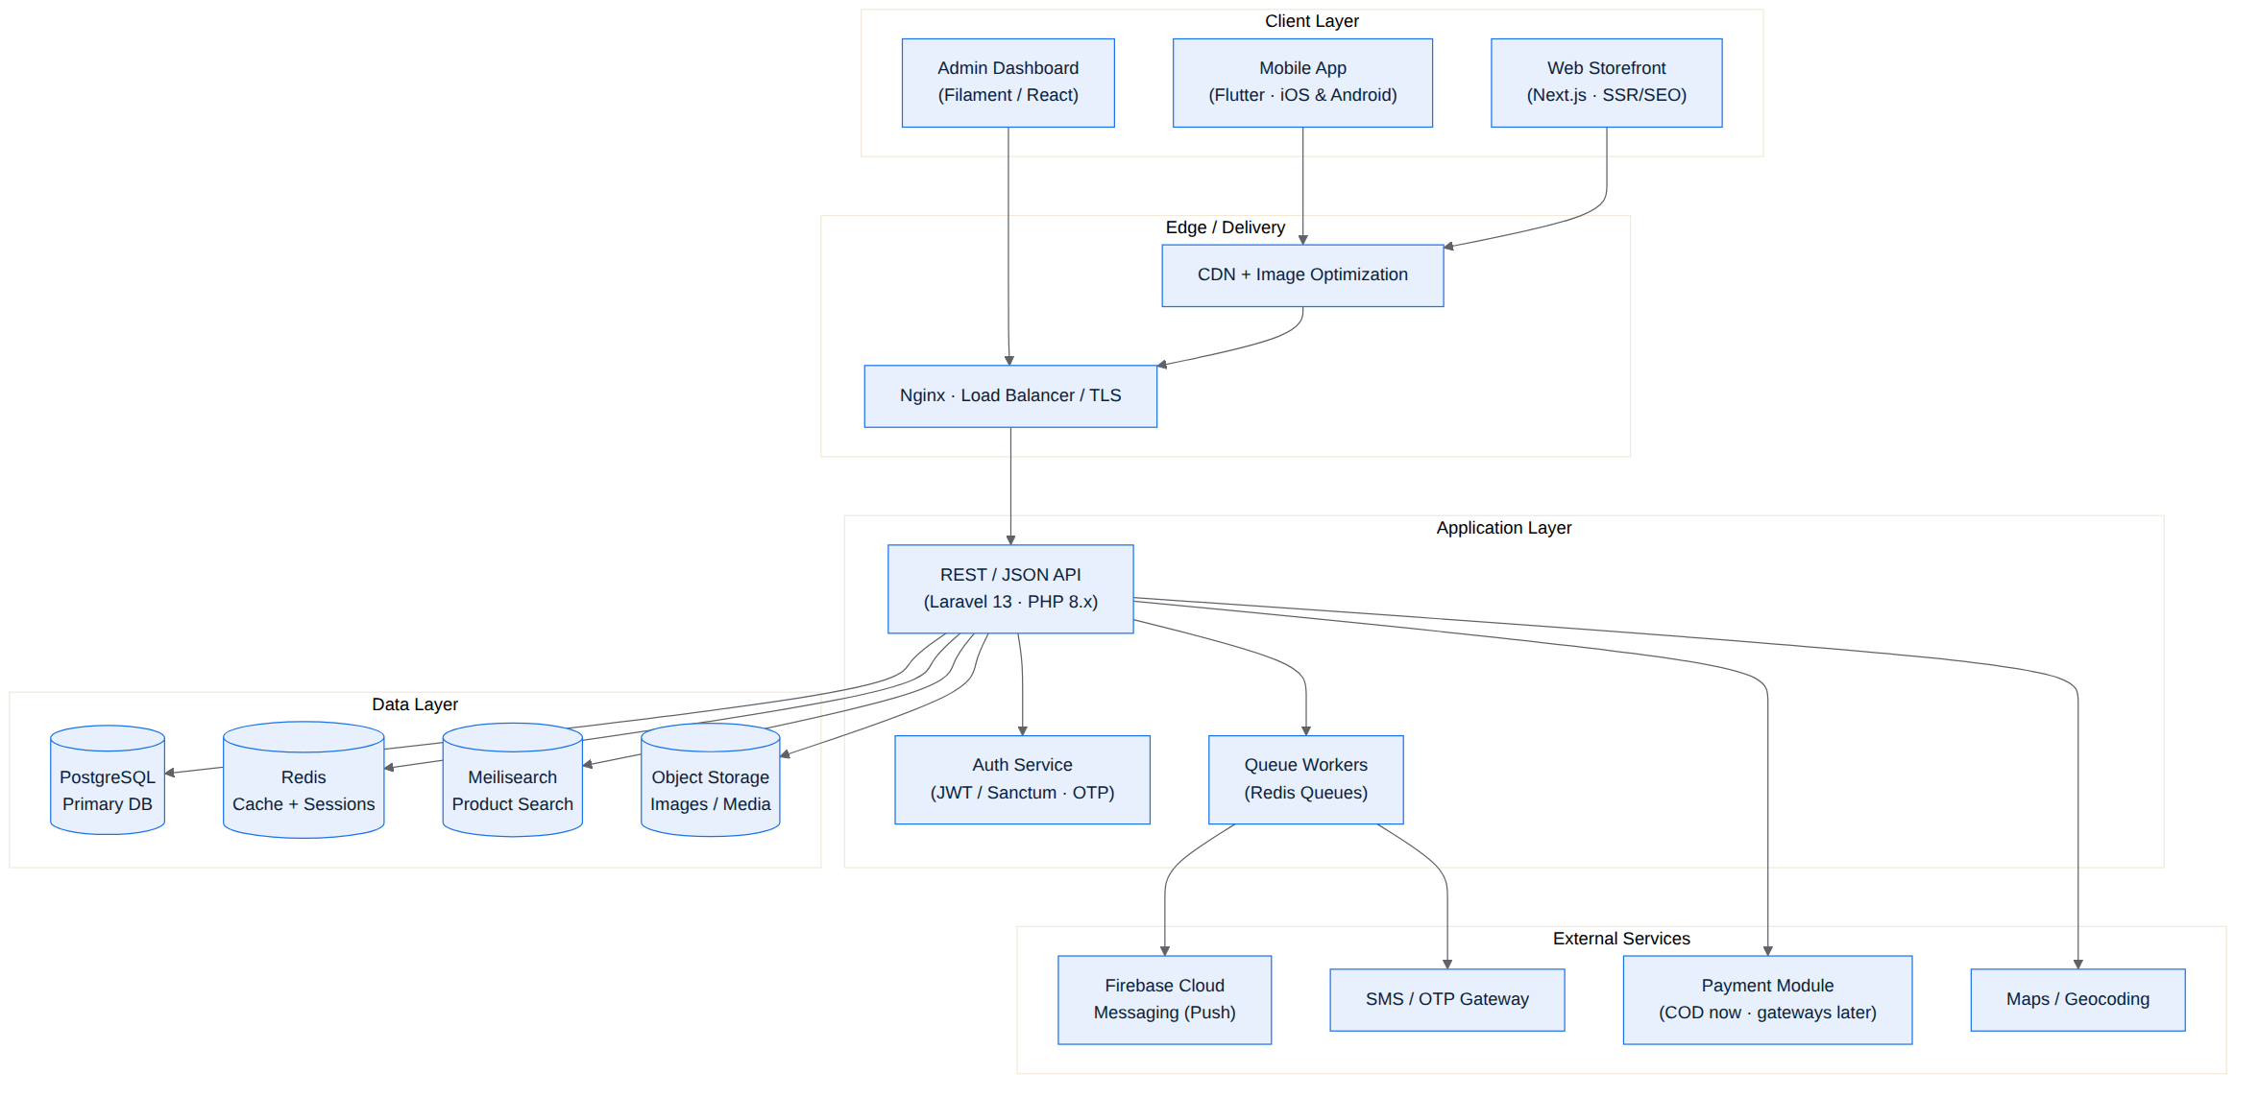
Figure 1. High-level system architecture of the Shubayr platform.
الشكل 1: المعمارية العامة لمنصة شُبَيّر.

9. UML & System Diagrams
مخططات UML ومخططات النظام
This section contains the full set of UML diagrams that the development team will implement against.

9.1 Use Case Diagram
Shows every actor (Guest, Customer, Delivery Agent, Store Manager, Admin) and the actions each can perform inside the system boundary.
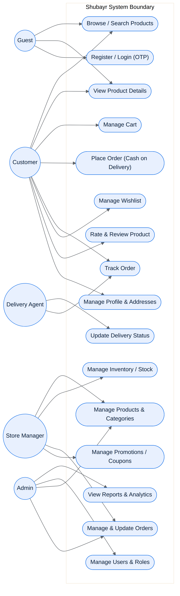
Figure 2. Use case diagram — actors and their interactions.
الشكل 2: مخطط حالات الاستخدام — الفاعلون وتفاعلاتهم مع النظام.

9.2 Class Diagram
The object model: the main domain classes, their attributes and key methods, and the relationships and multiplicities between them. This maps directly to the backend models.
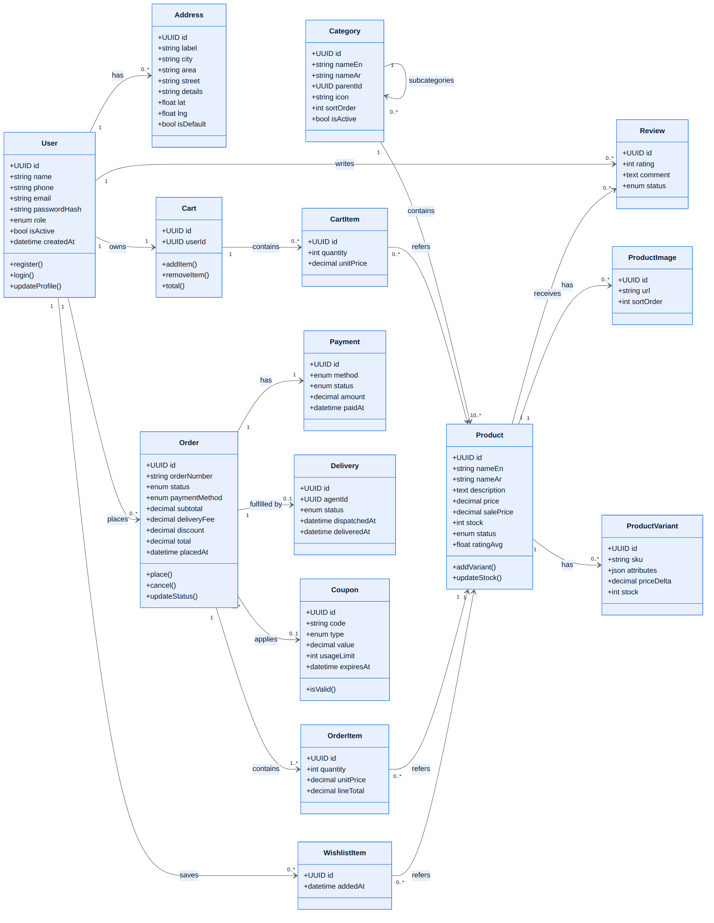
Figure 3. Class diagram — domain model and relationships.
الشكل 3: مخطط الأصناف — النموذج الكائني والعلاقات.

9.3 Entity-Relationship (Data Model)
Following the team review the data model grew significantly, so it is presented as two related views: the commerce core (users, RBAC, catalog, orders, loyalty, ratings) and the inventory & supply chain (suppliers, purchasing, batches, warehouses, stock movements, reservations, picking, returns). Together they form the PostgreSQL schema in infra/db/schema.sql.
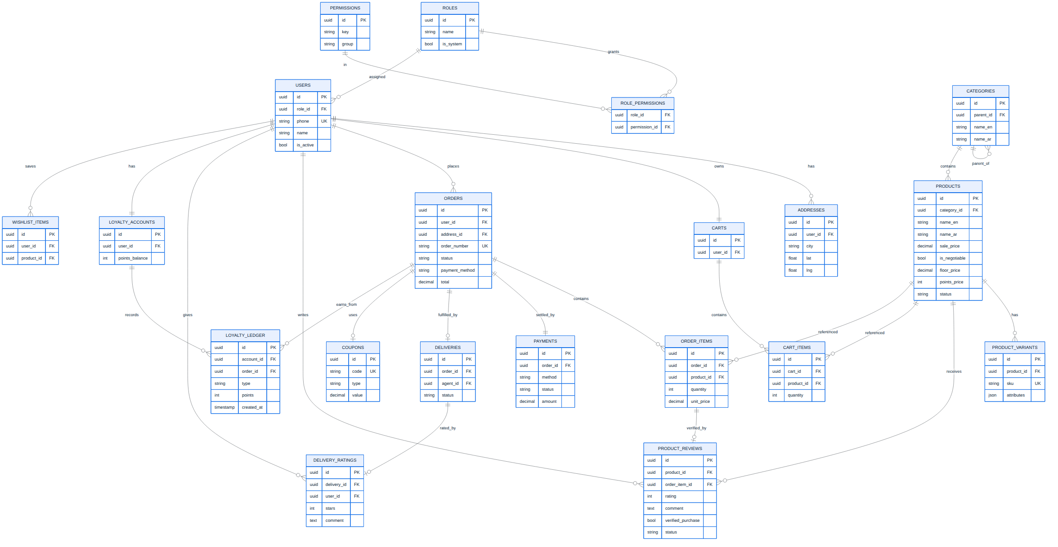
Figure 4. ER diagram (A) — commerce core: users/RBAC, catalog, orders, loyalty, ratings.
الشكل 4: مخطط الكيانات (أ) — نواة التجارة: المستخدمون والصلاحيات، الكتالوج، الطلبات، الولاء، التقييمات.
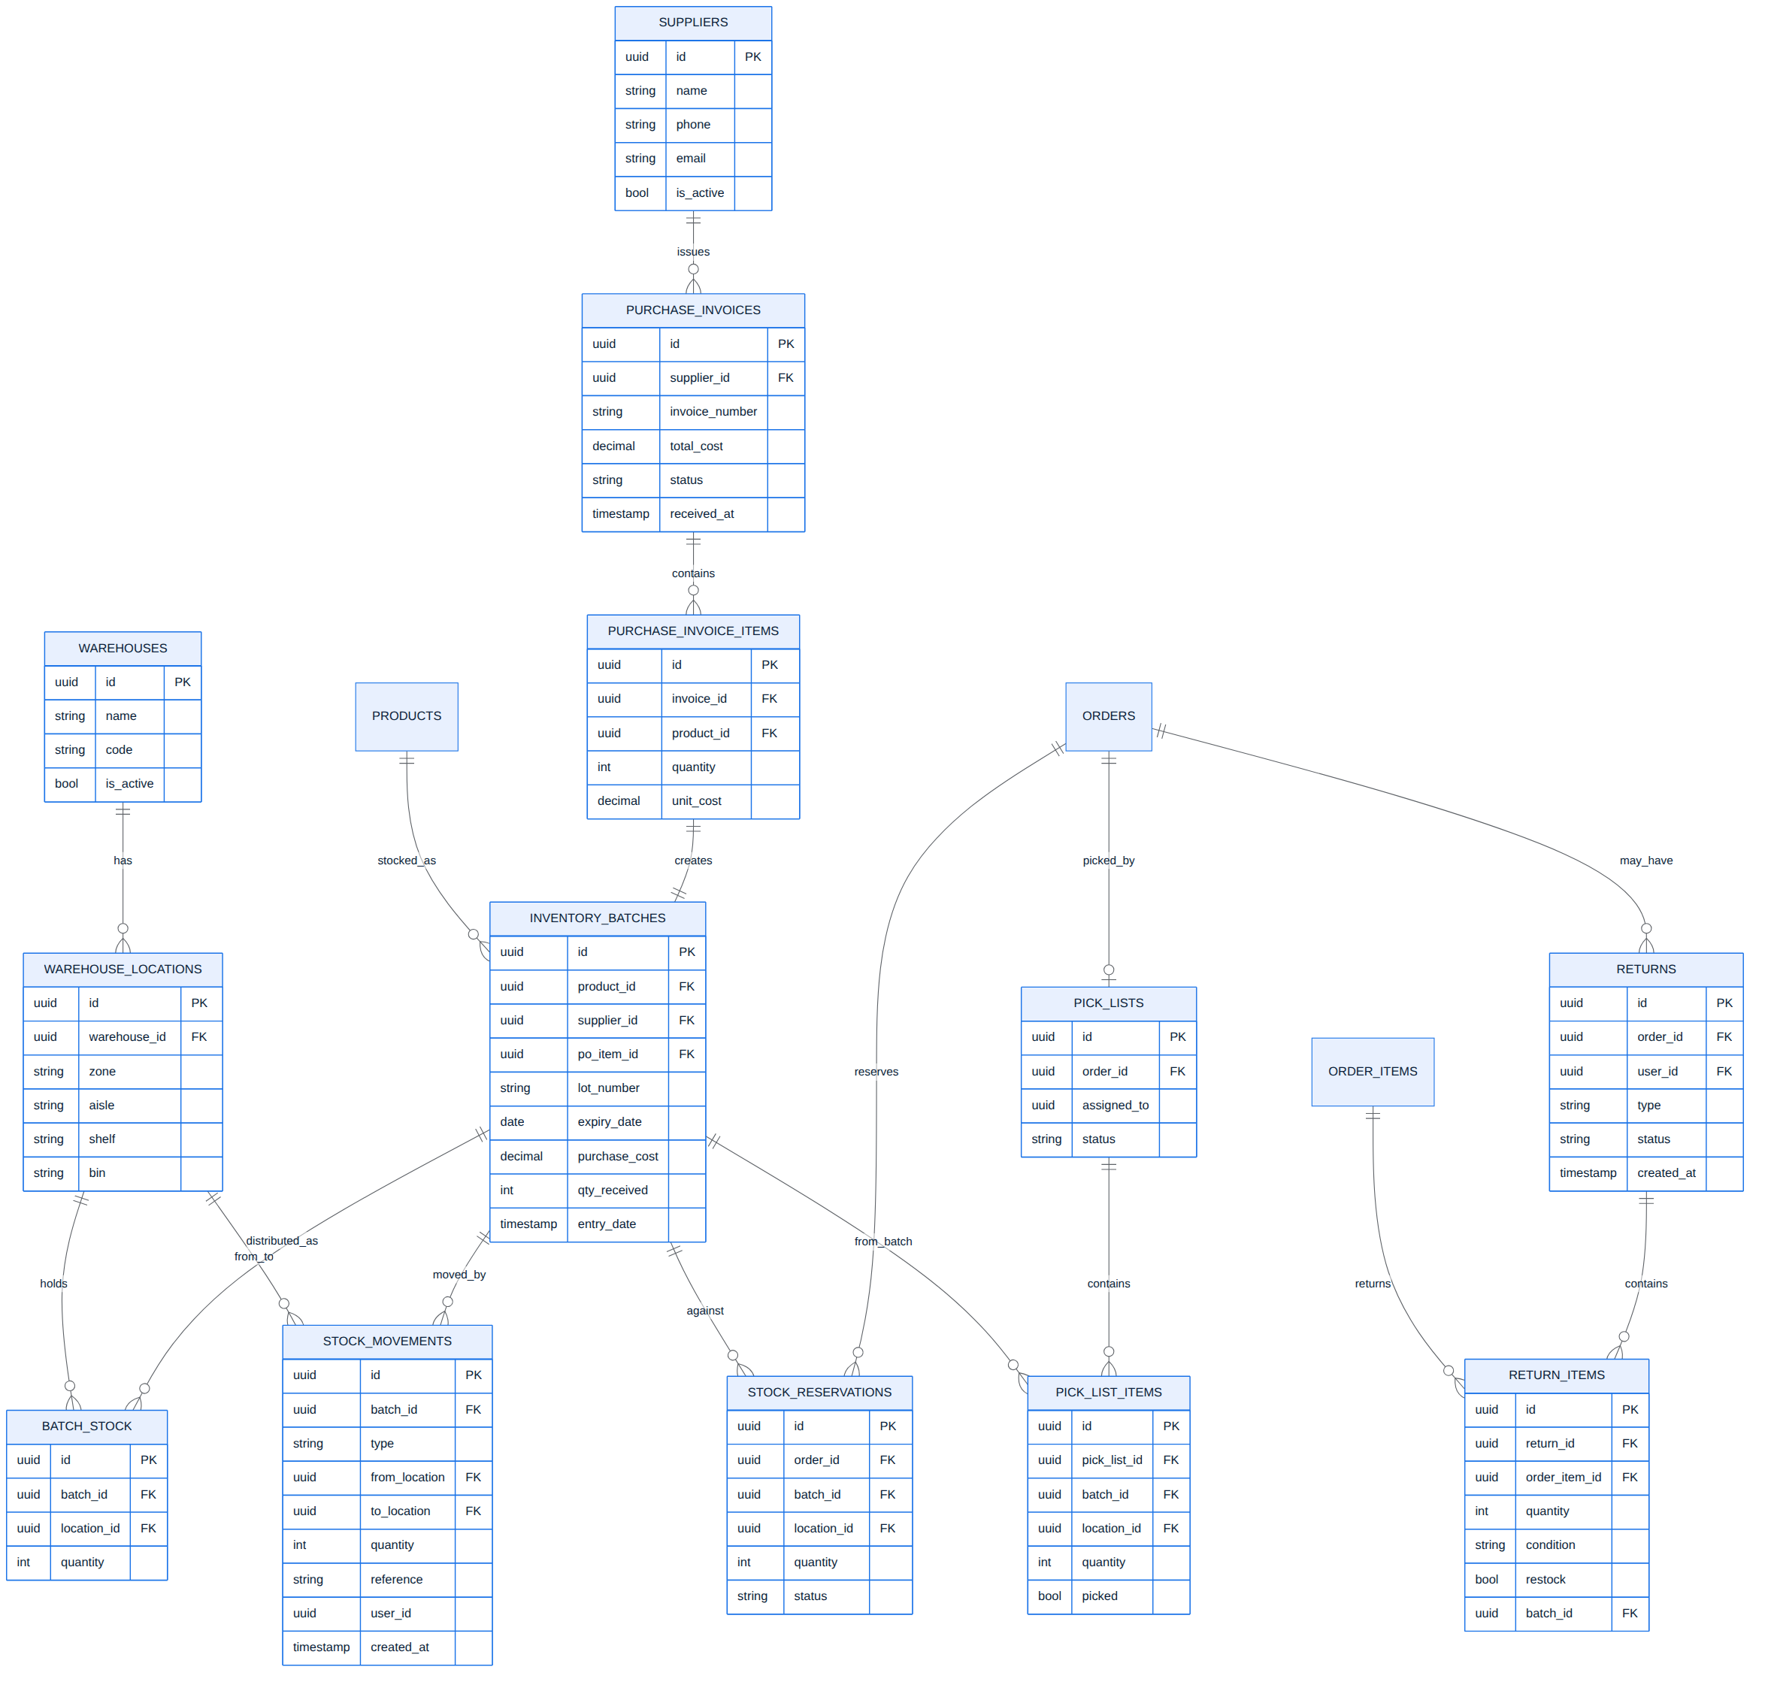
Figure 5. ER diagram (B) — inventory & supply: suppliers, purchasing, batches, locations, movements, reservations, picking, returns.
الشكل 5: مخطط الكيانات (ب) — المخزون والتجهيز: المجهزون، المشتريات، الدفعات، المواقع، الحركات، الحجز، السحب، المرتجعات.

9.4 Sequence Diagram — Checkout (Cash on Delivery)
Step-by-step message flow when a customer places a COD order, including the stock check, order creation, stock decrement, and confirmation notification.
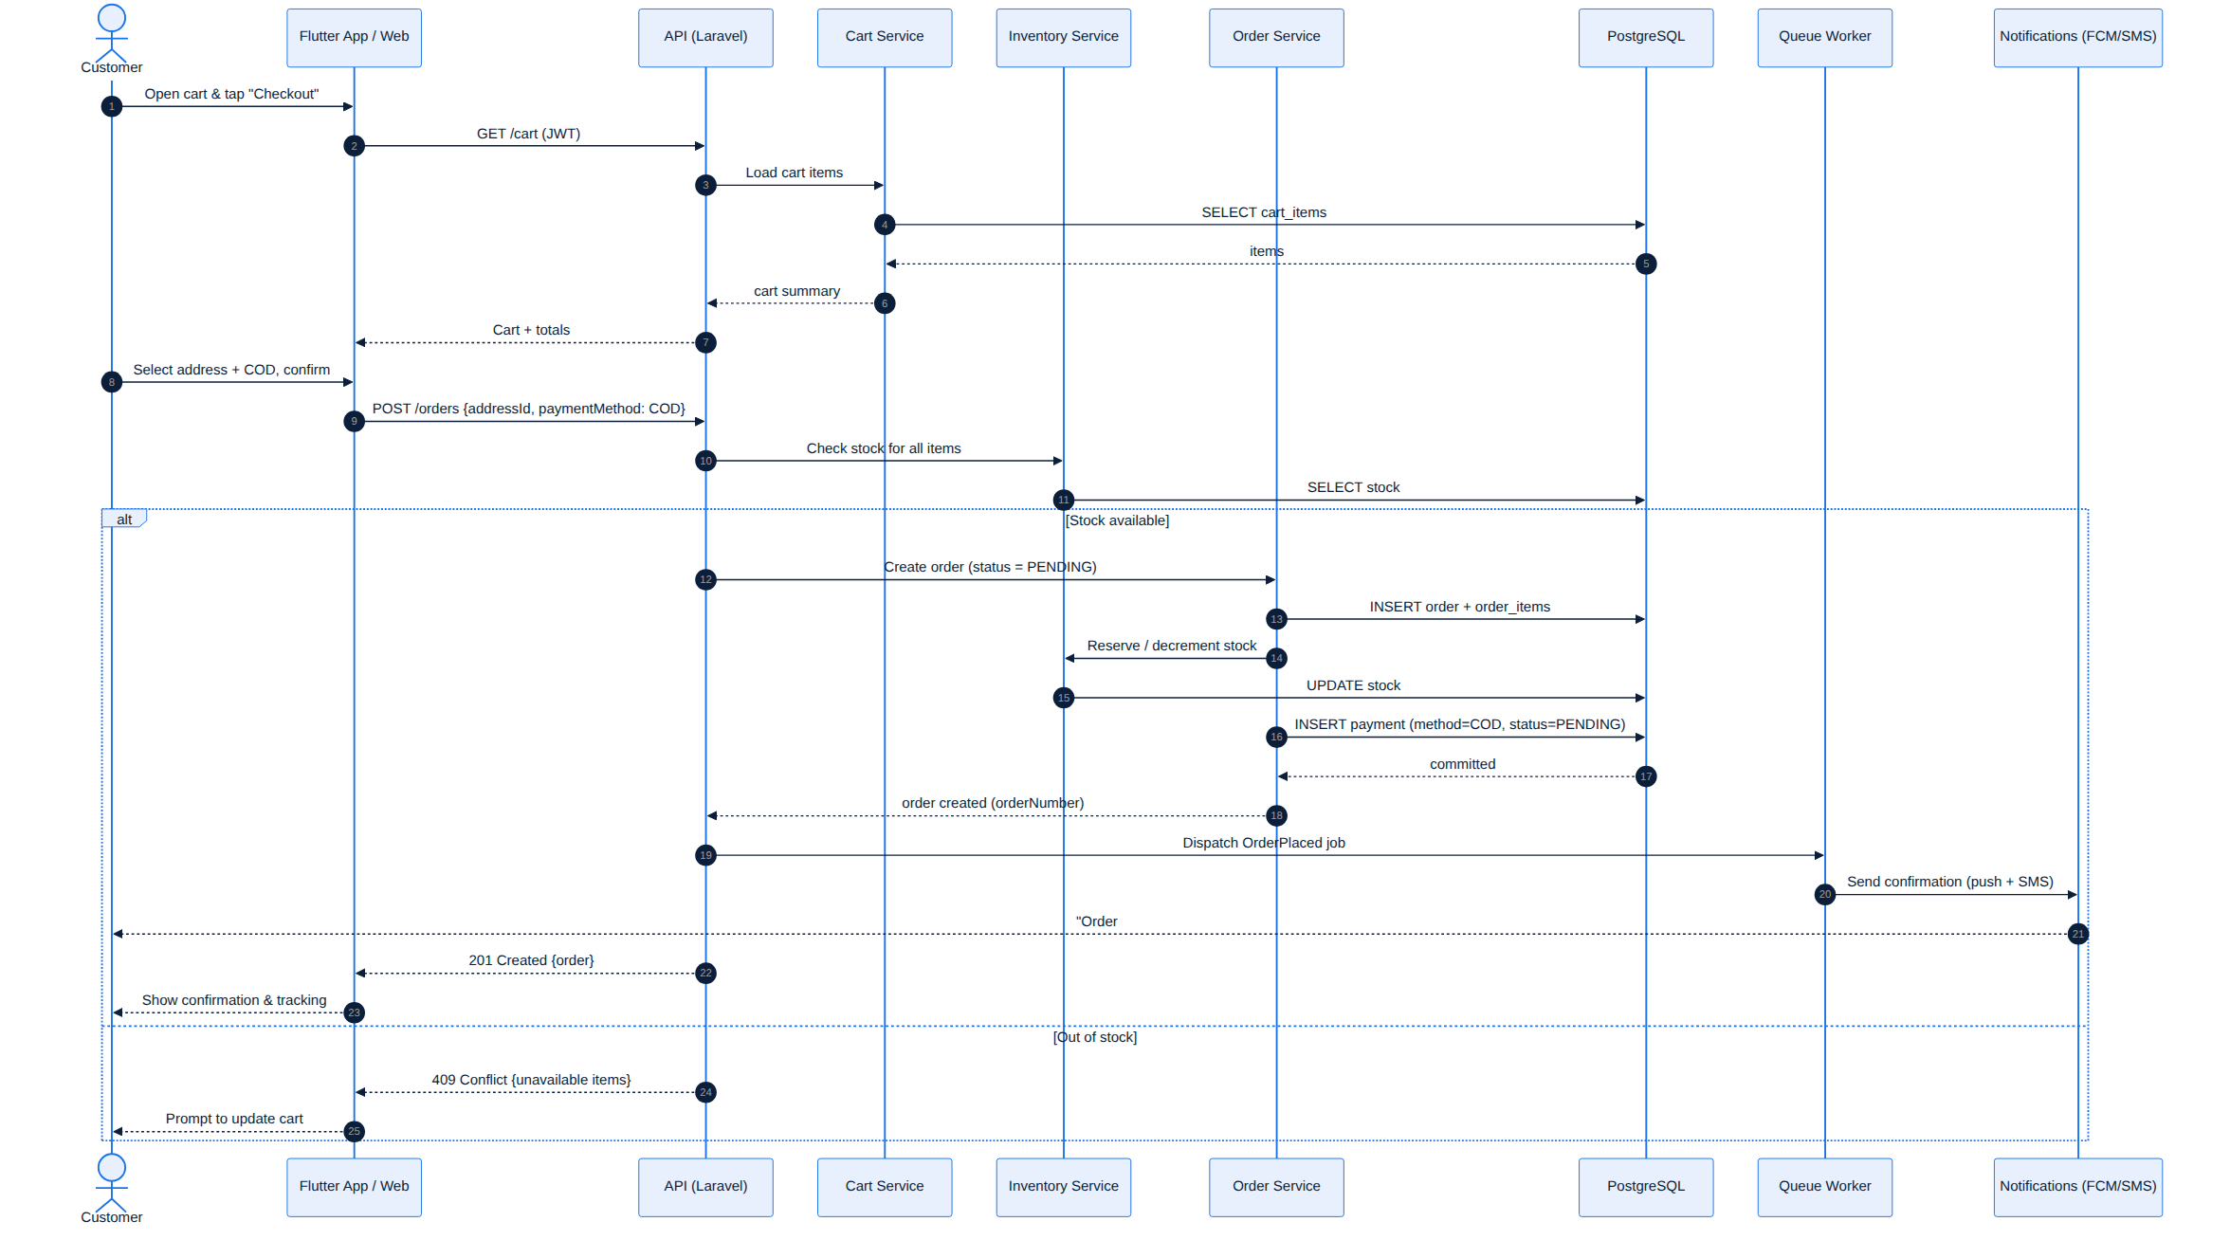
Figure 6. Sequence diagram — placing a Cash-on-Delivery order.
الشكل 6: مخطط التتابع — إتمام طلب بالدفع عند الاستلام.

9.5 Sequence Diagram — Registration / Login (OTP)
How phone-based registration and login work using a one-time password sent by SMS, ending with issued JWT tokens.
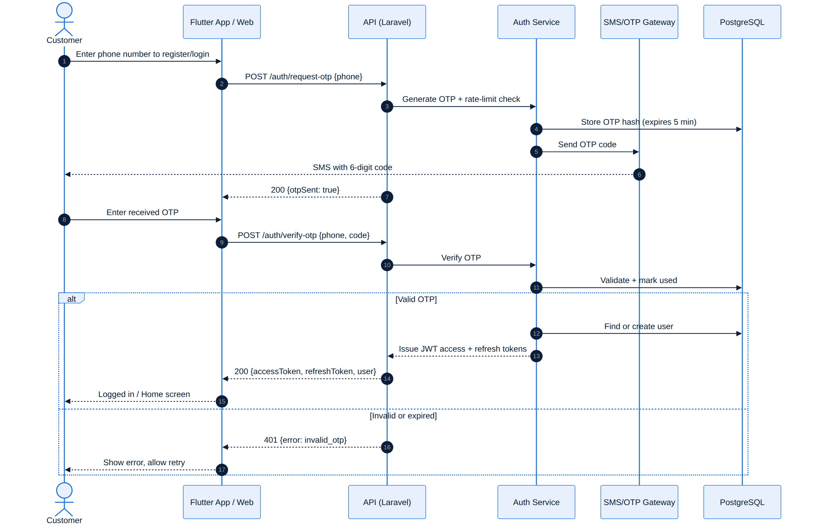
Figure 7. Sequence diagram — OTP registration and login.
الشكل 7: مخطط التتابع — التسجيل والدخول عبر رمز التحقق OTP.

9.6 Sequence Diagram — Order Tracking & Status Updates
How staff confirm and progress an order, how the delivery agent updates status, and how the customer receives live push notifications and a tracking timeline.
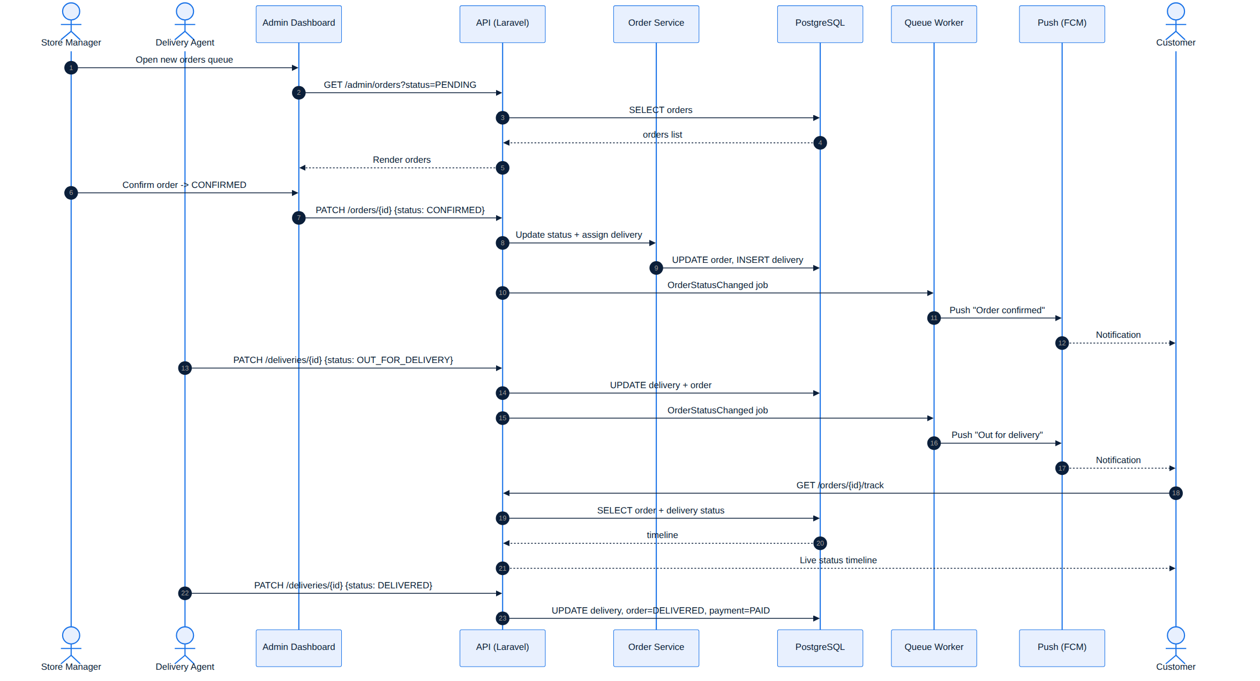
Figure 8. Sequence diagram — order processing, delivery, and tracking.
الشكل 8: مخطط التتابع — معالجة الطلب والتوصيل والتتبّع.

9.7 Activity Diagram — Shopping to Order
The end-to-end customer journey as a workflow, including the decision points (login required, coupon, stock availability, confirmation).
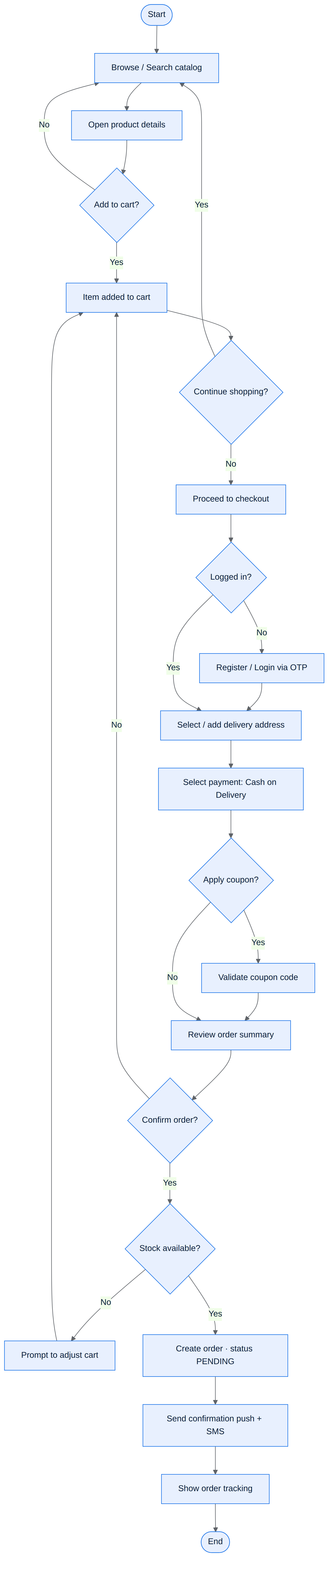
Figure 9. Activity diagram — from browsing to a placed order.
الشكل 9: مخطط النشاط — من التصفّح حتى تأكيد الطلب.

9.8 State Diagram — Order Lifecycle
Every state an order can be in and the events that move it between states, from placement to delivery, cancellation, or return.
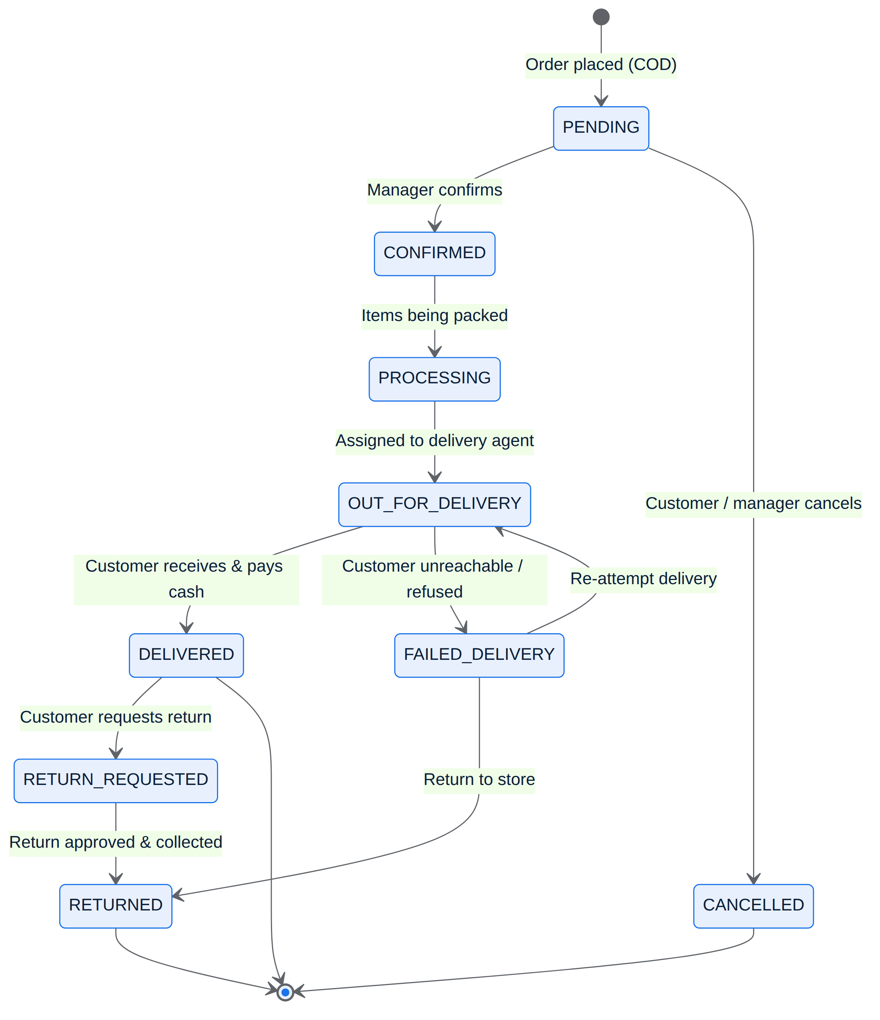
Figure 10. State machine diagram — order lifecycle.
الشكل 10: مخطط الحالات — دورة حياة الطلب.

9.9 Component Diagram
The internal software components — presentation, API gateway, domain services, and infrastructure — and how they depend on one another.
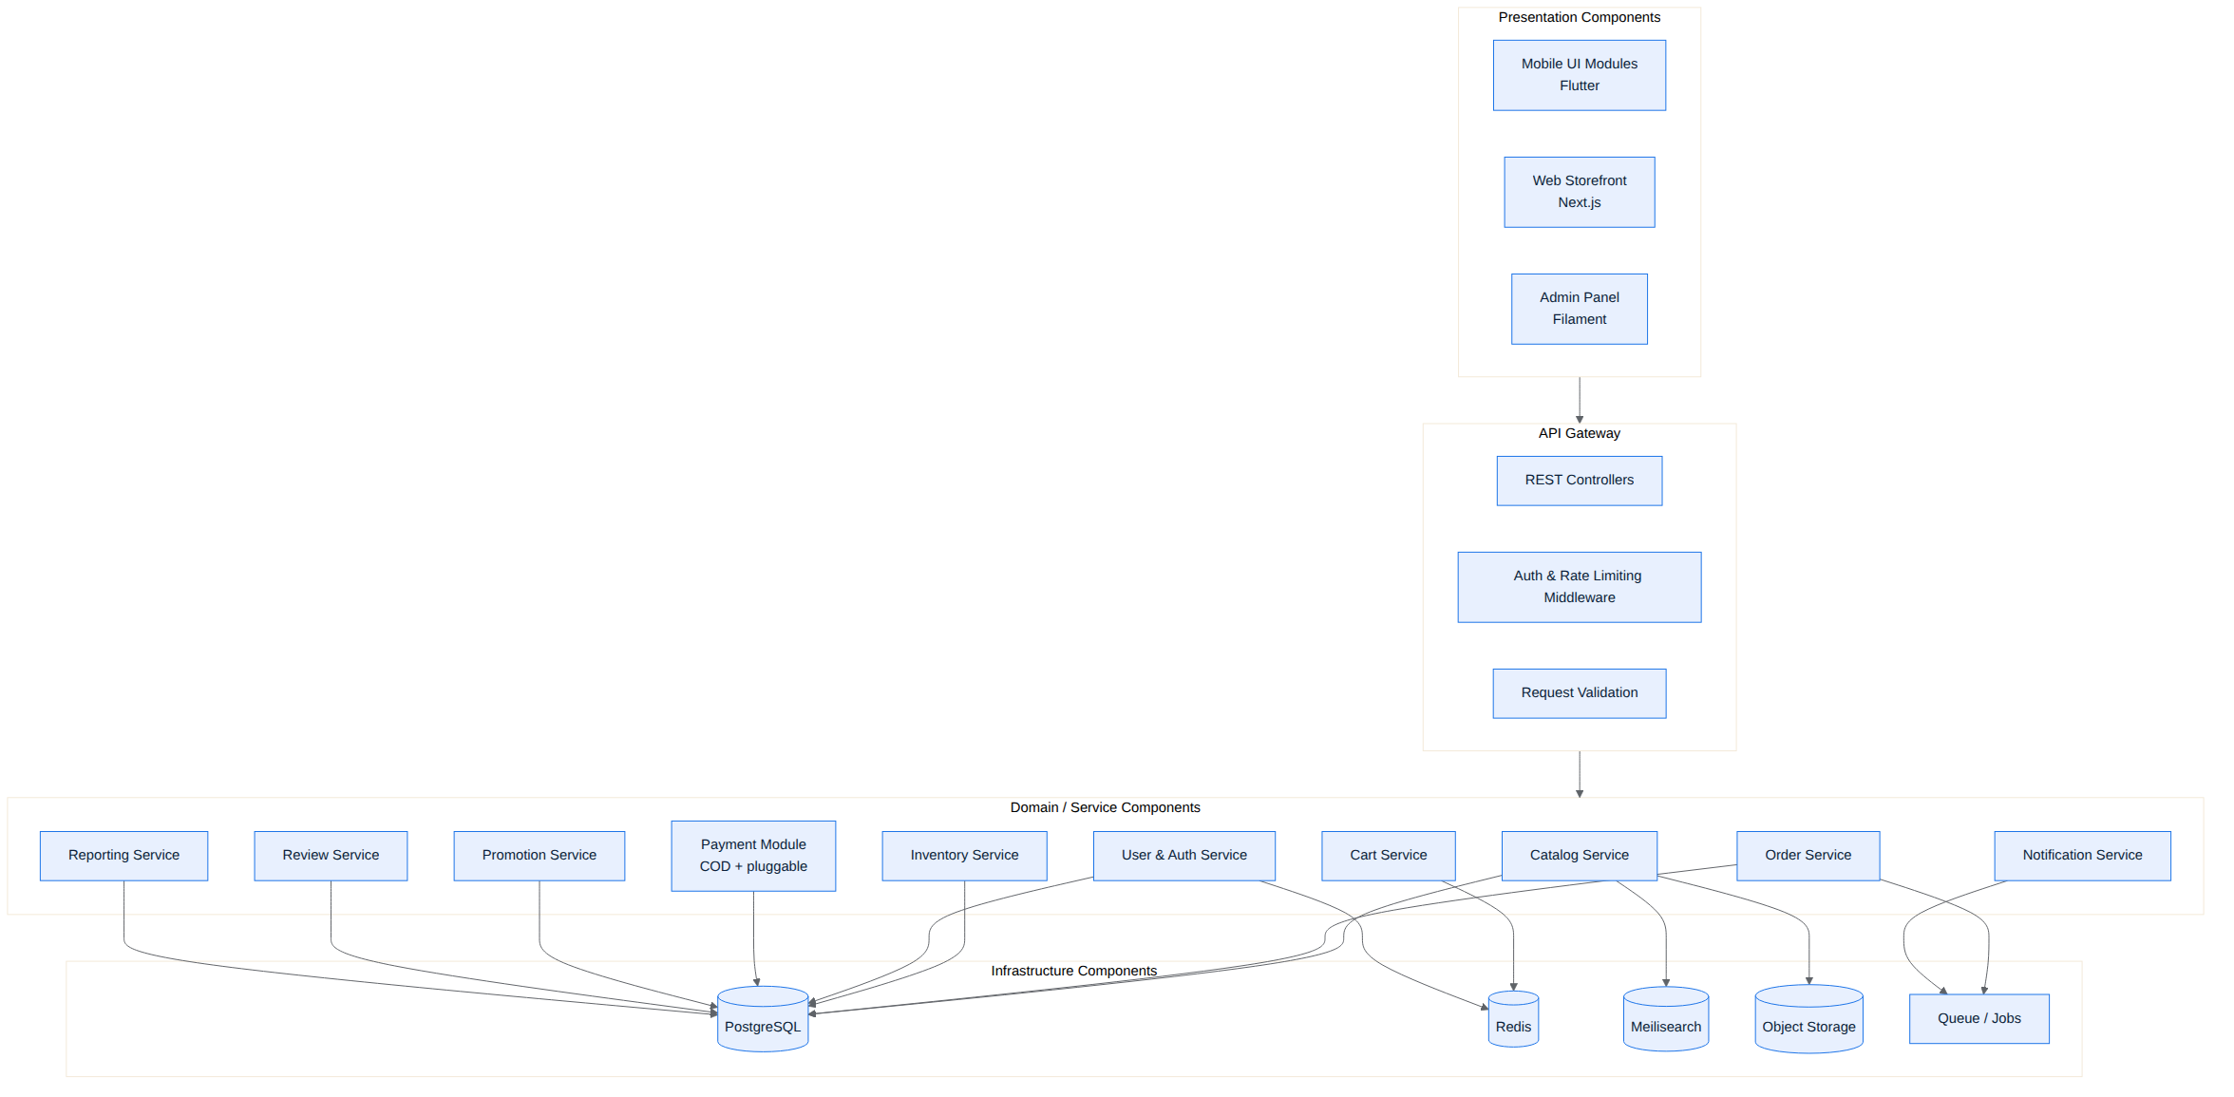
Figure 11. Component diagram — software components and dependencies.
الشكل 11: مخطط المكوّنات — مكوّنات النظام والاعتماديات بينها.

9.10 Deployment Diagram
How the software is deployed onto infrastructure: user devices, the cloud tiers (web, app, data), object storage, and third-party managed services.
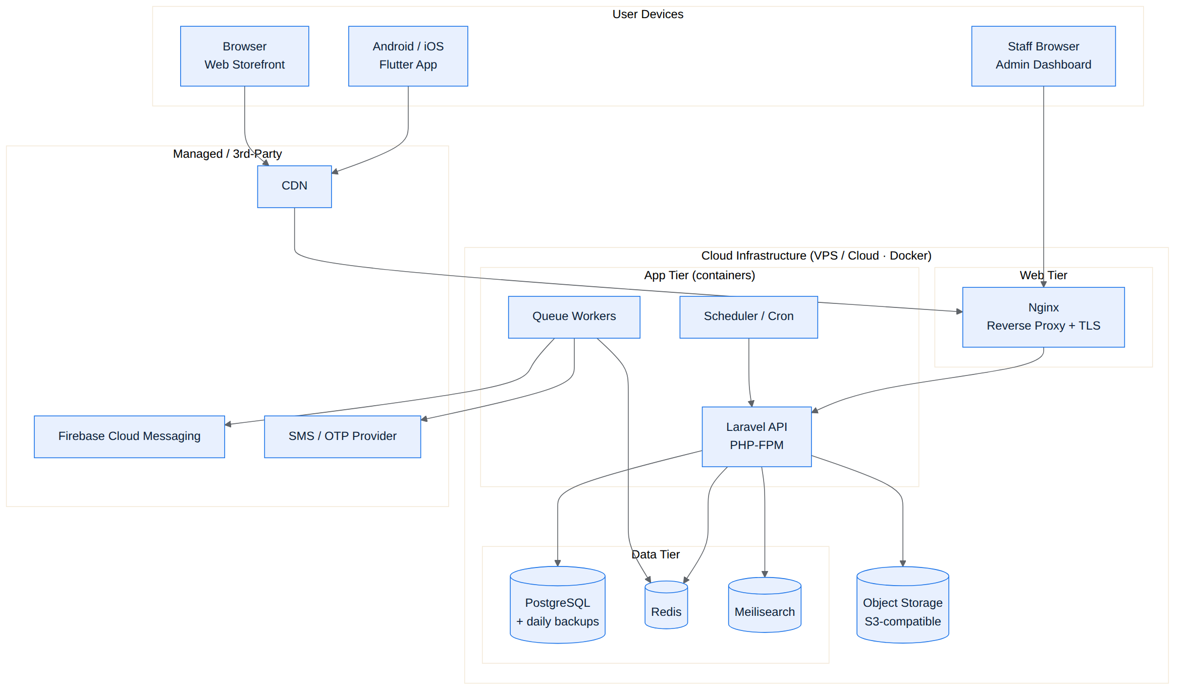
Figure 12. Deployment diagram — runtime infrastructure.
الشكل 12: مخطط النشر — البنية التحتية لوقت التشغيل.

10. Database Design
تصميم قاعدة البيانات
The PostgreSQL schema derived from the ER model. All primary keys are UUIDs; monetary values use fixed-precision decimals; every table carries created/updated timestamps.
Table | Purpose | Key fields
roles | Access roles & permissions | id, name, permissions(json)
users | Customers & staff accounts | id, role_id, name, phone(unique), email, is_active
addresses | Customer delivery addresses | id, user_id, city, area, street, lat, lng, is_default
categories | Departments & sub-categories | id, parent_id, name_en, name_ar, icon, sort_order
products | Catalog items | id, category_id, name_en, name_ar, price, sale_price, stock, status
product_variants | Size/color variants | id, product_id, sku(unique), attributes(json), stock
product_images | Product media | id, product_id, url, sort_order
carts / cart_items | Shopping carts | cart: user_id · item: product_id, quantity, unit_price
orders | Customer orders | id, user_id, address_id, order_number, status, payment_method, total
order_items | Lines within an order | id, order_id, product_id, quantity, unit_price, line_total
payments | Payment records | id, order_id, method, status, amount, paid_at
deliveries | Delivery/fulfilment | id, order_id, agent_id, status, dispatched_at, delivered_at
coupons | Discount codes | id, code(unique), type, value, usage_limit, expires_at
reviews | Product ratings & reviews | id, user_id, product_id, rating, comment, status
wishlist_items | Saved products | id, user_id, product_id, added_at

11. API Design Overview
تصميم واجهات الـ API
A versioned REST/JSON API under /api/v1. Customer endpoints require a JWT; admin endpoints additionally require a staff role. A representative subset is listed below.
Method & Endpoint | Description | Access
POST /auth/request-otp | Send OTP to a phone number | Public
POST /auth/verify-otp | Verify OTP, issue tokens | Public
GET /categories | List departments & sub-categories | Public
GET /products | List/filter/search products | Public
GET /products/{id} | Product detail with variants & reviews | Public
GET /cart | Get current cart | Customer
POST /cart/items | Add item to cart | Customer
POST /coupons/validate | Validate a coupon code | Customer
POST /orders | Place a COD order | Customer
GET /orders/{id}/track | Track order status timeline | Customer
POST /products/{id}/reviews | Submit a product review | Customer
GET /admin/orders | List/manage orders | Staff
PATCH /orders/{id} | Update order status | Staff
POST /admin/products | Create/update product | Staff
PATCH /deliveries/{id} | Update delivery status | Delivery
GET /admin/reports/sales | Sales & analytics data | Admin

12. Security & Data Protection
الأمان وحماية البيانات
- Transport security: All traffic over HTTPS/TLS; HSTS enabled.
- Authentication: Phone + OTP with hashed, short-lived codes and per-phone rate limiting; JWT access/refresh tokens.
- Authorization: Role-Based Access Control enforced on every protected endpoint.
- Input handling: Server-side validation, parameterized queries (no SQL injection), output escaping.
- Abuse protection: Rate limiting, throttling, and lockouts on auth and order endpoints.
- COD safeguards: OTP-verified phone on orders, delivery confirmation, and flagging of repeat failed-delivery numbers.
- Data protection: Least-privilege access to PII (phone, address); encrypted backups; secrets in a vault, never in code.
- Auditing: Admin actions and order status changes are logged for accountability.
الملخص
يُبنى الأمان على تشفير الاتصالات (HTTPS)، والمصادقة عبر OTP مع رموز مُجزّأة ومحدودة المحاولات ورموز JWT، ونظام صلاحيات RBAC، والتحقق من المدخلات ومنع حقن SQL، والحدّ من الإساءة، وحماية عمليات الدفع عند الاستلام عبر تأكيد الهاتف وتتبّع التوصيل، مع حماية البيانات الشخصية وتسجيل إجراءات الإدارة.

13. Localization & RTL Support
التعريب ودعم الاتجاه من اليمين لليسار
Shubayr is Arabic-first and bilingual. Every catalog entity stores both Arabic and English names, and the entire UI mirrors correctly for right-to-left reading.
- Full RTL layout mirroring in both the Flutter app and the web storefront.
- Bilingual content fields (name_ar/name_en) throughout the catalog.
- Arabic numerals, IQD currency formatting, and local date/time formats.
- Language switch that persists per user; SMS and push messages localized.
- Arabic-aware search (typo tolerance and normalization) via Meilisearch.

14. Delivery Roadmap & Milestones
خارطة الطريق والمراحل
A phased plan that delivers a working MVP early and layers in the rest. Estimated total build time is roughly 4–5 months with a small team working in parallel.
Phase | Focus | Approx. duration | Key deliverables
0 | Discovery & UI/UX design | 2–3 weeks | Requirements sign-off, wireframes, visual design, clickable prototype
1 | Backend foundation | 3–4 weeks | Database, Auth (OTP), catalog & categories API, admin scaffolding
2 | Cart, checkout & orders | 3 weeks | Cart, coupons, COD checkout, order lifecycle, notifications
3 | Admin dashboard | 3 weeks | Product/inventory/order management, promotions, reports
4 | Mobile app + web storefront | 4 weeks | Flutter app and Next.js storefront on the finished API
5 | QA, hardening & UAT | 2–3 weeks | Testing, performance & security passes, user acceptance
6 | Launch & handover | 1–2 weeks | Store submission, deployment, documentation, training

الملخص
خطة تنفيذ على مراحل تبدأ بالتصميم ثم الخلفية والمصادقة والكتالوج، فالسلة والدفع عند الاستلام والطلبات، ثم لوحة التحكم، ثم تطبيق الهاتف ومتجر الويب، وأخيرًا الاختبار والإطلاق والتسليم. المدة التقديرية الإجمالية نحو 4–5 أشهر بفريق صغير يعمل بالتوازي.

15. Budget Breakdown (US $10,000)
توزيع الميزانية
An indicative allocation of the US $10,000 one-time build budget across the work streams. Actual figures depend on the final team and rates.
Work stream | Allocation (USD) | Share
Discovery & UI/UX design | $1,200 | 12%
Backend API + admin dashboard | $3,000 | 30%
Mobile app (Flutter) | $2,800 | 28%
Web storefront (Next.js) | $1,500 | 15%
QA & testing | $700 | 7%
DevOps, deployment & setup | $500 | 5%
Project management & documentation | $300 | 3%
TOTAL | $10,000 | 100%

Recurring costs are separate from the build budget and are borne by the client: hosting/VPS (~$20–50/month), domain, SMS/OTP credits (usage-based), and app-store fees (Apple $99/year, Google $25 one-time).
الملخص
توزيع تقديري لميزانية البناء البالغة 10,000 دولار: التصميم 1,200$، الخلفية ولوحة التحكم 3,000$، تطبيق الهاتف 2,800$، متجر الويب 1,500$، الاختبار 700$، النشر والإعداد 500$، الإدارة والتوثيق 300$. التكاليف المتكرّرة (الاستضافة، النطاق، رسائل OTP، رسوم المتاجر) منفصلة ويتحمّلها العميل.

16. Recommended Team
الفريق المقترح
Role | Responsibility
Project Manager (part-time) | Planning, coordination, client communication, delivery.
Backend Developer | Laravel API, database, admin dashboard, integrations.
Flutter Developer | iOS + Android mobile app.
Web/Frontend Developer | Next.js storefront (can overlap with backend dev).
UI/UX Designer | Wireframes, visual design, Arabic-first RTL screens.
QA Engineer (part-time) | Test plans, functional & regression testing.

17. Risks & Mitigations
المخاطر وإجراءات التخفيف
Risk | Impact | Mitigation
Scope creep (new departments/features) | Delays, over-budget | Dynamic category model; change-control; MVP-first phasing.
COD failed deliveries / fraud | Lost cost, stock issues | OTP-verified orders, delivery confirmation, flag repeat offenders.
Image-heavy pages slow | Poor UX, drop-off | CDN, image optimization, lazy loading, caching.
Small budget vs. large scope | Quality risk | Phased delivery, reuse of frameworks (Filament), shared backend.
Adding payments later | Rework risk | Pluggable payment interface designed from day one.
Key-person dependency | Continuity risk | Documentation, code standards, Git, CI/CD.

18. Future Enhancements
تحسينات مستقبلية
- Online payment gateways: ZainCash, FastPay, Qi Card, and card processing.
- Loyalty & points program and referral rewards.
- Expansion to a multi-vendor marketplace if the business grows.
- In-app live chat and customer-support tickets.
- AI-based product recommendations and personalized home screen.
- Advanced analytics dashboards and marketing automation.

19. Version 2.0 — Team Review Architecture
الإصدار 2.0 — معمارية مراجعة الفريق
This version incorporates the team's review, which upgrades Shubayr from a basic store into a store with a proper inventory, purchasing, and fulfilment backbone. The eighteen rules below are now part of the design and the database schema. They are grouped by subsystem.
الملخص
يضيف هذا الإصدار مراجعة الفريق (18 نقطة) التي ترفع «شُبَيّر» إلى نظام متكامل يشمل المخزون والمشتريات والتجهيز: هوية بيضاء قابلة لإعادة التسمية، واجهات Flutter (زبون/مندوب/إدارة) + Flutter Web للإدارة + Next.js للمتجر العام، صلاحيات تفصيلية، إدخال البضاعة عبر فواتير شراء مرتبطة بمجهز، دفعات مخزنية مستقلة، مخازن ومواقع، حركات مخزنية لكل تغيير، سحب FEFO، حجز الكمية قبل الخصم، توجيه السحب، كلفة لكل دفعة وفصل سعر البيع، مرتجعات جزئية حسب الحالة، نقاط ولاء ودعم التفاوض بالنقاط، فصل تقييم المنتج عن تقييم التوصيل، وسجل تدقيق شامل.

19.1 White-label & System Interfaces
The store is generic/white-label: its name, logo, colors, and currency live in a store_settings table and are loaded at runtime, so the identity can change with no code changes. The client interfaces are:
Interface | Technology | Users / Purpose
Mobile app | Flutter (iOS + Android) | Customer, Delivery Agent, and Admin/Staff — role decides the experience.
Admin dashboard | Flutter Web | Same Flutter codebase built for the web, used by staff for management.
Public storefront | Next.js (React) | SEO-friendly public website for customers.
Backend | Laravel REST API | One API serving all of the above; all business logic lives here.

19.2 RBAC — Detailed Roles & Permissions
Access control is permission-based from the start, not just Admin/Manager. Roles are assigned fine-grained permissions (e.g. inventory.adjust, purchasing.manage, orders.confirm) enforced on every endpoint. Seed roles include Admin, Manager, Purchasing, Warehouse, Delivery, and Customer.

19.3 Suppliers & Purchasing
Goods never enter stock by editing a quantity. They enter only through a Purchase Invoice linked to a Supplier. Receiving the invoice creates inventory batches and places them into warehouse locations, recording the landed cost.
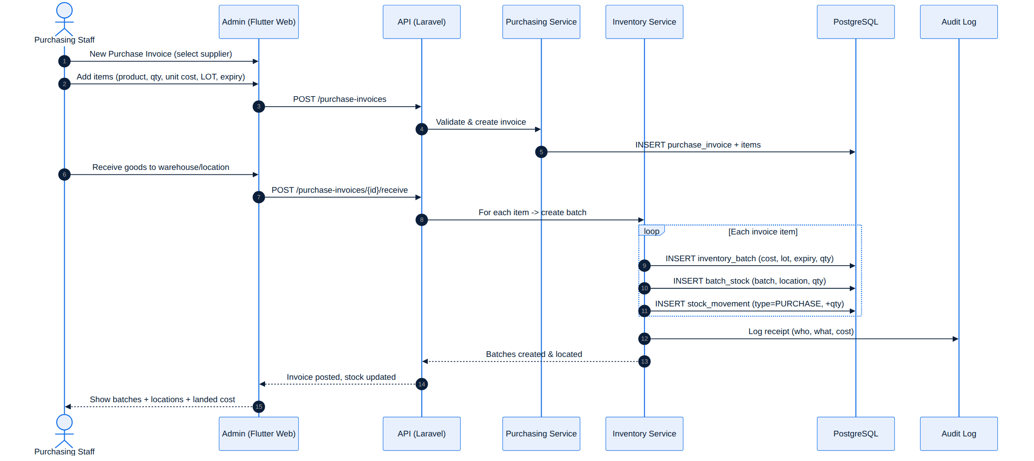
Figure 13. Sequence — receiving goods via a purchase invoice into batches & locations.
الشكل 13: مخطط التتابع — استلام البضاعة عبر فاتورة شراء إلى دفعات ومواقع.

19.4 Inventory: Batches, Warehouses & Locations
Each purchase batch of the same item stays independent, keeping its own quantity, purchase cost, entry date, LOT number, and expiry date (if any). A batch's quantity is distributed across warehouse locations structured as Warehouse → Zone / Aisle / Shelf / Bin, so the exact quantity in each location is always known.
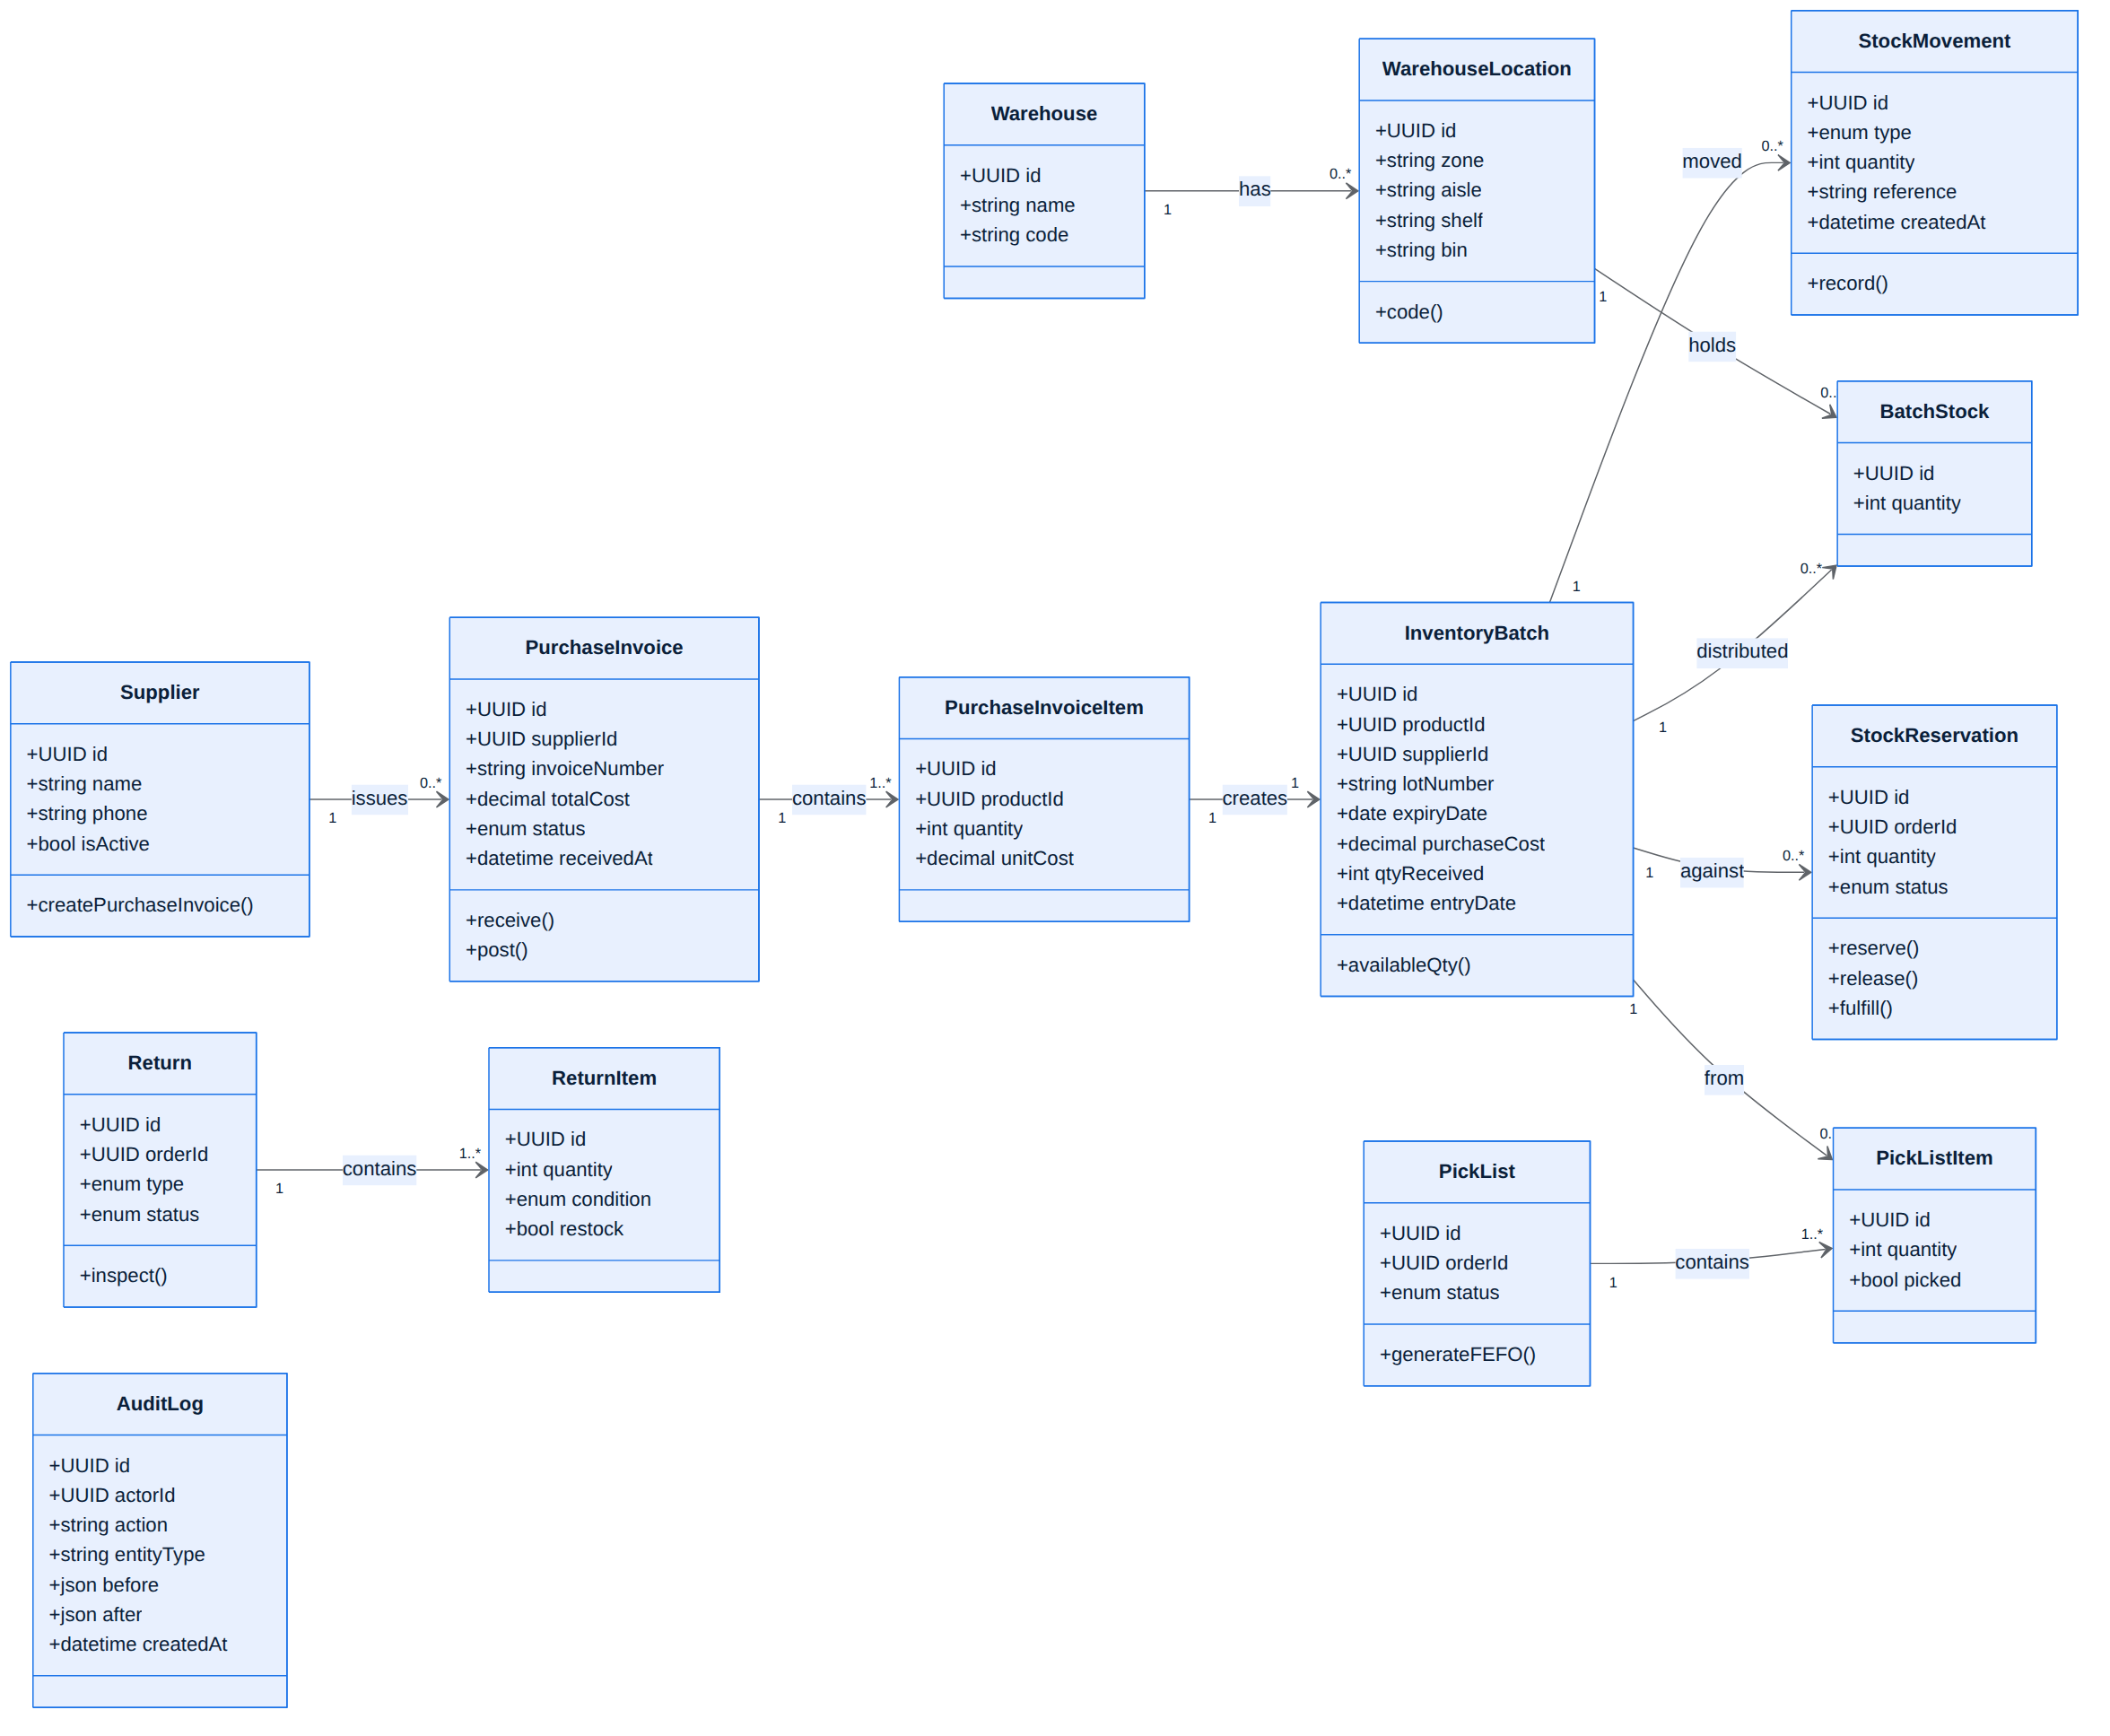
Figure 14. Class diagram — inventory & supply-chain domain.
الشكل 14: مخطط الأصناف — نطاق المخزون وسلسلة التجهيز.

19.5 Stock Movements & Controlled Adjustments
Every change to stock — purchase, sale, transfer, return, reservation, release, or adjustment — is recorded as a stock movement. There is no silent editing of a balance; the only manual change is an explicit, permissioned adjustment that is itself logged.

19.6 Order Reservation, FEFO & Picking
When an order is accepted, the required quantity is reserved first (it is not deducted yet), which prevents the same stock being sold to another order. For products with an expiry date, reservation and picking follow FEFO (First-Expiry-First-Out), drawing from the nearest-expiry batch. The system then generates a pick list telling the warehouse worker exactly what to pick: item + quantity + warehouse + shelf + batch. Stock is only deducted when the order is dispatched.
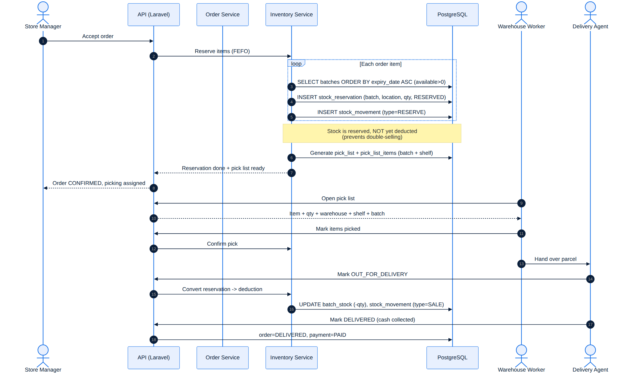
Figure 15. Sequence — reservation, FEFO batch selection, guided picking, and deduction on dispatch.
الشكل 15: مخطط التتابع — الحجز واختيار الدفعة بنظام FEFO والسحب الموجّه والخصم عند الإرسال.

19.7 Costing & Pricing
Each batch keeps its own purchase cost, and the system computes an average cost across batches. The selling price is stored separately on the product and is never changed automatically by purchase cost — pricing stays a deliberate business decision.

19.8 Returns — Partial & Condition-based
Returns are modeled from the start. A customer may return one item and keep the rest (partial returns are first-class). Each returned item is inspected and marked sellable, opened, or damaged; only sellable items are restocked (as a return-in movement into a batch). Opened items go to quarantine/open-box and damaged items are written off — not every return re-enters inventory.
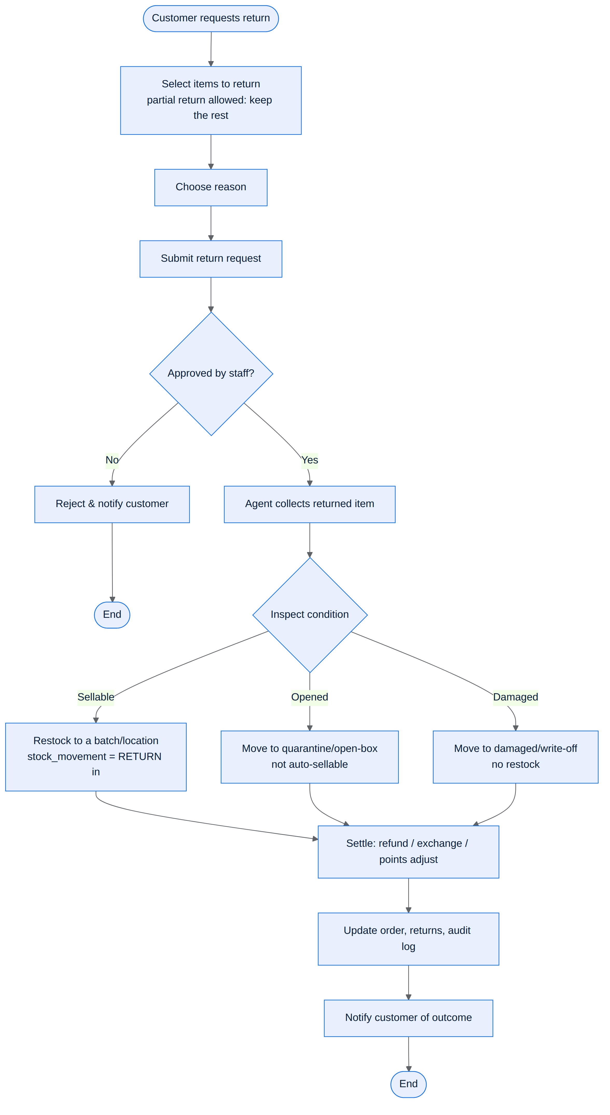
Figure 16. Activity — return handling with partial returns and condition-based restocking.
الشكل 16: مخطط النشاط — معالجة المرتجعات مع الإرجاع الجزئي وإعادة التخزين حسب الحالة.

19.9 Loyalty Points & Points Negotiation
A loyalty account and a points ledger exist from the start. Points are awarded after an order is delivered, and can be redeemed or adjusted. The data model also supports points-based negotiation now (products carry is_negotiable, floor_price, and points_price), so the negotiation feature can be built on top later without a schema change.

19.10 Ratings — Product vs Delivery
A product review (stars + comment) is tied to a real purchased order item and flagged as a verified purchase, which blocks fake reviews. Separately, the delivery/agent receives its own independent rating after the order is completed; the two are never mixed.

19.11 Audit Trail
Sensitive operations are logged to an audit trail with the actor, the action, the entity, and the before/after values: inventory changes, price changes, cost changes, purchases, returns, order-status changes, and permission changes. This gives full accountability.

19.12 New Database Entities (summary)
Area | New tables
RBAC | permissions, role_permissions
Purchasing | suppliers, purchase_invoices, purchase_invoice_items
Inventory | inventory_batches, warehouses, warehouse_locations, batch_stock, stock_movements
Fulfilment | stock_reservations, pick_lists, pick_list_items
Returns | returns, return_items
Loyalty | loyalty_accounts, loyalty_ledger
Ratings | product_reviews (verified), delivery_ratings
Audit / White-label | audit_logs, store_settings

The complete, validated PostgreSQL schema for all of the above ships in the project repository at infra/db/schema.sql (37 tables).

20. Appendix — Glossary
ملحق — مسرد المصطلحات
Term | Meaning
COD | Cash on Delivery — customer pays cash when the order is delivered.
OTP | One-Time Password — a short code sent by SMS to verify a phone number.
RBAC | Role-Based Access Control — permissions granted by user role.
JWT | JSON Web Token — a secure token used to keep a user logged in.
RTL | Right-to-Left — text/layout direction used for Arabic.
MVP | Minimum Viable Product — the first usable, launchable version.
API | Application Programming Interface — how apps talk to the backend.
CDN | Content Delivery Network — serves images fast from nearby servers.
UML | Unified Modeling Language — the standard diagrams in this document.
SKU | Stock Keeping Unit — a unique code identifying a product variant.
Batch / LOT | A specific quantity of an item received together, with its own cost and expiry.
FEFO | First-Expiry-First-Out — sell/pick the nearest-to-expire stock first.
Reservation | Holding stock for an accepted order before it is physically deducted.
Picking | Collecting the ordered items from their shelves/locations for dispatch.
Stock movement | A logged record of any change in stock (purchase, sale, transfer, return, adjust).
Purchase invoice | The document that brings supplier goods into stock as batches.
Loyalty ledger | The running record of points earned, redeemed, or adjusted per customer.
Audit trail | A log of sensitive actions (who changed what, before/after) for accountability.
White-label | Building so the store's name/branding can be changed without code changes.

— End of document — · نهاية الوثيقة —

