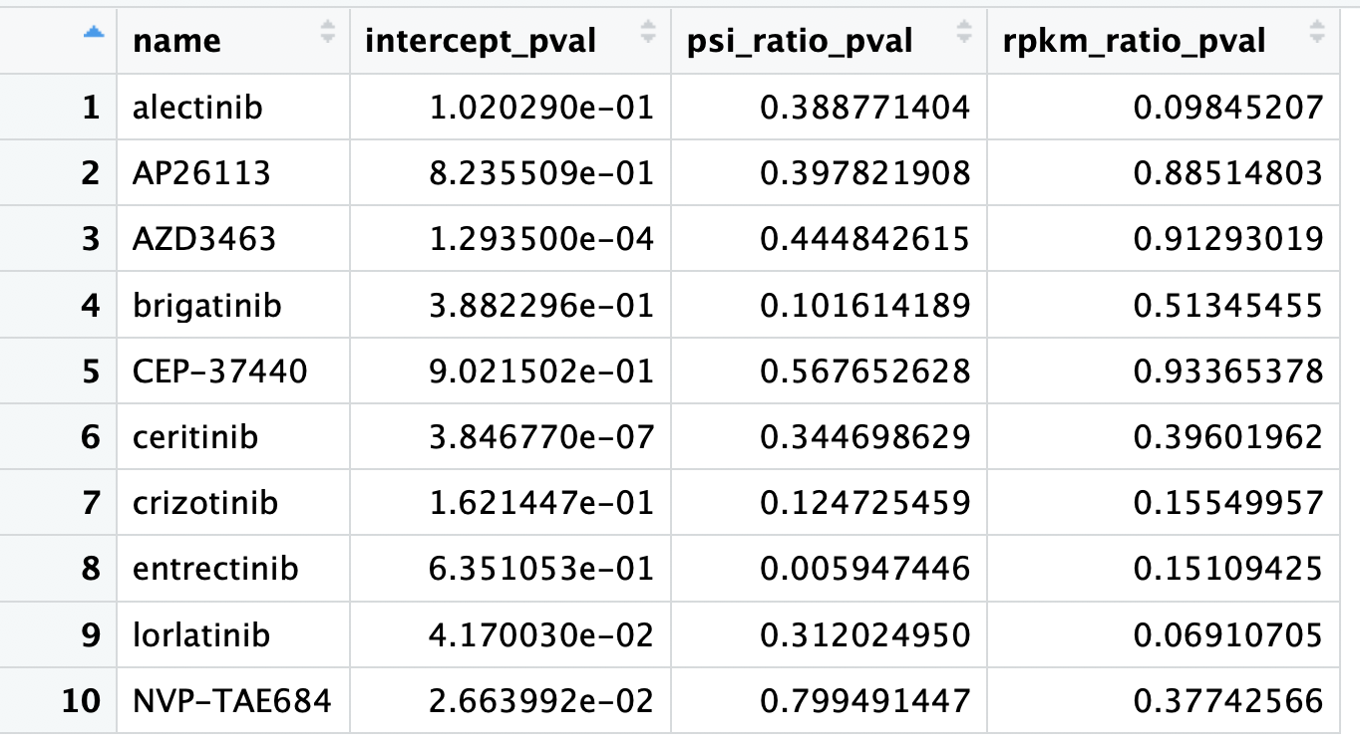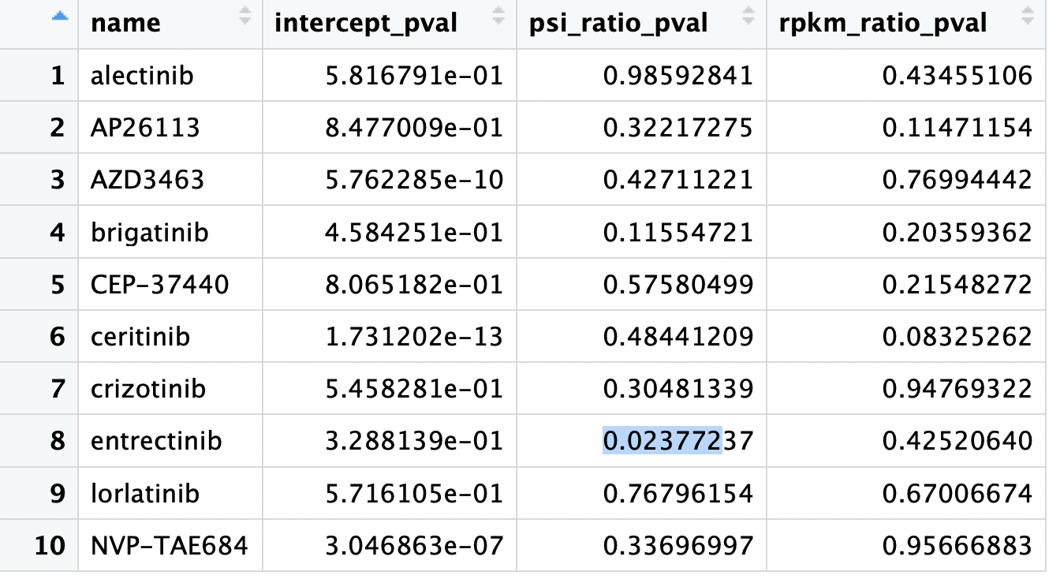

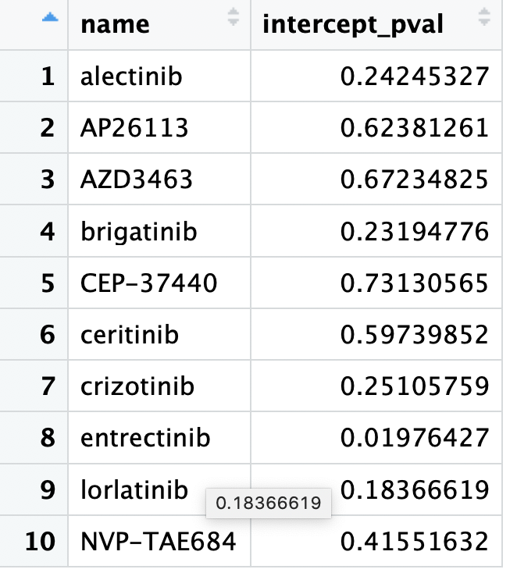 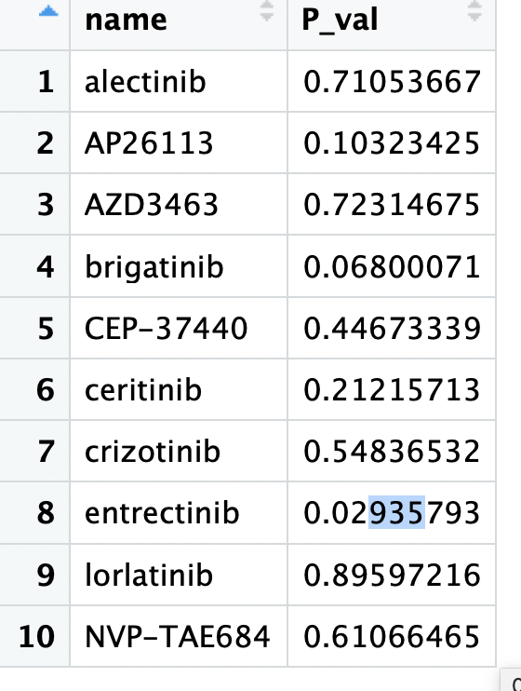

The bottom line from the dependency/essentiality scores is that EML4ALK lines don’t seem to be essential while the neuroblastoma alk fusion line does seem to be essential. This may be because the sgRNAs targeting ALK are located before ALK exon 19. This would mean that the sgRNAs cut off the inherent ALK gene but don’t cut the EML4ALK gene. Unfortunately, this also means that they don’t target ALKATI lines, and that the logic here is a little flawed. Therefore, I will exclude this data.

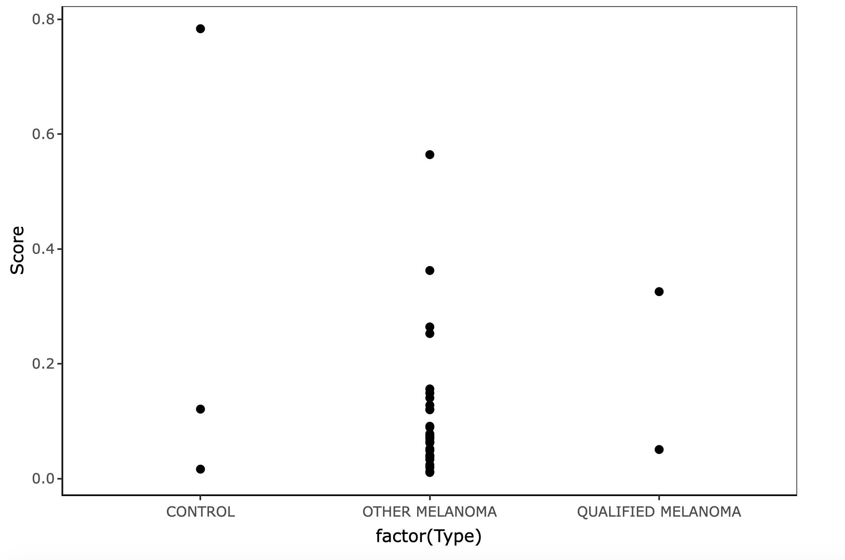

Order the crispr line and order sgRNAs for Exon19 onwards

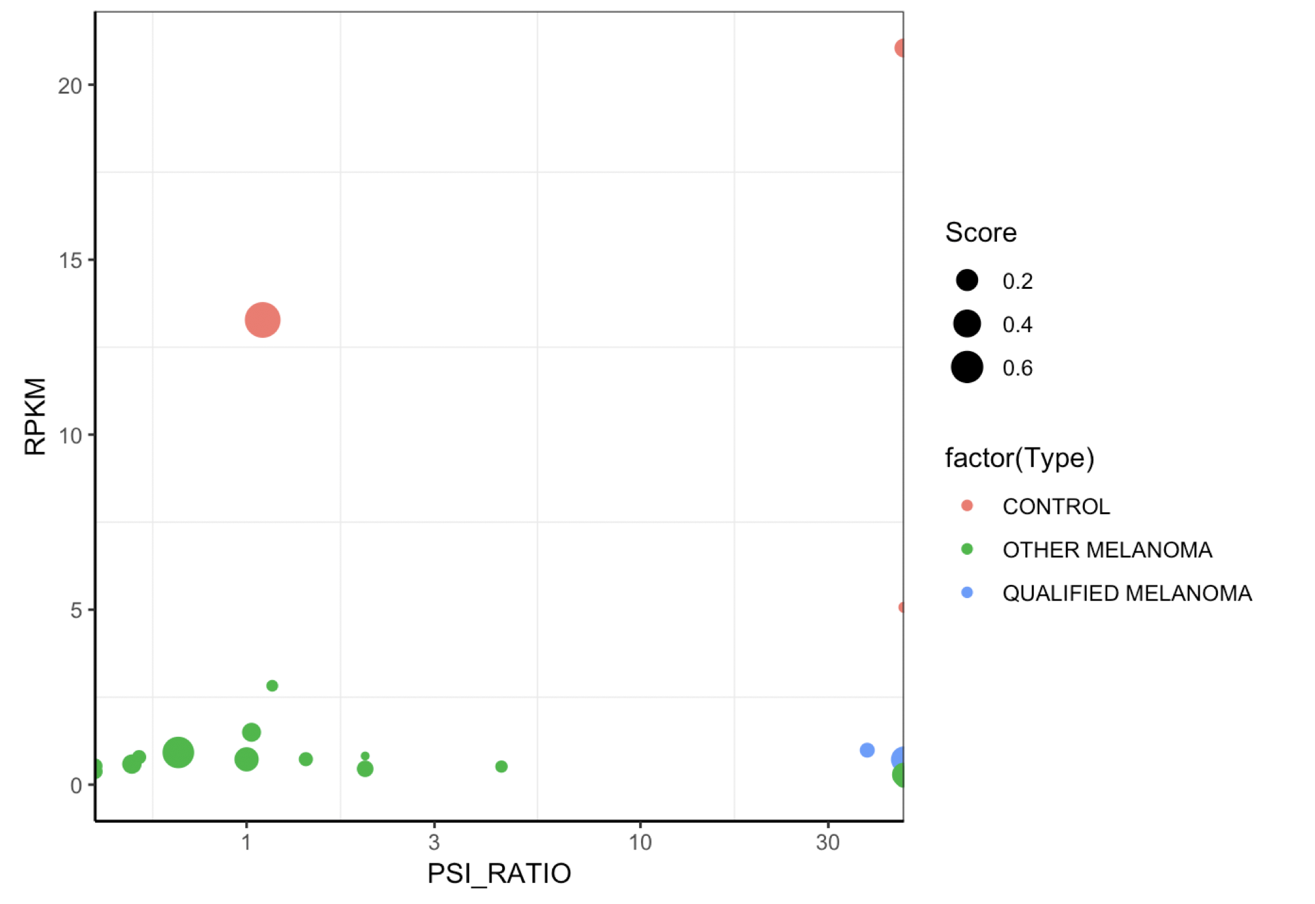

Consensus is to throw out the drugs that the EML4ALK lines don’t respond to

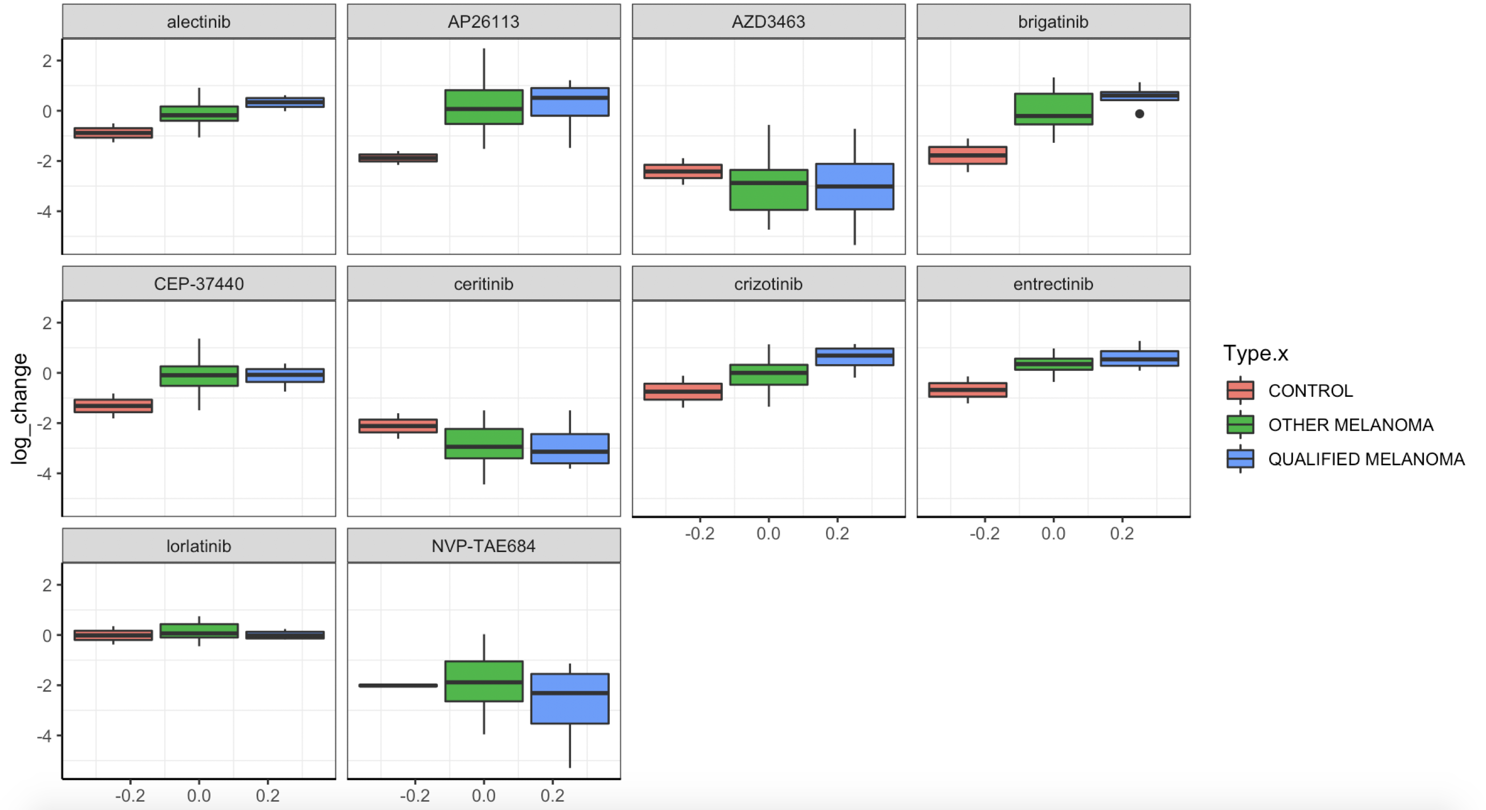

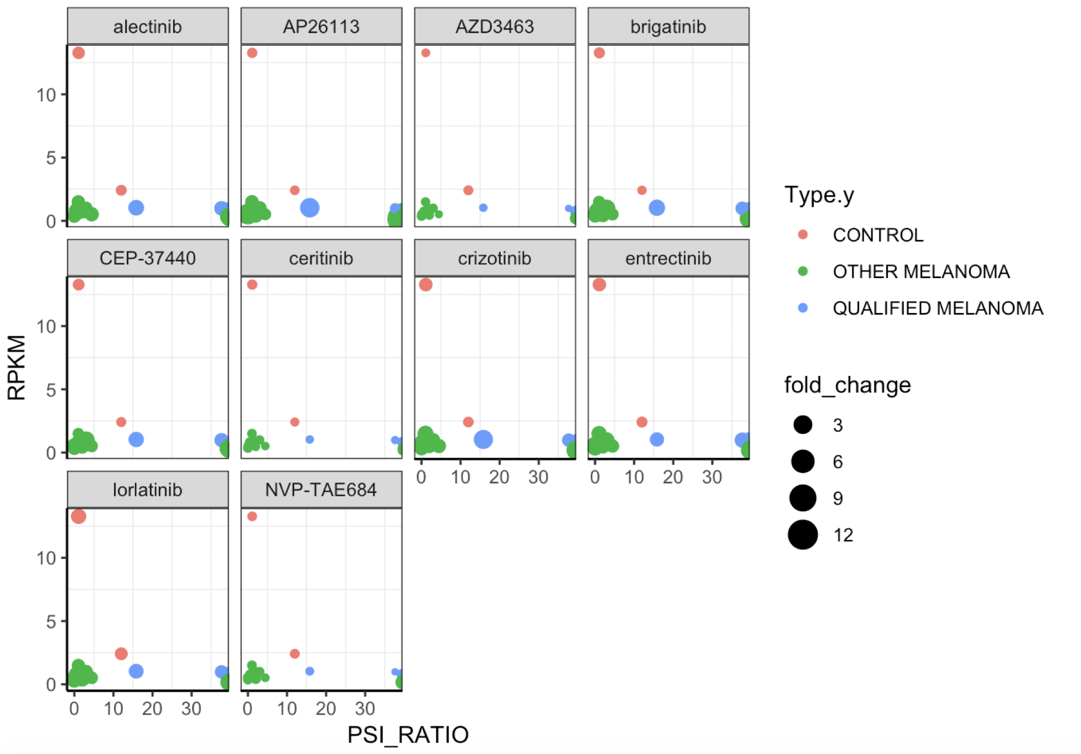

ALKATI melanoma figure notes:

A dependency score of 0 indicates that the gene is not essential. -1 is equivalent to pan essential genes

Please grab dependency scores etc for essential genes as well

**Lymphoma**:

* SUPM2—THIS IS NPM-ALK

**Neuroblastoma** ALK point mutations (Neuro PM):

* <https://depmap.org/portal/gene/ALK?tab=dependency>
* CHLA15
* NB1643
* KELLY

**Lung cancer**:

* NCIH3122_LUNG… THIS IS EML4ALK
* NCIH2228_LUNG… This is Eml4ALK
* SNU324_PANCREAS… This is also Eml4ALK

What I need from these cell lines:

* Expression data
* Gene dependency scores,
* Drug sensitivity fold change scores
* Cell line metadata could be interesting?

Steps:

* Download expression, CRISPR dependency, and drug sensitivity data
* Parse expression data for ALK exon expression
* Parse dependency data for ALK for each cell line
* Parse

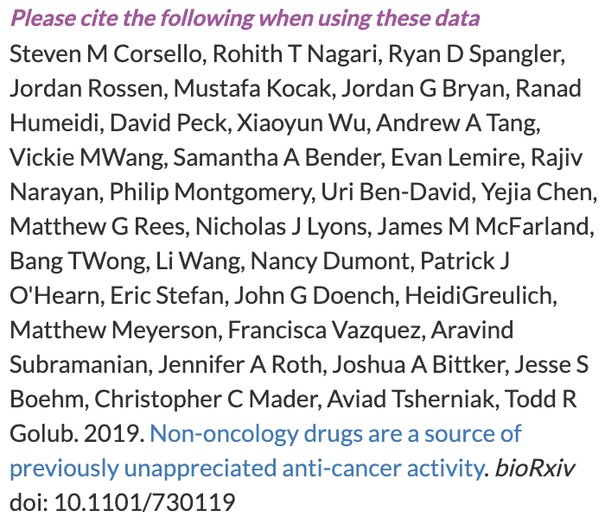

Should I follow plos’s guideline for double spacing

What about line numbers

Vancouver style citations

Insert figure captions in manuscript text, immediately following the paragraph where the figure is first cited (read order). Don’t include captions as part of the figure files themselves or submit them in a separate document.

There is a SUMRPKM column