
PROJECT HANDOFF & MASTER SPECIFICATION
Pakistan-first PUBG MOBILE scrims and tournament platform
As of 22 September 2026
Product rules • architecture • implementation status • audit findings • roadmap • operational handoff
Handoff principle
The latest approved product rule always overrides older notes, screenshots, migrations, and design references. When behavior, money, tournament rules, permissions, or user flow is not already locked, discuss the decision before building it.

Contents
Use this as the single continuity document when moving between ChatGPT, Codex, or another developer.
1. Executive handoff snapshot
2. Source-of-truth and status conventions
3. Project environment and repository
4. Core architecture and identity model
5. Engineering rules and definition of done
6. Roles and permissions
7. Team / Squad rules
8. Tournament types, fees, entries, and retries
9. Tournament / Stage / Session / Lobby / Match rules
10. Payments, credits, refunds, and finance rules
11. Results, scoring, advancement, and leaderboard
12. Notifications, support, privacy, and account lifecycle
13. Frontend and public-site status
14. Admin panel information architecture and UI references
15. Backend capability vs UI wiring
16. Database migration inventory and deployment status
17. Deep-audit findings: resolved vs still open
18. Verification and test status
19. Known technical debt / operational risks
20. Open decisions that must be discussed before implementation
21. Prioritized roadmap and recommended next steps
22. Codex operating procedure and handoff checklist
Appendix A. Approved admin visual references
Appendix B. Glossary and source inventory

1. Executive handoff snapshot
Where work stopped
The FREE Tournament contract is fully GREEN and remotely verified. The very next task is the PAID Tournament end-to-end verification using different values for Tournament Initial Registration Fee and Session attempt price. After the paid path is verified, resume the remaining deep audit section-by-section.

Area | Current status | What is true now | Immediate next step
Remote migrations | GREEN | All migrations through 20260913010000 were reported Local + Remote with no pending migration. | Do not redeploy historical migrations.
FREE Tournament flow | GREEN | 0 fee, no payment UI, no retry, free Session Entry, no financial rows; negative DB tests passed. | Preserve as regression baseline.
PAID Tournament flow | PENDING | Pricing separation was corrected in code, but paid runtime E2E has not yet been reported complete. | Test Tournament fee != Session attempt price.
Stages & Sessions foundation | IMPLEMENTED / PARTIAL | Stage/session setup UI and authoritative Session pricing foundation were implemented; free path runtime verified. | Verify paid path, then deepen UI during admin audit.
Session Entries | PARTIAL | Stable backend model exists; FREE source added by latest migration. No dedicated management UI. | Audit/build Session Entries after paid verification.
Lobbies / Operators | PARTIAL | Session-aware backend exists; existing UI is largely legacy. | Replace legacy Lobby controls with Session-aware flow.
Matches / Results | P0 OPEN | Schema and guards exist; trusted operational APIs/UI remain incomplete. | Design Match lifecycle + result authorization before UI.
Payments / Credits | PARTIAL | Strong ledger/refund backend; only part of player/admin UI exists. | Payment destination, retries, credits/refunds UI.
Leaderboard / Advancement | PENDING | Public leaderboard is intentionally honest/empty; advancement engine not implemented. | Build after verified results + immutable qualification events.
Roles | PARTIAL | Super Admin / Tournament Admin backend exists. Team DB still lacks final Co-Captain model. | Migrate Captain / Co-Captain / Player later.
Git / automated tests | PENDING | Working tree remains intentionally dirty; no proper checkpoint and no full automated DB regression suite. | Checkpoint at a safe milestone; add migration/RLS tests.

What has materially improved since the original deep audit
- Authoritative Session pricing: implemented by the 20260908010000 financial contract; paid/credit Session amounts derive from stored Session price rather than arbitrary Admin input.
- Free-vs-paid contract: implemented by 20260913010000 and deployed remotely. Free Tournaments have zero Stage/Session fees, retries off, and normal source_type=free participation without financial rows.
- Truthful pricing UI: Tournament Initial Registration Fee is separate from Session attempt price. The earlier accidental mixing was caught and corrected before deployment.
- Stages & Sessions setup: foundation UI was added so Admin can create/configure Stage and Session data and see readiness instead of dead-ending after Tournament creation.
- Public leaderboard honesty: fake/sample standings were removed; the public leaderboard now waits for a real authorized standings source.
- Homepage responsiveness: major mobile-first redesign and fake-data cleanup were completed; one normal-browser mobile interaction issue remains to revisit.

2. Source-of-truth and status conventions

Precedence
1. Latest explicitly approved product rule in conversation.
2. Latest deployed database contract and trusted runtime behavior.
3. Latest current working-tree implementation.
4. Older migrations, audits, design images, and historical planning documents only as context.
Important snapshot caveat
The uploaded app/components/lib/hooks/data archives are a 9 September snapshot. Work performed after that snapshot (especially 20260913010000 and its UI changes) is known through Codex implementation/verification reports and the remote migration history, but the exact newest source file is not present in the uploaded archive. Before a new developer continues, export the current E:\Scrims tree or create a Git checkpoint.

Status legend
Label | Meaning
GREEN | Implemented, deployed where relevant, and end-to-end/runtime verified for the stated path.
IMPLEMENTED | Code/backend exists but the whole user path may not yet be runtime verified.
PARTIAL | Only part of the required chain exists or existing UI is legacy.
PENDING | Planned/approved but not implemented.
P0 OPEN | A high-impact correctness or operations gap that blocks full tournament operation.
LOCKED RULE | Approved product rule; do not re-decide casually.
OPEN DECISION | Must be discussed before implementation; do not guess.

3. Project environment and repository
Project root | E:\Scrims
Framework | Next.js 16.3.1 App Router, React 19.2.8, TypeScript 5, Tailwind CSS 4
Motion/UI libraries | GSAP 3.15, @gsap/react 2.1, Lenis 1.3
Backend | Supabase Auth + Postgres + RLS + RPCs using @supabase/supabase-js / @supabase/ssr
Dev command | npm run dev
Build checks | npm run lint; npx tsc --noEmit; npm run build; git diff --check
Time policy | Database timestamps are timestamptz/UTC; user-facing tournament time is PKT / Asia-Karachi.
Environment keys | Public Supabase URL + publishable key only in app environment. Never request or embed the service-role key.
Branch / historical HEAD | master; initial baseline commit bbe8244. No later proper checkpoint was reported yet.
Backups | E:\Scrims_BACKUP_20260905 and E:\OpenAI_Codex_AppData_Backup_20260905 were created during earlier Codex recovery work.

Repository areas in the uploaded snapshot
- src/app - public, auth, account, team, tournament registration, leaderboard, and admin routes.
- src/components - admin, auth, layout, public sections, team, tournament, and UI primitives.
- src/lib - Supabase clients, admin auth, tournament public/money/date helpers, leaderboard public helper, animations.
- src/hooks - section animation hook.
- src/data - homepage/how-it-works/tournament presentation data.
- src/proxy.ts and src/lib/supabase/proxy.ts - request/session handling.
- supabase/migrations - database evolution and business rules.
- public/images - brand and homepage art assets.

Operational guardrails
- Never include node_modules, .next, .git, tsconfig.tsbuildinfo, or secret-bearing environment files in handoff archives.
- Codex restricted networking may fail even when the normal browser/PowerShell can reach Supabase. Do not weaken auth/schema because of a sandbox network error.
- If auth context is unavailable, report the test as blocked rather than using service-role shortcuts.
- When migration history differs Local vs Remote, stop before broad db push and inspect the mismatch.

4. Core architecture and identity model
Authoritative competition hierarchy
Tournament → Stage → Session → Session Entry / Attempt → Lobby → Match

Object | Purpose | Identity rule
Tournament | Top-level competition and registration container. | Stable UUID plus public Tournament ID/code.
Stage | Professional competition phase (Qualifier, Semifinal, Grand Final, etc.). | Stable UUID; never use “Stage 1/2/3” as the user-facing identity.
Session | Scheduled competition/attempt unit beneath a Stage. | Stable UUID; owns runtime concurrency, match defaults, and authoritative attempt price.
Session Entry | The right for one registration/team to participate in one exact Session. | Stable UUID; payment/credit/earned proof is provenance, not the participation identity.
Lobby | Operational grouping inside one Session. | Stable UUID; Session-local Lobby code/order.
Match | Actual played room/match within a Lobby. | Stable UUID; Lobby-local match numbering is presentation, not identity.
Squad | User-facing team roster pool for a Tournament. | Use “Squad” in UI; legacy internal roster names may remain in DB.

Identity principles
- Stable IDs are authoritative; never use team name, “Match 1”, Lobby label, or mutable display text as identity.
- Historical competition identity does not move when player account ownership, team membership, or financial ownership changes.
- Permanent audit/history rows should be append-only wherever the backend contract already treats them as evidence.
- A Lobby belongs to exactly one Session; assignments must resolve the exact active Session Entry.

5. Engineering rules and definition of done
Definition of done
A feature is not done when “the backend exists” or “the component renders”. It is done only when the full chain works: DB → RPC/action → page/tab → visible control → click → permission → DB change → UI refresh → success/error → manual test.

Build rules
- UI and functionality must be built together. Do not leave important backend operations with no usable UI unless they are intentionally internal helpers.
- Mobile usability has priority over desktop polish, while desktop must remain complete.
- Use ⓘ help only where terminology/setup needs explanation; hover/focus on desktop, tap on mobile.
- No fake public Tournament, leaderboard, player, team, or finance data. Empty states must be honest.
- Do not create controls solely because they appear in a concept image. Verify real backend capability and permission first.
- Never weaken RLS, trusted RPC checks, or immutable history to make UI testing easier.
- No service-role key in browser/server actions intended to run as the signed-in user.

Decision process for unresolved product behavior
1. Explain the decision in easy English.
2. Offer 2-3 concrete options.
3. Give a recommendation with tradeoffs.
4. Get explicit approval.
5. Lock the rule.
6. Only then create the Codex prompt and implementation.

Codex task sizing
Task type | Recommended setting | Rule
Small focused fix | GPT-5.6 Sol - Medium | One bug or one narrow verification. Do not restart completed work.
Complex multi-section UI/feature | GPT-5.6 Sol - High | Inspect current dirty tree first; keep scope explicit.
Large audit/security/architecture | GPT-5.6 Sol - High | Read migrations + app wiring; produce gaps before editing.

6. Roles and permissions

Platform admin roles - current backend
Role | Current rule | Status
Super Admin | Exactly one existing Super Admin must be explicitly bootstrapped. Global sensitive finance/security/staff authority. | IMPLEMENTED
Tournament Admin | At most two active seats. Tournament operations authority; stored role was migrated from legacy admin. | IMPLEMENTED
Lobby operator | Assignment to an active admin account with immutable operator-event history; not a separate platform role. | PARTIAL

Team roles - target product model
Role | Approved capabilities | Status
Captain | Full team authority; remove players, disband, transfer Captaincy / appoint Captain; plus Co-Captain abilities. | LOCKED RULE
Co-Captain | Accept recruitment/join requests, register team/tournament, payment-related actions, finalize Squad. | LOCKED RULE
Player | Normal active Squad member. | LOCKED RULE
Substitute | Should not remain a user-facing role in the final model. Current DB/UI still contains it. | PENDING

Important mismatch
The current DB/UI still uses captain/member/substitute in multiple places. Co-Captain is not yet a real backend role. Do not “rename labels” only; it needs a controlled data/permission migration.

Captain inactivity takeover - not locked
- Proposed direction: audited request + approvals + Super Admin review → Co-Captain to Captain.
- Captaincy must not auto-transfer merely because someone is Co-Captain.
- Exact inactivity proof, waiting period, approvals, and abuse protections are OPEN DECISIONS.

7. Team / Squad rules
Rule | Approved behavior | Implementation status
Permanent Team ID | Public ID like LU-XXXXXX; generated server-side, immutable and never reused. | IMPLEMENTED
Team count | Maximum 3 active teams per profile. | IMPLEMENTED
Squad size | Maximum 6 active members; stable roster_number 1-6 per membership row. | IMPLEMENTED
Captain | Exactly one Captain; transfer must be atomic and historical. | IMPLEMENTED
User-facing term | Use Squad, not Roster. Legacy DB names may remain internal. | LOCKED RULE
Tournament Squad snapshot | Immutable revisions; pre-lock edits create new revision/history. | IMPLEMENTED
Squad lock | Latest product rule: registration close time. No replacements afterward. Captain may remove, team can continue short-handed. | PENDING / MISMATCH
Self-leave during active Tournament Squad | Player cannot self-leave; Captain can remove; history preserved. | IMPLEMENTED
Disband | Competition/financial history must survive; paid/consumed participation must not be recycled. | IMPLEMENTED / PARTIAL

Unclaimed PUBG identity / future account claim
- Captain may create an Unclaimed Player slot using PUBG UID before that person has a LevelledUp account.
- If that UID later signs up, the account should claim the existing identity instead of creating a duplicate.
- Claim should require Captain approval when the identity is inside an active team; Admin contact path may be needed.
- Super Admin may detach a UID after proof when the PUBG account was transferred/sold. The old LevelledUp account remains; competition history never moves.
- Every detach/reassignment must require explicit Super Admin confirmation, reason/evidence, and audit history with effective dates.
- Future bans should support UID/profile, reason, Admin, date, evidence/notes, temporary expiry, and auditable unban.
- Official PUBG Developer API does not provide PUBG MOBILE data; V1 identity/result verification remains manual.
UID claim / transfer / ban systems
Approved direction, but NOT IMPLEMENTED yet.

8. Tournament types, fees, entries, and retries

Locked FREE vs PAID contract
Behavior | FREE Tournament | PAID Tournament
Classification | Tournament initial registration fee = 0. | Tournament initial registration fee > 0.
Initial payment | No payment flow at all. | Uses tournaments.entry_fee_minor + tournament currency.
Stage fee template | Exactly 0. | Must be positive.
Session attempt price | Exactly 0. | Must be positive and is authoritative for that exact attempt.
Retries | Not allowed. | Allowed only where Stage rules permit; every retry is paid.
Normal first participation | source_type=free, no financial sources. | Initial registration entitlement; paid Session attempts remain separate from the Tournament fee.
Earned advancement | One free earned attempt in the next Stage. | One free earned attempt in the next Stage; does not change Session price.
Already qualified, plays again | No retry because Free Tournament has no retries. | Extra attempt is paid even if already qualified.
Credit-backed attempt | Not applicable for normal entry. | Allowed against a positive authoritative Session price when credit rules permit.
Admin Grant | Exceptional manual override only; not the normal free route. | Exceptional manual override only.

Critical pricing separation
Tournament Initial Registration Fee and Session attempt price are different contracts. They may happen to have the same number, but the application must never assume they are the same.

Session Entry source types
Source | Meaning | Financial behavior | Status
free | Normal participation in a Free Tournament Session. | No payment, paid allocation, credit debit, or ledger debit. | GREEN
paid | Exact paid participation for a Session. | Must use exact authoritative Session price/currency. | IMPLEMENTED
earned | One qualification reward from prior competition participation. | No payment for that earned attempt; Session price remains unchanged. | PARTIAL
credit | Session attempt funded by eligible ledger credit. | Debit must equal exact Session price; provenance preserved. | IMPLEMENTED / UI MISSING
admin_grant | Exceptional trusted manual access. | May be zero-revenue; must remain audited. | IMPLEMENTED / UI MISSING

Current verification state
- FREE path is GREEN in the real remote database and real browser flow.
- PAID path code was corrected so initial payment uses the Tournament fee while Session price remains separate.
- PAID end-to-end verification with intentionally different amounts is the next unfinished task.

9. Tournament / Stage / Session / Lobby / Match rules

Tournament
- Tournament is the registration container and high-level event record.
- Initial Registration Fee is tournament-level. It is not the authoritative fee for future Session attempts.
- Current lifecycle UI historically supported draft/open/close/cancel better than live/complete; full lifecycle needs later audit.

Stage
- Use professional names: Open Qualifier, Qualifier, Quarterfinal, Semifinal, Grand Final, or custom name.
- Current backend includes matches-per-lobby template, fee template, currency, retry flag, knockout flag, advancement count, planned Lobby count, concurrency template, configuration version/history, and readiness.
- Knockout Stage cannot allow retry under the current DB rule.
- Stage values are templates for new Sessions; runtime Session settings are authoritative after creation.

Session
- Session owns runtime max concurrent Lobbies and default matches per Lobby.
- Session owns authoritative entry_fee_minor and fee_currency for one exact attempt.
- Session is a broad schedule window; Lobby carries the exact team-facing operational schedule.
- New Session copies Stage templates once; later Stage edits do not rewrite existing Session contracts.
- Session price becomes historical/locked after participation or financial history exists.

Lobby / operator
- Each Lobby belongs to one exact Session. Lobby codes/orders are Session-local.
- Operator default belongs to Lobby; future Match-level override may be added.
- Super Admin or Tournament Admin can transfer Lobby/operator assignments only through audited operations.
- Max two active Tournament Admins is the current staff-seat rule.
- Legacy Admin Lobby UI is not safe for multi-Session operation and must be replaced.

Match
- Match identity is stable UUID; Match 1 is only a Lobby-local presentation number.
- Runtime match count resolves from Lobby override → Session default, not tournament matches_per_day × number_of_days.
- Trusted Match create/start/end/complete/cancel operations are still a P0 gap in the application contract.

10. Payments, credits, refunds, and finance rules

Initial payment
- Current real payment method is manual reference submission and Admin review.
- Gateway/Stripe is planned; the schema supports manual/gateway concepts but Stripe itself is not integrated.
- Initial payment amount must come from Tournament Initial Registration Fee, not Session price.
- For Free Tournaments, payment UI/actions must be absent and DB rejects payment rows.

Payment destination
- Backend exists for versioned payment destination configuration and payer-safe projection.
- Payment submission snapshots the exact receiving destination/history.
- Admin configuration UI and payer-facing destination display remain missing.
- No service-role shortcut should be used to configure this from the app.

Credit ownership and operational use
- Original verified payment submitter remains the permanent financial owner/source.
- While the team is active, eligible team credit can be used operationally by Captain + future Co-Captain.
- Payer leaving the team does not make team credit unusable while the team remains active.
- On disband, unused credit should become directly available to the original payer.
- Captaincy transfer never changes financial provenance.
- Multiple payers retain separate provenance; ledger is append-only with audited debit/reversal.

Refund rules
Situation | Rule | Status
Voluntary withdrawal before registration close | Captain can receive eligible credit for unused paid entries. | IMPLEMENTED BACKEND
At/after registration close | No Captain voluntary refund. | LOCKED RULE
LevelledUp cancellation | Refund/credit unused eligible entries; preserve payment/source provenance. | IMPLEMENTED BACKEND
Paid Session consumed | Becomes terminal when first applicable Match goes live; cannot be recycled/refunded as unused. | LOCKED RULE / PARTIAL
Refund mode | Manual by default; automatic mode exists. Sensitive mode changes are Super Admin only and audited. | IMPLEMENTED BACKEND / UI MISSING

Duplicate payment reference - unresolved mismatch
Product rule vs current DB
Locked product rule: flag duplicate transaction/reference IDs for Admin review; do not automatically reject merely because a similar reference exists. Current deployed duplicate-reference logic historically rejects active duplicates. This requires a dedicated later migration/UI repair.

11. Results, scoring, advancement, and leaderboard

Results - target V1
- PUBG MOBILE custom-room host data is not guaranteed through an official public developer API, so V1 is manual result entry with screenshot/evidence support.
- Team result fields: placement, kills, placement points, kill points/total points, damage when available.
- Player result fields: stable player identity/UID, kills, damage, participation.
- Before result entry, eligibility must trace confirmed registration → exact Session Entry → Lobby → Match and selected lineup.
- Lineup should be up to 4 active competitors chosen from the Squad pool of up to 6.

Penalties
- Raw performance values are preserved.
- Penalty is a separate adjustment with reason, evidence, Admin, timestamp, and audit trail.
- Official score = raw score + penalty adjustment (penalties may be negative).
- Disputes/flags must preserve evidence and review history.

Advancement / qualification
- After a Session/day of matches finishes, standings should be calculated provisionally.
- Admin chooses/has configured how many teams advance; Admin confirms/publishes the advancement outcome.
- Qualification grants one earned free attempt in the next Stage.
- A team that already qualified may still play another allowed attempt only by paying; qualification is not duplicated.
- Manual override requires reason/Admin/time and should be immutable/audited.
- Qualified withdrawal may allow Admin to select the next eligible team.
- Tie-breaker logic is NOT finalized and must be discussed before implementation.
- Current DB has advancement fields/placeholders but no complete immutable qualification-event engine.

Leaderboard
- Fake leaderboard data was removed.
- Public /leaderboard is intentionally honest while official standings are unavailable.
- No real public standings projection/aggregation is complete yet.
- Leaderboard should be built only after results, penalties, finalization, and advancement data are trustworthy.

12. Notifications, support, privacy, and account lifecycle

Notifications - planned
- Persistent in-app notifications for Lobby/slot/time/operator changes, qualification, cancellation, payment/credit events, Squad lock warnings, and support updates.
- In-app unread/history first; push/PWA later before native mobile app.
- No notification tables/functions/components are implemented yet.

Support - planned
- Platform support/chat with WhatsApp fallback.
- Payment disputes, UID ownership, Tournament exceptions, and registration problems need auditable support notes rather than ad-hoc hidden edits.

Public vs private data
May be public when appropriate | Must remain private/restricted
Standings, published performance, career stats, public Team identity, selected UID search/career data. | Payment references, private contact details, internal notes, proof/evidence, security details, sensitive audit metadata.

Account deletion
- Deletion should be blocked/pending while unresolved credit/refund/payment, active Tournament, or dispute obligations exist.
- Historical competition and required financial/audit history must be preserved even after user-facing account deletion/anonymization where legally/operationally required.

13. Frontend and public-site status
Surface | Current state | Status | Remaining work
Homepage | Dark/orange esports redesign, mobile-first, real public tournament projection, fake teams/stats removed. | IMPLEMENTED | Fix normal-browser/phone hamburger + footer accordion interaction if still reproducible; finish/confirm featured banner and final brand assets.
Public Leaderboard | Safe/empty “official standings pending” behavior instead of fabricated rows. | IMPLEMENTED | Build real standings projection later.
Auth | Signup/login/email confirmation/logout are wired. | IMPLEMENTED | Password recovery/reset not yet a full product flow.
Account | Profile + aggregate credit balances. | PARTIAL | Avatar editing, detailed ledger/history later.
Team | Create/manage teams, recruitment, join/leave/remove/transfer/disband largely wired. | PARTIAL | Co-Captain model, final lock rule, UID claims/history access.
Find Team | Lookup + recruitment flow. | IMPLEMENTED | Align roles after Co-Captain migration.
Tournament registration | Squad finalization + initial payment flow; Free Tournament omits payment section. | PARTIAL | Paid E2E verification; later retry purchase/earned entry UX.
Admin | Tournament management plus newly implemented Stage/Session foundation. | PARTIAL | Most operational sections still missing or legacy.

Homepage / visual asset notes
- Hero artwork exists and the blank-homepage opacity issue was fixed by visible-by-default progressive enhancement.
- Desktop final CTA uses public/images/final-cta-bg.png; mobile uses public/images/final-cta-mobile-bg.png.
- Public brand snapshot includes levelledup-crest.png and levelledup-logo-horizontal.png; exact final brand approval should be re-confirmed before broad marketing use.
- Mobile homepage collage was a layout reference only; fake numeric values in generated art must never be copied into live data.

14. Admin panel information architecture and UI references
Design rule
The generated admin screens are approved visual/layout references, not a contract for functionality. Real backend functions and permissions decide which controls exist.

Admin section | What it should contain | Current status
Overview | Real counts, setup blockers, pipeline, today’s Sessions, recent activity, quick actions, new-Admin workflow. | PENDING / REBUILD
Tournaments / Tournament Control | Tournament details/status, rules, registration, visibility, setup checklist, notices. | PARTIAL
Stages & Sessions | Stage list/configuration, readiness, Sessions, schedules, runtime defaults, Session price. | IMPLEMENTED / PARTIAL
Session Entries | Stable Entry IDs, source/provenance, create/cancel, assignment status, history. | PENDING
Lobbies & Operators | Session-filtered Lobbies, operator assignment, exact Session Entry assignments, history. | PENDING / LEGACY UI
Matches & Results | Match lifecycle, result review, evidence, penalties, disputes, publish. | P0 OPEN
Teams & Registrations | Team/Squad details, eligibility, registration status, lock state, messaging. | PARTIAL
Payments, Credits & Refunds | Payment review, destinations, paid entries, ledger, refunds, approvals. | PARTIAL / UI MISSING
Leaderboard & Results | Standings preview, publish/unpublish, sync/recalculate, public visibility. | PENDING
Audit & Settings | Real audit sources, roles/permissions, financial settings, security controls that truly exist. | PENDING
Staff Management | Super Admin grants/revokes the two Tournament Admin seats with reason/audit. | PENDING

Do not implement fake settings
- Concept art may show Finance Admin, Support role, maintenance mode, IP restrictions, 2FA controls, API-key rotation, Discord webhooks, email preferences, or generic security dashboards.
- Those items are not all real backend capabilities today. Never implement them simply because they appear in a reference image.
- Known real audit sources include staff changes, payment events, payment-destination history, refund-mode history, Stage configuration history, Session price history, and Lobby operator history.

15. Backend capability vs UI wiring

Now wired / materially improved after the original audit
Capability | Current UI/flow status
Create named Stage | Wired in the new Stage & Session setup foundation.
Configure Stage | Wired; Free/Paid rules constrain fee/retry behavior.
Stage readiness/setup checks | Wired into setup/readiness presentation.
Create Tournament Session | Wired.
Configure Session runtime defaults | Wired.
Set authoritative Session price | Wired for paid; unavailable as positive price for free.
Free Tournament normal Session Entry | Created atomically in verified free approval flow; source_type=free.

Important backend capabilities still missing from the application UI
Capability / RPC family | Why it matters | Current status
Session Entry create/cancel/history | Paid/earned/credit/admin-grant attempts and immutable participation history. | PENDING
Session-aware Lobby creation | Required once a Stage has multiple Sessions. | PENDING
Lobby Match override | Operational match-count control. | PENDING
Lobby operator assignment/history | Operator staffing and audited transfers. | PENDING
Payment destination get/set | Tells payer where to send money and lets Admin version the destination. | PENDING
Refund mode get/set | Manual/automatic financial policy. | PENDING
Create/review refund cases + issue credits | Needed for practical cancellation/withdrawal operations. | PENDING
Credit debit / reversal + team balances/history | Operational credit spending and correction. | PENDING
Super Admin staff-seat management | Grant/revoke two Tournament Admin seats. | PENDING
Trusted Match lifecycle | Create/start/end/complete/cancel. | P0 OPEN
Result upsert/finalize authorization | Required for Admin result operations. | P0 OPEN

Internal helpers should NOT become buttons
- Authorization predicates such as levelledup_has_admin_role.
- Visibility predicates such as levelledup_stage_visible_to_player.
- Timestamp, guard, normalization, and trigger helper functions.
- Append-only audit enforcement functions.

16. Database migration inventory and deployment status
Remote state
Codex reported that every migration before 20260913010000 was Local + Remote, then successfully applied 20260913010000 as the sole pending migration. Afterward no pending migrations remained.

Version | Migration | Purpose
20260823180000 | create_profiles | Profiles / Auth extension
20260823210000 | create_teams | Teams and permanent team identity foundation
20260823220000 | create_team_roster_members | Persistent team Squad members
20260825090000 | secure_team_lookup | Secure Team ID lookup
20260825210000 | repair_team_lookup_security | Team lookup security repair
20260825230000 | allow_multiple_active_teams | Up to multiple active teams per profile
20260825234500 | create_team_join_requests | Join-request workflow
20260826003000 | complete_core_team_management | Core team actions/guards
20260826013000 | optional_ign_team_transfer_disband | IGN, Captain transfer, disband behavior
20260826023000 | team_recruitment_v1 | Recruitment posts/requests
20260826033000 | create_tournaments | Tournament schema
20260826043000 | create_tournament_registrations | Tournament registrations
20260826053000 | create_tournament_matches | Match schema
20260826063000 | create_match_results | Match result schema/functions
20260826073000 | create_admin_authorization | Admin authorization
20260826083000 | create_admin_tournament_management | Admin Tournament management RPCs
20260826093000 | preserve_tournament_history | Tournament history preservation
20260826103000 | admin_tournament_registration_management | Admin registration operations
20260826113000 | tournament_registration_time_boundaries | Registration time guards
20260826123000 | public_tournament_projection | Public Tournament projection
20260826133000 | deferred_tournament_roster_finalization | Deferred Squad finalization
20260826143000 | tournament_stages_multi_lobby_slots | Stage/Lobby/slot foundation
20260827010000 | correct_tournament_roster_model | Stable 1-6 roster_number and roster corrections
20260828010000 | tournament_manual_payments | Manual payment attempts/review
20260828020000 | editable_tournament_squad_revisions | Immutable Squad revisions
20260828030000 | tournament_cancellation_team_credits | Cancellation credits
20260828040000 | manual_tournament_lobby_assignment | Manual Lobby assignment
20260830010000 | cancelled_tournament_payment_reconciliation | Late payment reconciliation after cancellation
20260830020000 | prevent_duplicate_manual_payment_references | Normalized duplicate-reference guard
20260830030000 | restrict_tournament_credit_reads | Safe player credit projection
20260830040000 | tournament_assignment_identity_projection | Stable assignment identity projection
20260830050000 | stage_session_financial_refund_foundation | Paid entries/refund cases/refund mode foundation
20260831010000 | secure_credit_ownership_ledger | Append-only credit ownership ledger
20260901010000 | pre_registration_close_withdrawal_credits | Unused-entry withdrawal credits
20260902010000 | disbanded_team_tournament_participation | Preserve paid competition on disband/self-leave guards
20260902020000 | tournament_stage_identity_and_names | Permanent Stage IDs and professional names
20260902030000 | stage_configuration_and_readiness | Stage fee/rules/readiness/config history
20260903010000 | stage_planning_and_setup_foundation | Stage planning/concurrency/setup summary
20260903020000 | tournament_admin_payment_destination_history | Payment destination history + nonpaid legacy foundation
20260903030000 | stage_scoped_matches_and_setup_checks | Stage-scoped Matches / setup checks
20260905010000 | tournament_stage_sessions | First-class Sessions, Session Lobbies, operators/readiness
20260905020000 | tournament_session_entries | Stable Session Entry identity and exact assignment/finance scope
20260908010000 | authoritative_session_financial_contract | Authoritative Session fee/currency and exact-price allocations
20260913010000 | free_paid_tournament_contract | Free-vs-paid invariant, source_type=free, UI/back-end contract; deployed and free flow verified

Migration discipline
- Never edit an already-deployed historical migration to change production behavior; create a new corrective migration.
- When applying remotely, confirm Local + Remote history and ensure the intended migration is the sole pending item.
- Backfills must preserve historical financial/competition identity and refuse ambiguous money rewrites.
- New migrations should include guards, audit provenance, idempotency where appropriate, and RLS/grant review.

17. Deep-audit findings: resolved vs still open

Resolved or materially repaired
Original audit finding | Current outcome | Status
No authoritative Session fee; Admin could supply arbitrary amount. | 20260908010000 added Session fee/currency, price history, lock rules, and exact-price paid/credit allocation. | RESOLVED / IMPLEMENTED
New Tournament could dead-end because Stage setup had no UI. | Stage & Sessions foundation now exposes Stage creation/config/readiness and Session creation/configuration. | RESOLVED / PARTIAL
Tournament fee shown as if it were every attempt price. | UI now separates Initial Registration Fee from Session attempt price. | RESOLVED
Free Tournament normal participation had no proper source. | 20260913010000 added source_type=free; real free approval flow verified no money rows. | GREEN
Fake/public leaderboard data. | Fake rows removed; honest pending state used. | RESOLVED
Legacy runtime match-total claim. | UI wording changed so tournament matches/day × days is presentation-only, not runtime authority. | RESOLVED

Still open / needs later audit
Finding | Why it matters | Priority
Paid E2E separation not runtime verified | Must prove initial Tournament payment remains distinct from Session attempt price when values differ. | NEXT
Session Entries management UI missing | Admin cannot practically create/cancel/review paid/earned/credit/grant entries. | P0/P1
Legacy Lobby UI | Does not operate safely across multiple Sessions/Session Entries. | P0
Trusted Match lifecycle missing | Cannot run competition fully from app. | P0
Result authorization/UI missing | Cannot enter/finalize official results end-to-end. | P0
Payment destination UI missing | Players need real receiving-account instructions; Admin needs versioned configuration UI. | P0/P1
Duplicate reference behavior mismatch | DB auto-reject vs product rule flag/review. | P1
Co-Captain model absent | Permissions cannot match approved team operation rules. | P1
Squad lock time mismatch | Latest rule = registration close; older DB has separate roster_lock_at/default. | P1
Refund/credit administration UI missing | Strong backend cannot be operated safely from UI. | P1
Advancement engine missing | Earned qualification cannot be derived/confirmed as immutable event. | P1
Generic audit/settings UI missing | History exists across tables but no consolidated operational view. | P2
Notifications/support/UID claims missing | Required for mature operations and player support. | P2

18. Verification and test status

FREE Tournament end-to-end verification - GREEN
Test Tournament | TEST - Free Tournament Contract 20260913
Public ID | LU-T-KQWZW837
Stage | Open Qualifier
Session | Free Session 1
Team | Haider (LU-EP3JLD)
Classification | FREE; tournament fee 0 PKR; public UI shows INITIAL ENTRY: FREE
Stage checks | Fee 0, retry false, positive fee/retry rejected with PostgreSQL 22023
Session checks | Attempt price 0, runtime config 2 concurrent Lobbies / 4 matches per Lobby; positive price rejected
Captain UI | Sections 01-03 continuous; no payment methods/reference/history; initial Session selection and Squad finalization succeeded
Approval | Succeeded without payment; confirmed registration + finalized Squad
Session Entry | Created atomically; source_type=free; active; exact Tournament/Stage/Session/Registration/Team scope; financial source IDs NULL
Financial absence | 0 payment rows, 0 paid allocations, 0 credit-ledger rows
Negative tests | Positive Stage fee, retry=true, positive Session price, payment row for free Tournament, and paid Session Entry were all rejected; rollback-only
Validation | lint PASS; tsc PASS; build PASS; git diff --check PASS (line-ending warnings only)

Paid verification - still pending
- Use a clearly labeled test Tournament.
- Intentionally set Tournament Initial Registration Fee and Session attempt price to different positive values (example 500 vs 700 PKR).
- Prove initial payment row uses Tournament fee/currency.
- Prove Session price remains separately stored/displayed and a future paid allocation requires the exact Session price.
- Prove registration cannot be approved without verified initial payment, then succeeds after verification.
- Do not implement Stripe, retry purchase UI, or advancement during this verification.

Automated testing gap
No complete regression harness
The project still lacks a comprehensive migration-chain PostgreSQL test suite, RLS authorization matrix, and automated end-to-end tournament lifecycle tests. Manual Codex/runtime checks are valuable but should not remain the only safety net.

19. Known technical debt / operational risks
Risk / debt | Impact | Recommended handling
Dirty Git working tree / no proper checkpoint | Harder rollback and handoff; many migrations/features exist beyond initial commit. | After paid verification, create a reviewed checkpoint commit before broad next-phase work.
Uploaded source snapshot is older than current working tree | Another developer cannot reproduce latest code from chat uploads alone. | Export fresh current tree or commit it.
No automated DB/migration/RLS test suite | Financial/permission regressions may slip through. | Add disposable-DB chain tests and role matrix.
Legacy Lobby/admin wiring remains | Breaks once multiple Sessions are used operationally. | Replace before multi-Session production Tournament.
Mobile header/footer interactions once failed in normal browser/phone | Potential real-user navigation issue despite Codex browser success. | Reproduce on real phone; debug hydration/cache/z-index/pointer-events, not redesign.
Duplicate reference guard contradicts approved workflow | Legitimate duplicate-looking submissions cannot be flagged/reviewed. | Dedicated migration + Admin warning UX.
Co-Captain absent | Approved operational delegation cannot happen safely. | Role migration + permission review across team/tournament/payment actions.
Results operations incomplete | Platform cannot finish official competition end-to-end. | Design trusted Match/result RPCs before building visual controls.

20. Open decisions that must be discussed before implementation
Decision | What is already known | What still needs approval
Tie-breakers | Advancement and leaderboard need deterministic ranking. | Exact order: placement/kills/etc.; how ties across Session/Lobby are resolved.
Solo / Duo support | Current history contains solo/duo legacy defaults. | Whether/when LevelledUp product officially supports Solo/Duo and how Squad/roster rules change.
Captain inactivity takeover | Proposed audited request + approvals + Super Admin review. | Waiting period, evidence, quorum, abuse prevention.
Advancement aggregation scope | Top-N after Session/day is the intended experience. | Whether N is per Lobby, whole Session, or configurable; replacement/tie rules.
Stripe / gateway rollout | Paid Tournaments should eventually support manual + gateway. | Provider, settlement/currency model, webhook/reconciliation UX, rollout order.
Dispute windows / result evidence | Results should support evidence and flags. | Exact filing deadline, who can open/resolve, publication freeze behavior.

Do not guess
Any unresolved decision that changes money, tournament rules, permissions, scoring, or user flow must go through the explicit decision process before Codex implementation.

21. Prioritized roadmap and recommended next steps

Immediate next action
1. Finish PAID Tournament verification
Use GPT-5.6 Sol - Medium. Create/reuse a test Tournament with Tournament Initial Registration Fee != Session attempt price. Verify payment row, Admin verification, approval, Session entitlement behavior, negative DB guards, and UI wording. If GREEN, mark the free/paid foundation GREEN as a whole.

Then resume the deep audit/build sequence
Phase | Scope
2. Overview + Tournament Control | Re-audit current post-foundation UI, lifecycle controls, visibility, setup blockers, and honest dashboard metrics.
3. Session Entries | Build real management UI for free/paid/earned/credit/admin-grant sources, cancellation, provenance, and assignment state.
4. Lobbies & Operators | Replace legacy Lobby controls with exact Session + Session Entry assignments, schedules, operator audit/history.
5. Matches & Results | Create trusted Match lifecycle contract, result authorization, manual result/evidence/penalty/dispute UI.
6. Teams & Registrations | Implement Captain/Co-Captain/Player roles, remove Substitute UX, fix Squad lock = registration close, eligibility/messaging.
7. Payments & Credits | Payment destination UI, duplicate-flag workflow, retry purchase/manual + future Stripe, credit ledger/refund/admin operations.
8. Leaderboard & Advancement | Standings engine, immutable qualification events, Admin confirmation/publish, earned next-Stage entries, tie-breakers.
9. Audit, Settings & Staff | Consolidate real audit histories, refund settings, two Tournament Admin seats; avoid fake settings.
10. Notifications / Support / UID identity | In-app notifications, support, claim/transfer/ban workflows, privacy/deletion handling.
11. Reliability pass | Migration/RLS tests, E2E tests, real-device mobile QA, performance, Git checkpoint/release process.

22. Codex operating procedure and handoff checklist

Every Codex prompt should include
- Work from exactly E:\Scrims.
- Inspect current dirty working tree first; do not reset, revert, clean, stash, or discard existing work.
- Read latest migrations before changing a backend contract.
- Do not invent RPC names or backend capabilities.
- Do not use the service-role key or bypass RLS to make tests pass.
- Keep scope to one manageable task and stop before unrelated audit areas.
- Run lint, TypeScript, build, and git diff --check when code changed.
- Separate static verification, local verification, and remote/authenticated verification in the report.

Before declaring an admin section GREEN
1. Trace every real backend capability relevant to that section.
2. Confirm each important operation has a visible control or is intentionally internal.
3. Confirm no visible control points to a missing or legacy-wrong backend.
4. Confirm permissions and RLS with the correct role.
5. Confirm success, error, empty, and historical states.
6. Confirm DB mutation/read result and UI refresh.
7. Confirm important actions are audited/history-preserving.
8. Run desktop + mobile usability checks.
9. Manually execute the end-to-end flow against Supabase when safe.

Handoff checklist for a new developer/assistant
Step | Action
1 | Get a fresh snapshot of the current E:\Scrims working tree; the uploaded archive predates the latest foundation changes.
2 | Run git status and capture current branch/dirty files. Do not clean them.
3 | Run Supabase migration history and confirm all versions through 20260913010000 remain Local + Remote.
4 | Run lint / tsc / build / git diff --check.
5 | Read this handoff and the latest migrations 20260905010000, 20260905020000, 20260908010000, 20260913010000.
6 | Finish the paid E2E verification before beginning a new subsystem.
7 | After foundation is fully GREEN, create a proper reviewed Git checkpoint.
8 | Continue the admin audit in the roadmap order and update this handoff after each green section.

A. Approved admin visual references
- These images were explicitly approved as layout/style references.
- They may contain aspirational controls that do not exist in the real backend.
- Use them for density, hierarchy, workflow guidance, and new-Admin friendliness - never as permission/schema truth.
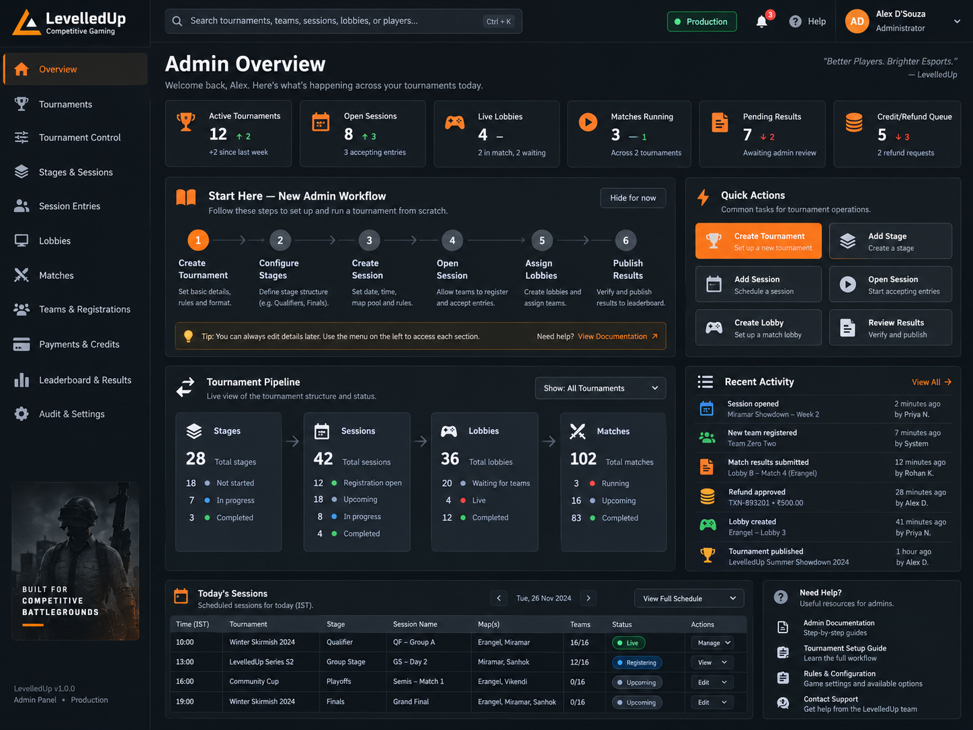  Admin Overview reference | 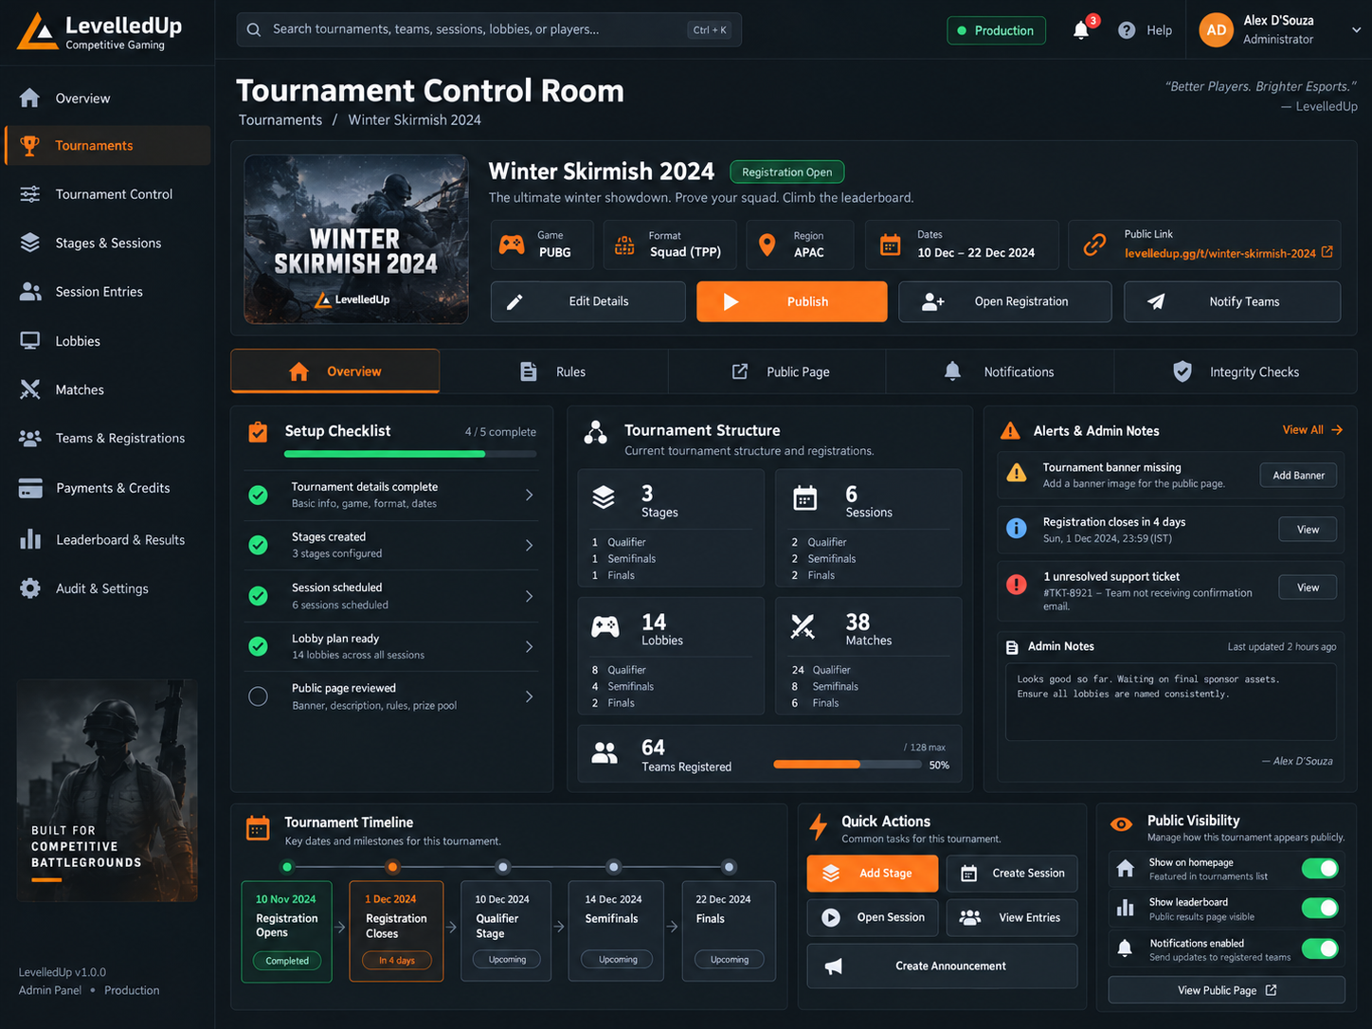  Tournament Control reference
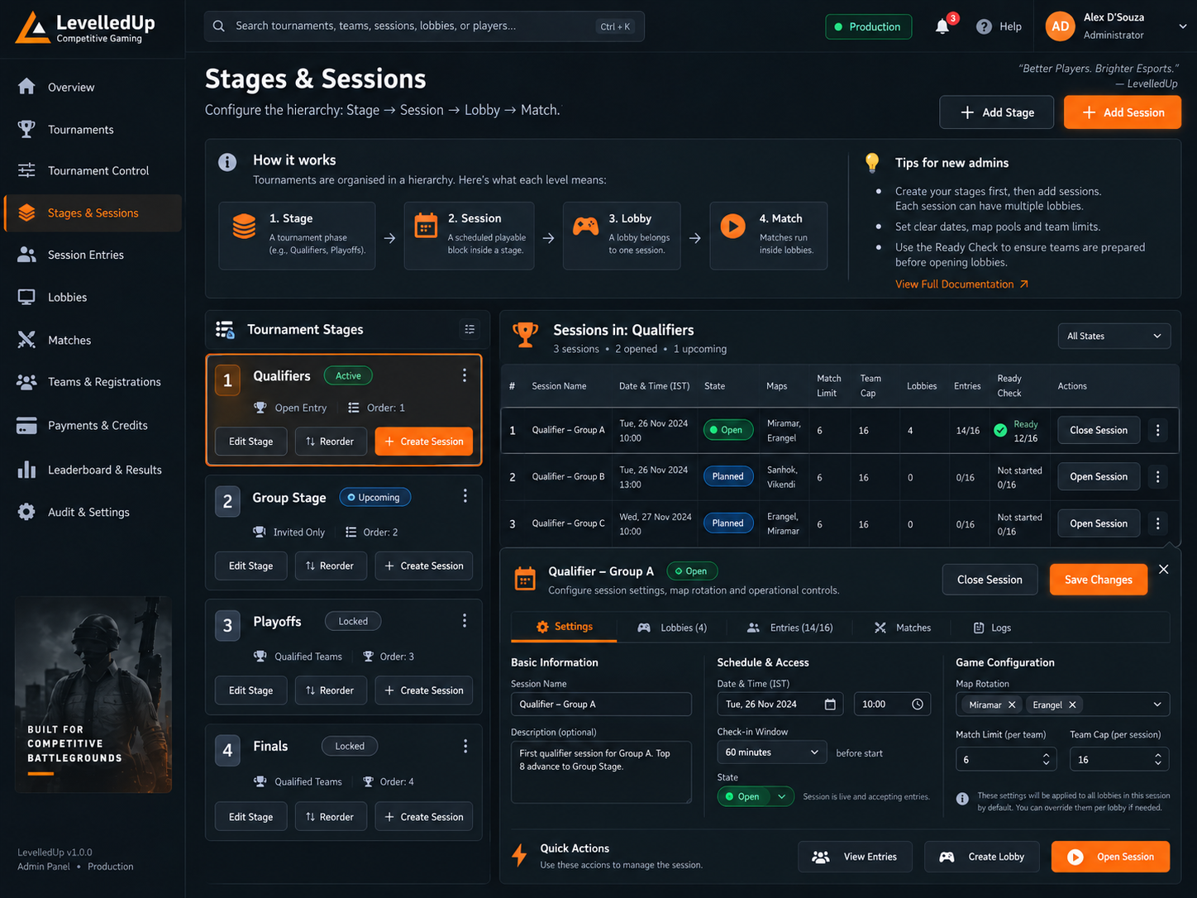  Stages & Sessions reference | 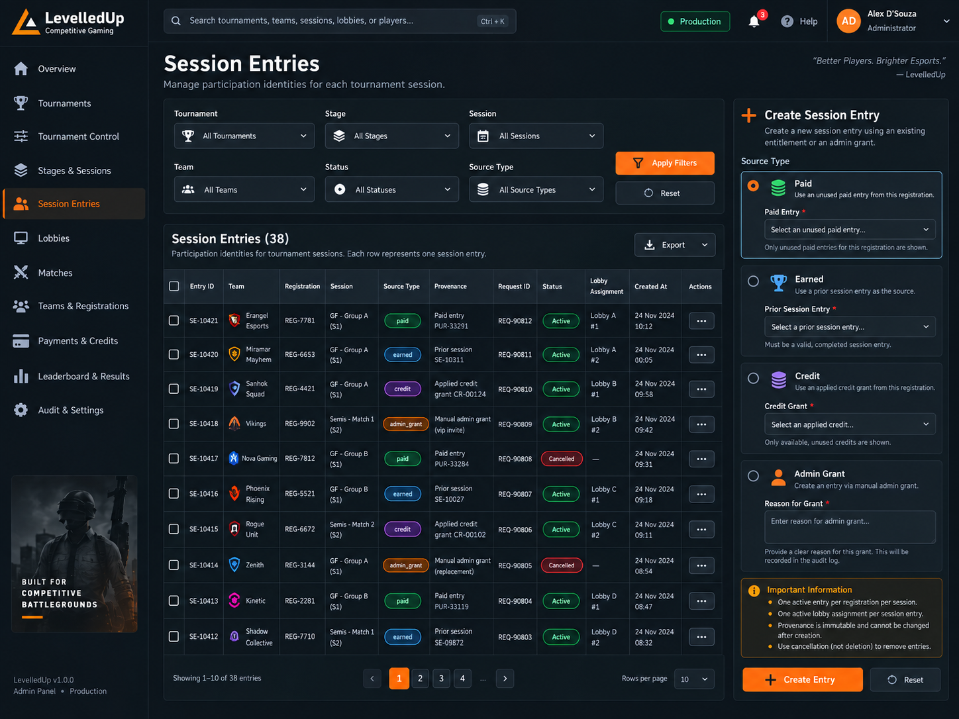  Session Entries reference
Reference only: implement controls only when the current backend and permissions support them.

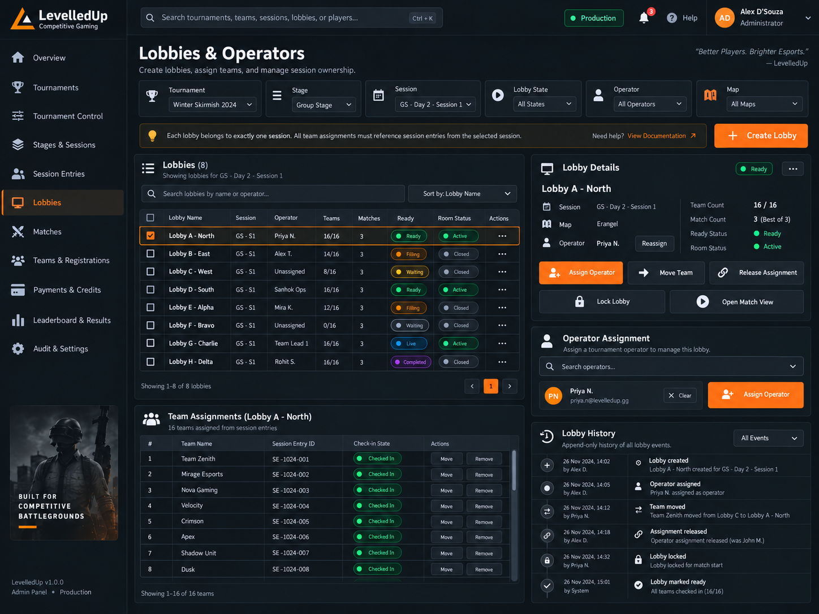  Lobbies & Operators reference | 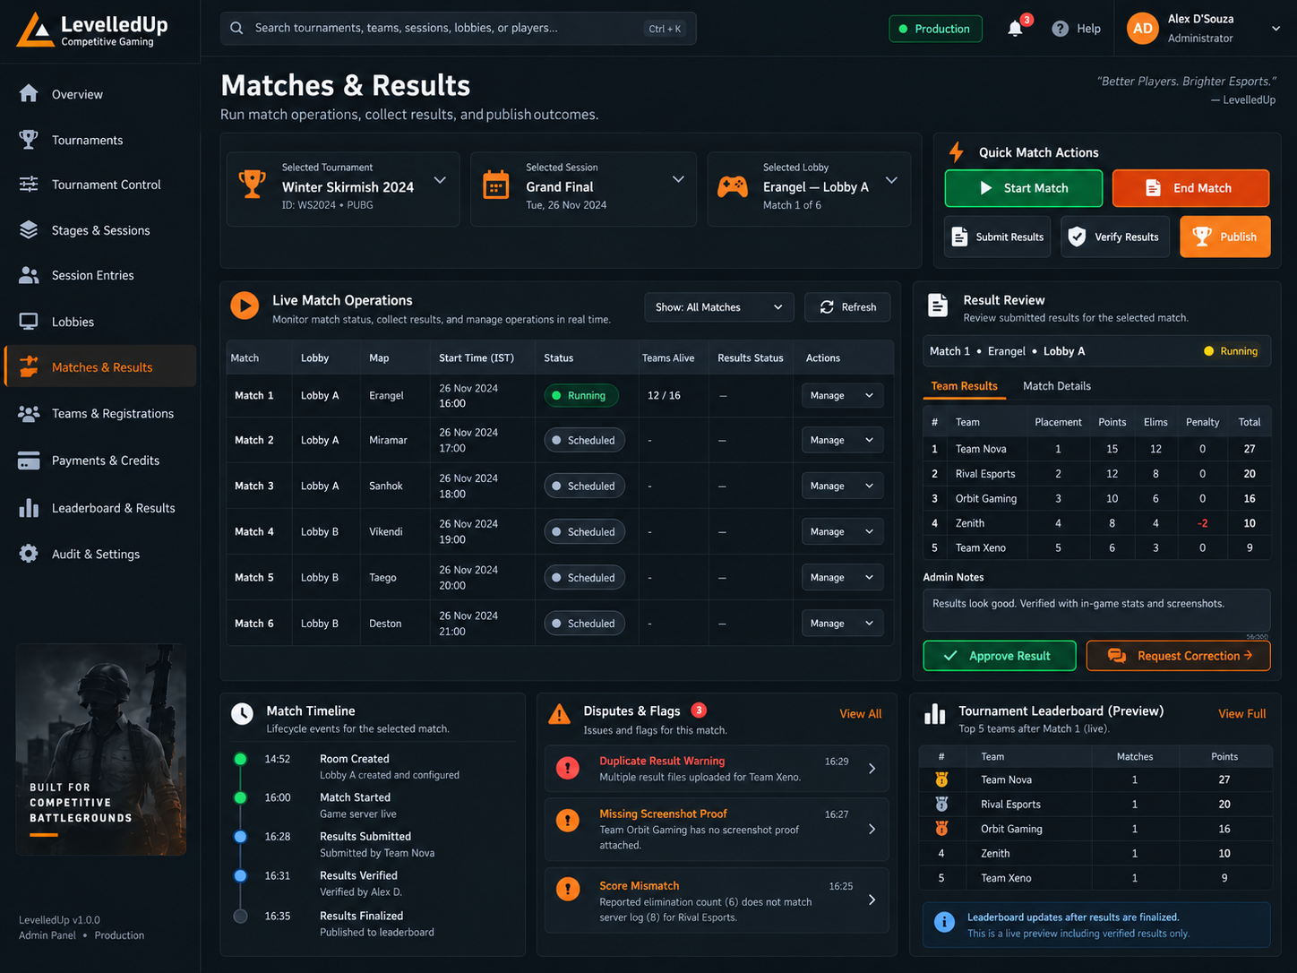  Matches & Results reference
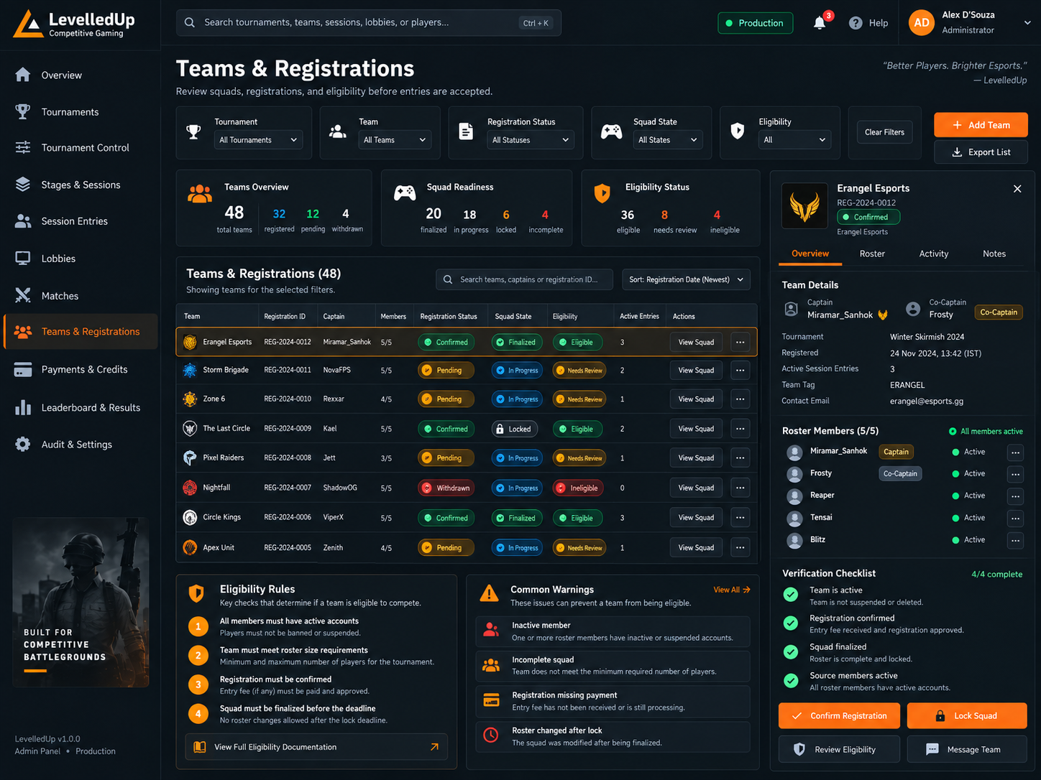  Teams & Registrations reference | 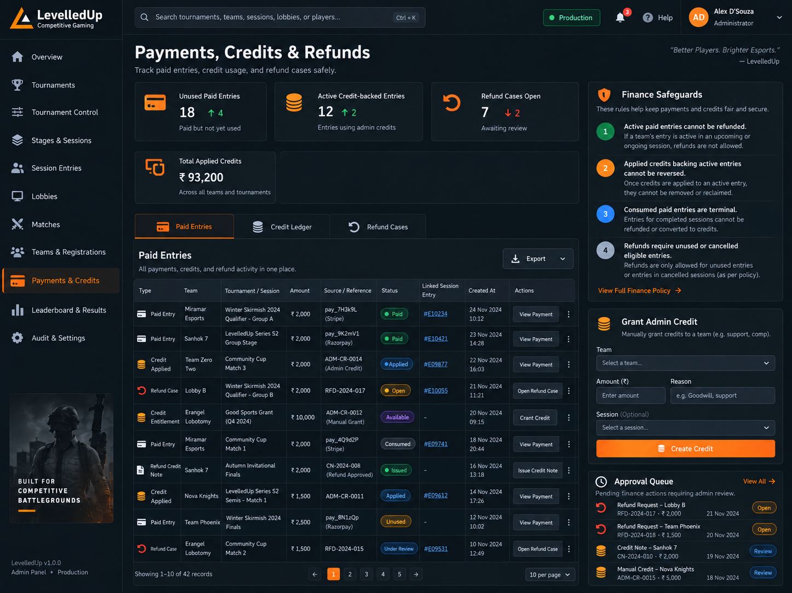  Payments, Credits & Refunds reference
Reference only: implement controls only when the current backend and permissions support them.

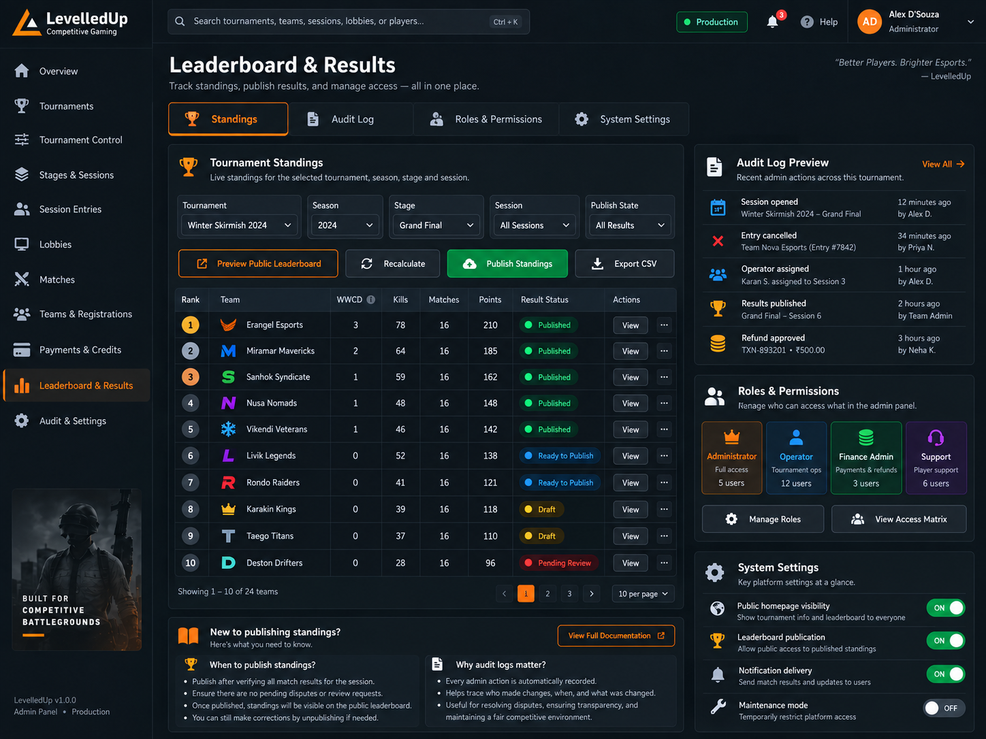
Leaderboard & Results reference
Reference only: implement controls only when the current backend and permissions support them.

B. Glossary and source inventory

Glossary
Term | Meaning
Squad | User-facing Tournament roster snapshot/pool; use this word instead of Roster.
Session | Scheduled attempt unit under a Stage; owns runtime configuration and attempt price.
Session Entry | Stable participation right for one registration/team in one exact Session.
Initial Registration Fee | Tournament-level amount required to join a Paid Tournament initially.
Session attempt price | Authoritative price for one exact paid Session attempt/retry.
Earned entry | Payment-free next-Stage attempt earned by confirmed qualification; not a zero-priced Session.
Admin Grant | Exceptional trusted manual entry, not normal free participation.
Operational team credit | Credit that can be used by the active team while original payer provenance remains immutable.
Tournament Admin | One of at most two active operational Admin seats under the Super Admin.

Primary source material used for this handoff
- Uploaded source archives: app.zip, components.zip, lib.zip, hooks.zip, data.zip, proxy.zip, public.zip, Scrims.zip.
- Uploaded Supabase migrations through 20260908010000_authoritative_session_financial_contract.sql.
- LevelledUp end-to-end wiring audit (6 September 2026) and earlier audit notes.
- Codex implementation report for 20260913010000_free_paid_tournament_contract.sql.
- Codex deployment report confirming 20260913010000 Local + Remote with no pending migrations.
- Codex FREE Tournament runtime verification report, including rollback-only negative DB tests.
- Approved Admin visual reference images listed in Appendix A.
- Conversation-approved product rules summarized throughout this document.
Not independently included in the uploaded archive
The exact text of 20260913010000_free_paid_tournament_contract.sql and the newest post-13-September frontend source were not uploaded to this conversation snapshot. Their status here is based on the Codex deployment/runtime reports. Export the current repository before the next major handoff.

END OF HANDOFF
Update this document whenever a product rule is locked, a migration is deployed, or an admin section becomes GREEN.

