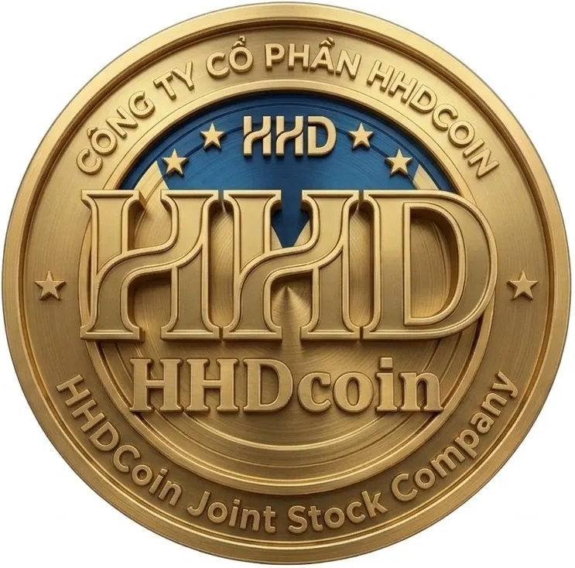
HHD COIN (HHD) — ONE-PAGE INVESTOR MEMO
"Empowering Education, Research & Digital Innovation Through Blockchain" | June 2026
$0.005  Seed Price | $0.020  Public Price | $20M  Launch FDV | $25M  Hard Cap | 1 Billion  Total Supply | BNB Smart Chain  Platform

THE ASK  $970,000 (Seed + Private A/B) for 13% of total token supply (130M HHD). Minimum ticket $10,000. Use of funds: 36% tech, 21% marketing, 15% legal, 15% liquidity, 8% ops, 4% reserve. | VISION 2030  Become the leading blockchain-powered knowledge economy token in Southeast Asia: 20M+ wallets, 50+ partner universities across 15 countries, $1B+ market cap (conservative base case). | REVENUE MODEL  7 streams: platform transaction fees (2%), staking fees (0.5%), NFT credential minting, Launchpad commissions (5%), HHDAI API subscriptions, B2B enterprise licenses, treasury DeFi yield. Projected $57M revenue by 2030 (base case).

OPPORTUNITY  Vietnam ranked #1 globally for crypto adoption (Chainalysis 2023). A $605B EdTech market by 2030 has no dominant blockchain-native knowledge economy token in SEA. HHD Coin fills this gap with academic credibility, institutional partnerships, and a clear 36-month exchange listing pathway.  FOUNDING EDGE  Associate Professor Do Huu Hai (Ph.D., PGS.TS.) brings unique academic credibility: ORCID-verified 20+ Scopus/WoS publications, creator of the HHD-index macroeconomic framework, HHDAI 2.0 intelligence platform, and institutional ties to VIU, Ton Duc Thang University, and a network of SEA research co-authors.  TOKEN UTILITY  10 distinct utility vectors: platform payments, staking rewards (8–55% APY), governance voting, research grants, NFT credential minting, DEX liquidity, DAO membership, AI services access, launchpad participation, and referral rewards. Each creates genuine token demand. | INVESTMENT TERMS  Round Price Raise  Seed $0.005 $250K  Private A $0.008 $320K  Private B $0.010 $400K  Public $0.020 $2,000K  EXCHANGE PATHWAY  • Q3 2026: PancakeSwap DEX + MEXC IEO  • Q4 2026: Gate.io, BitMart (Tier 3)  • Q3 2027: KuCoin, Bybit (Tier 2)  • Q1 2028: OKX (Tier 1.5)  • Q3 2028: BINANCE (Target)  • Q4 2028: Coinbase (Target)  TARGET VCs  Binance Labs, Coinbase Ventures, Animoca Brands, a16z Crypto, Pantera Capital, Spartan Group, HashKey Capital

LEGAL STRUCTURE  Cayman Islands Foundation + Singapore Pte Ltd + HHDCoin Joint Stock Company (Vietnam) | COMPLIANCE  CertiK + PeckShield Audit | Cayman legal opinion | Full team KYC | OFAC screening | PROJECTIONS  Base case: $800M market cap by 2030 | $57M annual revenue | $43.7M treasury | CONTACT  haidh1975@gmail.com  https://hhdcoin.net  t.me/HHDCoin  June 2026


HHD COIN — EXCHANGE LISTING STRATEGY DOCUMENT
4-Phase Exchange Progression: DEX → Tier-3 CEX → Tier-2 CEX → Tier-1 CEX (Binance + Coinbase)
PHASE 1: DECENTRALIZED EXCHANGES (Q3–Q4 2026)
Self-listing on DEX requires no exchange approval — permissionless deployment of liquidity pools establishes price discovery and initial trading volume.

Exchange | Network | Initial Liquidity | Target Pair | Lock Period | Timeline
PancakeSwap v4 | BNB Smart Chain | $150,000 | HHD/USDT + HHD/BNB | 12 months LP lock | Q3 2026 — Mainnet launch
Uniswap v4 | Ethereum (wHHD) | $50,000 | wHHD/USDC | 6 months LP lock | Q4 2026 — Post bridge
1inch Aggregator | Multi-chain routing | Automatic routing | Best price routing | N/A | Q4 2026 — Auto-listed

Exchange Diversification — Regional & Niche Platforms
In addition to the major global exchanges in Phases 2–4, HHD Coin will pursue regional Southeast Asian platforms and education/impact-token-focused exchanges in parallel. This broadens early access to the project's target community (students, researchers, educators) and reduces dependence on any single listing outcome.
Exchange / Platform | Focus | Strategic Rationale | Target Timeline
Coin98 Exchange | Vietnam-based, SEA retail users | Direct access to Vietnam's #1-ranked crypto-adoption user base | Q4 2026 (parallel with Tier-3)
WhiteBIT / Onyxcoin allies | EU-Vietnam crypto bridge | EU user access ahead of MiCA registration | Q1–Q2 2027
Impact/EdTech token platforms (e.g., Republic, CoinList-style launchpads) | Mission-aligned investors | Attracts EdTech and impact-focused investors who value the HHD use case over pure speculation | Q2 2027
Indodax / regional SEA exchanges | Indonesia, Philippines, Thailand users | Expands SEA EdTech community beyond Vietnam ahead of regional university partnerships | Q3 2027

Parallel application strategy: rather than waiting for sequential approvals, HHD Foundation will submit applications to multiple Tier-3 exchanges simultaneously (MEXC, Gate.io, BitMart, LBank, CoinEx, Coin98) once audit and legal documentation are finalized in Q3 2026. This shortens overall time-to-multiple-listings and reduces the risk of any single application delay blocking the roadmap.

PHASE 2: TIER-3 CENTRALIZED EXCHANGES (Q4 2026 – Q2 2027)
Exchange | Daily Volume Req. | Market Cap Req. | Holders Required | Audit Required | KYC Level | Estimated Listing Cost | Target Timeline
MEXC Global | $100K+/day | $5M+ | 5,000+ | Full audit required | Project entity KYC | $0–$20K | Q4 2026
Gate.io | $200K+/day | $10M+ | 10,000+ | CertiK preferred | Full KYC + legal docs | $10–$50K | Q1 2027
BitMart | $50K+/day | $5M+ | 3,000+ | Recommended | Project KYC | $0–$30K | Q1 2027
LBank | $50K+/day | $3M+ | 2,000+ | Recommended | Project KYC | $5–$20K | Q2 2027
CoinEx | $100K+/day | $5M+ | 5,000+ | Required | Full KYC + compliance | $10–$30K | Q2 2027

Key preparation actions: CoinGecko and CoinMarketCap listing within 2 weeks of DEX launch; achieve 5,000+ holders before CEX applications; publish audit report; establish official social channels with active community.

PHASE 3: TIER-2 CENTRALIZED EXCHANGES (Q3 2027 – Q1 2028)
Exchange | MC Required | Daily Volume | Holder Count | TVL Required | Additional Requirements | Target Timeline
KuCoin | $30M+ | $500K+/day | 100K+ holders | $1M+ TVL | Functioning DAO, active governance, 2nd audit | Q3 2027
Bybit | $50M+ | $1M+/day | 200K+ holders | $2M+ TVL | Market maker, institutional investors, $1M+ raise | Q4 2027
OKX | $80M+ | $2M+/day | 500K+ holders | $5M+ TVL | Legal opinion, clear tokenomics, major ecosystem usage | Q1 2028

PHASE 4: TIER-1 EXCHANGES — BINANCE & COINBASE (2028)
Binance — 36-Month Action Plan (Target: Q3 2028)
Timeline | Milestone | Specific Requirement | Responsibility
M1–M6 (2026) | Foundation | CertiK audit, legal structure, team KYC, whitepaper | Founder + CLO
M7–M12 (2026) | Market Entry | DEX + MEXC launch, 50K holders, $1M+ market cap | CMO + CTO
M13–M18 (2027) | Volume Build | KuCoin listing, $500K/day volume, market maker | CMO + BD
M19–M24 (2027) | Community Scale | 500K+ holders, active DAO, $30M+ market cap | Community team
M25–M30 (2028) | Binance Readiness | $100M+ market cap sustained 90 days, OKX listed | Full team
M31–M36 (2028) | Binance Submission | $5M+/day volume, Binance Labs relationship, ecosystem TVL $10M+ | CEO + BD
M36 (Q3 2028) | BINANCE LISTING | HHD/USDT pair listed on Binance Spot | MILESTONE

Binance Listing Checklist
Criterion | Requirement | HHD Target | Status
Market Cap | Sustained $100M+ (90 days) | $150M by Q2 2028 | Planned
Trading Volume | $5M+/day sustained 90 days | $8M+/day via Bybit+OKX | Planned
Holder Count | 500,000+ active wallets | 700,000+ target | In progress
Smart Contract | CertiK + 1 additional audit | CertiK + PeckShield | Q2 2026
Security | No critical vulnerabilities, bug bounty | Immunefi bug bounty program | Q3 2026
Legal | Non-security opinion, Cayman structure | DLA Piper legal opinion | Q2 2026
Team KYC | All team members publicly verifiable | Full team doxxed + KYC | Completed
Tokenomics | Non-inflationary, transparent vesting | Deflationary + public vesting | Completed
Product | Working product with real users | 100K+ DAU on dApp | Q1 2028
Governance | Functioning on-chain governance | HHD DAO v2.0 live | Q4 2027
Liquidity | Professional market maker | Wintermute/GSR engaged | Q1 2028
Ecosystem | Multiple dApps and integrations | EdTech + Research DAO + NFT | Q4 2027
Binance Labs | Investment or grant preferred | Application + pitch | Q1 2027

Coinbase — Listing Requirements (Target: Q4 2028)
Criterion | Coinbase Standard | HHD Approach
Process | Free, merit-based, application via Coinbase Asset Hub | Submit complete application package with all supporting docs
Securities Law | Must not be a security under Howey Test | Cayman Foundation + Utility token legal opinion (DLA Piper)
Technology | Functional mainnet, published open-source code | BSC mainnet + GitHub public repo + verified BscScan contracts
Security | No critical vulnerabilities, independent audit | CertiK + Trail of Bits audit planned for 2028
Team | Identifiable individuals, no sanctions lists | Full team KYC + doxxed profiles + OFAC screening
Compliance | AML/KYC procedures, sanctions screening | Sumsub KYC + Chainalysis AML monitoring
Community | Organic, legitimate user base | No wash trading commitment + real community metrics
Financials | Transparent, no fraudulent activity | Quarterly public treasury reports + on-chain verification
Exchanges | Prior exchange listing history preferred | KuCoin + Bybit + OKX history by application date

MARKET MAKER STRATEGY
A professional market maker is engaged at each listing tier to manage spreads, provide order book depth, and prevent excessive volatility immediately after launch — directly addressing the risk of large price swings post-listing.
Market Maker | Type | Service Level | Initial Capital Commitment | Engagement Timeline | Purpose
Gotbit | Tier 2 — Community-focused MM | Telegram community trading volumes, spread management | $50,000 HHD + stablecoin pair | Q4 2026 (post-DEX) | Initial CEX listing support
Kairon Labs | Tier 2 — Crypto-native MM | BSC/CEX liquidity, affordable pricing | $150,000 equivalent | Q1 2027 (pre-Tier-2) | KuCoin, Bybit readiness
GSR Markets | Tier 1 — OTC + MM | Liquidity provision, OTC desk, large-block trades | $500,000 equivalent | Q4 2027 (pre-OKX) | OKX and Binance volume
Wintermute | Tier 1 — Algorithmic MM | Spread management, order book depth, 24/7 coverage | $1,000,000+ equivalent | Q1 2028 (pre-Binance) | Binance listing readiness

Liquidity glide path: as HHD progresses through exchange tiers, market maker capital commitment scales from $50K (Tier-3 support) to $1M+ (Tier-1 readiness), funded from the 4% Liquidity Provision allocation (40,000,000 HHD) plus a portion of Treasury reserves. Spread targets tighten progressively: ±2% (Tier-3) → ±1% (Tier-2) → ±0.3% (Tier-1), matching Binance's listing expectations referenced in Part IX of the Whitepaper.

COMMUNITY BUILDING & RELATIONSHIP STRATEGY
Strong, organic communities directly drive the trading volume that exchanges require for listing decisions. Beyond the social media channels and 24-month marketing calendar in Part XI of the Whitepaper, HHD Foundation will run the following recurring activities:
Activity | Frequency | Audience | Goal
AMA (Ask Me Anything) sessions on Telegram/X Spaces | Bi-weekly | Crypto community + token holders | Transparency, Q&A on roadmap and audits
Webinars with crypto + EdTech communities | Monthly | Crypto investors, university partners | Cross-pollinate crypto-native and education audiences
University/research partner spotlights | Monthly | Academic network (Lund, Granada, VNU, VIU) | Demonstrate real-world adoption to exchanges
Trading competitions on each new exchange listing | Per listing event | Exchange users | Bootstrap volume immediately post-listing
Governance proposal review calls | Per proposal | DAO members (staked holders) | Demonstrate functioning on-chain governance
Quarterly Transparency Report livestream | Quarterly | All stakeholders | Treasury, burn, and audit status updates

LEGAL & AUDIT DOCUMENTATION READINESS
Centralized exchanges — especially Tier-1 (Binance, Coinbase) — require a complete legal and audit documentation package before any listing review begins. The following must be finalized BEFORE Phase 2 applications are submitted (target: end of Q2 2026):
Document | Issuing Party | Status Target
CertiK Smart Contract Audit Report | CertiK | Completed Q2 2026, published on GitHub + hhdcoin.net
PeckShield Secondary Audit Report | PeckShield | Completed Q1 2028 (ahead of Tier-1 applications)
Non-Security Legal Opinion Letter | DLA Piper or equivalent (Cayman law firm) | Completed Q2 2026
Cayman Foundation Constitutional Documents | Ogier Law (Cayman registered agent) | Completed Q1 2026
HHDCoin Joint Stock Company Business Registration | Vietnam Department of Planning and Investment | Completed Q1 2026
AML/KYC Policy Document | Sumsub + internal compliance | Completed Q2 2026
Bug Bounty Program Listing (Immunefi) | Immunefi | Live before mainnet trading enabled
Team KYC Verification Records | Each core team member | Completed pre-TGE

LISTING APPLICATION REQUIREMENTS CHECKLIST
Document / Requirement | Purpose | Responsible Party | Status
Smart Contract Audit Report (CertiK) | Security verification — all exchanges require this | CTO + CertiK | Q2 2026
Second Audit Report (PeckShield) | Dual audit increases credibility, required for Tier-1 | CTO + PeckShield | Q1 2028
Legal Opinion Letter | Confirms non-security status in key jurisdictions | CLO + DLA Piper | Q2 2026
KYC Documentation (All Core Team) | Exchange due diligence requirement | All team members | Pre-launch
Cayman Foundation Registration Docs | Entity verification for listing applications | CLO + Ogier Law | Q1 2026
Tokenomics Documentation | Transparent allocation and vesting schedules | CFO + CTO | Completed
Community Metrics Report | Organic community verification (Telegram, Twitter, Discord) | CMO | Ongoing
Trading Volume Evidence | Historical DEX and CEX trading data | CMO + MM partner | Ongoing
Holder Address Report | On-chain wallet holder verification | CTO (BscScan data) | Ongoing
Treasury Transparency Report | Quarterly financial + on-chain treasury report | CFO | Quarterly
Roadmap Completion Evidence | Track record of delivering on roadmap commitments | CEO + CTO | Ongoing
Governance Activity Report | Evidence of functioning DAO and community governance | CEO + Community | Q4 2026+
Partnership Agreements | University, enterprise, and ecosystem partnerships | CEO + BD | Ongoing
Anti-Manipulation Declaration | No wash trading, no price manipulation policy | CMO + CFO | Pre-launch
Bug Bounty Program | Immunefi or similar bug bounty evidence | CTO | Q3 2026

HHD FOUNDATION | HHDCoin Joint Stock Company | haidh1975@gmail.com | https://hhdcoin.net | June 2026

