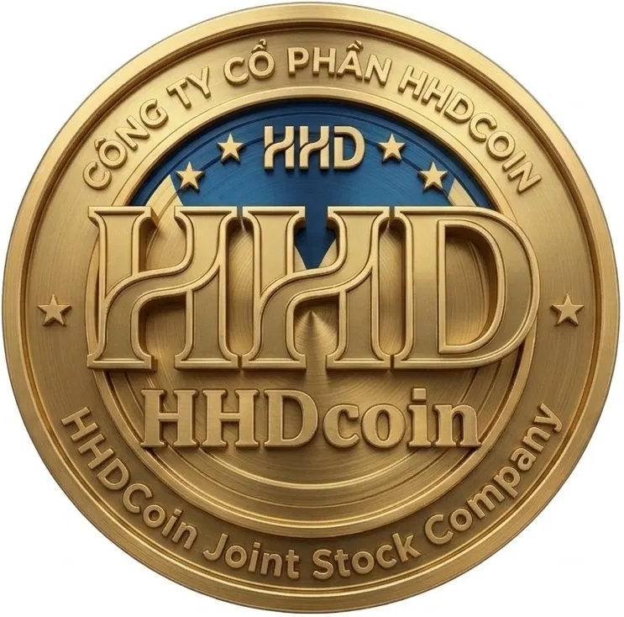
HHD COIN
Ticker: HHD
"Empowering Education, Research & Digital Innovation Through Blockchain"

INVESTOR PITCH DECK | JUNE 2026
Do Huu Hai, Ph.D. (PGS.TS.) | Founder & CEO
VIU | Ton Duc Thang University | HHDCoin Joint Stock Company

THE PROBLEM
Why the knowledge economy needs a dedicated token
# | Problem | Scale | Cost
1 | 617M+ people lack basic literacy; SEA education access deeply inequitable | Global / SEA | $200B+ lost productivity
2 | Academic credential fraud costs institutions billions; verification is slow & centralized | Global | $50B+ annual fraud
3 | Researchers & educators not directly compensated for IP and knowledge creation | Global | $100B+ value extraction
4 | Vietnamese SMEs face high barriers to digital transformation — no tokenized incentive layer | Vietnam / SEA | $30B+ opportunity cost
5 | Early-stage AI & deep-tech startups in SEA lack crypto-native funding infrastructure | SEA | $15B+ funding gap

THE SOLUTION
HHD Coin — The Knowledge Economy Token
HHD Coin is the first blockchain token purpose-built for the education, research, AI, and digital transformation ecosystem in Vietnam and Southeast Asia.

HHD Solution | Target User | Mechanism
HHD EdTech Platform | Students, educators | Tokenized scholarships, course rewards, decentralized learning
HHD Research DAO | Researchers, academics | Peer-review rewards, citation incentives, grant allocation
HHD Credential Chain | Universities, employers | NFT-based verifiable degrees on BNB Smart Chain
HHD DigiX Program | SMEs, enterprises | Token grants for digital transformation, AI adoption scoring
HHD Innovation Fund | Startups, innovators | DAO-governed micro-grants, AI startup launchpad
HHDAI 2.0 Platform | Researchers, policy makers | Proprietary macro-intelligence platform (token-gated access)

MARKET OPPORTUNITY
$605B EdTech market by 2030 — HHD targets the tokenized layer

$605B  Global EdTech 2030 | $5.8B  Blockchain in Education | $25B  SEA EdTech 2030 | #1  Vietnam Crypto Adoption

Vietnam: 100M population, #1 global crypto adoption index, $9B EdTech market by 2030, Government $7B+ digital transformation program.

Evidence: World Economic Forum research (2024) finds blockchain can make academic credentials globally recognized and instantly verifiable, breaking down institutional barriers — directly validating the HHD Credential Chain use case.

COMPETITIVE ADVANTAGE
Why HHD Coin is hard to copy
Moat | Description | Why It's Defensible
Academic Founder Credibility | Founder is a published Associate Professor (PGS.TS.) with 20+ Scopus/WoS papers and an ORCID-verified research record | Cannot be replicated by purely financial teams — credibility is earned over a career
HHDAI 2.0 Proprietary Platform | Macro-intelligence platform with 11 economic models, built on the founder's own HHD-index framework | Unique IP — competitors would need years of original research to match
Vietnam Institutional Network | Direct ties to VIU, Ton Duc Thang University, and an international co-author network (Lund University, Universidad de Granada, VNU Hanoi) | Real-world distribution channel for pilots, credentials, and grants — not easily bought
First-Mover in SEA EdTech-Blockchain | No dominant token currently combines education + research + AI + digital transformation for the Vietnam/SEA market | Network effects compound once universities and SMEs onboard
#1 Crypto Adoption Market | Vietnam ranks #1 globally for crypto adoption (Chainalysis), giving HHD a built-in, crypto-literate early-user base | Geographic advantage difficult for non-local projects to replicate

TOKENOMICS
1 billion fixed supply, deflationary burn, tiered staking, on-chain governance
Parameter | Value
Total Supply | 1,000,000,000 HHD (1 Billion — Fixed)
Initial Circulating | 100,000,000 HHD (10% at TGE)
Hard Cap | $25,000,000 USD
Soft Cap | $3,000,000 USD
Seed Price | $0.005 | Private: $0.010 | Public: $0.020
Target FDV at Launch | $20,000,000 USD
Burn Mechanism | 1% transaction burn + quarterly buyback burn
Staking APY | 8% – 55% (tiered, 30–365 day lockup)
Governance | 1 HHD staked = 1 vote (OpenZeppelin Governor)

TOKEN ALLOCATION
1,000,000,000 HHD across 11 categories — fully vested, no inflation
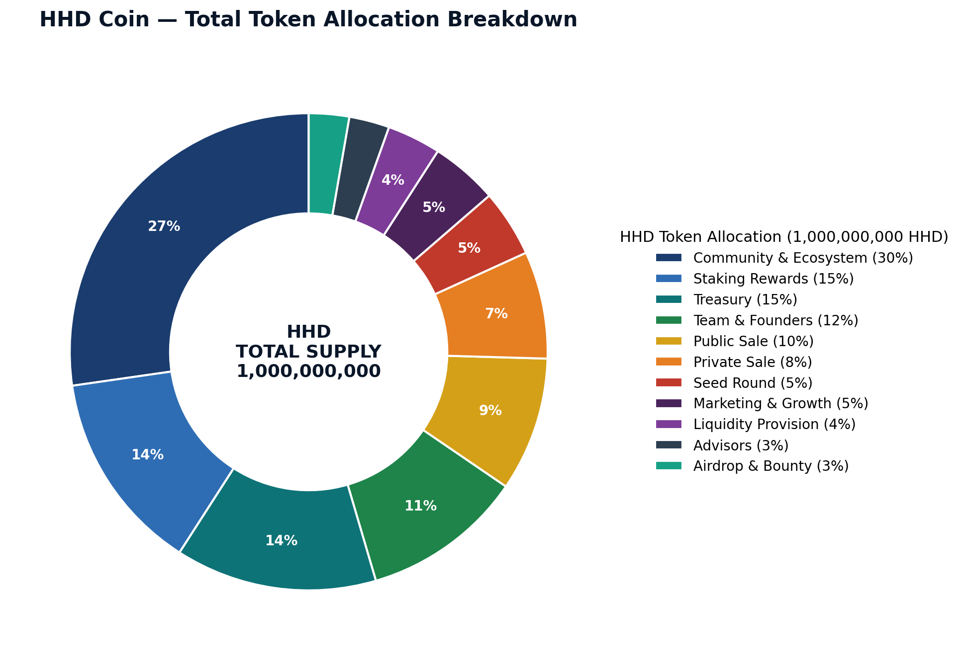

TECHNOLOGY STACK
BNB Smart Chain — EVM-compatible, ultra-low fees, Binance ecosystem
Layer | Technology | Why This Choice
Primary Chain | BNB Smart Chain (BEP-20) | < $0.01 fees, 3,000 TPS, Binance ecosystem, EVM compatible
Cross-Chain | LayerZero v2 (wHHD on ETH) | Battle-tested bridge, ETH DeFi access
Smart Contracts | Solidity 0.8.x + OpenZeppelin 5.x | Industry standard, battle-tested security
Oracles | Chainlink Price Feeds + VRF | Decentralized, manipulation-resistant
Storage | IPFS + Filecoin | Credential documents, research papers, permanent storage
DEX | PancakeSwap v4 | Largest BSC DEX, $2B+ daily volume
Governance | OpenZeppelin Governor + Timelock | Proven DAO architecture, 48h execution delay
Audit | CertiK + PeckShield (planned) | Dual audit = highest exchange listing credibility
AI Integration | HHDAI 2.0 (proprietary) | Unique competitive moat — macro research intelligence

ROADMAP
Clear milestones — from launch to Binance in 36 months
Phase | Timeline | Key Milestones | Exchange Target
Phase 1  Foundation | Q1–Q2 2026 | Smart contract + CertiK audit, legal structure (Cayman + SG), seed round, team KYC, whitepaper | Seed round close
Phase 2  Launch | Q3–Q4 2026 | BSC mainnet, PancakeSwap listing, Public Sale/IEO, dApp v1.0, staking launch, 100K community | MEXC, Gate.io
Phase 3  Growth | 2027 | Research DAO, NFT credentials, cross-chain bridge, governance v2, 2M community, $30M+ market cap | KuCoin, Bybit
Phase 4  Expansion | 2028 | OKX listing, HHDAI 3.0, SME DigiX platform, $100M+ market cap, Binance application | OKX + BINANCE
Phase 5  Leadership | 2029–2030 | Coinbase listing, 20M users, ASEAN knowledge economy leadership, $1B+ market cap target | Coinbase

FINANCIAL PROJECTIONS
Three-scenario model — conservative to bull case
Metric | 2026 | 2027 | 2028 | 2029 | 2030
Base Market Cap | $20M | $60M | $200M | $400M | $800M
Base Token Price | $0.02 | $0.06 | $0.20 | $0.40 | $0.80
Conservative Market Cap | $5M | $15M | $50M | $100M | $200M
Bull Case Market Cap | $50M | $200M | $600M | $1.5B | $3B
Total Revenue (Base) | $95K | $830K | $4.5M | $16.5M | $57M
Treasury Balance | $2.4M | $1.7M | $3.2M | $11.7M | $43.7M
Active Wallets | 50K | 500K | 2M | 7M | 20M

Revenue sources: Transaction fees (2%), staking revenue (0.5%), NFT minting burns, Launchpad commissions (5%), HHDAI API subscriptions, B2B enterprise licenses, treasury DeFi yield.

USE OF FUNDS
Seed + Private Sale: $970,000 raised
Category | Amount | % of Raise | Purpose
Technology Development | $350,000 | 36% | Smart contracts, dApp, HHDAI 3.0, security audits
Legal & Compliance | $150,000 | 15% | Cayman Foundation, Singapore Pte Ltd, legal opinions, KYC/AML
Marketing & Community | $200,000 | 21% | KOL campaigns, PR, conferences, community managers
Liquidity Provision | $150,000 | 15% | Initial DEX liquidity (PancakeSwap, Uniswap)
Operations & Team | $80,000 | 8% | Core team salaries, infrastructure, tools
Reserve Fund | $40,000 | 4% | Emergency reserve, unexpected compliance costs
TOTAL | $970,000 | 100% | Full deployment over 12 months

THE ASK
Raising $970,000 across Seed + Private rounds for 13% of total token supply
$970,000  Total Raise (Seed + Private A/B) | 130,000,000 HHD  13% of Total Supply Offered | $5–10M FDV  Implied Valuation Range

What we are asking for:
- Capital: $970,000 across Seed ($250K @ $0.005) + Private A ($320K @ $0.008) + Private B ($400K @ $0.010)
- Strategic value-add: Introductions to Tier-1/Tier-2 exchanges (KuCoin, Bybit, OKX, Binance Labs), market makers, and EdTech ecosystem partners
- Minimum ticket: $10,000 (Seed) | Use of proceeds breakdown shown on previous slide
- Timeline: Seed round open now (Q1 2026); Private rounds close before Public Sale/IEO in Q3–Q4 2026

TEAM & ADVISORS
Academic credibility + blockchain expertise + international research network
Name | Role | Credentials
Do Huu Hai, Ph.D. | Founder & CEO | Associate Professor (PGS.TS.), VIU & Ton Duc Thang University; ORCID: 0000-0001-5811-7154; Creator: HHD-index, HHDAI 2.0; 20+ Scopus/WoS papers; Expert: Green HRM, ESG, FinTech, Industry 4.0/5.0
CTO (TBA) | Chief Technology Officer | 8+ years Solidity/BSC development; Previous DeFi protocol experience; BSC ecosystem expertise
CFO (TBA) | Chief Financial Officer | CFA designation; 10+ years traditional + crypto finance; Investment banking background
CLO (TBA) | Chief Legal Officer | International crypto law specialist; Cayman Islands corporate structure expertise; Exchange listing compliance
CMO (TBA) | Chief Marketing Officer | Web3 growth hacking; KOL network APAC; Previous Top-50 CMC project marketing lead

Academic & Industry Advisory Board:
Name | Institution | Expertise / Value to HHD
Sandeep Jagtap, Ph.D. | Lund University, Sweden | Industry 4.0, sustainable innovation — Research DAO design
Andreas Norrman, Ph.D. | Lund University, Sweden | Supply chain digitalization — HHD DigiX framework, EU partnerships
Senior Researcher (TBC) | Universidad de Granada, Spain | ESG & sustainable finance — HHDAI model validation
Pham Viet Thang, Ph.D. | Phenikaa University, Vietnam | Digital transformation, SME — Vietnam institutional relations
Nguyen Thi Anh Thu, Ph.D. | VNU Hanoi, Vietnam | Finance, EdTech policy — university & MOET network

INVESTOR OPPORTUNITY
Join the knowledge economy revolution
Round | Price | Tokens | Raise | Min Ticket | Vesting | Bonus
Seed (OPEN) | $0.005 | 50M HHD | $250K | $10,000 | 6m cliff + 18m linear | +20% tokens
Private A | $0.008 | 40M HHD | $320K | $25,000 | 3m cliff + 9m linear | +10% tokens
Private B | $0.010 | 40M HHD | $400K | $50,000 | 3m cliff + 9m linear | Pro rata rights
Public Sale | $0.020 | 100M HHD | $2M | $100 | 6m linear (20% TGE) | Open to all

Target VCs: Binance Labs, Coinbase Ventures, Animoca Brands, a16z Crypto, Pantera Capital, Spartan Group, HashKey Capital

3x–10x (Conservative)  Seed ROI Potential | 36 Months  Path to Binance | Vietnam #1  Global Crypto Adoption Index

WHY NOW + NEXT STEPS
The window for early-stage EdTech token leadership in SEA is open
- Vietnam is the #1 country globally for crypto adoption — massive organic demand for legitimate EdTech tokens
- MiCA (EU, 2024) and emerging global regulatory clarity create compliance-first opportunities for well-structured projects
- BNB Chain ecosystem grants and Binance Labs funding are actively seeking Education + AI + DeFi cross-sector projects
- Post-FTX market: institutional investors prioritize utility tokens with real-world use cases — HHD fits perfectly
- Founder (Do Huu Hai) brings unique academic + research credibility that no purely financial team can replicate
- First-mover advantage in Vietnam/SEA EdTech blockchain — no dominant player in this specific niche

NEXT STEPS FOR INVESTORS:
- Step 1: Sign NDA and receive full investor data room access
- Step 2: Review audited smart contracts and legal opinion letter
- Step 3: Schedule 1:1 call with founder team
- Step 4: Execute SAFT (Simple Agreement for Future Tokens) — seed minimum $10,000

Contact: haidh1975@gmail.com | https://hhdcoin.net | t.me/HHDCoin
HHD Foundation | HHDCoin Joint Stock Company | ORCID: 0000-0001-5811-7154 | June 2026

