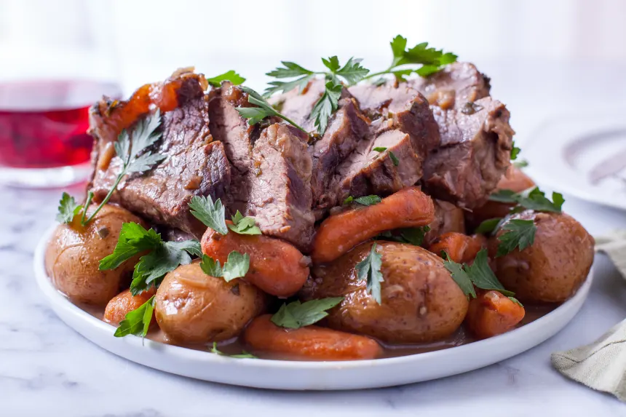
Crock-Pot Beef Roast
ingredients  - 5carrots, peeled and cut into 2-inch slices  - 1onion, quartered  - 2 -3lbs boneless chuck roast  - ¹⁄₂cup water or 1/2 cup beef broth  - 1tablespoon chives, chopped  - 2tablespoons parsley, chopped  - ¹⁄₈teaspoon pepper  - 1(1 ounce) package onion soup mix  - 2tablespoons Worcestershire sauce  - 1(10 3/4 ounce) can cream of mushroom soup |  |  | Directions  - Put potatoes, carrots and onion on bottom of crockpot.  - Place the roast on top, fat side up.  - Pour in water or beef broth.  - Sprinkle chives, parsley, pepper and Onion Soup mix over the meat.  - Pour Worcestershire sauce and mushroom soup over meat.  - Cover and cook on low 8-10 hours.  - **Note: If your roast is frozen, start it on low the night before with just the water or broth. Add the rest of the ingredients the next morning and cook until dinnertime! If done this way, you can easily remove the fat layer in the morning before adding the other ingredients.
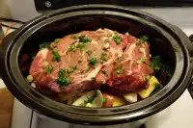 |  |  |  | 

Cost:

Nutrition:

Optional material:

Tips:

More to discuss:

