Lækker kylling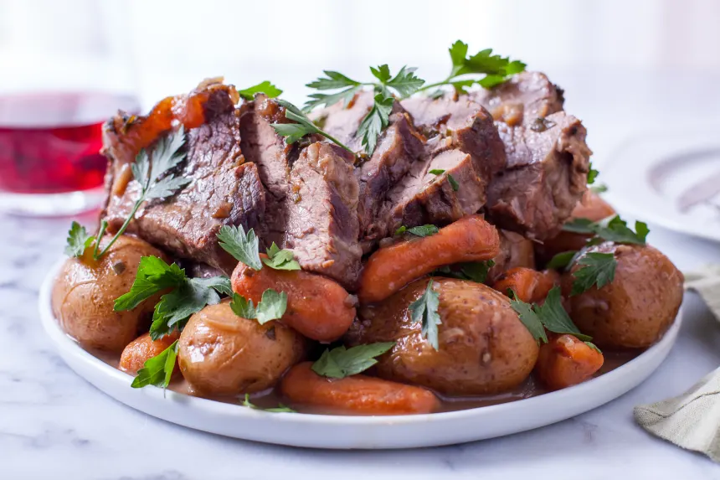
Ingredienser:  4 stk Kyllinglår  1 stk Agurk  2 stk Hvidløger  2 spsk Soya sauce  2 spsk Balsamicoeddike  1 spsk Chiliolie |  |  | Opskrift:  - Put potatoes, carrots and onion on bottom of crockpot.  - Place the roast on top, fat side up.  - Pour in water or beef broth.  - Sprinkle chives, parsley, pepper and Onion Soup mix over the meat.  - Pour Worcestershire sauce and mushroom soup over meat.  - Cover and cook on low 8-10 hours.
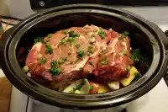 |  |  |  | 

Materialeomkostninger:

Nutrition:

Optional material:

Tips:

More to discuss:

